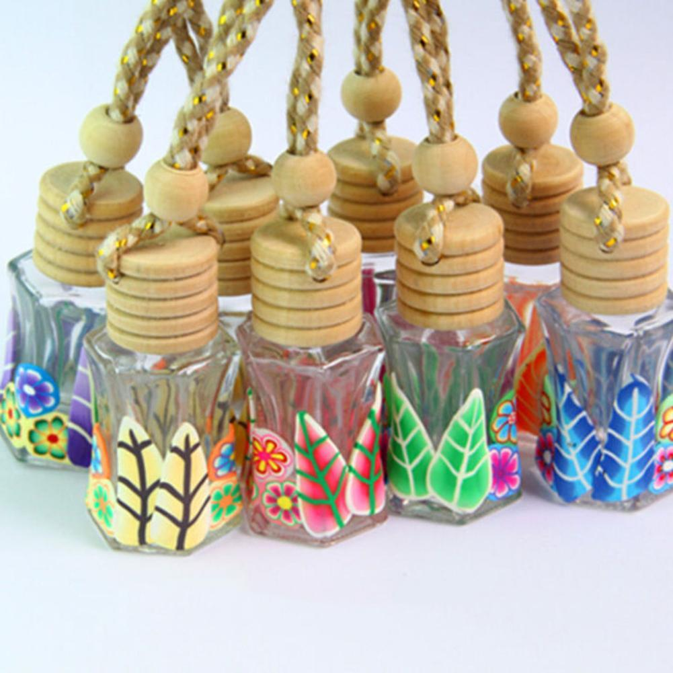`
PERFUMES
&
FREGNANCE
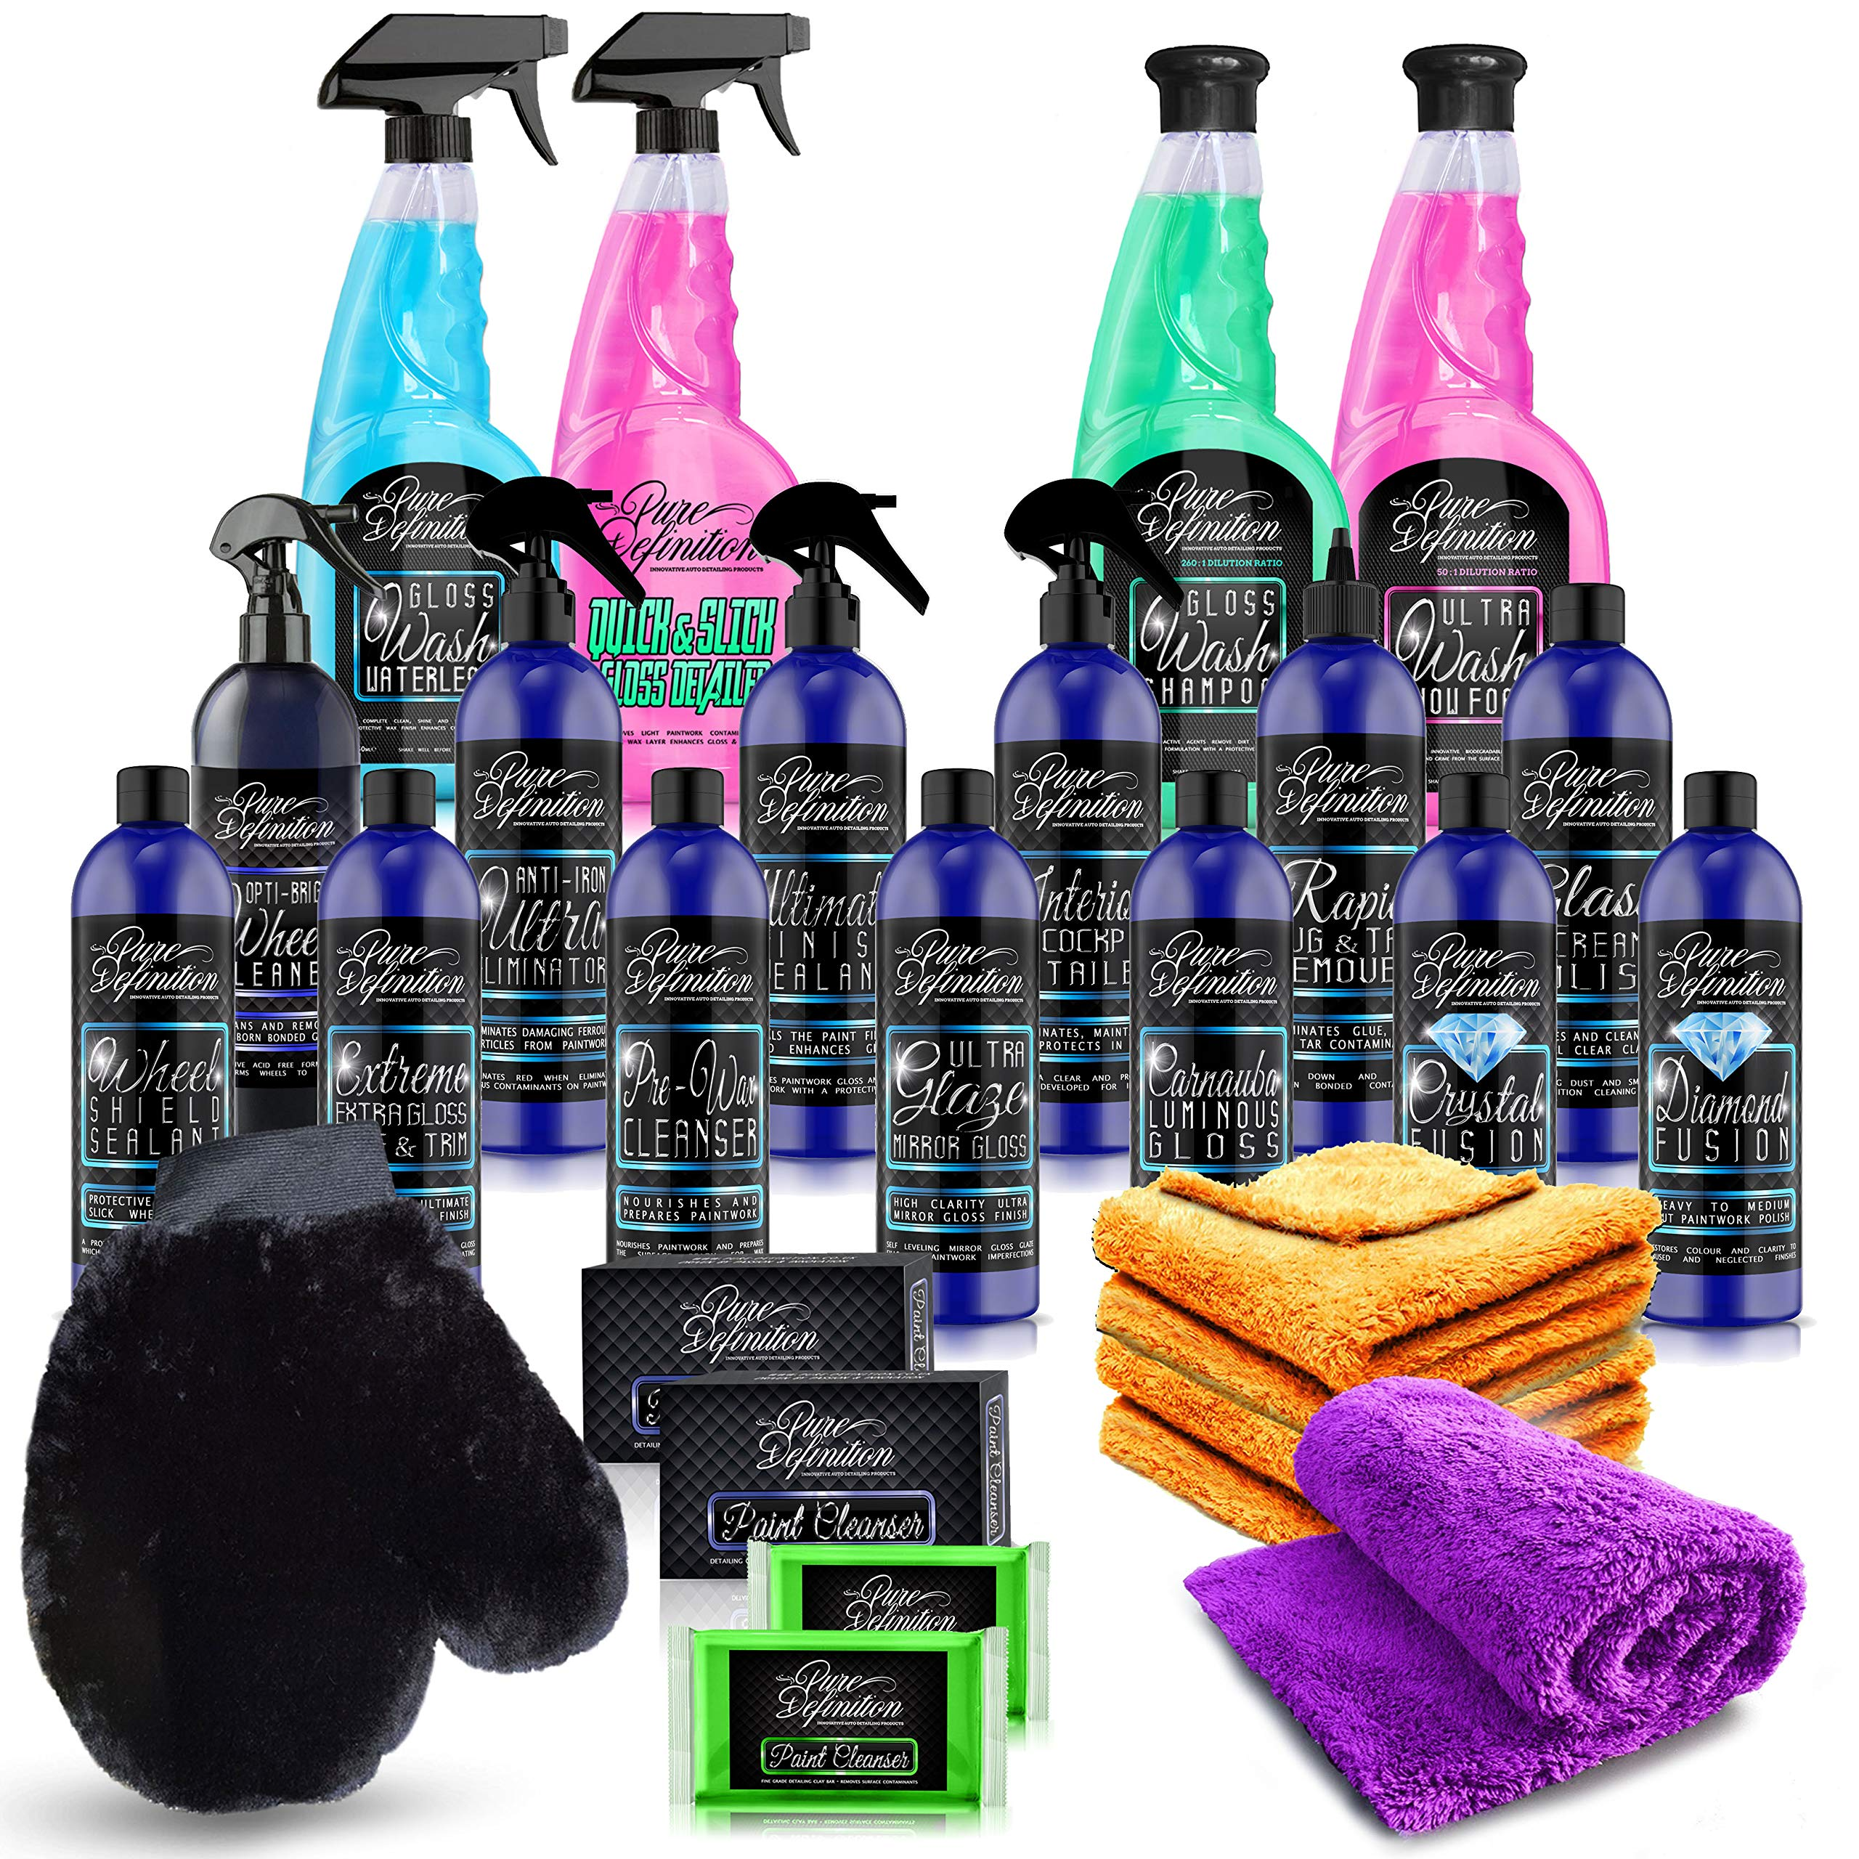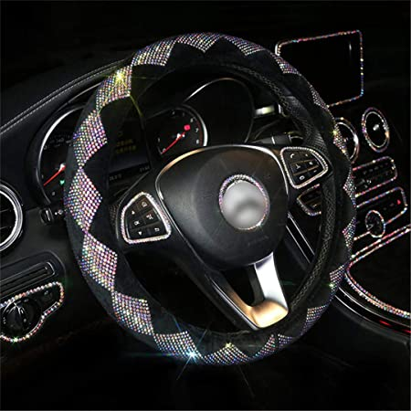
POLISH
&
CLEANERS
STEERING COVERS
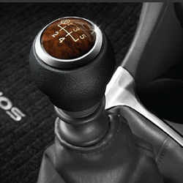
GEAR SET
&
GARE COVERS
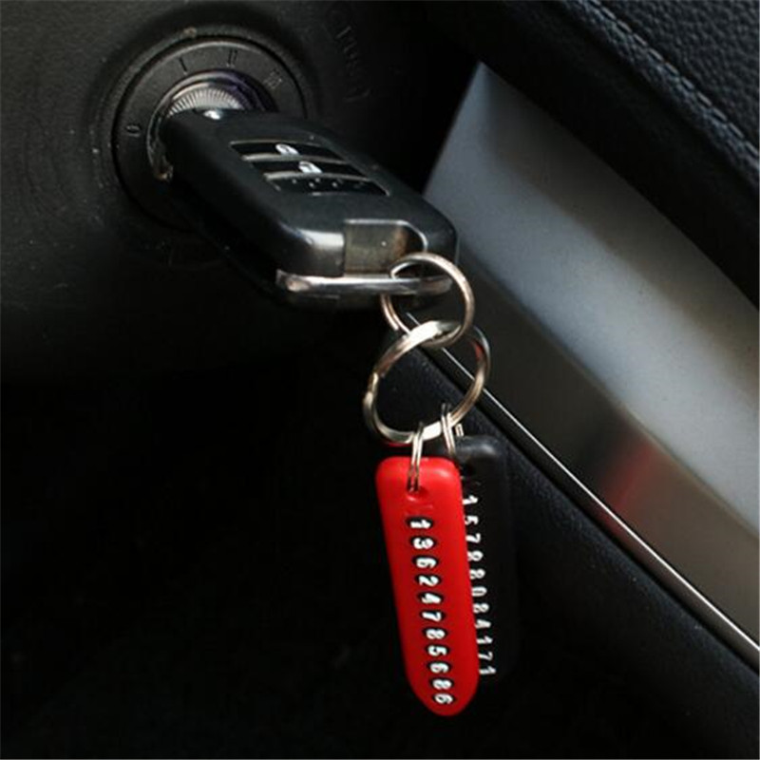
KEY
CHAINS
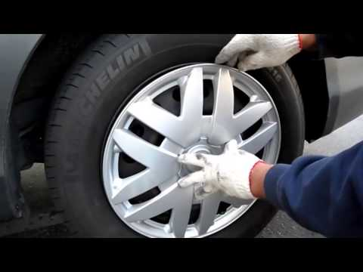
WHEEL
COVERS

DEVELOPED BY AAYAM INSTIUTE OF COMPUTER INTELLIGENCE
CONTACT: +91 983902138 newa1carshringar@gmail.com newa1carshringar.netlify.app
OPP. TB HOSPITAL, FRONT OF KOTWALI ROAD, FAIZABAD ROAD,
BARABANKI, UTTARPRADESH. PIN: 225001.
NEW A1 CAR SHRINGAR

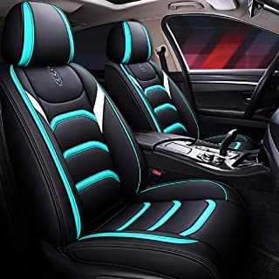
SEAT COVERS

