1. Download node.js from <https://nodejs.org/en/>

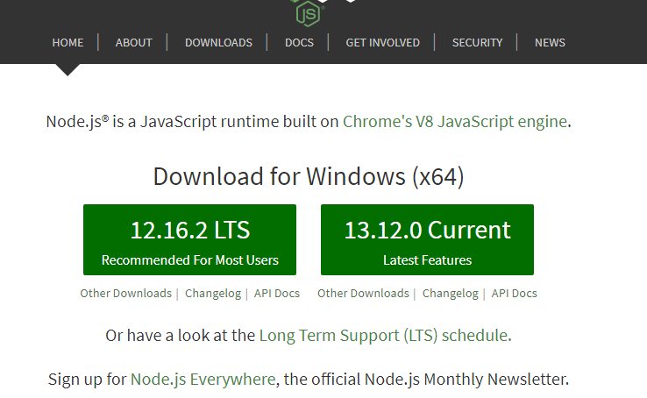

Click on LTS, download and install

1. Visual studio code is defaulted in VDIs if not get it from open repository
2. Once node installation is done, type node command prompt in windows search and open.

Verify node, npm installed or not by writing these two commands

Node –v, npm –v

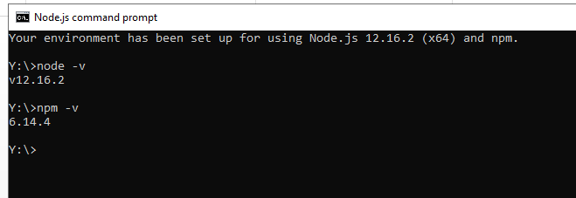

1. Now install angular cli by typing “npm install –g @angular/cli”
2. Create new angular app by typing “ng new myNgApp(any name)”

It takes much time. Be patient. And once finished, looks like this

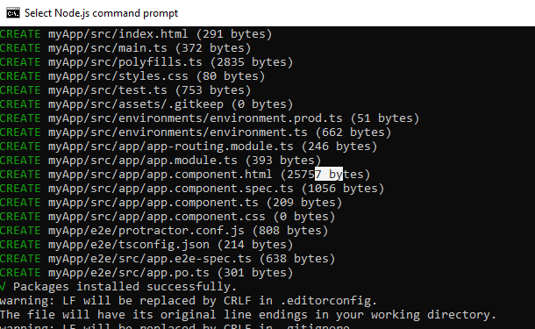

1. Launch the application by “ng serve”.

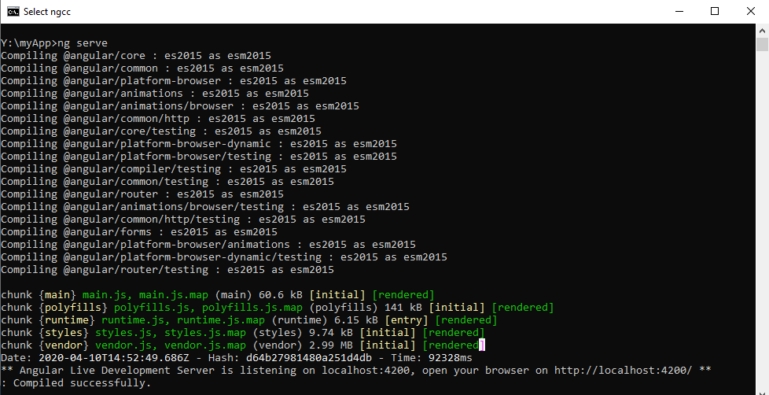

Once it’s compiled successfully, open browser at http://localhost:4200/ as displayed on cmd.

Install Primeng

~~~~~~~~~~~~

<https://primefaces.org/primeng/showcase/#/setup>

run these commands in node cmd

npm install primeng --save

npm install primeicons –save

include these in the index.html

 <link rel="stylesheet" type="text/css" href="/node_modules/primeicons/primeicons.css" />

<link rel="stylesheet" type="text/css" href="/node_modules/primeng/resources/themes/nova-light/theme.css" />

<link rel="stylesheet" type="text/css" href="/node_modules/primeng/resources/primeng.min.css" />