**Based On the Below Student table We are Written All the Queries.**

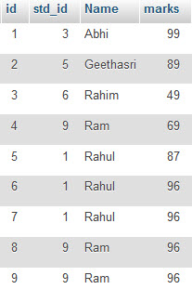

**Question 1. Query To Find Second Highest Marks Of A Student?**

**Question 2. Query To Find Duplicate Rows In Table?**

**Question 3. What Is The Query To Fetch First Record From Student Table?**

**Question 4. What Is The Query To Fetch Last Record From The Student Table?**

**Question 5. What Is Query To Display First 4 Records From Student  Table?**

**Question 6. What Is Query To Display Last 3 Records From Student Table?**

**Question 7. What Is Query To Display Nth Record From Student Table?**

**Question 8. How To Get 3 Highest Marks From Student Table?**

**Question 9. How To Display Odd Rows In Student Table?**

**Question 10. How To Display Even Rows In Student Table?**

**Question 11. How Can I Create Table With Same Structure Of Student Table?**

**Question 12. Select All Records From Student Table Whose Name Is ‘abhi’ And ‘geethasri’.**

**Question 13:**

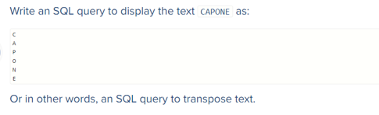

**Questions 14:**

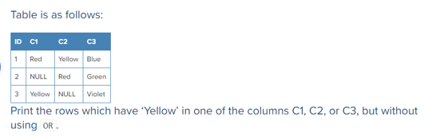

**Questions 15:**

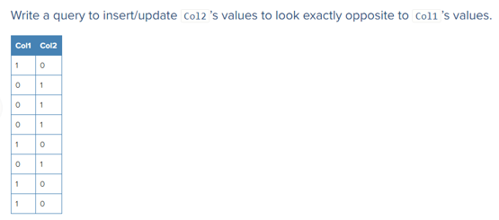

**Questions 16:**

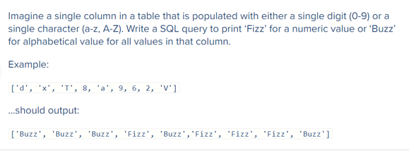

**Questions 17:**

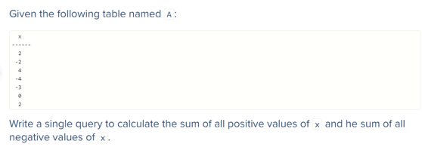

**Questions 18:**

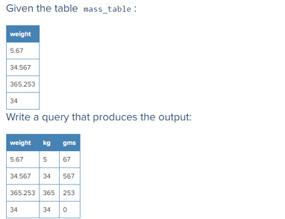

**Questions 19:**

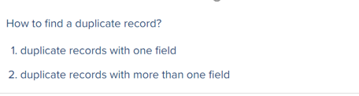

**Questions 20:**

Please find the below table details. Write Query for Inner join, Left outer Join, Right outer Join and Full join.

