Game Design Document

Fill up the following document

1. Write the title of your project.
2. Multiplayer Running Game
3. What is the goal of the game?
4. The goal is reach the final level which lvl 3
5. Write a brief story of your game.
6. Two best friends are there on day another boy who angry on both of

Them so he told kept race to go to the top of the mountian winners

Great so they both started running

1. Which are the playing characters of this game?

* Playing characters are the ones who respond to the user based on the input from the user.
* Cars, monkeys, dinos, wizards, etc., are the playing characters in the game.

|  |  |  |
| --- | --- | --- |
| Number | Character Name | What can this character do? |
| 1 | Player 1 | He can run based 1 player |
| 2 | Player 2 | He can run based 2 player |
| 3 |  |  |
| 4 |  |  |
| 5 |  |  |
| 6 |  |  |
| 7 |  |  |
| 8 |  |  |

1. Which are the Non-Playing Characters of this game?

* Non-Playing characters are the ones that don't have an action or behavior when the user interacts with the game.
* Hurdles, stones, bananas, coins, etc., are non-playing characters in the game.

|  |  |  |
| --- | --- | --- |
| Number | Character Name | What can this character do? |
| 1 | rocks | Come in opositie direction |
| 2 | dino | Come in opositie direction |
| 3 | coins | Come in opositie direction |
| 4 |  |  |
| 5 |  |  |
| 6 |  |  |
| 7 |  |  |
| 8 |  |  |

Draw your imagination of this game. What does this game look like?

* Draw the game either on your computer or on paper.
* Add images of the game scenes to show each of the playing and non-playing characters at least once.

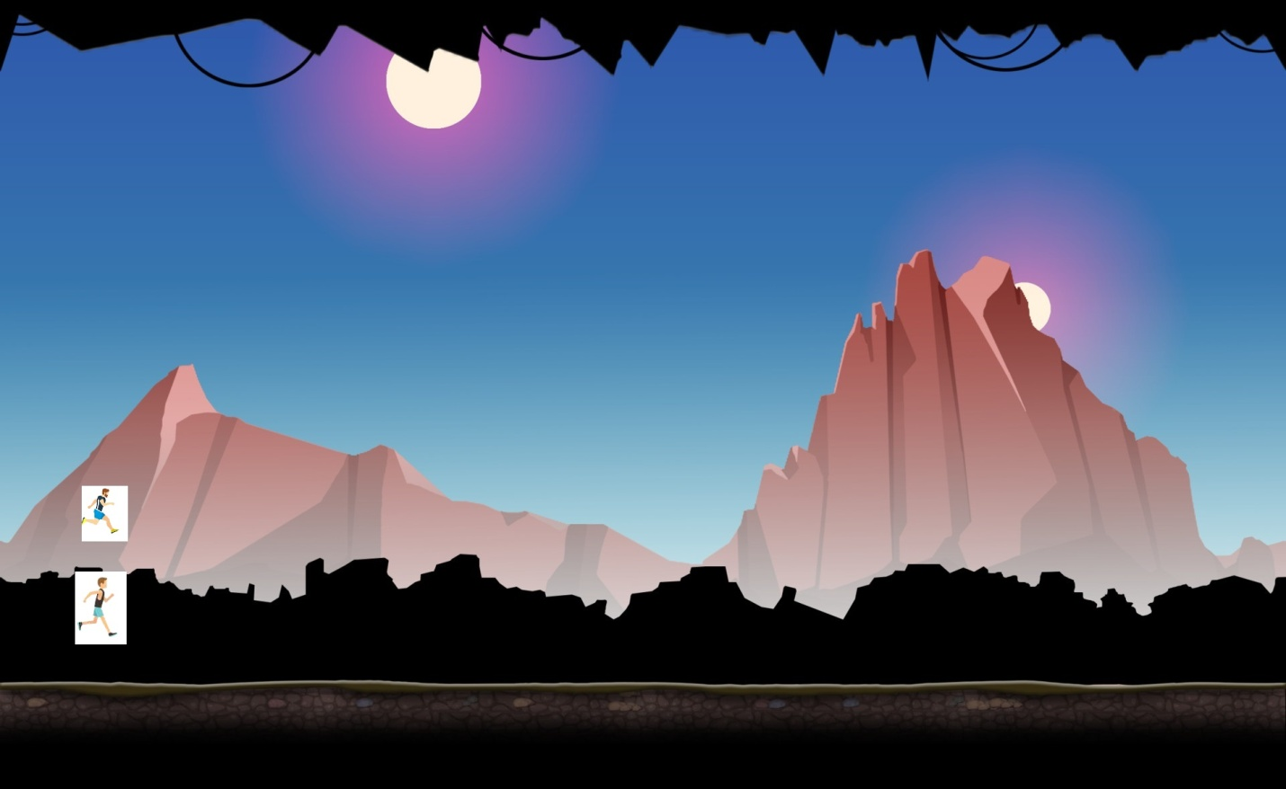

How do you plan to make your game engaging?

1. After end of the map there is second level its makes engaging