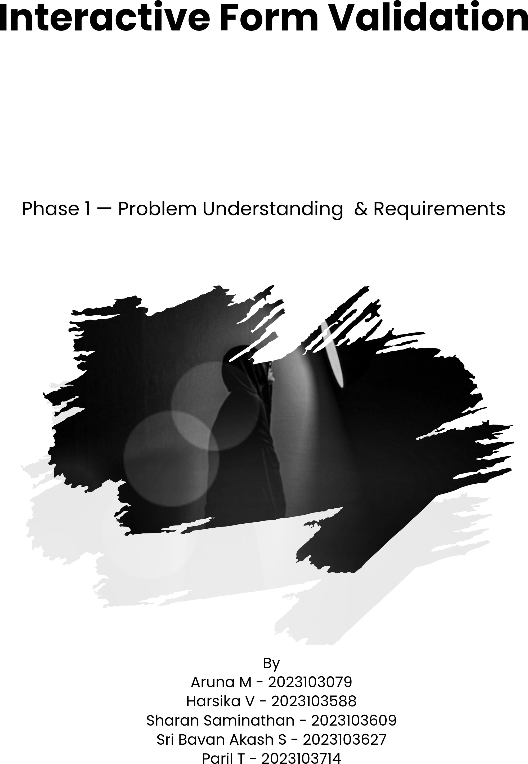

Problem Statement
Many web forms still rely on server-side validation or static client-side checks that provide poor feedback, causing user frustration, higher abandonment rates, and incorrect data.
The goal of this project is to build an Interactive Form Validation frontend that:
- Provides fast, accessible, and user-friendly validation feedback in real-time
- Reduces form submission errors
- Improves conversion and completion rates
Scope: A single-page frontend application demonstrating robust validation for common form types (registration, login, contact, profile update), with extensible validation rules and excellent UX and accessibility.

Users & Stakeholders

Primary Users
- End users filling forms (students, job applicants, customers)
- Novice users who need clear guidance and accessible UI

Secondary Users / Stakeholders
- Product owner / course instructor (approves deliverables)
- UX designer (reviews wireframes & accessibility)
- Frontend developers (implement & maintain)
- QA/testers (validate behavior & edge cases)
- Backend developer (may provide API endpoints for submission/real-time checks)

User Stories
- As a user, I want real-time inline validation so I can correct mistakes while typing.
- As a user, I want helpful error messages that explain how to fix my input.
- As a user, I want form fields to show clear success states once valid.
- As a user with assistive tech, I want accessible validation (ARIA, announcements) so screen readers can understand errors.
- As a product owner, I want the validation logic to be configurable so the same component can be reused across forms.
- As a tester, I want a test suite of input scenarios so I can verify edge cases and regressions.
- As a developer, I want the project to be modular and documented for easy maintenance.

MVP Features
Real-time validation (on input and on blur) for fields:
- Email (format + MX-like structure)
- Password (strength rules: min length, uppercase, lowercase, number, special char)
- Confirm password (matches)
- Name (non-empty, max length)
- Phone number (pattern validation, optional country code)
- Date (valid date and range)
- Custom text (e.g., username: allowed characters and uniqueness check via mock API)
Additional Features:
- Inline error messages and success indicators
- Accessible error linking (aria-describedby, role="alert" where appropriate)
- Prevent submission until all required fields are valid
- Form-level summary of errors on attempted submit
- Modular validation utility library (functions / rules)
- Unit tests for validation rules

Wireframes / API Endpoint List

Wireframes (Low-Fidelity Descriptions)
Registration Form — Layout (Single Column)
- Header: "Create an account"
- Inputs (stacked): Full name, Email, Username, Password, Confirm password, Phone number, Date of birth, Submit button
- Each input: label, field, inline helper / success / error text
- Below submit: form-level error summary container (collapsible)
Contact Form — Layout (Two Columns on Wide Screens)
- Left column: Name, Email, Subject
- Right column: Message textarea, Attachment (optional)
- Bottom: Submit button and confirmation toast

API Endpoint List (Mock / Optional for MVP)
- POST /api/validate-username — payload { username: string } → returns { available: boolean } (used for uniqueness check; can be mocked)
- POST /api/submit-form — payload: full form data → returns { success: boolean, errors?: {...} }

Acceptance Criteria
- All required fields show validation feedback in real-time and on blur.
- Error messages are human-readable and suggest corrective action (e.g., "Use at least 8 characters, including one number").
- Form cannot be submitted while validation errors exist.
- Screen reader users receive error announcements; the errors are navigable via aria-describedby.
- Visual success and error states meet contrast and design accessibility guidelines.
- Validation logic is covered by unit tests (≥ 80% for critical validation functions).
- The UI is responsive (mobile-first) and works on modern browsers.

