

Tech Stack Selection
Recommended technologies and rationale:
• HTML5 + CSS3 (Tailwind CSS recommended) — Fast prototyping, responsive utilities, consistent UI states.
• JavaScript (ES6+) — Core application logic and validators; works in all modern browsers.
• React (optional; recommended) — Component model and hooks simplify state, effects, and testing. Use vanilla JS if frameworks are restricted.
• Vite — Fast dev server and build tool for quick iteration.
• Jest + Testing Library — Unit and integration testing for validators and components.
• TypeScript (optional) — Static types for validator inputs/outputs to reduce runtime bugs.
• Accessibility tools (axe, Lighthouse) — Automated checks to ensure WCAG compliance.
• Mock server (json-server) or in-app mocks — For username uniqueness checks and submit endpoint during demo.
• Deployment: GitHub Pages / Netlify / Vercel — Simple static site hosts for demos.

UI Structure & API Schema Design
UI Structure (Pages / Components):
• Registration (primary demo)
• Contact (secondary demo)
• Demo / Accessibility (show live-region and screen-reader behaviors)
• Top-level components: App, FormContainer, InputField, PasswordField, PhoneInput, DateInput, FormSummary, Toast

API Schema (mock endpoints):
• POST /api/validate-username
Request: { "username": "string" }
Response: { "available": true | false, "suggestions"?: ["string"] }
• POST /api/submit-form
Request: Full form payload (see sample below)
Response: { "success": true } or { "success": false, "errors": { ... } }

Sample registration payload:
{ "fullName": "Ananya Sharma", "email": "ananya.sharma@example.com", "username": "ananya_s", "password": "********", "phone": "+918765432109", "dob": "1999-07-22"}

Data Handling Approach
State & data flow:
• Local field state (useState) for individual inputs; Form-level state (useReducer or context) for aggregated validity.
• ValidationResult shape: { valid: boolean, errors: string[], warnings?: string[] }
Synchronous vs Asynchronous validation:
• Synchronous: regex and length checks — run on input and blur.
• Asynchronous: remote uniqueness checks (debounced, 500ms) with cancellation of in-flight requests.
Sanitization & security:
• Trim inputs on blur and before submit.
• Normalize phone numbers to E.164-like format for storage.
• Never persist raw passwords to localStorage; keep them ephemeral in memory.
• Escape/encode displayed user data to prevent XSS in demo outputs.

Component / Module Diagram
Suggested file / folder layout:
src/
├─ components/
│ ├─ FormContainer.jsx
│ ├─ InputField.jsx
│ ├─ PasswordField.jsx
│ ├─ PhoneInput.jsx
│ ├─ DateInput.jsx
│ ├─ FormSummary.jsx
│ └─ Toast.jsx
├─ validators/
│ ├─ index.js
│ ├─ email.js
│ ├─ password.js
│ ├─ username.js
│ └─ phone.js
├─ api/
│ └─ index.js
├─ hooks/
│ ├─ useDebounce.js
│ └─ useFormReducer.js
├─ utils/
│ └─ normalizers.js
└─ App.jsx

Component diagram (visual):
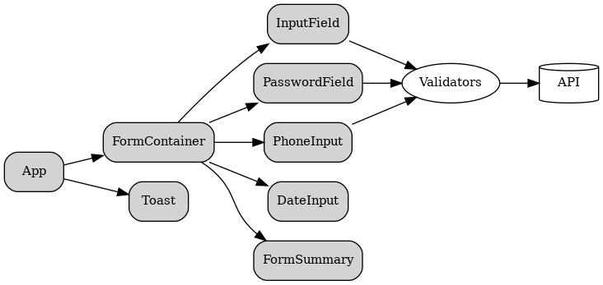

Basic Flow Diagram
User interaction flow (high level):
• Render Registration page (FormContainer mounts).
• User types: synchronous validators run; async checks debounced.
• Field-level states update (valid/invalid, helper text, spinner).
• On submit: run full validation; if invalid show FormSummary and focus first invalid field.
• If valid: sanitize payload and POST to /api/submit-form; show success or error toast based on response.
Flow diagram (visual):
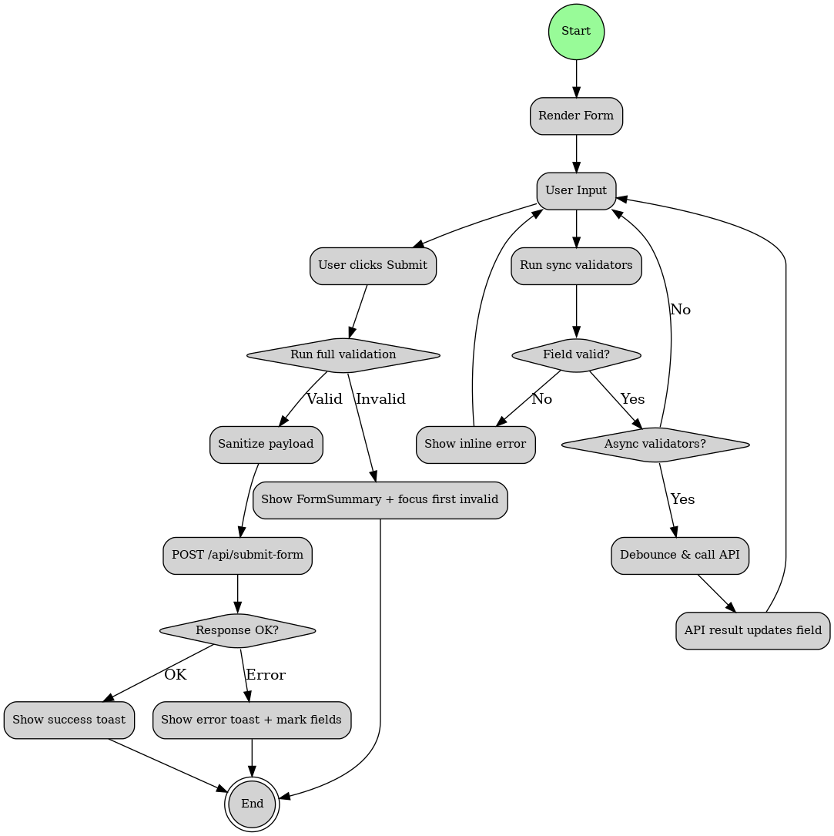

Non-functional requirements & Deliverables
Non-functional requirements:
• Accessibility: ARIA attributes, live regions, keyboard-first navigation, color contrast (WCAG AA).
• Responsiveness: mobile-first design, modern browser support.
• Testability: unit tests for validators (target ≥ 80% coverage for core validation logic).
• Performance: debounce network checks, avoid heavy re-renders.
Deliverables for Phase 2 submission:
• Phase 2 — Solution Design & Architecture document (this file).
• Component and Flow diagrams (PNG/SVG).
• Sample API schema and payload examples.
• README with instructions to run demo and mock API.
• Optional: starter React component and validation utilities.
Prepared for: Skill Development Course — Frontend (Interactive Form Validation)
Author: Student

