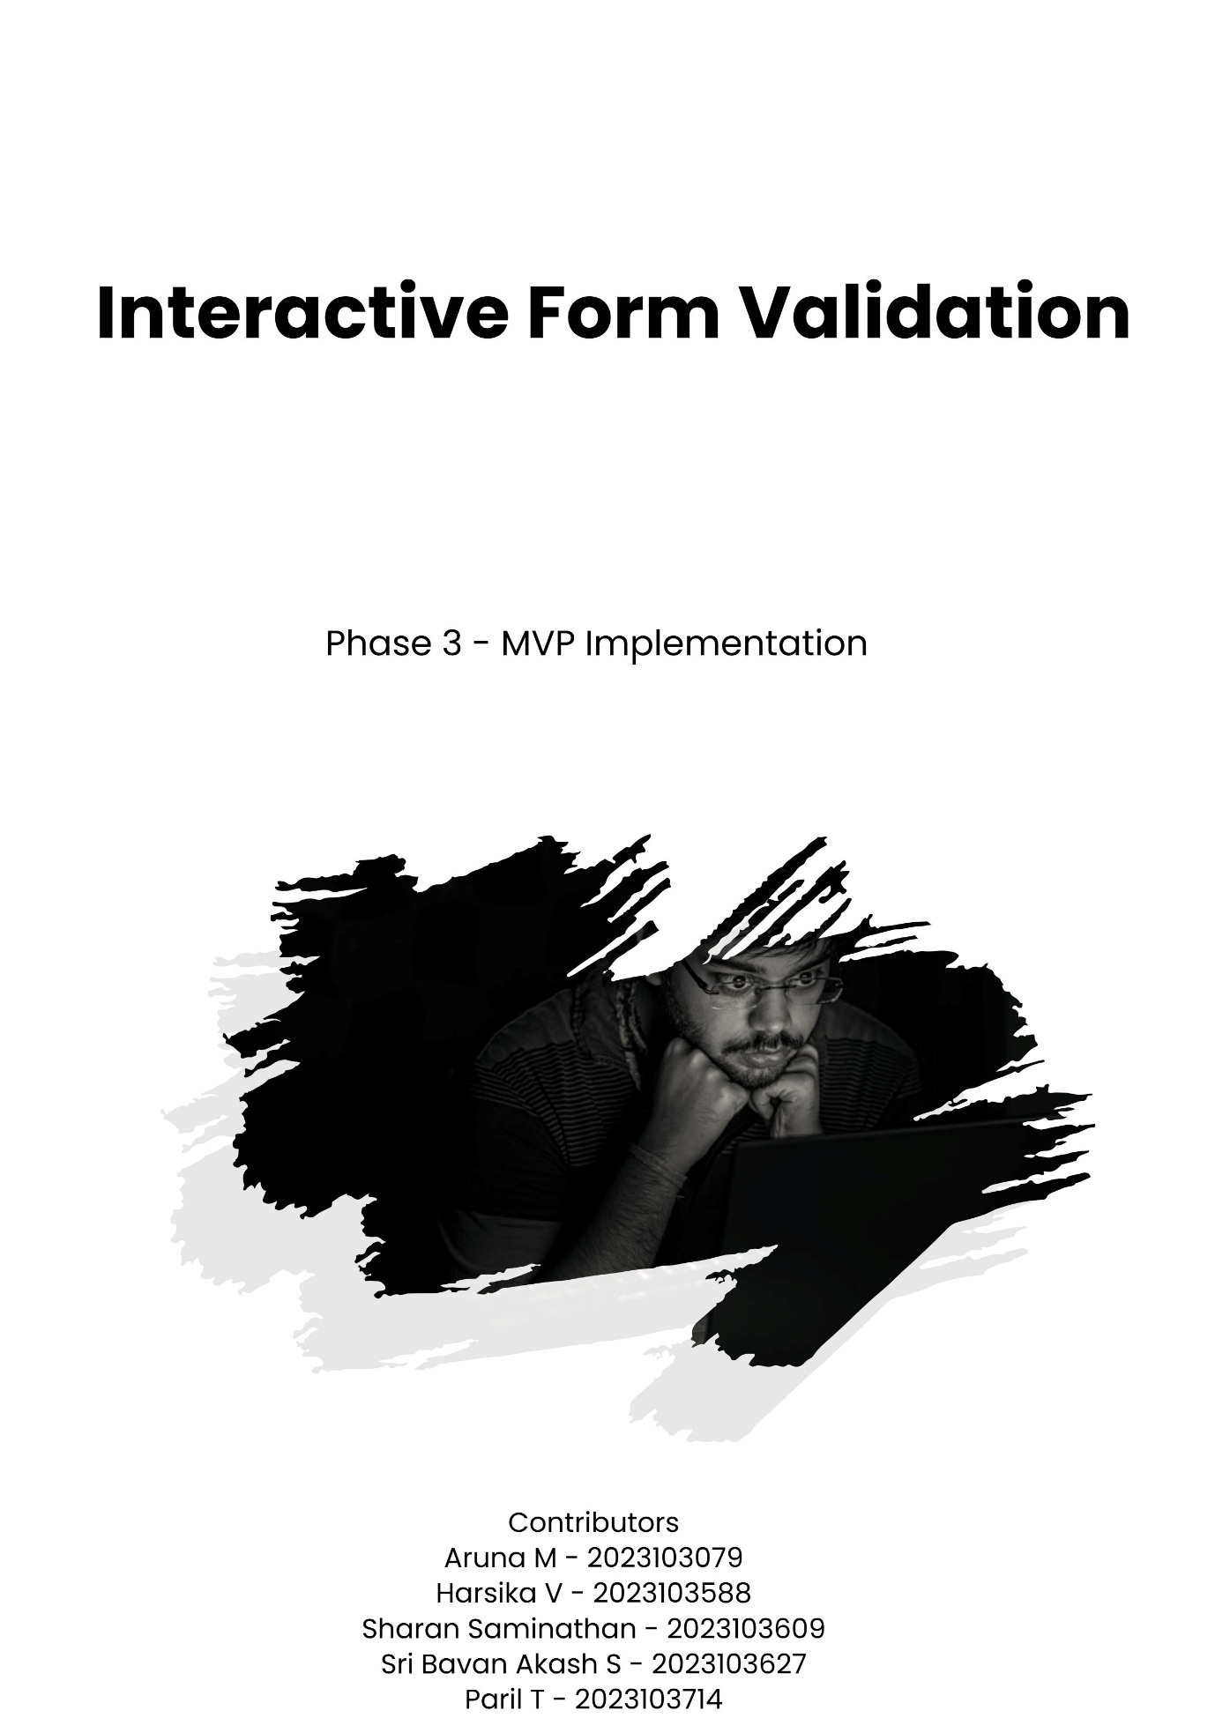

Project Setup
- Created the base project structure using HTML, CSS, and JavaScript.
- Organized files and folders for better readability and scalability.
- Linked the project repository to GitHub for version control and collaborative development.
- Configured a live development environment to preview updates instantly.

Core Features Implementation
The key functionalities of the form were developed in this phase:
- Added all input fields including First Name, Second Name, Department (Dropdown), Username, Password, Confirm Password, Email, and Contact.
- Implemented real-time validation to ensure users receive instant feedback on incorrect or incomplete inputs.
- Integrated password match validation between “Password” and “Confirm Password” fields.
- Used regular expressions (RegEx) for validating email format and contact numbers.
- Displayed custom error messages dynamically beside each input field.

Data Storage (Local State / Database)
- Used JavaScript local state management to temporarily hold form data entered by the user.
- Ensured smooth data flow and clearing of inputs after successful form submission.
- No external database integration was required as this is a frontend-only project.

Testing Core Features
- Comprehensive testing was conducted to ensure the core validation logic worked accurately:
- Checked for empty fields, invalid inputs, and incorrect email/contact formats.
- Verified password confirmation feature for both matching and mismatching scenarios.
- Tested responsiveness and alignment of all input components.
- Debugged and fixed validation edge cases for improved reliability.
Version Control (GitHub)
- Created a public repository on GitHub to manage code versions.
- Regular commits were made after completing major functionalities.
- Repository link: https://github.com/ArtSharan/interactive-form-validation
- Version control ensured safe tracking of all updates, bug fixes, and feature enhancements.

Outcome
By the end of this phase, the core functional version of the Interactive Form Validation was successfully developed. The application could validate user inputs dynamically and display instant feedback for errors, achieving the intended interactivity goals.
This provided a strong foundation for the next phase, which focused on UI/UX enhancement and deployment.

