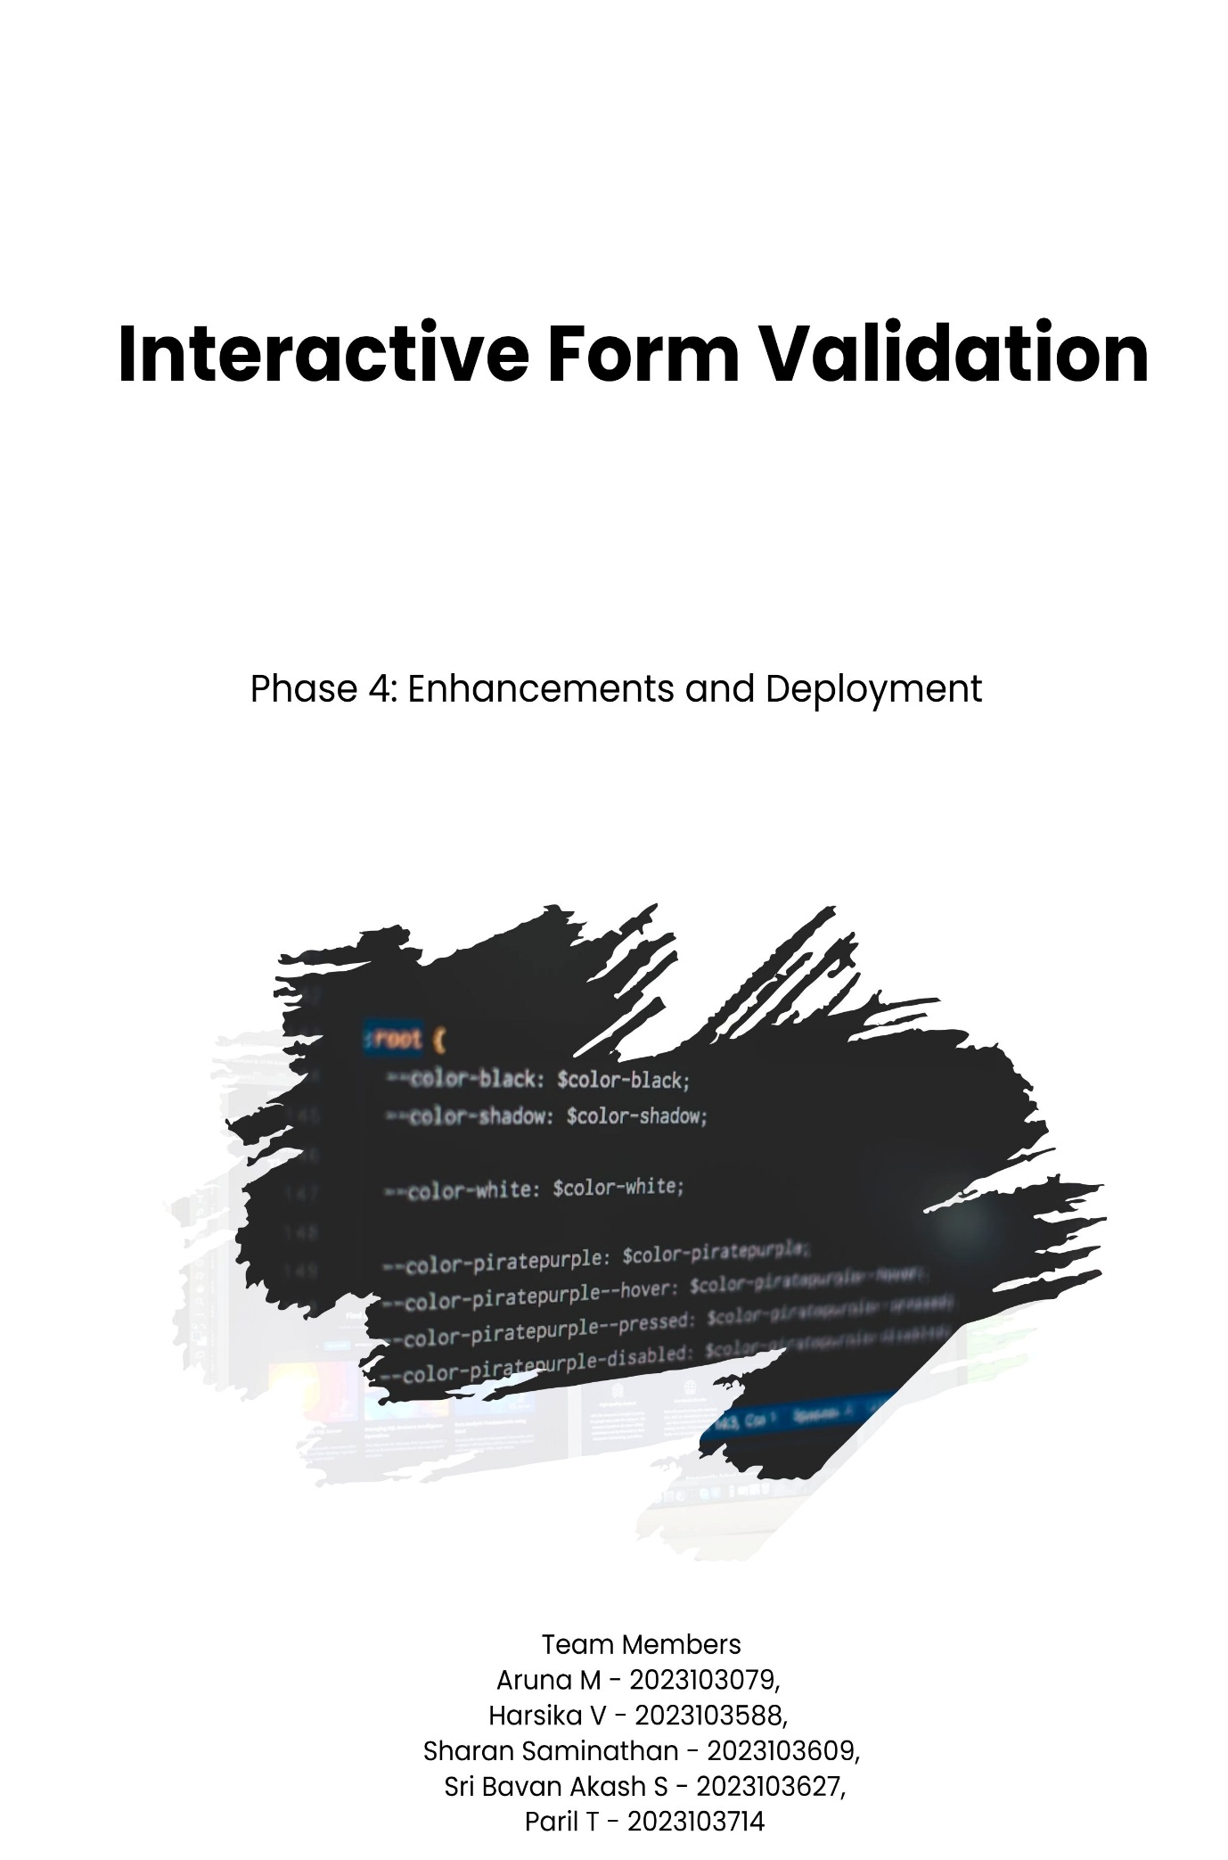1. Additional Features
- During this phase, several new features were integrated to make the form more interactive and user-friendly:
- Added real-time validation for all input fields including First Name, Second Name, Username, Password, Confirm Password, Email, and Contact.
- Implemented department selection dropdown for dynamic user categorization.
- Designed a confirmation mechanism to ensure password and confirm password fields match.
- Included responsive layouts that adapt to various screen sizes.

2. UI/UX Improvements
- A modern and clean split-screen design was implemented with a welcoming left panel and a form on the right.
- Incorporated a gradient “Submit” button with hover animations to improve visual feedback.
- Used soothing background imagery and color gradients to enhance the aesthetic appeal.
- Ensured input highlighting and error messages appear dynamically to guide the user.
- Improved accessibility by optimizing label placements and contrast ratios.

3. API Enhancements
- Since this is a frontend project, no external APIs were integrated.
However, JavaScript-based form validation functions act as mini validation APIs by:
- Checking field completeness and format correctness.
- Validating email and contact number patterns.
- Displaying custom alert messages for invalid inputs.
- These validation functions ensure data integrity before submission.

4. Performance & Security Checks
- Verified that all form interactions occur without lag or reloads for a smooth user experience.
- Checked responsiveness across browsers (Chrome, Edge, Firefox).
- Implemented client-side input sanitization to prevent injection or invalid data entries.
- Tested application load time and optimized media to ensure fast page rendering.

5. Testing of Enhancements
All enhancements were tested using:
- Manual testing for each input field validation and visual element.
- Cross-browser compatibility testing to ensure consistent design and function.
- Responsive testing using Chrome DevTools for various screen resolutions.
- Ensured that all error messages display correctly for invalid data entries.

6. Deployment
The final application was successfully deployed using Netlify, allowing real-time access from any device.
Deployment Link: https://interactiveformwithvalidation.netlify.app/
GitHub Repository: https://github.com/ArtSharan/interactive-form-validation

Deployment Steps:

- The project folder was built using HTML, CSS, and JavaScript files.
- The repository was connected to Netlify for continuous deployment.
- Netlify automatically built and deployed the live version.
- Testing was performed on the deployed version to ensure smooth performance.

7. Outcome
The final version of the Interactive Form Validation project provides:
- A sleek and responsive user interface.
- Accurate and real-time validation feedback.
- A visually engaging design suitable for modern web applications.
- A fully deployed live application accessible via Netlify.

