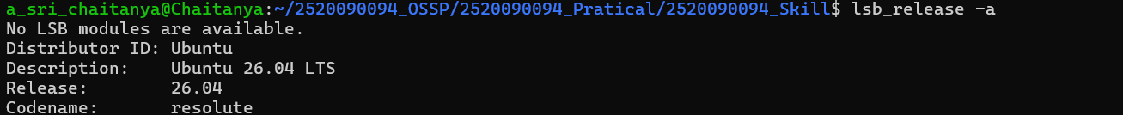
SKILL-01
1.) UNDERSTANDING THE BASICS OF THE OS(SKILL)

2.)

CREATING A
Program
