Skill:3
a*)Code
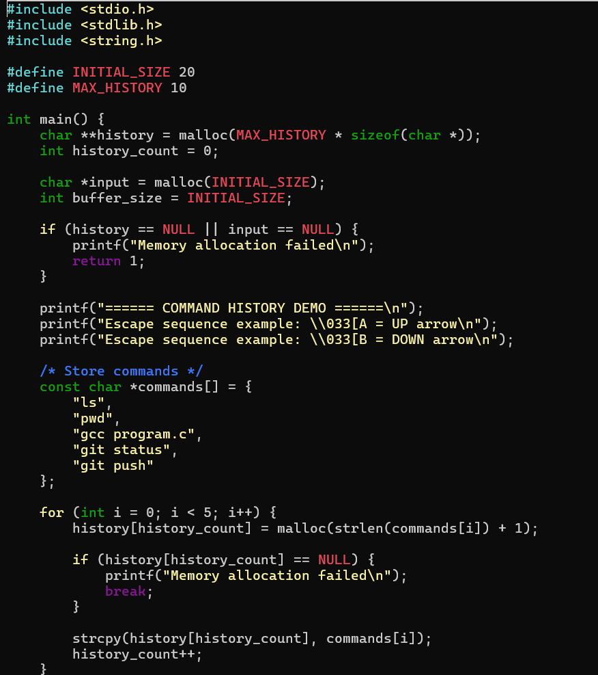
Output
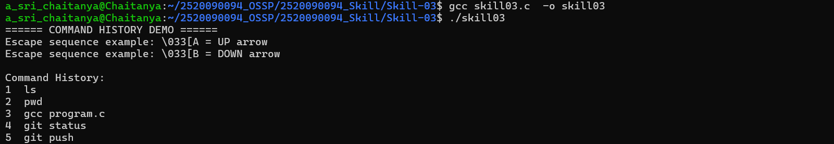
Part – B:
Code(Dynamic Buffer + Linked List):
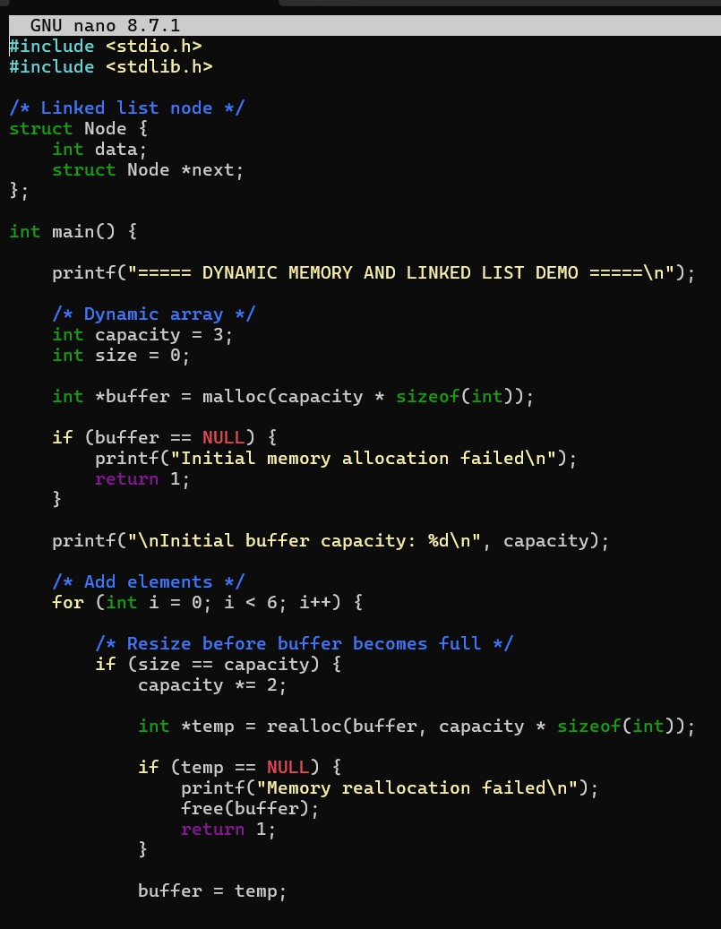
Code 