WEEK 5

Model Optimization and Experimentation
A plan, an experimental design and measured results for hyper-parameter tuning with scikit-learn, Optuna and Hyperopt
Machine Learning Engineering Programme – Week 5 Deliverable
Author: ____________________
November 2026

Contents
1. Introduction and Rationale
2. Background: What Is Being Optimized?
3. Optimization Methods
4. Experimental Design
5. Implementation in Python
6. Results and Analysis
7. Preventing Overfitting and Ensuring Generalization
8. Anticipated Challenges and Troubleshooting
9. Guidelines for Reproducing the Results
10. Discussion and Potential Improvements
11. Conclusion
References
All results in Sections 6 to 7 were produced by running the code in Section 5 (single CPU core, scikit-learn 1.9.1). Nothing in the tables is estimated or invented.

1. Introduction and Rationale

1.1 Why optimize a model?
Choosing an algorithm is rarely enough. Almost every model exposes hyper-parameters – settings fixed before training, such as the learning rate of a boosting model, the depth of a tree or the regularization strength of an SVM. They control model capacity and the bias–variance trade-off (Week 4), and a poor choice can leave most of a model's potential unused or make it fail completely.
Our own experiment shows both effects. On the digits dataset, the support-vector machine's accuracy over a 9 × 9 grid of C and gamma values ranges from 10.4% (essentially guessing) to 98.1%. On the Diabetes data, tuning a gradient-boosting regressor lowered cross-validated RMSE from 61.0 to about 56.6 – a 7.2% reduction – at a cost of a few minutes of computation.

1.2 Why experimentation matters
Hyper-parameter tuning is an empirical activity: the response surface relating settings to performance is unknown, noisy and often non-convex. Reliable improvement therefore needs a disciplined experimental method rather than ad-hoc trial and error:
- Hypotheses – state what you expect to improve and why, so results can be interpreted instead of merely admired.
- Controls – fix everything that is not being studied (data split, seeds, metric, budget) so differences can be attributed to the search strategy or parameter.
- Replication – repeat stochastic searches with several seeds; a single lucky run proves little.
- Honest measurement – estimate the performance of the *tuned* model on data that played no role in tuning.
- Documentation – record parameters, versions, scores and timings so any result can be reproduced and audited.

1.3 Objectives of this report
- Describe the main optimization techniques – manual, grid, random, Bayesian, multi-fidelity – with their pros and cons.
- Present a complete, reusable experimental design: research questions, parameter space, control variables, budget and protocol.
- Run that design in Python with scikit-learn, Optuna and Hyperopt and report real results with uncertainty.
- Explain how to detect and prevent overfitting *to the validation data* – the central risk of aggressive tuning.
- Anticipate practical problems and give troubleshooting measures and reproduction guidelines.
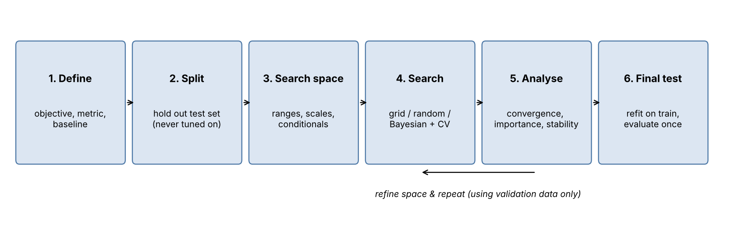
Figure 1: Overall optimization workflow followed in this report.

2. Background: What Is Being Optimized?

2.1 Parameters, hyper-parameters and the objective function
Parameters (tree split points, regression coefficients, network weights) are learned from data by the training algorithm. Hyper-parameters are chosen by the practitioner and are not learned by the training procedure itself. Tuning treats the whole train-and-validate procedure as a black-box function:
λ* = argmin over λ ∈ Λ of CV-score( Model(λ), D_train )
where λ is a vector of hyper-parameter values and Λ is the search space. Evaluating this function is expensive (a full cross-validated training run), noisy (random seeds, fold assignment) and has no usable gradient. These three properties explain why specialised search strategies exist.

2.2 Types of hyper-parameters
Table 1: Hyper-parameter types and how to search them
Type | Examples | Search recommendation
Continuous, scale-sensitive | learning rate, regularization C, gamma, alpha | Sample on a log scale (e.g. 0.005 to 0.3); a linear scale wastes almost all trials on large values
Continuous, bounded | subsample fraction, dropout, l1_ratio | Sample uniformly within bounds
Integer | tree depth, number of trees, min_samples_leaf, k in k-NN | Sample integers; consider log scale for wide ranges (e.g. 50 to 5000 trees)
Categorical | kernel, penalty type, activation, optimizer | List of choices; use one-hot style handling in surrogate methods
Conditional | gamma only matters if kernel = rbf; max_leaf_nodes only for some trees | Use define-by-run (Optuna) or nested spaces (Hyperopt) so irrelevant parameters are not sampled
Budget / resource | n_estimators, epochs, training-set size | Use as the "fidelity" axis for early-stopping methods (Hyperband, halving)

2.3 Link to the bias–variance trade-off
Most hyper-parameters move a model along the complexity axis: depth, number of trees and learning rate increase capacity; regularization strength, subsampling and minimum leaf size reduce it. The optimum is therefore a *balance*, and the evaluation protocol from Week 4 (stratified or time-aware cross-validation, appropriate metrics) defines which balance counts as best. The tuning objective must also match the final business metric; tuning accuracy and reporting recall is a common source of disappointment.

2.4 Why defaults are only a starting point
Library defaults are chosen to work acceptably across many problems; they are rarely optimal for a specific dataset. They are nevertheless an essential baseline: any tuning result must be compared with the default configuration, because on some problems the default is already near-optimal (as our SVM experiment shows in Section 6.1) and the tuning effort is better spent on features or data quality.

3. Optimization Methods

3.1 Manual tuning
The practitioner changes one setting at a time guided by learning curves and intuition. It builds understanding of the model and is useful for choosing the initial ranges, but it is slow, irreproducible, biased towards familiar settings and cannot explore interactions between parameters systematically.

3.2 Grid search
Grid search evaluates every combination in a Cartesian product of manually chosen values. In scikit-learn it is implemented by GridSearchCV.
from sklearn.model_selection import GridSearchCV
grid = GridSearchCV(pipe, {"svc__C": np.logspace(-2, 3, 9),
"svc__gamma": np.logspace(-5, 0, 9)},
cv=StratifiedKFold(5, shuffle=True, random_state=42), n_jobs=-1)
grid.fit(X_train, y_train)

- Pros: exhaustive within the grid; simple; deterministic and easily parallelised; results are easy to visualise as heat-maps.
- Cons: cost grows exponentially with the number of parameters (the curse of dimensionality: 5 parameters × 5 values = 3,125 fits per fold); resolution is limited by the chosen values; trials are wasted on unimportant parameters; the optimum may fall between grid points.
- Best for: 1–3 hyper-parameters, cheap models, final local refinement around a known good region.

3.3 Random search
Random search draws each configuration independently from distributions defined over the space (RandomizedSearchCV). Bergstra and Bengio (2012) showed that when only a few hyper-parameters really matter, random search finds good values much faster than grid search because every trial tests a *new value of every parameter*, while a grid repeats the same few values of the important parameter many times (Figure 2).
from scipy.stats import loguniform, randint, uniform
dist = {"learning_rate": loguniform(5e-3, 3e-1), "max_depth": randint(1, 7),
"n_estimators": randint(50, 501), "subsample": uniform(0.5, 0.5),
"min_samples_leaf": randint(1, 31)}
rs = RandomizedSearchCV(GradientBoostingRegressor(random_state=0), dist, n_iter=30,
cv=cv, scoring="neg_root_mean_squared_error", random_state=0)

- Pros: budget is set directly (n_iter); scales to many parameters; handles continuous and mixed spaces; trivially parallel; anytime – can be stopped at any point.
- Cons: uninformed – earlier results do not guide later trials; may miss narrow optima; results vary between seeds.
- Best for: the default first choice for medium and large spaces; a strong baseline against which sophisticated methods must prove themselves.
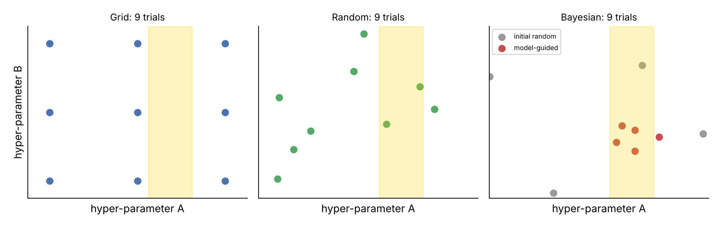
Figure 2: Where grid, random and Bayesian search place nine trials. The shaded strip marks the range of an important hyper-parameter.

3.4 Bayesian optimization
Bayesian optimization builds a surrogate model of the objective from past trials and uses an acquisition function (e.g. expected improvement) to decide which configuration to try next, balancing exploitation of promising regions and exploration of uncertain ones. The loop is: (1) evaluate a few random starting points; (2) fit the surrogate; (3) choose the point maximising the acquisition function; (4) evaluate it and update.
Table 2: Common Bayesian and model-based optimizers
Method | Surrogate | Characteristics | Libraries
Gaussian-process BO | Gaussian process | Sample-efficient in low dimensions (< ~20); struggles with categorical/conditional spaces and many trials | scikit-optimize, BoTorch, Ax
TPE (Tree-structured Parzen Estimator) | Two density models: good vs. bad trials | Handles mixed, conditional spaces; scales well; default of Hyperopt and Optuna | Hyperopt, Optuna
SMAC | Random forest | Robust with categorical and conditional parameters | SMAC3, Auto-sklearn
CMA-ES / evolutionary | Population distribution | Good for continuous, noisy, higher-dimensional spaces; easy to parallelise | Optuna, Nevergrad

import optuna
def objective(trial):
p = dict(n_estimators=trial.suggest_int("n_estimators", 50, 500),
learning_rate=trial.suggest_float("learning_rate", 5e-3, 0.3, log=True),
max_depth=trial.suggest_int("max_depth", 1, 6),
subsample=trial.suggest_float("subsample", 0.5, 1.0),
min_samples_leaf=trial.suggest_int("min_samples_leaf", 1, 30))
model = GradientBoostingRegressor(random_state=0, **p)
return -cross_val_score(model, X_train, y_train, cv=cv,
scoring="neg_root_mean_squared_error").mean()

study = optuna.create_study(direction="minimize",
sampler=optuna.samplers.TPESampler(seed=0))
study.optimize(objective, n_trials=30)

from hyperopt import fmin, tpe, hp, Trials, STATUS_OK
space = {"n_estimators": hp.quniform("n_estimators", 50, 500, 1),
"learning_rate": hp.loguniform("learning_rate", np.log(5e-3), np.log(0.3)),
"max_depth": hp.quniform("max_depth", 1, 6, 1),
"subsample": hp.uniform("subsample", 0.5, 1.0),
"min_samples_leaf": hp.quniform("min_samples_leaf", 1, 30, 1)}
def fn(p):
p = {**p, **{k: int(p[k]) for k in ("n_estimators", "max_depth", "min_samples_leaf")}}
return {"loss": cv_rmse(**p), "status": STATUS_OK}
best = fmin(fn, space, algo=tpe.suggest, max_evals=30, trials=Trials())

- Pros: uses past evidence, so it usually needs fewer expensive evaluations; supports pruning and early stopping; good for costly models such as deep networks.
- Cons: inherently sequential (parallel variants are less efficient); more complex to set up; surrogate can be misled by noisy objectives; with cheap models the overhead and gains may be negligible – our results in Section 6 show exactly this.

3.5 Multi-fidelity methods: successive halving and Hyperband
These methods start many configurations on a small budget (few trees, few epochs, a subset of data) and repeatedly discard the worse ones, giving the survivors more budget. In scikit-learn, HalvingRandomSearchCV implements successive halving; Optuna provides pruners (MedianPruner, HyperbandPruner) that stop unpromising trials mid-training. They are most valuable when training is expensive and early performance predicts final performance.

3.6 Other techniques
- Evolutionary and population-based training: maintain a population of configurations, mutate and recombine them; PBT also adapts hyper-parameters during training of neural networks.
- Early stopping: treat the number of boosting rounds or epochs as automatically tuned by monitoring a validation set, removing one hyper-parameter from the search.
- Warm-starting and meta-learning: begin the search from configurations that worked on similar datasets.
- AutoML systems (Auto-sklearn, FLAML, AutoGluon): search over algorithms and pre-processing as well as hyper-parameters.

3.7 Comparison of approaches
Table 3: Summary comparison of search strategies
Criterion | Grid | Random | Bayesian (TPE/GP) | Successive halving
Uses past results | No | No | Yes | Yes (discards losers)
Scales with dimensions | Poorly | Well | Well (TPE) / moderate (GP) | Well
Parallelism | Perfect | Perfect | Limited | Good
Reproducibility | Deterministic | Seed needed | Seed needed | Seed needed
Setup effort | Very low | Low | Medium | Low–medium
Handles conditional spaces | Awkward | Awkward | Yes (Optuna, Hyperopt) | Limited
Best use case | Few parameters, cheap models | Strong default for most tasks | Expensive evaluations, many parameters | Expensive training with an informative budget axis

3.8 Library overview
Table 4: Python libraries used or recommended
Library | Strength | Typical entry point
scikit-learn | Integrated with pipelines and CV; Grid, Random and Halving search | GridSearchCV, RandomizedSearchCV, HalvingRandomSearchCV
Optuna | Define-by-run spaces, TPE/CMA-ES, pruning, visualisation, importance analysis | optuna.create_study().optimize(...)
Hyperopt | Mature TPE implementation; distributed trials via Spark/Mongo | fmin(fn, space, algo=tpe.suggest)
scikit-optimize | Gaussian-process search with a scikit-learn style API | BayesSearchCV, gp_minimize
Ray Tune / Keras Tuner | Distributed tuning for deep learning | tune.run, kt.Hyperband
MLflow / Weights & Biases | Experiment tracking and comparison | mlflow.log_params, mlflow.log_metric

4. Experimental Design

4.1 Research questions and hypotheses
Table 5: Research questions, hypotheses and the experiment that tests each
ID | Question | Hypothesis | Experiment
RQ1 | How much does tuning improve over default settings? | Tuning lowers CV error by a clear margin when defaults are not tuned for the data | E2 (default vs. tuned)
RQ2 | Does random search match grid search at lower cost? | Yes, when few parameters dominate | E2: grid (108 fits) vs. random (30)
RQ3 | Does Bayesian optimization beat random search at equal budget? | Modestly, mostly in early trials | E2: Optuna / Hyperopt vs. random
RQ4 | Is the CV score of the best configuration an honest estimate? | No – it is optimistically biased | E3: nested CV, test-set gap
RQ5 | Which hyper-parameters matter most? | A few dominate (capacity and learning-rate controls) | E4: importance analysis
RQ6 | Can multi-fidelity search cut cost without hurting quality? | Yes for boosting using n_estimators as budget | E5: successive halving
RQ7 | How sensitive is a different model family to its hyper-parameters? | SVM accuracy collapses in bad regions of (C, gamma) | E1: 9 × 9 SVM grid

4.2 Datasets, models and baselines
Table 6: Experimental subjects
Experiment | Dataset | Model | Metric | Baseline
E1 | Digits: 1,797 images, 64 features, 10 classes (1437 train / 360 test) | SVM (RBF) in a StandardScaler pipeline | Accuracy | Default SVC
E2–E5 | Diabetes: 442 samples, 10 features; 353 train / 89 test | GradientBoostingRegressor | RMSE (lower is better) | Default hyper-parameters; mean predictor (RMSE 73.2)

Both datasets ship with scikit-learn so the experiments need no downloads. The Diabetes data are small and noisy, which makes them a demanding test of overfitting during tuning: with only 353 training rows, the CV estimate used for selection has substantial variance.

4.3 Parameter space
Table 7: Search space for gradient boosting (E2–E5)
Hyper-parameter | Type / scale | Range (random & Bayesian) | Grid values | Rationale
n_estimators | Integer | 50 – 500 | 100, 300, 500 | Number of boosting rounds; trades off with learning rate
learning_rate | Float, log | 0.005 – 0.3 | 0.01, 0.05, 0.2 | Shrinkage; dominant regularizer
max_depth | Integer | 1 – 6 | 2, 3, 5 | Interaction depth of each tree
subsample | Float | 0.5 – 1.0 | 0.6, 1.0 | Stochastic boosting; reduces variance
min_samples_leaf | Integer | 1 – 30 | 1, 15 | Leaf smoothing; guards against fitting noise

The grid contains 3 × 3 × 3 × 2 × 2 = 108 configurations. The continuous space used by random and Bayesian search contains infinitely many. Ranges were chosen from documented practice and prior knowledge: learning rates span almost two orders of magnitude on a log scale, depths stay shallow because the dataset is small and noisy, and the maximum of 500 trees keeps single evaluations cheap.
Table 8: Search space for the SVM (E1)
Hyper-parameter | Scale | Values
C | log | 9 values from 10⁻² to 10³
gamma | log | 9 values from 10⁻⁵ to 10⁰

4.4 Control variables
Table 9: What is held constant so that comparisons are fair
Variable | Control
Data split | One fixed 80/20 split (random_state=42); the test set is not touched during any search
Cross-validation | The same 5-fold shuffled KFold (seed 42) for every configuration of every method
Model randomness | random_state=0 inside the estimator, so the same configuration always gives the same score
Metric | Cross-validated RMSE for selection; test RMSE for the final report
Budget | 30 trials for random, Optuna and Hyperopt (grid: 108 configurations by construction)
Starting phase | Optuna uses 10 random start-up trials before TPE modelling begins
Hardware | Single CPU core, so wall-clock time is comparable across methods
Replication | Random, Optuna and Hyperopt each repeated with seeds 0, 1 and 2; mean and standard deviation reported
Pre-processing | No feature scaling needed for trees; for the SVM scaling sits inside the pipeline to avoid leakage

4.5 Experiment plan
Table 10: Experiments
ID | Purpose | Procedure | Outputs
E1 | Landscape of an SVM; value of tuning vs. cost of ignoring it | Grid over 81 (C, gamma) pairs with 5-fold CV; compare with default SVC on the test set | Heat-map; best parameters; test accuracy
E2 | Compare strategies at matched budgets | Default vs. grid vs. random vs. Optuna vs. Hyperopt; 3 seeds for stochastic methods | Best CV RMSE, test RMSE, time, convergence curves
E3 | Quantify selection bias | Nested CV (outer 5-fold, inner 3-fold random search, 15 trials) vs. flat CV of the winner | Unbiased RMSE estimate and its spread
E4 | Explain the landscape | Hyper-parameter importance (fANOVA) and trial scatter from an Optuna study | Importance ranking; trial plots
E5 | Cheaper search | Successive halving with n_estimators as the resource | Quality and time relative to full searches

4.6 Analysis plan and decision rules
- Primary comparison: best mean CV RMSE per method, plus convergence curves showing quality as a function of number of trials.
- Generalization check: test RMSE of each tuned model, and the gap between CV and test scores.
- Uncertainty: report mean ± standard deviation across seeds; treat differences smaller than the seed-to-seed spread as inconclusive.
- Practical significance: a difference must exceed the fold-to-fold noise of the CV estimate to justify a more complex search method.
- Cost: wall-clock time and number of model fits.

4.7 Project time plan
Table 11: Suggested allocation of the 30–35 hour effort
Phase | Activities | Hours
Literature and method study | Read search-method papers and library documentation; decide on spaces | 5–6
Environment and baseline | Set up environment, fixed splits, default-model baselines, logging | 3–4
Experiment implementation | Grid, random, Optuna, Hyperopt, halving, nested CV scripts | 8–9
Running and monitoring | Execute experiments, repeat seeds, handle failures | 4–5
Analysis and visualisation | Tables, convergence and importance plots, statistical comparison | 4–5
Report writing and review | Structure, discussion, reproducibility notes, proof-reading | 5–6

5. Implementation in Python

5.1 Environment
Table 12: Software versions used for the reported results
Package | Version
Python | 3.12.3
scikit-learn | 1.9.1
Optuna | 5.0.0
Hyperopt | 0.3.0
scikit-optimize | 0.10.2
NumPy | 2.5.4
SciPy | 1.18.1
pandas | 3.0.6

pip install scikit-learn==1.9.1 optuna==5.0.0 hyperopt==0.3.0 \
scikit-optimize==0.10.2 numpy scipy pandas matplotlib

5.2 Shared setup and objective function
import numpy as np, time, json
from sklearn.datasets import load_diabetes
from sklearn.model_selection import train_test_split, KFold, cross_val_score
from sklearn.ensemble import GradientBoostingRegressor
from sklearn.metrics import mean_squared_error

X, y = load_diabetes(return_X_y=True)
X_train, X_test, y_train, y_test = train_test_split(X, y, test_size=0.2, random_state=42)
cv = KFold(n_splits=5, shuffle=True, random_state=42) # identical for all methods

def cv_rmse(**params):
model = GradientBoostingRegressor(random_state=0, **params)
return -cross_val_score(model, X_train, y_train, cv=cv,
scoring="neg_root_mean_squared_error").mean()

def test_rmse(params):
model = GradientBoostingRegressor(random_state=0, **params).fit(X_train, y_train)
return mean_squared_error(y_test, model.predict(X_test)) ** 0.5

5.3 Strategy implementations
Grid search and the convergence bookkeeping are written as explicit loops so that the best-so-far score after every trial can be recorded:
from sklearn.model_selection import ParameterGrid
grid = {"n_estimators": [100, 300, 500], "learning_rate": [0.01, 0.05, 0.2],
"max_depth": [2, 3, 5], "subsample": [0.6, 1.0], "min_samples_leaf": [1, 15]}
best, curve = float("inf"), []
for params in ParameterGrid(grid): # 108 configurations
score = cv_rmse(**params)
best = min(best, score); curve.append(best)

# Random search with the same bookkeeping
rng = np.random.default_rng(seed)
for _ in range(30):
p = dict(n_estimators=int(rng.integers(50, 501)),
learning_rate=float(np.exp(rng.uniform(np.log(5e-3), np.log(0.3)))),
max_depth=int(rng.integers(1, 7)),
subsample=float(rng.uniform(0.5, 1.0)),
min_samples_leaf=int(rng.integers(1, 31)))
...

The Optuna and Hyperopt implementations are those shown in Section 3.4. Successive halving and nested cross-validation use scikit-learn directly:
from sklearn.experimental import enable_halving_search_cv
from sklearn.model_selection import HalvingRandomSearchCV, RandomizedSearchCV

halving = HalvingRandomSearchCV(
GradientBoostingRegressor(random_state=0),
{"learning_rate": loguniform(5e-3, 0.3), "max_depth": randint(1, 7),
"subsample": uniform(0.5, 0.5), "min_samples_leaf": randint(1, 31)},
resource="n_estimators", min_resources=50, max_resources=500,
n_candidates=40, factor=3, cv=cv,
scoring="neg_root_mean_squared_error", random_state=0).fit(X_train, y_train)

# Nested CV: inner loop tunes, outer loop measures
outer = KFold(5, shuffle=True, random_state=7); scores = []
for tr, va in outer.split(X_train):
inner = RandomizedSearchCV(GradientBoostingRegressor(random_state=0), dist, n_iter=15,
cv=KFold(3, shuffle=True, random_state=1),
scoring="neg_root_mean_squared_error", random_state=0).fit(X_train[tr], y_train[tr])
scores.append(mean_squared_error(y_train[va], inner.predict(X_train[va])) ** 0.5)

5.4 Logging every trial
For serious projects every trial should be recorded – parameters, CV mean and standard deviation, fit time, seed and code version – in a CSV file or an experiment tracker. A minimal approach with MLflow:
import mlflow
with mlflow.start_run(run_name="optuna_tpe_seed0"):
mlflow.log_params(study.best_params)
mlflow.log_metric("best_cv_rmse", study.best_value)
mlflow.log_metric("test_rmse", test_rmse(study.best_params))
mlflow.log_artifact("convergence.png")

6. Results and Analysis

6.1 Experiment E1 – the SVM landscape
The default scaled RBF-SVM already reaches a cross-validated accuracy of 98.1% and 97.5% on the test set. A 9 × 9 grid search (81 configurations, 28 s) selects C = 3.16 and gamma = 0.0133, with CV accuracy 98.1% and test accuracy 98.1%.
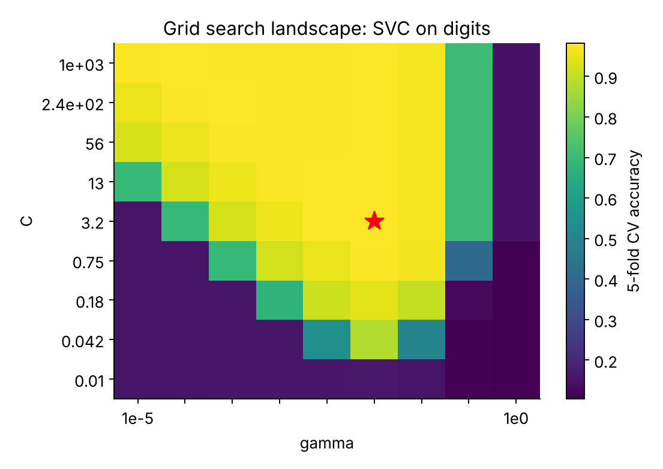
Figure 3: Cross-validated accuracy over the (C, gamma) grid; the star marks the best cell.
Two lessons follow. First, tuning did not improve CV accuracy over the default (98.12% vs. 98.12%): the default gamma="scale" heuristic already lies in the good region, and the 0.6-point test difference corresponds to about two images of 360 – within noise. Reporting this honestly matters; tuning is not always rewarded. Second, the landscape is very uneven: only 26% of the grid lies within one accuracy point of the best, and the worst cells score 10.4%. Tuning therefore acts mainly as insurance against bad regions, and the heat-map shows a diagonal ridge in which C and gamma trade off – an *interaction* that a one-parameter-at-a-time search would not discover.

6.2 Experiment E2 – comparing search strategies
Table 13 gives the main results on the Diabetes data. The default gradient-boosting model has CV RMSE 60.96 and test RMSE 53.93; a mean predictor scores 73.22.
Table 13: Search strategies on the Diabetes data (RMSE; mean over 3 seeds where stochastic)
Strategy | Trials | Best CV RMSE | Std (seeds) | Test RMSE | Std (seeds) | Time (s)
Default hyper-parameters | 1 | 60.96 | – | 53.93 | – | <1
Grid search | 108 | 56.67 | n/a | 51.51 | n/a | 110
Random search | 30 | 56.59 | ± 0.10 | 52.98 | ± 0.75 | 29
Optuna (TPE) | 30 | 56.40 | ± 0.34 | 53.02 | ± 1.07 | 26
Hyperopt (TPE) | 30 | 56.60 | ± 0.32 | 52.10 | ± 0.46 | 29
Successive halving | 59 (mixed budgets) | 56.52 | (1 run) | 52.33 | (1 run) | 19

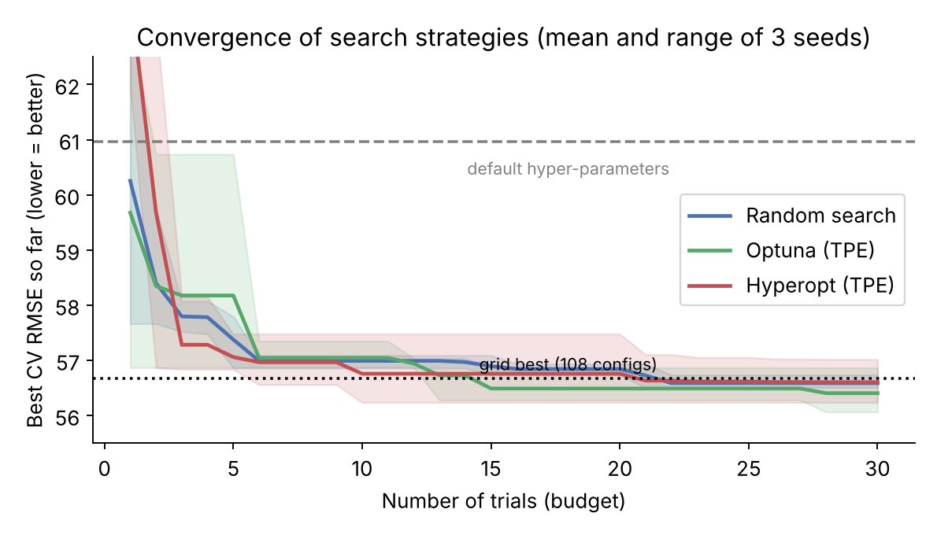
Figure 4: Best CV RMSE found as a function of the number of trials.
Tuning helps. Every method lowers CV RMSE from 61.0 to about 56.4–56.7, a reduction of roughly 7.0% to 7.5%. Test RMSE improves as well, from 53.93 to between 51.51 and 53.02, i.e. 1.8%–4.5% – a smaller improvement than on the selection data (see 6.3).
Random search matches grid search at 28% of the cost. With 30 trials random search reaches mean CV RMSE 56.59, against 56.67 for 108 grid fits, because the best region (low learning rate, shallow trees, strong leaf regularization) is wide enough for random sampling to hit.
Bayesian methods are competitive, not dominant. Optuna's TPE obtained the lowest mean CV RMSE (56.40) and converged to the grid optimum in about 15 trials, but Hyperopt (56.60) was no better than random search (56.59). The differences (≤ 0.2 RMSE) are smaller than the seed-to-seed standard deviation (0.1–0.3) and far below the noise of 5-fold CV on 353 rows, so no ranking among the three stochastic methods can be claimed from three seeds. This agrees with the literature: on cheap, low-dimensional problems random search is a very strong baseline, and the benefit of surrogate modelling grows with evaluation cost and dimensionality.
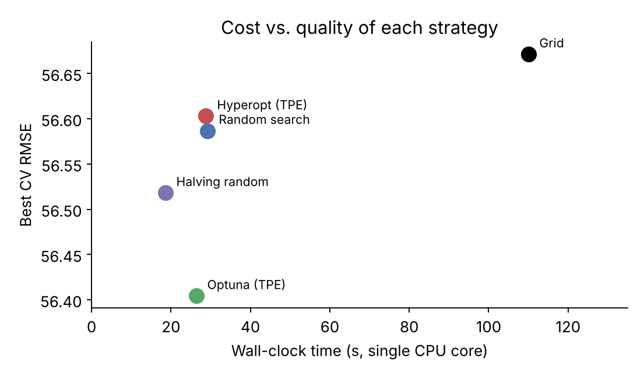
Figure 5: Cost–quality trade-off of the strategies (single CPU core).

6.3 Experiment E3 – selection bias and generalization
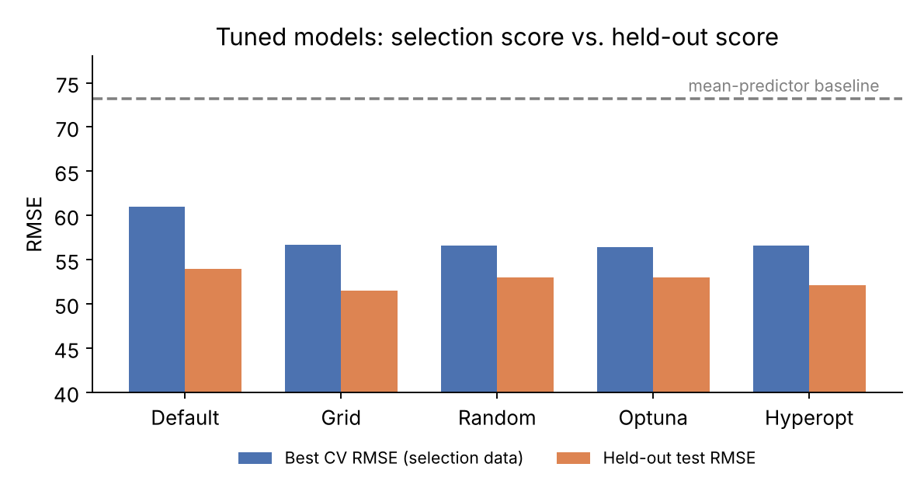
Figure 6: Tuned models: CV score used for selection vs. held-out test RMSE.
For every tuned model the CV RMSE (≈ 56.6) is higher than the test RMSE (≈ 53.0), which at first looks like an improvement on unseen data. It is a property of this particular 89-row test set, which happens to be easier than the training folds: the default model shows the same pattern (CV 61.0 vs. test 53.9). What matters is that *relative* improvement on the test set (1.8%–4.5%) is clearly smaller than on the CV data (7.2%–7.5%): part of the CV gain is selection bias – the winner was chosen *because* it scored well on those folds.
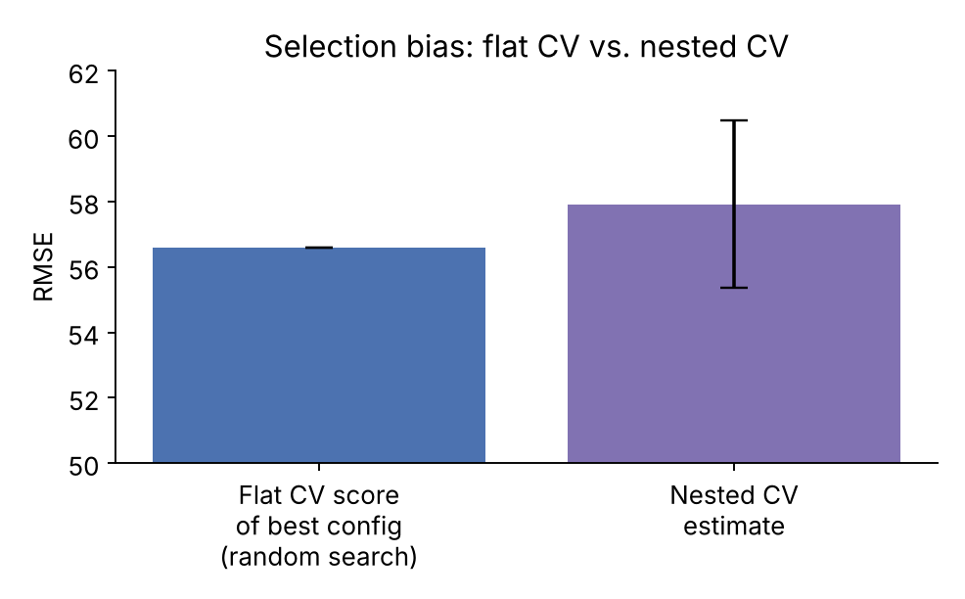
Figure 7: Nested CV gives a less optimistic estimate than the flat CV score of the selected configuration.
Nested cross-validation quantifies this. The nested estimate of the whole procedure "random search with 15 trials" is RMSE 57.92 ± 2.56, versus 56.59 reported by flat CV for the winning configuration – an optimism of about 1.3 RMSE points (2.4%). The large fold-to-fold spread (54.5 to 60.8) is itself a warning that small score differences between configurations are not trustworthy on a dataset of this size.

6.4 Experiment E4 – which hyper-parameters matter?
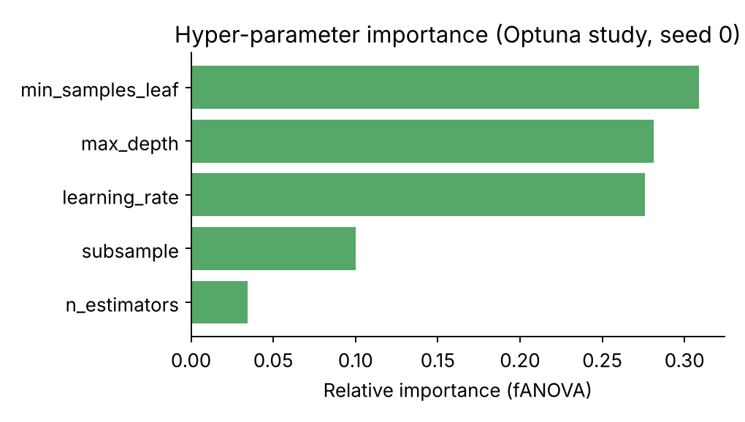
Figure 8: fANOVA importance of each hyper-parameter in an Optuna study.
Three parameters – min_samples_leaf (31%), max_depth (28%) and learning_rate (28%) – account for about 87% of the explained variation in CV score, whereas n_estimators contributes only 3%. This is exactly the "low effective dimensionality" that makes random search efficient. In practice it suggests fixing n_estimators at a generous value (or using early stopping), and concentrating the budget on the tree-complexity and shrinkage parameters.
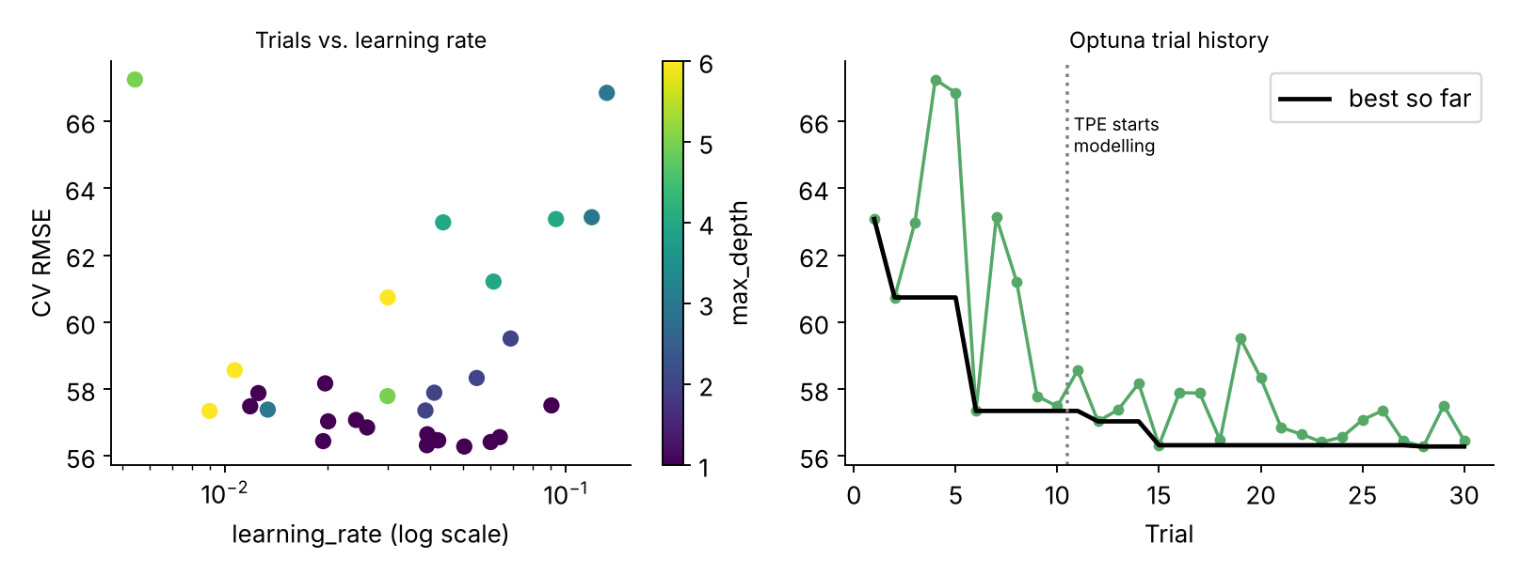
Figure 9: Optuna trials: CV RMSE against learning rate (left) and the trial history (right).
The scatter plot shows that very high learning rates combined with deep trees give the worst results, while the best trials cluster at low-to-moderate learning rates with shallow trees. The history plot shows the effect of the 10 random start-up trials followed by model-guided trials; improvement continues in small steps, a typical "diminishing returns" curve.
Selected configurations. The grid search selected learning_rate = 0.01, max_depth = 2, n_estimators = 500, subsample = 0.6, min_samples_leaf = 15. Optuna (seed 0) selected learning_rate = 0.050, max_depth = 1, n_estimators = 496, subsample = 0.68, min_samples_leaf = 21. Despite differing in details, both choose very shallow trees, a small learning rate and strong leaf regularization – a consistent finding that signals a high-noise problem needing heavy regularization.

6.5 Experiment E5 – successive halving
Halving random search evaluated 59 candidate–budget combinations over 3 rounds in 19 s (versus 29 s for 30 full random-search trials). It reached CV RMSE 56.52 and test RMSE 52.33, matching the other methods. For this small, fast model the saving is modest, but the principle becomes decisive when a single full evaluation costs minutes or hours.

6.6 Summary of findings against hypotheses
Table 14: Outcome of each research question
ID | Result | Verdict
RQ1 | CV RMSE fell from 61.0 to ≈56.6 (7.2%); test RMSE from 53.9 to ≈53.0 (1.8%). On the SVM, no CV gain over a strong default. | Supported for boosting; model-dependent
RQ2 | Random search (30 fits) reached the grid optimum (108 fits) within 0.1 RMSE. | Supported
RQ3 | Optuna slightly better, Hyperopt equal to random; differences within seed noise. | Not conclusive
RQ4 | Flat CV was optimistic by ≈1.3 RMSE vs. nested CV; relative gains shrank on the test set. | Supported
RQ5 | Three of five parameters carry ≈87% of importance. | Supported
RQ6 | Halving matched quality at ≈63% of random-search time. | Supported (small effect here)
RQ7 | SVM accuracy ranged from 10.4% to 98.1% across the grid. | Supported

7. Preventing Overfitting and Ensuring Generalization
Hyper-parameter search can overfit just as model training can: with enough configurations, some will score well on the validation folds by chance. The more trials, the larger the effect. The following safeguards should be built into every optimization plan.

7.1 Protecting the evaluation data
- Final test set. Split off a test set before any tuning and evaluate the final chosen model on it exactly once (Section 4.4).
- Nested cross-validation. Use it whenever you need a trustworthy estimate of a tuned procedure or when comparing tuned models (Section 6.3). Cheaper alternative: a three-way train/validation/test split with the search confined to train + validation.
- Pipelines inside the search. Scalers, imputers, encoders and feature selectors must be fitted inside each fold; pass the whole Pipeline to the search object so that leakage cannot occur.
- Consistent folds. Use identical folds for all configurations so that differences reflect the configuration, not the split. For small data, consider repeated k-fold to reduce the noise of the objective.

7.2 Choosing among near-equal configurations
- One-standard-error rule: among configurations whose CV score is within one standard error of the best, choose the *simplest* (shallowest tree, strongest regularization, fewest features). In our study the best-found models already lean this way.
- Inspect score plateaus: prefer a configuration in the middle of a broad good region over a sharp isolated peak; the former is more stable under data shifts and re-training.
- Stability check: re-run the top 3–5 configurations with different CV seeds and report mean ± std; large variation means the ranking is not trustworthy.

7.3 Controlling the search itself
- Limit the budget and the space. Wide spaces and thousands of trials increase selection bias; decide the budget in advance and avoid "one more run" after looking at test performance.
- Include regularization parameters in the space (learning rate, subsampling, minimum leaf size, L1/L2 penalties, dropout) so the search can move towards simpler models.
- Early stopping on a held-out validation split for boosting and neural networks, rather than treating the number of rounds as a free parameter.
- Monitor the train–validation gap for the winners (return_train_score=True): a widening gap as tuning proceeds is a symptom of overfitting to the folds.
- Use the right metric. Tune the metric that reflects the business objective and class balance (Week 4); a mismatch overfits to the wrong target.

7.4 Checking generalization after tuning
- Compare the tuned model with the default and with a trivial baseline on the untouched test set; a gain that vanishes there was selection noise.
- Where available, validate on a temporal or external hold-out (later period, different site) to test robustness to distribution shift.
- Report confidence intervals (e.g. bootstrap over the test set) rather than single numbers.
- After deployment monitor performance and re-tune when data drift is detected.

8. Anticipated Challenges and Troubleshooting
Table 15: Challenges and troubleshooting measures
Challenge | Symptom | Troubleshooting measure
Computational cost | Search takes hours; experiments cannot be repeated | Start with random search and a small budget; use n_jobs; subsample data for early rounds; use halving/pruning; cache pre-processing; reduce CV folds in early stages
Noisy objective | Best configuration changes with the CV seed; tiny score differences | Repeated CV; report std; apply one-standard-error rule; do not over-interpret differences smaller than noise
Search space badly specified | Best values lie on the boundary of the range | Widen that range and repeat; use log scale for rates and penalties; check the importance plot
Wasted or invalid trials | Errors for incompatible combinations (e.g. unsupported penalty/solver); NaN scores | Use conditional spaces; set error_score in sklearn; return a large penalty in custom objectives; catch exceptions
Over-optimistic result | Large gap between CV and test, or between CV and production | Nested CV; fresh hold-out; limit trials; check for leakage
Class imbalance | High accuracy but poor minority recall after tuning | Tune F1/PR-AUC or a cost-based metric; stratified folds; include class_weight in the space
Non-reproducible results | Different scores on re-run | Set seeds for split, estimator, sampler (TPESampler(seed=...), rstate); pin library versions; store the study database
Parallelism vs. Bayesian efficiency | Parallel TPE workers do not improve proportionally | Use batches with random start-up trials; accept some inefficiency; combine with pruning
Slow or failing training runs | A few huge configurations dominate runtime | Cap training time or iterations; use pruners; set timeouts per trial
Surrogate misled | Bayesian search stagnates at a poor optimum | Increase random start-up trials; add exploration; restart from a different seed; compare with random search
Library version drift | API changes break scripts (e.g. renamed parameters) | Pin versions in requirements.txt; run a smoke test with 2–3 trials before the full job
Memory problems | Out-of-memory with many parallel workers or large data | Reduce n_jobs; use memory-mapping or float32; evaluate on a subsample

9. Guidelines for Reproducing the Results

9.1 Repository layout
week5-optimization/
requirements.txt # pinned versions (Section 5.1)
e1_svc_grid.py # SVM landscape (E1)
e2_compare_search.py # default, grid, random, Optuna, Hyperopt, nested CV, halving
make_figures.py # produces all figures from the stored result files
results/
e1.json e2.json # raw scores, curves, timings, best parameters
figures/ # PNG files used in this report

9.2 Step-by-step
- Create a clean virtual environment and install the pinned requirements.
- Run python e1_svc_grid.py (about 30 s) and python e2_compare_search.py (about 8–10 minutes on one core).
- Run python make_figures.py to regenerate the figures from results/*.json.
- Compare your numbers with Tables 13 and 14 of this report. Timings vary with hardware; scores should match to within the random-number-generator differences of other library versions.

9.3 Reproducibility checklist
- Seeds fixed for data split, estimator, sampler and CV splitter.
- Library and Python versions recorded and pinned.
- The same folds and metric used for every method.
- All trials stored (parameters, mean and std score, time), not only the best.
- Data source and any pre-processing documented; data version identified.
- Hardware (CPU cores) and parallelism settings noted when reporting timings.
- Test set evaluated once, after all choices were frozen.
- Scripts run end-to-end from a clean checkout, with figures generated from stored results.
Practical tip
Store the Optuna study in an SQLite file (storage="sqlite:///study.db") and Hyperopt Trials objects with pickle. Interrupted searches can then be resumed and any trial can be inspected later.

10. Discussion and Potential Improvements

10.1 Interpretation
The experiments support a pragmatic strategy. Start with the default model as a baseline; run a modest random or TPE search (20–50 trials) over a space that includes regularization; verify the gain with nested CV or a held-out set; and stop when improvements fall below the noise of the evaluation protocol. On the Diabetes data about 15 trials were enough to reach what 108 grid evaluations found, and further effort mostly buys selection bias rather than real performance.
The results also show that hyper-parameter tuning is not a substitute for better data or features: after tuning, the model explains only about half of the variance in the target. When the noise floor of a problem is high, the headroom from tuning is limited, and effort is better spent on feature engineering, additional data or different model families.

10.2 Limitations of this study
- Only three seeds were used for stochastic methods; a larger replication (20–30 seeds) would allow proper statistical tests such as the Wilcoxon signed-rank test on paired results.
- Two small datasets and two model families were studied; conclusions about relative method performance may change for expensive deep-learning models or very large spaces.
- The Diabetes test set has 89 rows, so test RMSE has a wide confidence interval; differences of 1–2 RMSE points are not distinguishable.
- Time measurements come from one CPU core and exclude the benefits of parallel execution.

10.3 Potential improvements and extensions
Table 16: Ideas for improving the optimization plan
Improvement | Expected benefit
Repeated k-fold or more seeds inside the objective | Less noisy objective; more reliable ranking of configurations
Pruning (Optuna MedianPruner/HyperbandPruner) and early stopping | Large cost savings for expensive models with no loss of quality
Multi-objective optimization (error vs. latency or model size) | Pareto-optimal models for deployment constraints
Search over pre-processing and model family jointly (AutoML, FLAML, Auto-sklearn) | Discovers gains beyond hyper-parameters
Warm-start from previous studies and transfer learning of priors | Fewer trials on similar tasks
Ensembling the top-k configurations | Reduces variance; often outperforms the single best model
Distributed tuning (Ray Tune, Optuna with a shared database) | Scales to large budgets and deep learning
Statistical testing and confidence intervals on results | Evidence-based claims instead of point comparisons
Automated experiment tracking (MLflow, Weights & Biases) | Auditable, shareable, comparable experiments

11. Conclusion
Model optimization is most effective when treated as a controlled experiment rather than a guessing game. This report described the main search strategies, set out an experimental design with explicit research questions, parameter spaces and control variables, and executed it with scikit-learn, Optuna and Hyperopt.
The measured results lead to four practical conclusions. (1) Tuning can matter, but not always: gradient boosting improved by about 7.2% in CV RMSE, whereas a scaled SVM was already near-optimal at its defaults, though the grid showed accuracy collapsing in bad regions. (2) Cheap, simple methods are strong: random search with 30 trials matched a 108-point grid, and Bayesian methods offered at most a marginal edge on this inexpensive problem. (3) Reported tuning scores are optimistic: nested CV exposed an optimism of about 1.3 RMSE points, so an untouched test set and honest uncertainty reporting are indispensable. (4) Reproducibility is part of the method: fixed seeds, pinned versions, logged trials and scripted figures make the results verifiable.
Following the plan in this document – baseline first, well-designed space, matched budgets, nested validation, careful troubleshooting – gives a Machine Learning Engineer a defensible, repeatable route from a default model to a reliably better one.

References
- Bergstra, J., Bengio, Y. (2012). Random Search for Hyper-Parameter Optimization. Journal of Machine Learning Research, 13, 281–305.
- Bergstra, J., Bardenet, R., Bengio, Y., Kégl, B. (2011). Algorithms for Hyper-Parameter Optimization. NeurIPS 24.
- Snoek, J., Larochelle, H., Adams, R. P. (2012). Practical Bayesian Optimization of Machine Learning Algorithms. NeurIPS 25.
- Akiba, T., Sano, S., Yanase, T., Ohta, T., Koyama, M. (2019). Optuna: A Next-generation Hyperparameter Optimization Framework. KDD 2019.
- Li, L., Jamieson, K., DeSalvo, G., Rostamizadeh, A., Talwalkar, A. (2018). Hyperband: A Novel Bandit-Based Approach to Hyperparameter Optimization. JMLR, 18.
- Hutter, F., Hoos, H., Leyton-Brown, K. (2011). Sequential Model-Based Optimization for General Algorithm Configuration (SMAC). LION 5.
- Cawley, G., Talbot, N. (2010). On Over-fitting in Model Selection and Subsequent Selection Bias in Performance Evaluation. JMLR, 11, 2079–2107.
- Pedregosa, F. et al. (2011). Scikit-learn: Machine Learning in Python. JMLR, 12, 2825–2830.
- scikit-learn documentation: Tuning the hyper-parameters of an estimator (scikit-learn.org/stable/modules/grid_search.html).
- Optuna documentation (optuna.readthedocs.io) and Hyperopt documentation (hyperopt.github.io/hyperopt).
- Hastie, T., Tibshirani, R., Friedman, J. (2009). The Elements of Statistical Learning, 2nd ed. Springer.

