WEEK 4

Model Evaluation and Validation Techniques
A practical framework for measuring, validating and diagnosing machine learning models with Python and scikit-learn
Machine Learning Engineering Programme – Week 4 Deliverable
Author: ____________________
November 2026

Table of Contents
1. Introduction
2. Evaluation Metrics
3. Validation Techniques
4. Detecting Overfitting and Underfitting
5. Error Analysis
6. Practical Guidelines and Checklist
7. Conclusion
References
Each section contains theory, a scikit-learn code example and results from running that code on bundled datasets.

1. Introduction

1.1 Why model evaluation matters
Building a machine learning model is only half of the job; the other half is knowing how much to trust it. A model that scores well on the data it was trained on may fail in production, and a model that appears to fail may simply have been measured with the wrong yardstick. Model evaluation is the discipline of answering three questions with evidence: How well does the model perform? How reliable is that estimate? Why does the model make the mistakes it makes?
Rigorous evaluation supports several engineering goals at once:
- Model selection – comparing algorithms and hyper-parameter settings on a fair, like-for-like basis.
- Generalisation assurance – estimating performance on data the model has never seen, which is the only performance that matters after deployment.
- Risk management – understanding the cost of different error types (e.g. a missed cancer diagnosis versus a false alarm) before the model affects real people or money.
- Debugging and iteration – locating the data, feature or modelling problems that cause errors so that effort is spent where it pays off.
- Communication – giving stakeholders numbers and visuals that are honest, reproducible and relevant to the business objective.

1.2 Overfitting and underfitting
A supervised model is trained to minimise error on a finite sample, but it is judged on new data drawn from the same underlying distribution. The gap between those two situations produces the two classical failure modes:
- Underfitting (high bias) – the model is too simple to capture the structure in the data. Both training and validation error are high and close together. Example: fitting a straight line to a clearly curved relationship, or a decision tree limited to a single split.
- Overfitting (high variance) – the model is so flexible that it memorises noise and quirks of the training sample. Training error is very low but validation error is noticeably higher. Example: an unpruned decision tree that reaches 100% training accuracy.
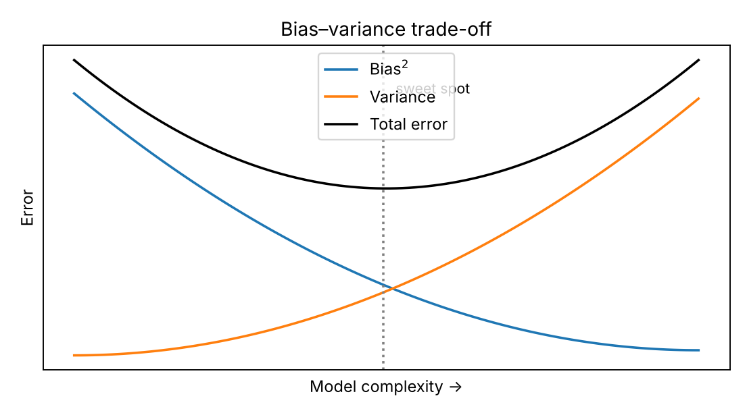
Figure 1: The bias–variance trade-off: total error is lowest at an intermediate model complexity.
Expected prediction error can be decomposed as bias² + variance + irreducible noise. Increasing model complexity lowers bias but raises variance; the objective of evaluation and validation is to find the complexity where their sum is smallest, and to detect when we have drifted to either side.
Table 1: Typical symptoms of under- and overfitting
Symptom | Underfitting | Good fit | Overfitting
Training performance | Poor | Good | Excellent
Validation performance | Poor | Good (close to training) | Clearly worse than training
Train–validation gap | Small | Small | Large
Learning curves | Both plateau at a poor level | Converge at a good level | Gap persists as data grows
Typical fixes | More features, more complex model, less regularisation | Keep; monitor | More data, regularisation, simpler model, early stopping, ensembling

1.3 The importance of robust validation
A single number computed on a single split can be misleading for three reasons: the split may be unrepresentative (high variance of the estimate), the test set may have been used repeatedly to make decisions (information leakage), and the metric may not reflect the real objective. Robust validation addresses these risks by using resampling (cross-validation), keeping a truly untouched test set, preserving class proportions and data structure (stratified, grouped or time-aware splits) and reporting uncertainty (mean ± standard deviation) rather than a bare point estimate.

1.4 Scope and experimental setup of this report
This report is written as a guide that can be followed step by step. Each concept is explained theoretically and then demonstrated with scikit-learn code. To keep the discussion concrete, all numbers and figures were produced by actually running the code on datasets bundled with scikit-learn (so the results are reproducible without any download):
- Classification: the Breast Cancer Wisconsin (Diagnostic) dataset – 569 samples, 30 numeric features, binary target (malignant / benign). Data were split 80/20 with stratification (455 training / 114 test samples); a standardised logistic regression is the model under study.
- Regression: the Diabetes dataset – 442 samples, 10 features, continuous target (disease progression score). A standardised Ridge regression is used, with an 80/20 split (89 test samples).
- Random seeds are fixed (random_state=42) so that every table in this document can be regenerated.
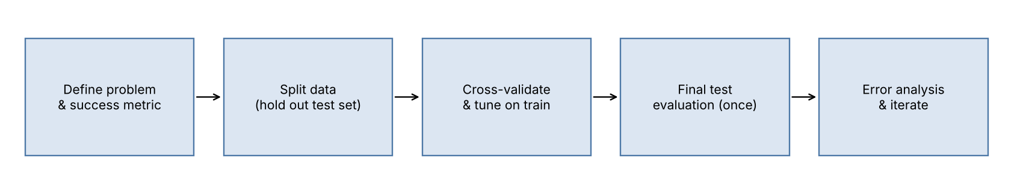
Figure 2: Recommended evaluation workflow used throughout this report.
import numpy as np, pandas as pd, matplotlib.pyplot as plt
from sklearn.datasets import load_breast_cancer, load_diabetes
from sklearn.model_selection import train_test_split, StratifiedKFold, KFold, cross_validate
from sklearn.pipeline import Pipeline
from sklearn.preprocessing import StandardScaler
from sklearn.linear_model import LogisticRegression, Ridge
from sklearn.metrics import *

X, y = load_breast_cancer(return_X_y=True)
X_train, X_test, y_train, y_test = train_test_split(
X, y, test_size=0.2, stratify=y, random_state=42)

model = Pipeline([("scale", StandardScaler()),
("clf", LogisticRegression(max_iter=5000))])
model.fit(X_train, y_train)

2. Evaluation Metrics
A metric converts model predictions into a number that summarises quality. There is no universally best metric: the right one depends on the problem type (classification or regression), the class balance, the relative cost of different errors and the audience. This section catalogues the most important metrics and explains when to prefer each.

2.1 Classification metrics

2.1.1 The confusion matrix – the foundation
For a binary problem, every prediction falls into one of four cells. Most classification metrics are simple ratios of these counts. By convention one class is designated the positive class (the event of interest).
Table 2: Binary confusion matrix
 | Predicted positive | Predicted negative
Actual positive | True Positive (TP) – correctly detected | False Negative (FN) – missed case (Type II error)
Actual negative | False Positive (FP) – false alarm (Type I error) | True Negative (TN) – correctly rejected

2.1.2 Threshold-based metrics
Table 3: Core classification metrics
Metric | Formula | Interpretation | Use when
Accuracy | (TP+TN) / (TP+TN+FP+FN) | Share of all predictions that are correct | Classes are balanced and errors cost the same
Precision (PPV) | TP / (TP+FP) | Of the cases flagged positive, how many are truly positive | False positives are costly (spam filter, fraud investigation workload)
Recall (sensitivity, TPR) | TP / (TP+FN) | Of all real positives, how many were found | False negatives are costly (disease screening, safety)
Specificity (TNR) | TN / (TN+FP) | Of all real negatives, how many were correctly cleared | Need to avoid false alarms among negatives
F1-score | 2·P·R / (P+R) | Harmonic mean of precision and recall | Imbalanced data; need one balanced number
Fβ-score | (1+β²)·P·R / (β²·P+R) | β>1 weights recall more; β<1 weights precision more | Unequal cost of FP vs FN
Balanced accuracy | (TPR + TNR) / 2 | Average recall over classes | Imbalanced data, accuracy-style summary
Matthews corr. coeff. (MCC) | (TP·TN − FP·FN) / √((TP+FP)(TP+FN)(TN+FP)(TN+FN)) | Correlation between predictions and truth, −1 to +1 | Single robust score even for very imbalanced data

Why accuracy alone can mislead
In a fraud dataset where only 3.6% of cases are positive, a "model" that always predicts "not fraud" is 96.4% accurate yet detects nothing (recall = 0). Section 2.2 reproduces this experiment.

2.1.3 Ranking and probability-based metrics
Many models output a probability or score. Threshold-free metrics evaluate the quality of that score across all possible cut-offs:
- ROC curve and ROC-AUC – plots true-positive rate against false-positive rate as the threshold varies. AUC is the probability that a randomly chosen positive is scored higher than a randomly chosen negative (0.5 = random, 1.0 = perfect). It is insensitive to class ratio, which is useful for comparing models but can look over-optimistic when positives are rare.
- Precision–Recall curve and Average Precision (PR-AUC) – focuses entirely on the positive class and is much more informative than ROC when positives are rare.
- Log loss (cross-entropy) – penalises confident wrong predictions heavily; evaluates the quality of probabilities, not just ranking.
- Brier score – mean squared difference between predicted probability and the 0/1 outcome (lower is better); measures calibration plus discrimination.

2.1.4 Multi-class and multi-label problems
For more than two classes, per-class precision, recall and F1 are averaged. The choice of averaging is itself a modelling decision:
- Macro average – unweighted mean over classes; every class counts equally (good when rare classes matter).
- Weighted average – mean weighted by class support; reflects overall population but hides poor performance on small classes.
- Micro average – pools all TP/FP/FN before computing the ratio; equals accuracy for single-label multi-class problems.

2.1.5 Computing classification metrics in scikit-learn
y_pred = model.predict(X_test)
y_proba = model.predict_proba(X_test)[:, 1] # P(class = 1 = benign)

print("Accuracy :", accuracy_score(y_test, y_pred))
print("Precision :", precision_score(y_test, y_pred))
print("Recall :", recall_score(y_test, y_pred))
print("F1 :", f1_score(y_test, y_pred))
print("Balanced accuracy :", balanced_accuracy_score(y_test, y_pred))
print("MCC :", matthews_corrcoef(y_test, y_pred))
print("ROC-AUC :", roc_auc_score(y_test, y_proba))
print("Average precision :", average_precision_score(y_test, y_proba))
print("Log loss :", log_loss(y_test, y_proba))
print("Brier score :", brier_score_loss(y_test, y_proba))
print(classification_report(y_test, y_pred, target_names=["malignant","benign"]))

Running this on the held-out test set gives the results in Table 4. (Class 1 = benign is treated as the positive class.)
Table 4: Classification results – logistic regression on the 114-sample test set
Metric | Value | Comment
Accuracy | 0.982 | Overall correctness
Precision | 0.986 | Few false alarms
Recall | 0.986 | Few missed positives
F1-score | 0.986 | Balanced precision/recall
Balanced accuracy | 0.981 | Mean recall across both classes
MCC | 0.962 | Strong agreement even accounting for class sizes
ROC-AUC | 0.995 | Near-perfect ranking of cases
Average precision | 0.997 | Near-perfect precision–recall behaviour
Log loss | 0.078 | Confident, mostly correct probabilities
Brier score | 0.022 | Low probability error

precision recall f1-score support

malignant 0.98 0.98 0.98 42
benign 0.99 0.99 0.99 72

accuracy 0.98 114
macro avg 0.98 0.98 0.98 114
weighted avg 0.98 0.98 0.98 114

2.2 Choosing classification metrics
Metric choice should flow from the cost of errors and the data distribution, not from habit. The following decision guide summarises the reasoning:
Table 5: Metric selection guide for classification
Scenario | Recommended metric(s) | Rationale
Balanced classes, equal error costs | Accuracy, F1, ROC-AUC | Simple and adequate; all errors are equally important
Rare positive class (fraud, defects, rare disease) | PR-AUC, F1/Fβ, recall at fixed precision, MCC | Accuracy is dominated by the majority class; ROC-AUC can hide poor precision
Missing a positive is very costly (screening, safety) | Recall (sensitivity), F2, then tune threshold | Prioritise catching every positive; accept more false alarms
False alarms are costly (manual review, user annoyance) | Precision, F0.5, precision at top-k | Make each flagged case count
Probabilities are used downstream (risk scoring, pricing) | Log loss, Brier score, calibration curve | Probability quality matters, not just class labels
Comparing many models regardless of threshold | ROC-AUC / PR-AUC | Threshold-free ranking quality
Multi-class with important rare classes | Macro-F1, per-class recall | Prevents large classes from masking weak ones
Ranking / recommendation outputs | Precision@k, NDCG, MAP | Only the top of the list is seen by users

Worked example: the accuracy paradox
We generated a synthetic dataset with 5,000 samples in which only about 3.6% are positive and compared a trivial classifier that always predicts the majority class with a class-weighted random forest. Accuracy alone ranks the trivial model almost level with a real model, while recall exposes the difference – and the random forest's modest recall shows that this is a genuinely hard problem requiring further work (threshold tuning, better features, resampling).
Table 6: Imbalanced-data experiment (positive rate 3.6%)
Model | Accuracy | Recall | Precision | F1 | PR-AUC | ROC-AUC
Always predict "negative" | 0.964 | 0.000 | undefined | 0.000 | – | 0.500
Random forest (balanced class weights) | 0.974 | 0.267 | 1.000 | 0.421 | 0.673 | 0.903

The ROC-AUC of 0.903 looks reassuring, yet the PR-AUC of 0.673 reveals that precision falls quickly as recall rises – a typical case where PR-based metrics tell the more honest story.

Decision threshold tuning
Class labels come from applying a threshold (default 0.5) to the predicted probability. Changing the threshold trades precision against recall. The right operating point should be chosen on validation data according to business cost, not left at the default.
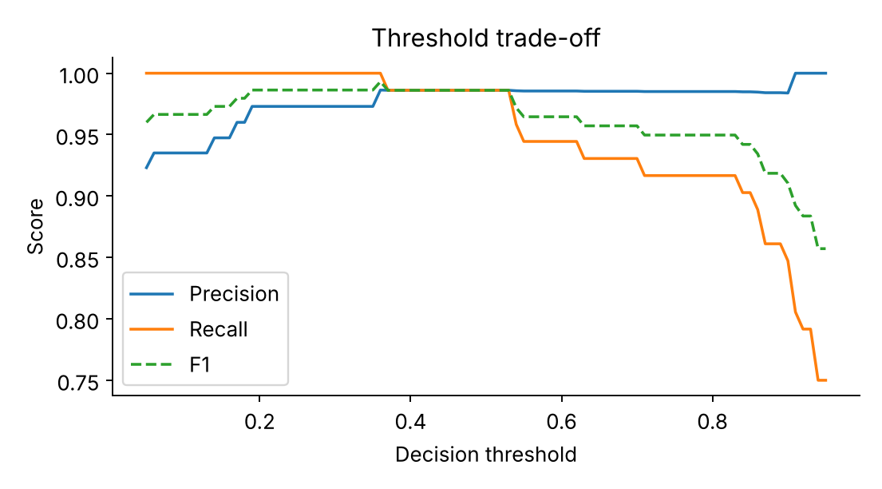
Figure 3: Precision, recall and F1 as the decision threshold changes (logistic regression, test set).
from sklearn.metrics import precision_recall_curve
prec, rec, thr = precision_recall_curve(y_test, y_proba)
f1 = 2*prec*rec/(prec+rec+1e-12)
best = thr[np.argmax(f1[:-1])]
print("Threshold maximising F1:", round(best, 3))
y_pred_custom = (y_proba >= best).astype(int)

2.3 Regression metrics
In regression the target is continuous, so metrics summarise the size and distribution of the residuals, e = y − ŷ.
Table 7: Core regression metrics
Metric | Formula | Properties | Use when
MAE | mean(|e|) | Same units as target; robust to outliers; easy to explain | Typical error size matters; outliers should not dominate
MSE | mean(e²) | Squared units; punishes large errors heavily; differentiable | Large errors are disproportionately bad; used as training loss
RMSE | √MSE | Same units as target; sensitive to outliers | Default reporting metric when big misses matter
R² (coefficient of determination) | 1 − SSres/SStot | Fraction of variance explained; 1 is perfect, 0 equals predicting the mean, can be negative | Comparing against a mean baseline; unit-free summary
Adjusted R² | 1 − (1−R²)(n−1)/(n−p−1) | R² penalised for the number of predictors p | Comparing linear models with different numbers of features
Median absolute error | median(|e|) | Extremely robust to outliers | Heavy-tailed errors
MAPE / sMAPE | mean(|e/y|) | Percentage error, scale-free; undefined when y≈0; biased to under-prediction | Business reporting across different scales (y strictly positive)
RMSLE | √mean((log(1+ŷ)−log(1+y))²) | Penalises relative error; under-prediction costs more than over-prediction | Targets spanning orders of magnitude (prices, counts)

Xr, yr = load_diabetes(return_X_y=True)
Xr_tr, Xr_te, yr_tr, yr_te = train_test_split(Xr, yr, test_size=0.2, random_state=42)
reg = Pipeline([("scale", StandardScaler()), ("ridge", Ridge(alpha=1.0))]).fit(Xr_tr, yr_tr)
pred = reg.predict(Xr_te)

print("MAE :", mean_absolute_error(yr_te, pred))
print("MSE :", mean_squared_error(yr_te, pred))
print("RMSE :", mean_squared_error(yr_te, pred) ** 0.5)
print("R2 :", r2_score(yr_te, pred))
print("MedAE :", median_absolute_error(yr_te, pred))

Table 8: Regression results – Ridge regression vs. a mean-predicting baseline (test set)
Metric | Ridge regression | Baseline (predict training mean)
MAE | 42.81 | –
MSE | 2892.0 | –
RMSE | 53.78 | 73.22
R² | 0.454 | -0.012
Median absolute error | 37.38 | –

The model reduces RMSE from 73.2 (baseline) to 53.8 and explains about 45% of the variance. Always comparing against a naive baseline (mean, median, last value, majority class) is essential: it tells you whether the model has learned anything at all and puts the metric on a meaningful scale.

2.4 Choosing regression metrics
- Use RMSE when large errors are particularly harmful (e.g. energy demand forecasting) and MAE when all errors matter proportionally or when the data contain outliers you do not want to dominate.
- Report R² for a scale-free sense of explanatory power, but never alone: a high R² can coexist with large absolute errors, and R² computed on training data always flatters.
- Prefer RMSLE or MAPE when relative error is what the business cares about (e.g. a 10% price error is equally bad for a cheap and an expensive item).
- Always inspect residual plots (Section 5.4); two models with the same RMSE can have very different error structures.
- Align the evaluation metric with the training loss where possible, but be willing to evaluate with a different metric when it better reflects business impact.

3. Validation Techniques
Validation techniques answer the question: how should the data be divided so that our performance estimate is honest and stable? The core principle is that the data used to evaluate a model must never influence how that model was built.

3.1 The three-way split: train, validation, test
- Training set – used to fit model parameters.
- Validation set (or cross-validation folds) – used to compare models, select hyper-parameters and choose thresholds.
- Test set – used once, at the very end, to report the final expected performance. If it is consulted repeatedly during development it silently becomes a second validation set and the estimate turns optimistic.

3.2 Hold-out (train–test split)
The simplest approach: randomly set aside a fraction (commonly 20–30%) for evaluation. It is fast and easy but has two weaknesses: it wastes data for training, and the estimate depends on which samples happened to land in the test set.
X_train, X_test, y_train, y_test = train_test_split(
X, y, test_size=0.2, stratify=y, random_state=42)

To quantify the second weakness, the same model was evaluated on 30 different random 80/20 splits of the breast-cancer data. The F1-score ranged from 0.958 to 1.000 (mean 0.984, standard deviation 0.009) purely because of how the split fell. A single hold-out score could therefore be off by several percentage points in either direction.
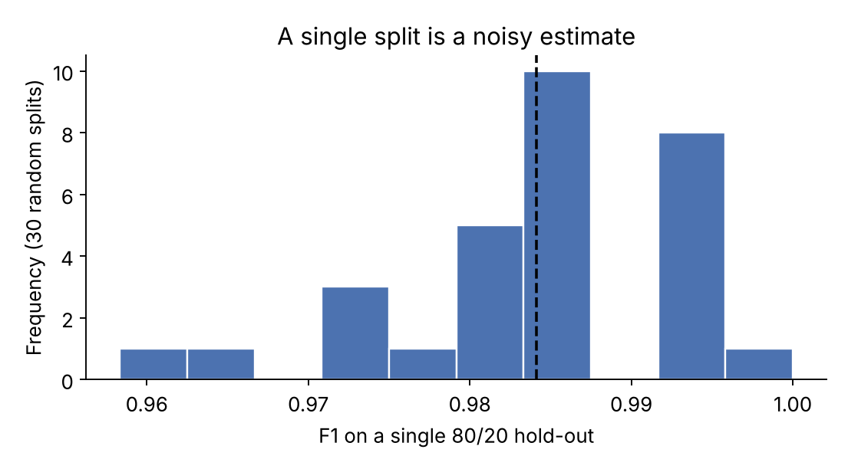
Figure 4: Distribution of F1 across 30 different random hold-out splits.

3.3 K-fold cross-validation
K-fold cross-validation partitions the data into k equally sized folds. The model is trained k times, each time using k−1 folds for training and the remaining fold for validation. The k scores are averaged, and their standard deviation indicates how stable the model is. Every observation is used for validation exactly once and for training k−1 times, so data are used efficiently.
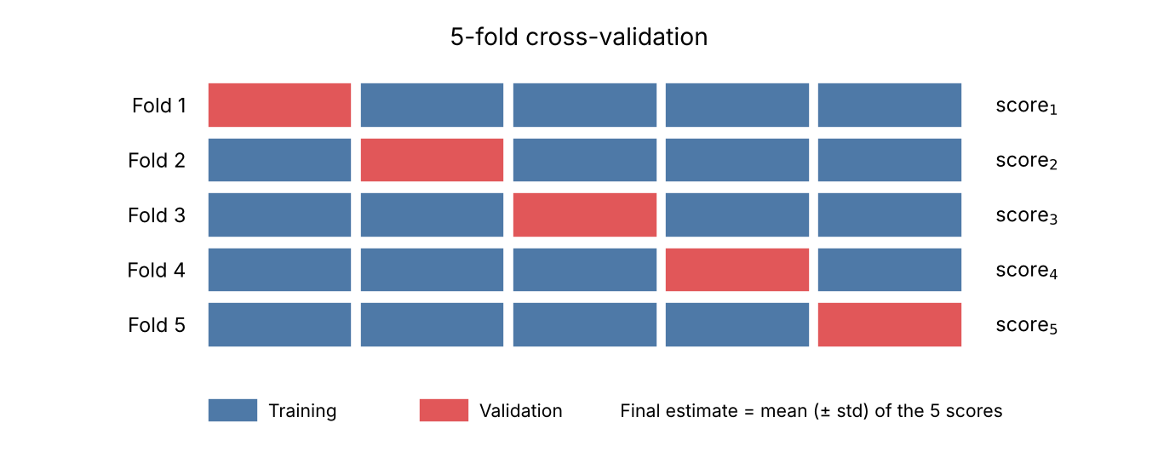
Figure 5: Illustration of 5-fold cross-validation.
from sklearn.model_selection import KFold, cross_val_score
cv = KFold(n_splits=5, shuffle=True, random_state=42)
scores = cross_val_score(model, X, y, cv=cv, scoring="f1")
print(f"F1 = {scores.mean():.3f} ± {scores.std():.3f}")

Choice of k. k = 5 or 10 is the standard compromise: larger k lowers the bias of the estimate (training sets are closer to full size) but increases computation time and the variance of the estimate; smaller k is cheaper but each model sees less data.

3.4 Stratified sampling and stratified k-fold
With random splitting, folds can end up with class proportions that differ from the overall data – a serious problem for imbalanced datasets, where a fold may contain very few (or no) positives. Stratified splitting preserves the class proportions in every fold. scikit-learn applies stratification automatically when cross_val_score is given a classifier and an integer cv, but it is good practice to be explicit.
from sklearn.model_selection import StratifiedKFold
skf = StratifiedKFold(n_splits=5, shuffle=True, random_state=42)
scores = cross_val_score(model, X, y, cv=skf, scoring="f1")

# Several metrics at once, plus training scores to detect overfitting
res = cross_validate(model, X, y, cv=skf, return_train_score=True,
scoring=["accuracy", "precision", "recall", "f1", "roc_auc"])
pd.DataFrame(res).agg(["mean", "std"]).T

Table 9: 5-fold stratified cross-validation – logistic regression (mean ± std)
Metric | Validation folds | Training folds
ACCURACY | 0.974 ± 0.017 | 0.988 ± 0.001
PRECISION | 0.968 ± 0.029 | 0.986 ± 0.003
RECALL | 0.992 ± 0.011 | 0.995 ± 0.002
F1 | 0.979 ± 0.013 | 0.991 ± 0.001
ROC-AUC | 0.995 ± 0.005 | 0.998 ± 0.001

Cross-validation puts the F1 estimate at 0.979 ± 0.013. Comparing validation and training columns shows a small gap of about one percentage point – evidence of a healthy fit with only mild overfitting. Note that the ±0.013 spread gives a realistic sense of uncertainty that a single split cannot.

3.5 Other important validation strategies
Table 10: Additional validation strategies
Technique | How it works | Strengths | Weaknesses / when to use
Repeated (stratified) k-fold | Repeats k-fold with different shuffles and averages all scores | Lower-variance estimate; reveals sensitivity to the split | More computation. Use for small datasets and close model comparisons
Leave-One-Out (LOOCV) | k = n; one sample validates each model | Nearly unbiased; uses almost all data | Very expensive; high variance. Only for very small datasets
Group k-fold | Keeps all rows of a group (patient, user, device) in the same fold | Prevents leakage via correlated samples | Required when rows are not independent
Time-series split | Training window always precedes validation window (expanding or rolling) | Respects temporal order; no look-ahead bias | Fewer training data in early folds. Use for forecasting and any time-dependent data
Bootstrap / out-of-bag | Resample with replacement; evaluate on unsampled rows | Gives confidence intervals; free for random forests (OOB) | Can be optimistic; ~63% unique samples per bootstrap
Nested cross-validation | Inner loop tunes hyper-parameters; outer loop estimates performance | Unbiased estimate when tuning is part of the pipeline | Expensive. Use to compare tuned models fairly
Hold-out with large data | Single split with a large test set | Cheap and adequate when n is huge | Unstable when n is small

from sklearn.model_selection import (RepeatedStratifiedKFold, GroupKFold,
TimeSeriesSplit, LeaveOneOut, GridSearchCV)

# Repeated stratified k-fold (5 folds x 3 repeats)
rskf = RepeatedStratifiedKFold(n_splits=5, n_repeats=3, random_state=42)

# Group-aware splitting (e.g. several rows per patient)
scores = cross_val_score(model, X, y, groups=patient_ids, cv=GroupKFold(n_splits=5))

# Time series: validation data always come after training data
tscv = TimeSeriesSplit(n_splits=5)

# Nested CV: tuning inside, performance estimate outside
grid = GridSearchCV(model, {"clf__C": [0.01, 0.1, 1, 10]}, cv=StratifiedKFold(3), scoring="f1")
outer = cross_val_score(grid, X, y, cv=StratifiedKFold(5, shuffle=True, random_state=0))

3.6 Choosing a validation strategy
Table 11: Which validation method for which scenario?
Scenario | Recommended method | Rationale
Very large dataset (hundreds of thousands of rows or more), costly training | Single hold-out (train/validation/test) | Test set is large enough to be stable; cross-validation would be expensive
Small or medium dataset, i.i.d. rows | Stratified k-fold (k = 5 or 10) + final hold-out test set | Uses data efficiently and quantifies variability
Imbalanced classification | Stratified k-fold (or repeated), metrics such as F1/PR-AUC | Every fold retains minority-class examples
Tiny dataset (< ~100 rows) | Repeated k-fold or LOOCV | Maximises training data and reduces noise from a single partition
Multiple rows per entity (patients, customers) | GroupKFold | Prevents the same entity appearing in train and validation
Time-ordered data (sales, sensors, finance) | TimeSeriesSplit / walk-forward validation | Never trains on the future; mimics deployment
Hyper-parameter tuning and model comparison | Nested CV, or CV for tuning + untouched test set | Prevents optimistic bias from tuning on the evaluation data
Regression with a skewed target | KFold with shuffling (or stratify on target bins) | Ensures similar target distribution in each fold

To illustrate how the choice affects results on our data, Table 12 compares three estimates of the same model's F1-score.
Table 12: Different validation strategies give different views of the same model
Strategy | F1 estimate | Spread | Comment
Single 80/20 hold-out (seed 42) | 0.986 | not available | One number; no information about stability
30 random hold-outs (mean ± std) | 0.984 | ± 0.009 | Range 0.958 – 1.000
5-fold KFold | 0.982 | ± 0.007 | Every sample validated once
5-fold StratifiedKFold | 0.979 | ± 0.013 | Class proportions preserved in every fold

All strategies agree that the model is strong, but only the resampling-based ones tell us how much the estimate could move. Differences between plain and stratified folds are small here because the classes are only moderately imbalanced (63% benign), yet stratification becomes crucial as imbalance increases.

3.7 Preventing data leakage
Data leakage – information from outside the training fold influencing the model – is the most common reason an excellent validation score collapses in production. Typical sources and defences:
- Pre-processing fitted on all data. Scaling, imputation, feature selection or PCA fitted before splitting leaks test statistics into training. Always put pre-processing inside a Pipeline so it is re-fitted within each training fold.
- Target leakage. A feature that encodes the outcome or is only available after the event (e.g. "treatment_outcome" when predicting disease). Review every feature for availability at prediction time.
- Duplicated or near-duplicate rows across splits. De-duplicate before splitting, or group related rows.
- Temporal leakage. Random splitting of time series allows the model to see the future. Use time-ordered splits.
- Repeated peeking at the test set. Limit test-set evaluations to a final confirmation.
# WRONG: scaler sees the whole dataset, including validation folds
X_scaled = StandardScaler().fit_transform(X)
cross_val_score(LogisticRegression(), X_scaled, y, cv=5)

# RIGHT: scaler is re-fitted on the training part of every fold
pipe = Pipeline([("scale", StandardScaler()), ("clf", LogisticRegression())])
cross_val_score(pipe, X, y, cv=5)

4. Detecting Overfitting and Underfitting

4.1 Compare training and validation performance
The quickest diagnostic is to evaluate on both the training and validation data. A large gap signals overfitting; uniformly poor scores signal underfitting. In regression, our Ridge model scored R² = 0.528 on training data and 0.454 on the test set – a small gap, but both are modest, indicating that the model is limited (mild underfitting / limited signal). By contrast, an unconstrained random forest on the same data scored R² = 0.924 on training data but only 0.424 on test data: a textbook case of overfitting.
Table 13: Training vs. test R² for two regression models (Diabetes data)
Model | Train R² | Test R² | Gap | Diagnosis
Ridge regression | 0.528 | 0.454 | 0.073 | Low variance; limited by modest signal in the features
Random forest (300 trees, unconstrained) | 0.924 | 0.424 | 0.500 | Large gap – memorises training data (overfits)

4.2 Validation curves
A validation curve plots training and cross-validated scores while varying one hyper-parameter that controls model complexity. The best setting is where validation performance peaks; to the left the model underfits, to the right it overfits.
from sklearn.model_selection import validation_curve
from sklearn.tree import DecisionTreeClassifier
depths = range(1, 16)
train_s, val_s = validation_curve(
DecisionTreeClassifier(random_state=0), X, y,
param_name="max_depth", param_range=list(depths), cv=skf, scoring="accuracy")
plt.plot(depths, train_s.mean(1), label="Training")
plt.plot(depths, val_s.mean(1), label="Cross-validation"); plt.legend()

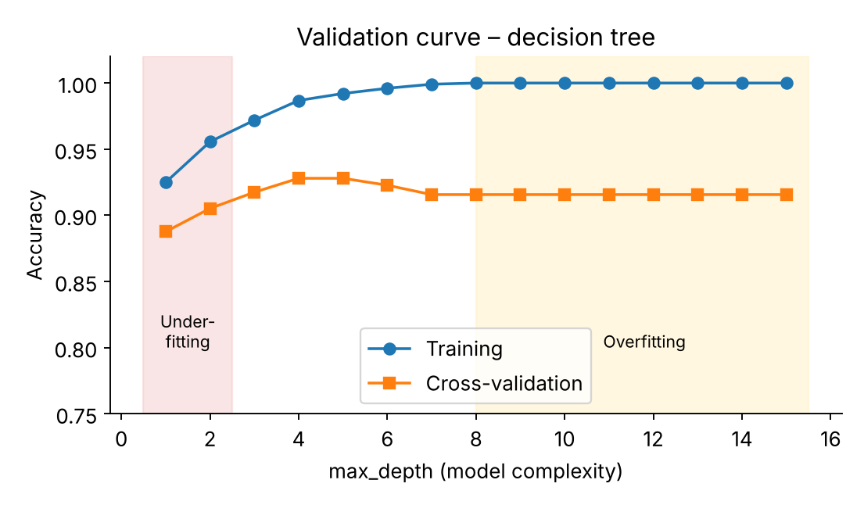
Figure 6: Validation curve for a decision tree on the breast-cancer data.
For a depth-1 tree (a single split) training accuracy is 0.925 and validation accuracy 0.888 – a simple model that underfits. At depth 15, training accuracy reaches 1.000 (perfect memorisation) while validation accuracy is only 0.916. Validation accuracy peaks at depth 4 (0.928), which is the complexity we should select.

4.3 Learning curves
Learning curves plot performance against the amount of training data. They reveal whether collecting more data would help:
- High bias: training and validation curves converge quickly to a low score. More data will not help; use a more expressive model or better features.
- High variance: a persistent gap between a high training curve and a lower validation curve. More data, regularisation or a simpler model should help.
- Good fit: curves converge at a high score with a small gap.
from sklearn.model_selection import learning_curve
sizes, train_s, val_s = learning_curve(model, X, y, cv=skf,
train_sizes=np.linspace(0.1, 1.0, 6), scoring="accuracy")

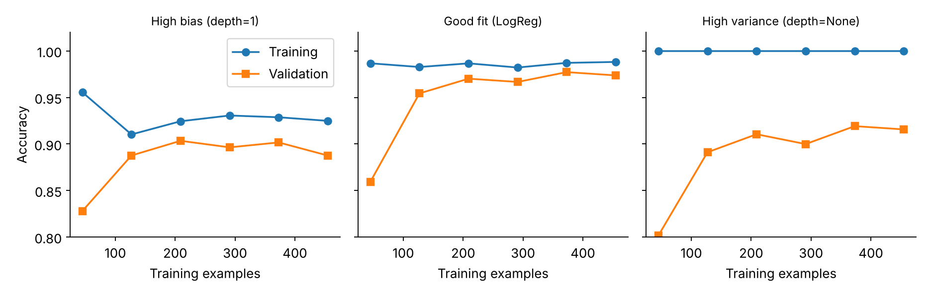
Figure 7: Learning curves illustrating high bias, a good fit, and high variance.

4.4 Remedies
Table 14: Remedies for under- and overfitting
Problem | Remedies
Underfitting (high bias) | Use a more flexible model; add or engineer informative features; reduce regularisation strength; train longer; remove noisy or over-aggressive feature selection
Overfitting (high variance) | Collect more data; apply regularisation (L1/L2, dropout, weight decay); limit model complexity (tree depth, number of features); early stopping; ensembling or bagging; data augmentation; cross-validated hyper-parameter tuning; feature selection

5. Error Analysis
Metrics tell us how much the model is wrong; error analysis tells us where, why and what to do about it. A systematic process turns a disappointing score into a prioritised list of improvements.

5.1 A systematic error-analysis workflow
- Collect the errors. Gather all misclassified (or high-residual) validation samples together with their features, true labels, predictions and confidence.
- Quantify the error types. Use the confusion matrix and per-class metrics to see which mistakes dominate (false positives vs. false negatives; which classes are confused).
- Slice the data. Compute metrics for sub-groups (feature ranges, categories, data sources, time periods, demographic groups) to find where performance collapses.
- Inspect examples manually. Read, view or listen to a sample of errors. Look for label noise, ambiguity, data-quality problems, and recurring patterns.
- Hypothesise causes and rank by impact. Estimate how many errors each cause explains and how hard it would be to fix.
- Fix, re-evaluate, repeat. Change data, features, model or threshold; re-run the same evaluation protocol to confirm improvement.

5.2 Confusion matrix and per-class diagnostics
from sklearn.metrics import ConfusionMatrixDisplay, confusion_matrix

cm = confusion_matrix(y_test, y_pred)
print(cm)

fig, ax = plt.subplots(1, 2, figsize=(9, 3.8))
ConfusionMatrixDisplay.from_predictions(y_test, y_pred, ax=ax[0],
display_labels=["malignant", "benign"])
ConfusionMatrixDisplay.from_predictions(y_test, y_pred, ax=ax[1],
display_labels=["malignant", "benign"], normalize="true")

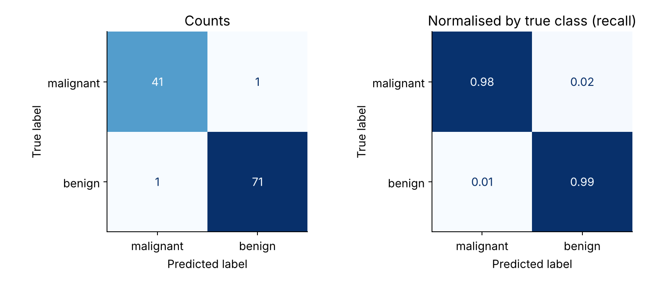
Figure 8: Confusion matrix (left: counts, right: normalised by true class) for the test set.
The matrix shows 41 true negatives (malignant correctly identified), 71 true positives, 1 false positive and 1 false negative – two errors out of 114 cases. In a medical context the two errors are not equal: classifying a malignant tumour as benign (the false positive here, since benign is the positive class) is far more dangerous than the reverse, so such a model might be tuned to favour recall of the malignant class. This is exactly the type of conclusion a raw accuracy figure would not reveal.
Tip: normalise the confusion matrix
Raw counts are dominated by large classes. normalize="true" shows recall per class, normalize="pred" shows precision per class, and for multi-class problems the off-diagonal cells directly reveal which classes are being confused with each other.

5.3 ROC, precision–recall and calibration diagnostics
from sklearn.metrics import RocCurveDisplay, PrecisionRecallDisplay
from sklearn.calibration import calibration_curve

RocCurveDisplay.from_predictions(y_test, y_proba)
PrecisionRecallDisplay.from_predictions(y_test, y_proba)

frac_pos, mean_pred = calibration_curve(y_test, y_proba, n_bins=6)

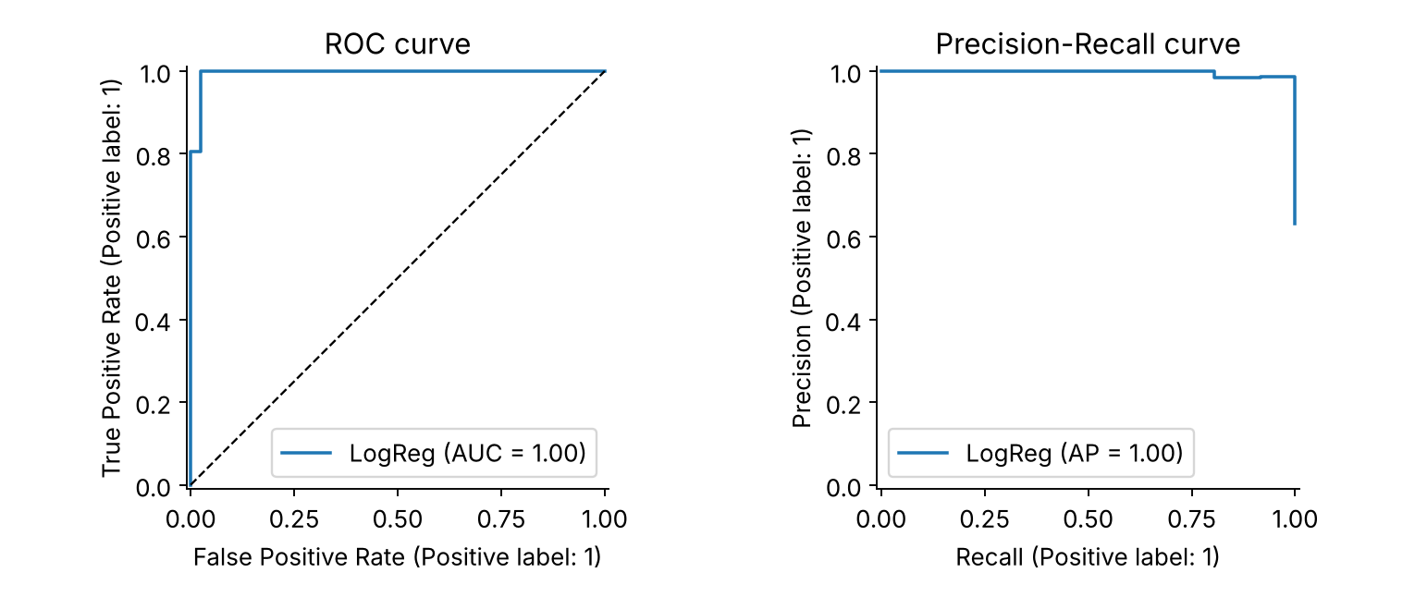
Figure 9: ROC curve and precision–recall curve for the logistic regression model.
A curve hugging the top-left of the ROC plot and the top-right of the PR plot indicates excellent separation. The calibration curve checks whether a predicted probability of, say, 0.8 really corresponds to roughly 80% of cases being positive; points far from the diagonal mean that probabilities should be recalibrated (e.g. with CalibratedClassifierCV) before being used for decisions.
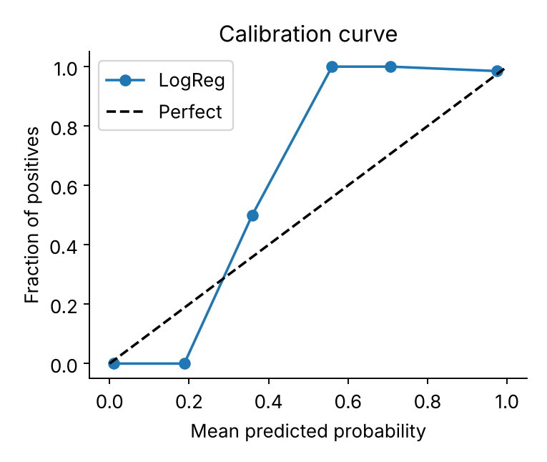
Figure 10: Calibration curve: closeness to the dashed diagonal indicates reliable probabilities.

5.4 Analysing individual errors and confidence
Looking at the model's confidence on its mistakes separates two very different situations: uncertain errors (probability near 0.5 – the sample is borderline, and more features or a threshold change may help) and confident errors (probability near 0 or 1 – often label noise, data leakage in reverse, or a systematic blind spot).
errors = np.where(y_pred != y_test)[0]
err_df = pd.DataFrame(X_test[errors], columns=load_breast_cancer().feature_names)
err_df["true"], err_df["pred"], err_df["p_benign"] = y_test[errors], y_pred[errors], y_proba[errors]
print(err_df.sort_values("p_benign")[["true", "pred", "p_benign"]])

In our test set the two misclassified samples had predicted benign-probabilities of 0.37 and 0.91. The first is a borderline case (the model was unsure), while the second is a confident mistake that deserves manual inspection – for instance to check whether the label is correct or whether the sample is unusual relative to the training data.
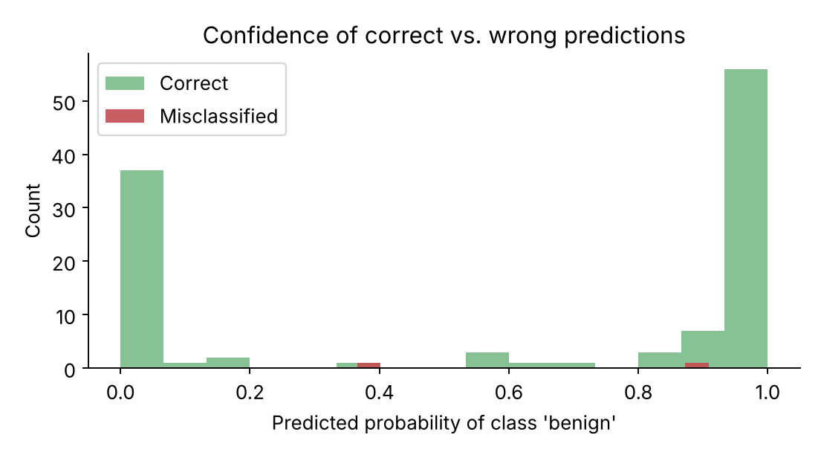
Figure 11: Distribution of predicted probabilities for correct and misclassified samples.

5.5 Slice-based error analysis
Aggregate metrics can hide sub-populations in which the model performs badly. Slicing the test set by a feature (or by categorical groups such as region, device type or customer segment) exposes these weak spots.
quartile = pd.qcut(X_test[:, 0], 4, labels=["Q1", "Q2", "Q3", "Q4"]) # 'mean radius'
slice_err = pd.Series(y_pred != y_test).groupby(quartile).mean()
slice_err.plot.bar(ylabel="Error rate")

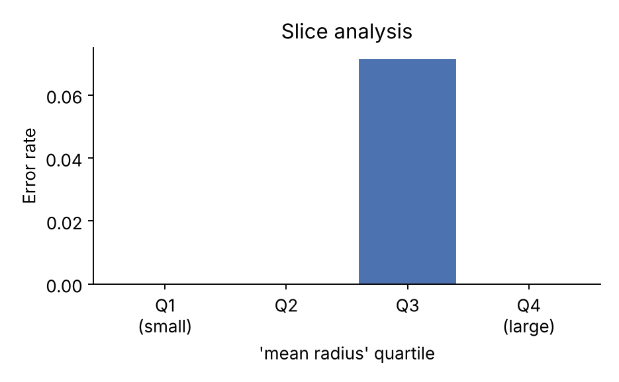
Figure 12: Error rate by quartile of the "mean radius" feature.
Here all errors fall in the third quartile (error rate 7.1% vs. 0% elsewhere). With only two errors this is not statistically conclusive, but in a real project such a pattern would trigger questions: is there something distinctive about samples with intermediate radius, and do we have enough training examples in that region? Always check the sample size of each slice before drawing conclusions.

5.6 Residual analysis for regression
For regression, the residual plots below are the primary diagnostic tools:
- Predicted vs. actual: points should follow the diagonal. Systematic curvature signals missing non-linearity; a flattened slope signals shrinkage towards the mean.
- Residuals vs. predicted: should look like a random cloud around zero. A funnel shape indicates heteroscedasticity (error grows with the target); curved patterns indicate model misspecification.
- Residual histogram / Q-Q plot: should be roughly symmetric and centred on zero; heavy tails indicate outliers.
residuals = yr_te - pred
fig, ax = plt.subplots(1, 3, figsize=(11, 3.5))
ax[0].scatter(pred, yr_te); ax[0].set_title("Predicted vs. actual")
ax[1].scatter(pred, residuals); ax[1].axhline(0, color="k")
ax[2].hist(residuals, bins=15); ax[2].set_title("Residual distribution")

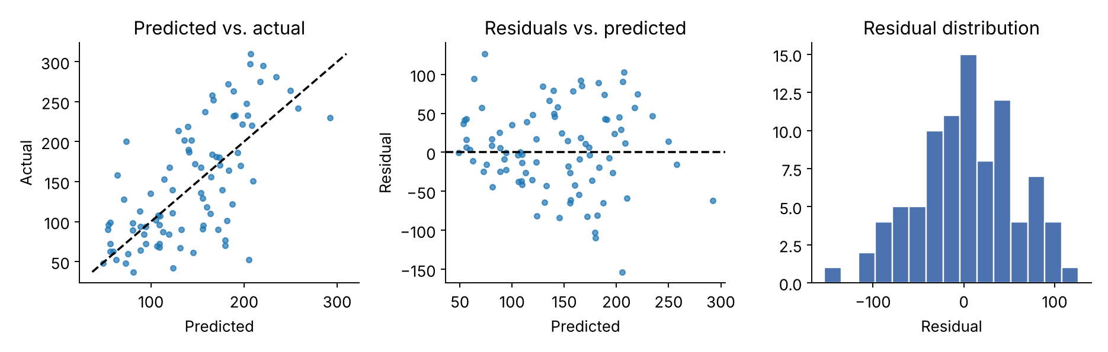
Figure 13: Regression diagnostics for the Ridge model on the Diabetes test set.
The model captures the general upward trend but the spread of residuals is wide (RMSE 53.8 on a target whose standard deviation is about 73), and predictions are compressed towards the middle of the range – typical of a linear model with modest signal. Possible next steps include non-linear features, interaction terms or additional predictors. Cross-validation confirms that this is not a split artefact: 5-fold CV gives RMSE 54.8 ± 2.6 and R² 0.48 ± 0.08.

5.7 Feature-level diagnostics
Understanding which features drive predictions can reveal spurious shortcuts or missing information. Permutation importance measures how much the validation score drops when one feature is randomly shuffled; it is model-agnostic and evaluated on held-out data, which makes it more trustworthy than impurity-based importances.
from sklearn.inspection import permutation_importance
r = permutation_importance(model, X_test, y_test, n_repeats=20,
scoring="f1", random_state=0)
imp = pd.Series(r.importances_mean, index=load_breast_cancer().feature_names)
print(imp.sort_values(ascending=False).head(10))

5.8 Linking symptoms to causes
Table 15: Common causes of model error and how to detect them
Suspected cause | How to detect | Typical remedy
Overfitting | Large train–validation gap; validation curve turns down | Regularise, simplify, more data
Underfitting | Training error also high; learning curves converge low | Richer model or features
Class imbalance | High accuracy but low minority recall; asymmetric confusion matrix | Class weights, resampling, threshold tuning, PR-based metrics
Label noise | Confident errors that look correct on manual review | Re-label, noise-robust loss, remove ambiguous samples
Poor or missing features | Errors concentrated in certain slices; low permutation importance across the board | Feature engineering, additional data sources
Data drift / distribution shift | Performance falls on newer data or a specific source | Re-train on recent data, monitor inputs, domain adaptation
Data leakage | Validation score implausibly high; collapses in production | Pipelines, group/time-aware splits, remove leaking features
Wrong threshold | Good AUC but poor precision or recall at 0.5 | Tune threshold on validation data to business cost
Poorly calibrated probabilities | Calibration curve far from diagonal; high log loss despite good accuracy | Platt scaling or isotonic regression
Outliers / heteroscedasticity (regression) | Residual plots; large errors on extreme targets | Robust loss, transform target, separate models

6. Practical Guidelines and Checklist

6.1 End-to-end evaluation recipe
from sklearn.model_selection import GridSearchCV

# 1. Hold out a test set that is never touched during development
X_dev, X_test, y_dev, y_test = train_test_split(X, y, test_size=0.2,
stratify=y, random_state=42)
# 2. Pipeline: pre-processing + model (prevents leakage)
pipe = Pipeline([("scale", StandardScaler()), ("clf", LogisticRegression(max_iter=5000))])
# 3. Tune and validate with stratified CV on the development data only
grid = GridSearchCV(pipe, {"clf__C": [0.01, 0.1, 1, 10, 100]},
cv=StratifiedKFold(5, shuffle=True, random_state=42),
scoring="f1", return_train_score=True).fit(X_dev, y_dev)
print(grid.best_params_, grid.best_score_)
# 4. Check for over/under-fitting with train vs. validation scores
print(pd.DataFrame(grid.cv_results_)[["param_clf__C","mean_train_score","mean_test_score"]])
# 5. One final, honest evaluation on the untouched test set
best = grid.best_estimator_
print(classification_report(y_test, best.predict(X_test)))
# 6. Error analysis: confusion matrix, ROC/PR, slices, residuals
ConfusionMatrixDisplay.from_estimator(best, X_test, y_test)

6.2 Checklist
- Define success first. Which metric reflects the real objective, and what is the cost of each error type?
- Establish a baseline (majority class, mean, previous model) and report improvement over it.
- Split correctly: stratified for classification, grouped for dependent rows, chronological for time series.
- Wrap pre-processing in a Pipeline so it is learned inside each training fold.
- Use cross-validation for model selection and report mean ± standard deviation.
- Keep the test set untouched until one final evaluation.
- Report several metrics (e.g. precision, recall, F1, PR-AUC, calibration) rather than accuracy alone.
- Check train vs. validation scores, validation curves and learning curves for over/underfitting.
- Tune the decision threshold to business costs instead of defaulting to 0.5.
- Perform error analysis: confusion matrix, confident errors, slices, residuals, feature importance.
- Document and seed everything so results can be reproduced, and monitor performance after deployment.

6.3 Common pitfalls
- Reporting training-set performance as if it were generalisation performance.
- Selecting a model by repeatedly looking at test-set scores.
- Using accuracy on heavily imbalanced data.
- Shuffling time-series data or splitting correlated rows randomly.
- Fitting scalers, imputers or feature selectors on the full dataset before cross-validation.
- Comparing models on a single split and treating a 0.5% difference as meaningful when the fold-to-fold standard deviation is larger.
- Ignoring calibration when probabilities drive decisions.

7. Conclusion
Evaluating a machine learning model is a structured process rather than a single calculation. It begins with defining a problem-appropriate metric, continues with a validation strategy that yields an honest and stable estimate of performance on unseen data, and finishes with error analysis that explains where and why the model fails.
The experiments in this report illustrate the key lessons. On the breast-cancer data, a logistic regression model achieved an F1-score of 0.979 ± 0.013 under stratified 5-fold cross-validation, but a single hold-out split could have reported anything between 0.958 and 1.000. On an imbalanced synthetic problem, a model that never detected a single positive still reached 96.4% accuracy. A random forest on the Diabetes data scored R² = 0.92 on training data but only 0.42 on test data, while validation and learning curves made the bias–variance trade-off visible.
A machine learning engineer who consistently (1) picks metrics that match business cost, (2) validates with leakage-free, stratified or structure-aware resampling, (3) separates tuning from final testing, and (4) investigates errors systematically will build models that are not just accurate on paper but dependable in practice.

References
- Pedregosa, F. et al. (2011). Scikit-learn: Machine Learning in Python. Journal of Machine Learning Research, 12, 2825–2830.
- scikit-learn documentation: Model evaluation – quantifying the quality of predictions (scikit-learn.org/stable/modules/model_evaluation.html).
- scikit-learn documentation: Cross-validation – evaluating estimator performance (scikit-learn.org/stable/modules/cross_validation.html).
- Hastie, T., Tibshirani, R., Friedman, J. (2009). The Elements of Statistical Learning, 2nd ed. Springer. (Chapter 7: Model Assessment and Selection.)
- James, G., Witten, D., Hastie, T., Tibshirani, R. (2021). An Introduction to Statistical Learning, 2nd ed. Springer.
- Géron, A. (2022). Hands-On Machine Learning with Scikit-Learn, Keras and TensorFlow, 3rd ed. O'Reilly.
- Saito, T., Rehmsmeier, M. (2015). The Precision-Recall Plot Is More Informative than the ROC Plot When Evaluating Binary Classifiers on Imbalanced Datasets. PLoS ONE, 10(3).
- Chicco, D., Jurman, G. (2020). The advantages of the Matthews correlation coefficient (MCC) over F1 score and accuracy in binary classification evaluation. BMC Genomics, 21.
- Cawley, G., Talbot, N. (2010). On Over-fitting in Model Selection and Subsequent Selection Bias in Performance Evaluation. JMLR, 11, 2079–2107.

