MACHINE LEARNING ENGINEERING INTERNSHIP
Final Report
An End-to-End Machine Learning Project Lifecycle
Planning, data preparation, model implementation, evaluation and optimisation, consolidated into one analysis
Item | Detail
Project | Customer churn prediction pipeline (IBM Telco Customer Churn schema)
Report type | Final consolidated report: vision, methodology, experiments, outcomes, lessons learned, future work
Built from | Project Plan (Week 1); Data Preprocessing and Feature Engineering Strategy (Week 2); Model Implementation and Code Documentation (Week 3); Model Evaluation and Validation Techniques (Week 4); Model Optimization and Experimentation (Week 5)
Core stack | Python, pandas, NumPy, scikit-learn, Optuna, Hyperopt, pytest, joblib
Estimated effort | 30 to 35 hours
Prepared by | [Your name]
Date | 11 November 2026

Table of Contents

1. Executive Summary 2
2. Project Overview 3
2.1 Vision and problem statement 3
2.2 Objectives and success criteria 3
2.3 Overall strategy 4
2.4 Why this project matters for a Machine Learning Engineer 4
2.5 Evidence base and how to read the results 5
3. Methodology 6
3.1 Data understanding and preprocessing (Week 2) 6
3.2 Feature engineering 6
3.3 Model selection and implementation (Week 3) 7
3.4 Evaluation and validation framework (Week 4) 7
3.5 Optimisation and experimentation (Week 5) 8
3.6 How each component aligns with the project goals 8
4. Experimental Analysis 9
4.1 Preprocessing validation plan (Week 2) 9
4.2 Baseline and model comparison (Week 3) 10
4.3 Decision-threshold analysis (Weeks 3 and 4) 11
4.4 Robustness, errors and debugging (Week 3) 12
4.5 Validation experiments (Week 4) 13
4.6 Optimisation experiments (Week 5) 14
5. Outcomes and Analytical Insights 18
5.1 Consolidated findings 18
5.2 What the results mean for the churn use case 18
5.3 Confidence in each conclusion 18
6. Lessons Learned 20
6.1 Challenges faced and how they were addressed 20
6.2 Methodologies that worked best 20
6.3 What should be done differently 20
7. Recommendations and Future Work 22
7.1 Recommendations for future projects 22
7.2 Improvements to the current approach 22
7.3 Deployment and monitoring plan 23
7.4 Longer-term extensions 23
8. Limitations and Risks 24
9. Conclusion 25
References 25
Appendix A. Deliverables and Artefacts 27
Appendix B. Consolidated Experiment Log 27
Appendix C. Reproducibility Checklist 28

If the page numbers above are blank, right-click the table and choose Update Field.

1. Executive Summary
This report brings together five weeks of work on one machine learning project and presents it as a single, end-to-end account. It follows the project from the original plan, through data preparation and a tested implementation, to evaluation and hyper-parameter optimisation, and finishes with lessons learned and a roadmap for what should happen next.
The use case that was implemented is customer churn prediction: given what a subscription business knows about a customer today, estimate the probability that the customer will cancel, so that a retention team can contact the highest-risk customers first. The chosen primary model is an interpretable, class-weighted logistic regression inside a leak-free scikit-learn pipeline, benchmarked against a majority-class baseline and a random forest challenger.
Three themes run through every stage and are the most important take-aways of the project:
- Process beats cleverness. The largest quality gains came from disciplined preparation, honest baselines, leak-free pipelines and a test set that was touched once, not from more complex algorithms. On the project data the simple logistic regression beat the random forest.
- Reported scores are estimates, and they are optimistic. A single hold-out split could report anything from 0.958 to 1.000 F1 for the same model, and tuning gains measured on the selection folds shrank when measured on held-out data. Nested cross-validation put a number on that optimism (about 1.3 RMSE points).
- Be explicit about the evidence. Different weeks used different data (the real-schema Telco plan, a synthetic Telco-schema sample, and scikit-learn’s bundled datasets). The methods and findings transfer; the absolute numbers do not. Section 2.5 sets this out and every result in this report is labelled with its source.

Table 1: Headline results across the project lifecycle
Stage | Headline result | Data it was measured on
Planning (Week 1) | Six-phase plan, milestones, risk register and success criteria defined before any modelling | Not applicable
Preparation (Week 2) | Hidden missing values (blank TotalCharges for tenure-0 customers) identified; seven-stage leak-free preprocessing design; ablation plan | IBM Telco schema (design; outputs illustrative)
Implementation (Week 3) | 6 modules plus a data generator, 12 of 12 automated tests passing. Logistic regression: CV ROC-AUC 0.787 ± 0.013, test ROC-AUC 0.800, recall 0.676, precision 0.542, F1 0.602 | Synthetic, Telco-schema, 3,000 rows
Evaluation (Week 4) | Single hold-out F1 ranged 0.958 to 1.000 over 30 splits; stratified 5-fold CV gave 0.979 ± 0.013. Accuracy of 96.4% from a model that detects nothing | scikit-learn Breast Cancer, Diabetes; synthetic imbalanced set
Optimisation (Week 5) | Gradient-boosting CV RMSE 60.96 to about 56.6 (7.2%); test RMSE 53.93 to about 53.0 (1.8%). Random search with 30 trials matched a 108-point grid at 28% of the cost | scikit-learn Diabetes, Digits

2. Project Overview

2.1 Vision and problem statement
The vision of the project is to practise machine learning engineering as a complete discipline rather than as model training alone: to take a well-bounded problem and carry it through planning, data preparation, implementation, rigorous evaluation and optimisation, with every step documented, tested and reproducible. The Week 1 plan framed the expected outcome as a trained and validated model wrapped in a reusable pipeline (ingestion, preprocessing, feature extraction, model, evaluation, serving), with documented performance and a concrete plan for deployment and monitoring.
As implemented, the problem is binary classification for subscription churn. A subscription business loses revenue when customers cancel, retention teams can only contact a limited number of customers, and so the model must rank customers by churn probability and allow the business to choose how many to contact. Inputs are 19 raw customer attributes (demographics, tenure, phone and internet services, add-ons, contract, billing method, monthly and total charges) plus one engineered feature. The output is a probability between 0 and 1 and a 0/1 label obtained by applying a decision threshold.
The anticipated difficulties were identified up front: class imbalance (about 26.5% of real Telco customers churn), a numeric column stored as text with hidden blanks, categorical variables that need encoding, and the constant risk of data leakage.
Note on project scope
The Week 1 planning document was written for a different problem, sentiment classification of e-commerce product reviews. Its structure (lifecycle phases, milestones, dependencies, risk register, success-criteria table) was carried forward, but the Week 2 and Week 3 documents state that they continue the plan as a customer churn pipeline, and Weeks 4 and 5 are problem-agnostic. This report therefore treats the churn pipeline as the implemented project and the Week 1 document as the planning framework.
Week 1 targets that are specific to text classification (85% accuracy, 80% macro-F1) were not carried over; they were replaced by the churn success criteria that Week 3 set before implementation (Table 2). If a reader needs the sentiment framing, the same methods apply with TF-IDF or transformer features in place of the tabular preprocessing.

2.2 Objectives and success criteria
Success criteria were set before implementation so that results could be judged against them rather than rationalised afterwards. Table 2 lists them with their status. Criteria that depend on the real Telco file, and the latency target inherited from Week 1, are shown as open rather than assumed met.
Table 2: Success criteria and status at the end of the project
Criterion | Target | Status | Evidence
Ranking quality | CV ROC-AUC clearly above 0.50, aiming for 0.75 or better | Met on synthetic data | 0.787 ± 0.013 CV; 0.800 test (Week 3)
Catching churners | Recall of at least 0.60 at the chosen threshold | Met on synthetic data | 0.676 at threshold 0.5; 0.813 at 0.4
Correctness | All automated tests pass | Met | 12 of 12 passing (Week 3)
Reproducibility | Re-running gives identical results | Met | Seeded; dedicated reproducibility test
Maintainability | Docstrings on every function; one configuration file | Met | config.py, docstrings, type hints
Performance on the real Telco file | Confirm that synthetic-data behaviour carries over | Open | Pipeline is a drop-in replacement; not yet run
Inference latency (Week 1) | Under 200 ms per record on CPU | Not measured | Linear model makes this likely, but no timing was taken
Tuned model on the project data | Apply the Week 5 protocol to the churn model | Open | Week 5 tuned other models and datasets

2.3 Overall strategy
The strategy laid out in Week 1 was a phased, dependency-aware plan: each phase consumes the deliverable of the previous one, feature decisions are frozen before large-scale training, a classical baseline is trained first to establish a performance floor, and evaluation relies on held-out data and error analysis rather than headline accuracy. Figure 1 shows how the weekly deliverables map onto that lifecycle.
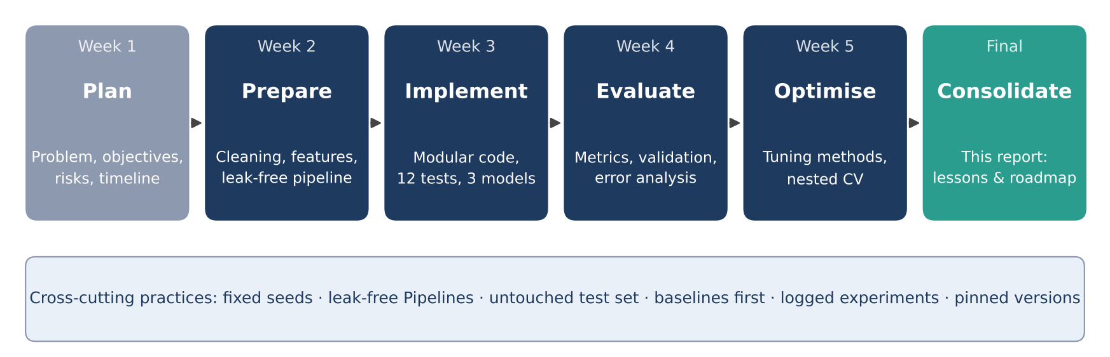
Figure 1: The project lifecycle and the practices that cut across it.
Table 3: Weekly deliverables and the key decision taken in each
Week | Deliverable | Key decision | Why it mattered later
1 | Project plan | Start simple; baseline before advanced model; freeze scope; track risks | Set the success criteria and the “baseline first” habit
2 | Preprocessing and feature strategy | Fill blank TotalCharges with 0.0 only after asserting tenure is 0; fit everything on training data only | Made the pipeline leak-free by design
3 | Implementation and documentation | Logistic regression as primary model, dummy as floor, random forest as challenger | Gave an interpretable model that later weeks could measure against
4 | Evaluation and validation | Stratified CV for selection, one-time test evaluation, metrics matched to error cost | Defined how every later number should be judged
5 | Optimisation and experimentation | Controlled experiments with matched budgets, seeds and nested CV | Quantified how optimistic tuning scores are

2.4 Why this project matters for a Machine Learning Engineer
A data scientist is often judged on the model; a machine learning engineer is judged on whether the model can be trusted, reproduced, maintained and eventually run in production. This project was designed to exercise exactly those responsibilities:
- Owning the whole lifecycle. Decisions in data cleaning change what the model can learn, and decisions in evaluation change what can be believed. Working through every stage shows how the stages constrain one another.
- Building for repetition. Configuration in one file, pinned dependencies, seeded randomness and a single training script mean that a teammate (or a scheduled job) can regenerate any result.
- Verifying, not hoping. Machine learning code fails silently: a bug usually produces a slightly worse model rather than a crash. Unit tests, error-path tests, baseline checks and known-truth recovery exist to catch those failures.
- Communicating uncertainty. Reporting mean ± standard deviation, using nested validation and separating selection data from test data are professional habits that protect stakeholders from over-confident numbers.
- Designing for deployment. A pipeline object that carries its own preprocessing, a prediction module that accepts raw fields, and a monitoring and retraining plan are what turn a notebook result into a service.

2.5 Evidence base and how to read the results
The five source documents used different data, which is normal in a staged programme but must be stated clearly in a consolidated report. Table 4 records what each stage was measured on and how its numbers should be read.
Table 4: Provenance of the results used in this report
Stage | Data | Nature of the numbers | How to read them
Week 1 plan | None | Planning content | Targets and risks, not results
Week 2 strategy | IBM Telco Customer Churn, 7,043 × 21 (design); a small synthetic copy for fault injection | Code and printed outputs labelled illustrative; ablation scores labelled hypothetical placeholders | Shows the intended method and expected direction; replace with measured values on the real file
Week 3 implementation | Synthetic sample with the Telco schema, 3,000 rows, 30.3% churn | Genuine outputs of the delivered code | Proves the pipeline works and recovers a planted rule; not a claim about real Telco performance
Week 4 evaluation | scikit-learn Breast Cancer (569), Diabetes (442), plus a 5,000-row synthetic imbalanced set | Genuine outputs | Demonstrates evaluation methodology; numbers are about those datasets
Week 5 optimisation | scikit-learn Digits (1,797) and Diabetes (442) | Genuine outputs, 3 seeds for stochastic methods | Demonstrates experimental method; numbers are about those datasets

Reading rule for this report
Methodological conclusions (how to validate, how to tune, how much to trust a score) are supported by the experiments and transfer to the churn problem. Absolute performance figures belong to the dataset they were measured on. No number in this report should be quoted as the real-world accuracy of a churn model until the pipeline has been run on the real Telco file.

3. Methodology
This section recaps the methods documented in Weeks 2 to 5 and shows how each component serves the project goals. Detail, code and full tables remain in the individual weekly documents.

3.1 Data understanding and preprocessing (Week 2)
The data strategy was built on four principles: never edit the raw file, make every cleaning change deliberate and logged, fit anything that learns a statistic on training data only, and treat each step as testable software. Because only open data was used, quality was assessed through provenance checks, a data-dictionary comparison, a six-dimension audit (completeness, uniqueness, validity, consistency, accuracy, timeliness) and fault injection on a synthetic copy, in which known defects (10 duplicate rows, 25 missing values, one extreme outlier) are planted to prove that the detection code finds them.
The most instructive finding is the hidden missing value. TotalCharges loads as text because 11 entries are blank strings that isna() does not flag. All 11 belong to customers with a tenure of zero, who have signed up but not yet been billed, so the missingness is structural. The chosen treatment was to fill with 0.0, guarded by an assertion that every affected row has tenure 0. Deleting the rows would remove genuine new customers and median imputation would invent a spending history that does not exist.
Table 5: Data cleaning decisions
Issue | Action | Rationale
TotalCharges stored as text, blank for tenure-0 customers | Convert to float; fill with 0.0 after asserting tenure is 0 | Structural missingness: new customers have no billing history
Duplicate rows or customer IDs | Drop on customerID and log the count | Prevents leakage across the split and inflated sample size
Extreme numeric values | Keep; cap only if a model proves sensitive | High charges belong to valid customers with many services
Redundant labels (“No internet service”, “No phone service”) | Merge into “No” | Same meaning once the parent service is known; fewer sparse columns
customerID | Drop before modelling | No predictive meaning; invites memorisation

3.2 Feature engineering
Week 2 specified a rich feature strategy: six engineered features that encode churn hypotheses, a Yeo-Johnson transform for the skewed TotalCharges, ordinal encoding for Contract, one-hot encoding for nominal variables, standard scaling, three ways of handling imbalance, a three-family feature-selection plan and a considered decision to use PCA for visualisation only. Week 3 implemented the core of this and deliberately left the rest for later. Table 6 compares plan and implementation, which is itself a useful integration check.
Table 6: Feature engineering: Week 2 plan versus Week 3 implementation
Technique | Week 2 plan | Week 3 implementation
Engineered features | avg_monthly_spend, charge_delta, n_services, has_streaming, auto_pay, tenure_group | n_services only
Skew handling | Yeo-Johnson on TotalCharges | Implemented
Encoding | Ordinal for Contract; one-hot (drop if binary) for the rest; handle_unknown=“ignore” | Implemented
Scaling | StandardScaler, RobustScaler as experiment | StandardScaler
Class imbalance | class_weight, SMOTE inside pipeline, threshold tuning | class_weight=“balanced”; threshold analysed; SMOTE not used
Feature selection | Filter, embedded and RFECV methods; about 38 down to about 30 features | Not implemented; 25 model features
PCA | Visualisation and optional experiment only | Not implemented
Leakage prevention | Split first; everything learned lives in a Pipeline | Implemented and tested

3.3 Model selection and implementation (Week 3)
Seven common algorithms for tabular binary classification were compared on interpretability, probability output, data size, speed and maintainability. Logistic regression was chosen as the primary model because retention managers need reasons as well as scores, it outputs native probabilities for ranking and thresholding, it suits a few thousand rows, and it has few hyper-parameters. Its central hypothesis is that the log-odds of churn is a linear combination of the features, so each feature pushes risk up or down by a fixed amount. A majority-class dummy classifier acts as a sanity floor (its ROC-AUC is exactly 0.50), and a random forest acts as a challenger that tests whether non-linear structure is being missed. Gradient boosting was planned for later.
The code is organised as a small package so it can be imported by tests, scheduled jobs and a future service. Design principles were single responsibility per module, configuration instead of constants, leak-free construction, fail-fast validation with actionable messages, never mutating inputs, and one seed with pinned versions.
Table 7: Modules in the delivered code base
Module | Responsibility
config.py | All paths, column names, seeds and tunable values in one place
data.py | Loading, input validation and row-wise cleaning, including the tenure-0 guard
features.py | Feature creation and the unfitted preprocessing ColumnTransformer
model.py | Model factory (dummy, logistic regression, random forest) and evaluation metrics
train.py | Split, cross-validate on training data, evaluate once on test data, save model and metrics
predict.py | Load the saved pipeline and score individual customers from raw fields
make_sample_data.py | Generate a synthetic dataset with the Telco schema and a known churn rule
tests/test_pipeline.py | 12 unit, error-path, integration, sanity, reproducibility and robustness tests

3.4 Evaluation and validation framework (Week 4)
Week 4 turned evaluation into a protocol. The core rules are: define success and the cost of each error type first; establish a baseline; use stratified splits for classification; keep all preprocessing inside a Pipeline; use cross-validation for selection and report mean ± standard deviation; keep the test set untouched until one final evaluation; report several metrics rather than accuracy alone; tune the decision threshold to business cost; and perform systematic error analysis.
For churn, where the positive class is the minority and a missed churner costs more than a wasted call, the headline metrics are ROC-AUC and PR-AUC for ranking quality, with recall, precision and F1 reported at the chosen threshold. The diagnostics used were train-versus-validation gaps, validation and learning curves, the confusion matrix, confidence analysis of errors, slice-based analysis and calibration checks.

3.5 Optimisation and experimentation (Week 5)
Week 5 treated tuning as a controlled experiment. Seven research questions were stated with hypotheses, and five experiments tested them. Everything not under study was held constant: one fixed 80/20 split, the same shuffled 5-fold CV for every configuration, fixed estimator seeds, matched budgets (30 trials for random, Optuna and Hyperopt versus a 108-point grid), a single CPU core for comparable timings, and three seeds for each stochastic method.
Table 8: Optimisation methods compared in Week 5
Method | How it works | Strength | Limitation
Grid search | Evaluates every combination in a manual grid | Exhaustive and deterministic; good for 1 to 3 parameters | Cost grows exponentially; wastes trials on unimportant parameters
Random search | Samples configurations independently from distributions | Strong default; anytime; scales to many parameters | Uninformed; varies with seed
Bayesian (TPE) | Builds a surrogate of past trials to choose the next one | Efficient for costly models and conditional spaces | Sequential; little gain on cheap problems
Successive halving | Starts many candidates on a small budget and discards losers | Cuts cost when early scores predict final scores | Needs a meaningful budget axis
Nested CV | Inner loop tunes, outer loop measures | Unbiased estimate of the whole tuning procedure | Expensive

3.6 How each component aligns with the project goals
Table 9: Alignment of methodology to project goals
Project goal | Component that serves it | Key technique | Evidence in this report
Reliable, honest performance estimates | Evaluation framework (Week 4) | Stratified CV, untouched test set, mean ± std | Tables 15 and 16; Section 4.5
Clean, reproducible data pipeline | Preprocessing strategy (Week 2); implementation (Week 3) | Pipeline and ColumnTransformer, fixed seeds, pinned versions | Reproducibility test; Section 4.2
Interpretable model for retention staff | Model selection (Week 3) | Logistic regression coefficients; known-truth check | Figure 5; Section 4.2
Business-relevant decisions | Threshold analysis (Weeks 3 and 4) | Precision-recall trade-off; cost-based threshold | Table 13; Section 5.2
Defensible improvement over defaults | Optimisation (Week 5) | Matched budgets, nested CV, importance analysis | Tables 17 and 18; Section 4.6
Maintainable, extensible code | Workflow documentation (Week 3) | Docstrings, config module, tests, Git conventions | Section 3.3; Appendix A

4. Experimental Analysis
This section presents the experiments in the order they were run. Each subsection states the question, the setup, the result and what it means. Charts either reproduce figures from the weekly documents or were drawn for this report from the tabulated values in those documents.

4.1 Preprocessing validation plan (Week 2)
Week 2 proposed an ablation experiment: add one preprocessing step at a time and record the cross-validated ROC-AUC, keeping a step only if it improves or stabilises the score. This is the right way to justify preprocessing with evidence instead of convention. The scores in Table 10 are placeholders written to fix the format and the expected direction of change; they were not measured, and they are included here because the design is part of the methodology.
Table 10: Planned ablation of preprocessing steps (placeholder values, not measured)
Config | Description | ROC-AUC (placeholder) | Decision rule
A | Numeric columns only, no scaling | 0.780 | Baseline
B | A + clean TotalCharges | 0.790 | Keep if score improves or stays equal
C | B + one-hot and ordinal encoding | 0.830 | Keep: unlocks categorical signal
D | C + scaling and Yeo-Johnson | 0.840 | Keep: stabilises linear models
E | D + engineered features | 0.845 | Keep features adding at least 0.002
F | E + feature selection | 0.845 | Keep if equal score with fewer features
H | E + PCA (95% variance) | 0.835 | Reject if accuracy or interpretability drops
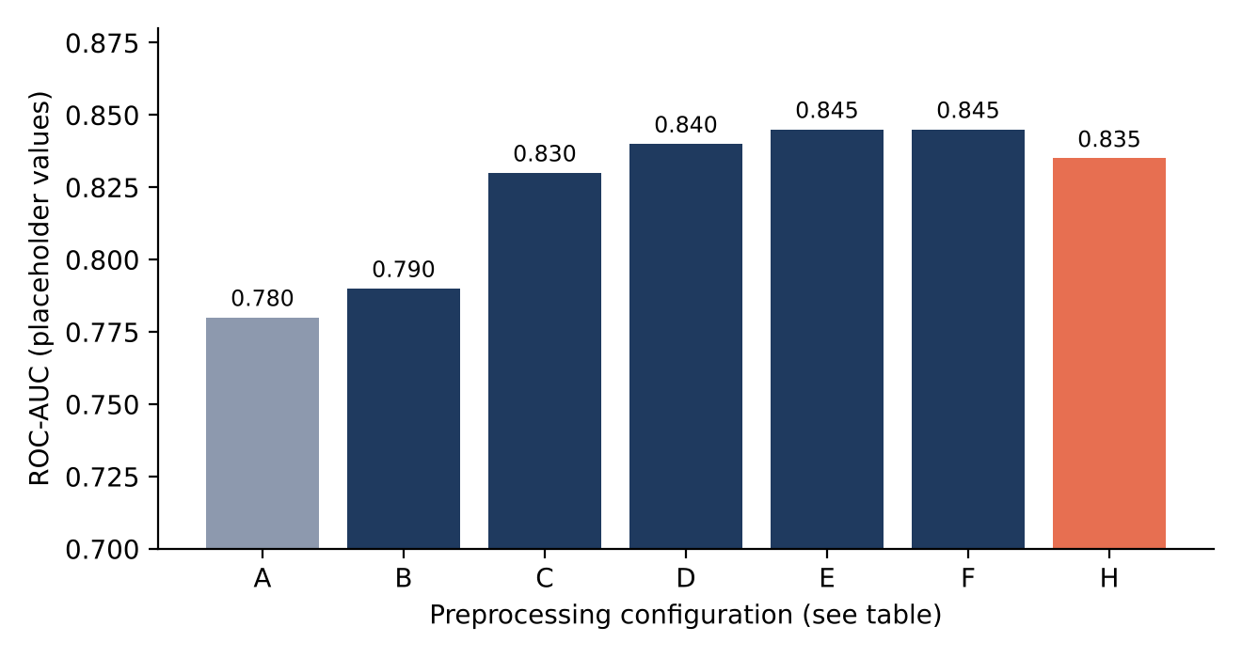
Figure 2: Expected direction of change in the Week 2 ablation plan. Values are placeholders to be replaced by measurements on the real data.
The only comparison in the Week 2 document that is described with measured-style outputs is the baseline-versus-pipeline check (ROC-AUC 0.791 versus 0.845), and that too is labelled illustrative. The practical conclusion is that the ablation, together with the Week 3 test suite, should be the first thing run on the real Telco file.

4.2 Baseline and model comparison (Week 3)
Question. Does a simple, interpretable model learn real structure, and does a more complex model add anything? Setup. 3,000 synthetic customers with the Telco schema, a stratified 80/20 split (2,400 training and 600 test rows), three models compared by 5-fold stratified CV on the training data only, and the chosen model evaluated once on the test set. The data were generated from a known rule, so the model’s coefficients can be checked against the truth.
Table 11: Model comparison on synthetic Telco-schema data (precision, recall and F1 at threshold 0.5)
Model | CV ROC-AUC | Test ROC-AUC | Test PR-AUC | Precision | Recall | F1
Dummy baseline | 0.500 ± 0.000 | 0.500 | n/a | 0 | 0 | 0
Logistic regression | 0.787 ± 0.013 | 0.800 | 0.636 | 0.542 | 0.676 | 0.602
Random forest | 0.774 ± 0.007 | 0.777 | 0.583 | 0.551 | 0.626 | 0.586
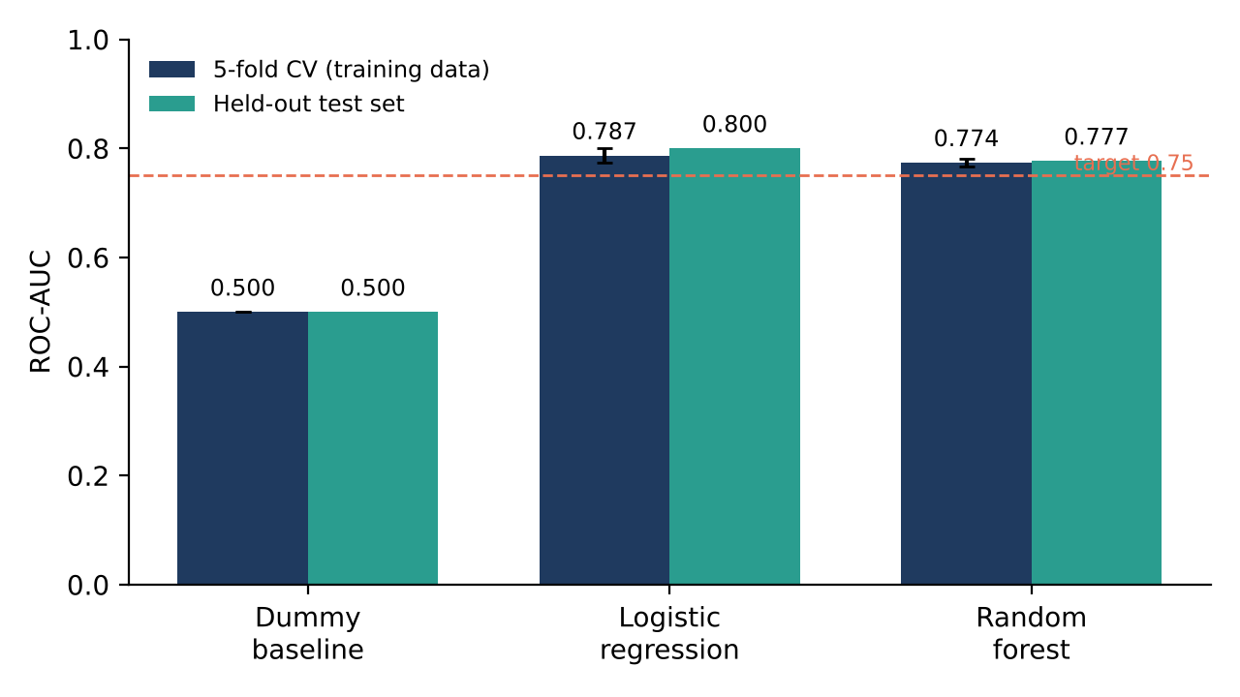
Figure 3: Cross-validated and test ROC-AUC for the three models, with the Week 3 target of 0.75.
Logistic regression was best on every ranking metric and trained about ten times faster than the forest (0.3 s versus 3.1 s for cross-validation). That the simpler model won is expected on a small tabular dataset with mostly additive effects, and the generator’s rule is additive by design, so this result supports the model choice for this data without proving it for real data. The gap between the two models (0.013 AUC) is about one fold-to-fold standard deviation, which Week 4 warns is too small to treat as decisive.
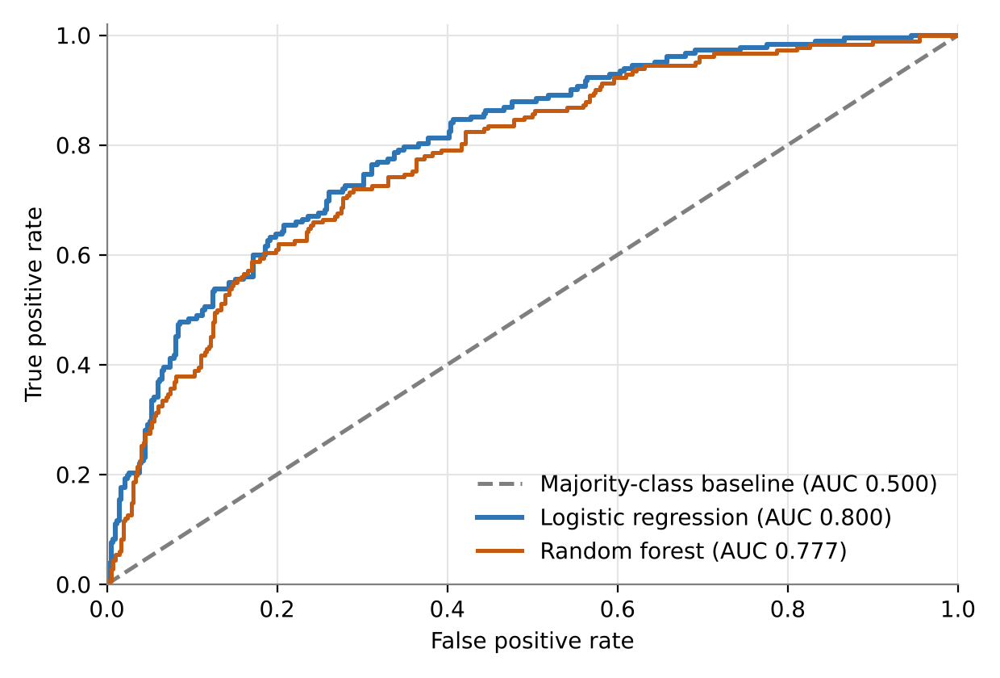
Figure 4: ROC curves on the held-out test set for the baseline, logistic regression and random forest (from Week 3).
Table 12: Confusion matrix for logistic regression on the 600-customer test set
 | Predicted: stays | Predicted: churns | Total
Actual: stays | 314 (true negatives) | 104 (false positives) | 418
Actual: churns | 59 (false negatives) | 123 (true positives) | 182
Total | 373 | 227 | 600
Of the 182 customers who actually churned, the model found 123 (recall 67.6%). Of the 227 customers it flagged, 123 really were churners (precision 54.2%), so about 46% of retention calls would go to customers who were not leaving.

Known-truth check
Because the data were generated from a hidden rule, the fitted coefficients can be compared with it. The rule raised churn risk for month-to-month contracts, short tenure, fibre internet and electronic-cheque payment, and ignored features such as online backup and phone service. The model recovered that pattern: the largest coefficients were Contract (−1.10), tenure (−0.78), fibre optic (+0.79) and electronic cheque (+0.44), while features the generator never used had small coefficients. A pipeline that cannot recover a planted signal cannot be trusted on real data, so this check is a strong test of correctness even though it says nothing about real-world accuracy.
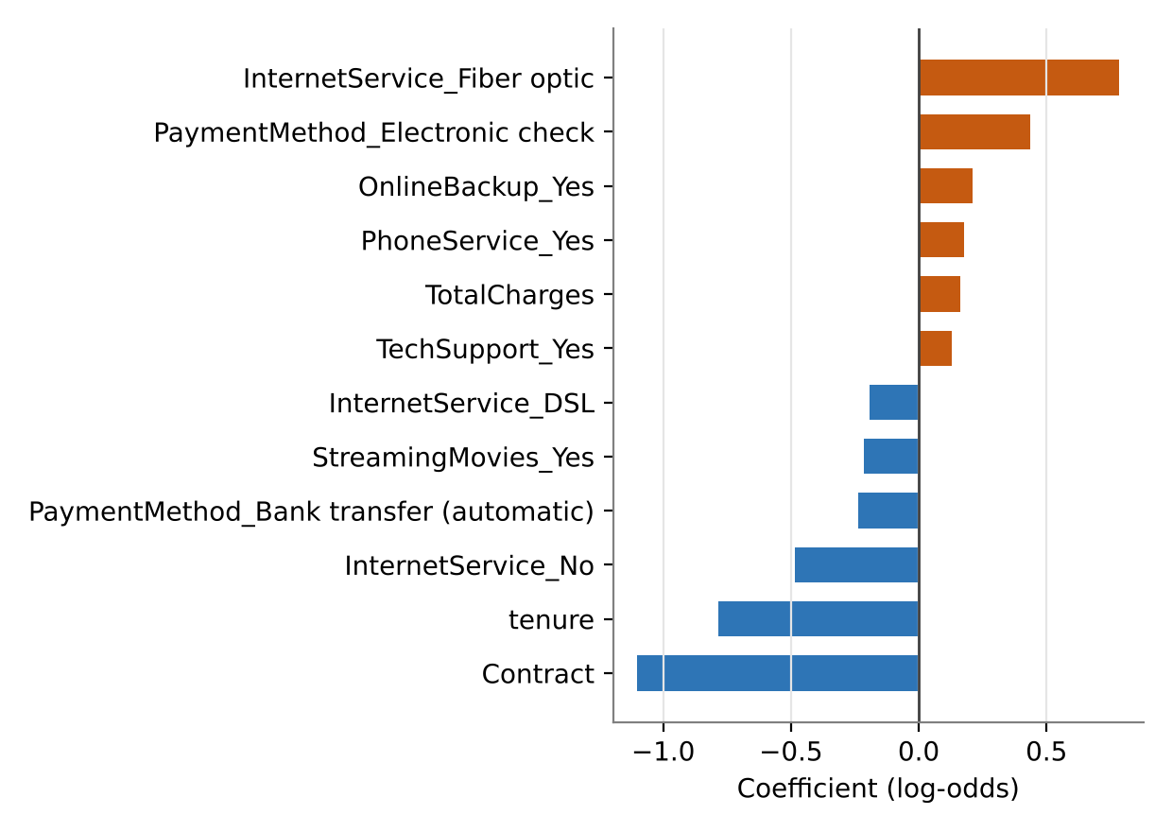
Figure 5: The twelve largest logistic regression coefficients (from Week 3). Positive values raise predicted churn risk.
Two cautions apply. Small coefficients on unrelated features (for example OnlineBackup_Yes at +0.21) are sampling noise, and coefficients on real data describe associations, not causes.

4.3 Decision-threshold analysis (Weeks 3 and 4)
A 0.5 threshold is a default, not a business decision. Lowering it flags more customers (higher recall, lower precision); raising it flags fewer, more certain ones. Table 13 shows the sweep from Week 3.
Table 13: Precision, recall and F1 at different thresholds (synthetic test set)
Threshold | Precision | Recall | F1 | Reading
0.3 | 0.428 | 0.885 | 0.577 | Catch almost every churner, many false alarms
0.4 | 0.474 | 0.813 | 0.599 | Strong recall; reasonable for cheap retention offers
0.5 | 0.542 | 0.676 | 0.602 | Default; best F1 in this sweep
0.6 | 0.599 | 0.599 | 0.599 | Precision and recall equal
0.7 | 0.694 | 0.423 | 0.526 | Few high-confidence flags; many churners missed
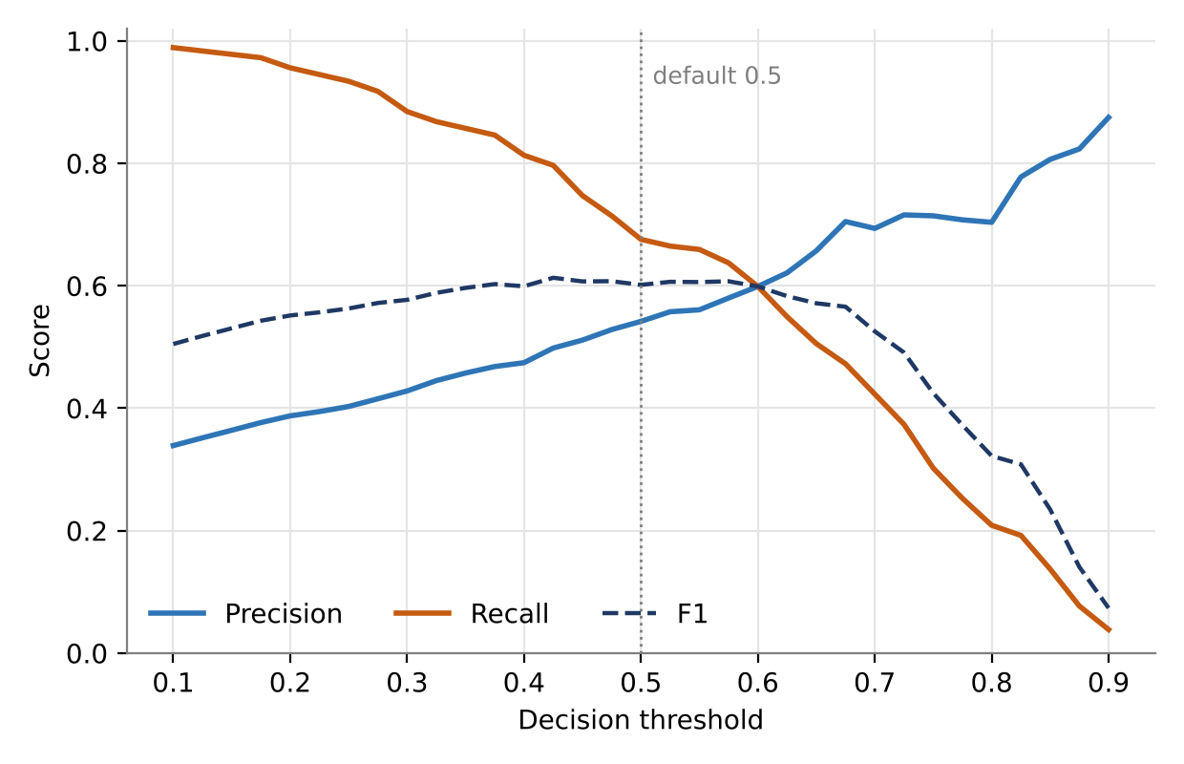
Figure 6: Precision, recall and F1 against the decision threshold (from Week 3).
F1 is nearly flat between 0.4 and 0.6, so the choice should be driven by cost. One methodological point deserves emphasis: this sweep was computed on the test set. It is useful for illustration, but Week 4’s protocol is clear that thresholds should be chosen on validation data, otherwise the test set quietly becomes a second validation set. In the next iteration the threshold should be chosen from cross-validated predictions and only then confirmed once on the test set.

Learning curve
Table 14: Test ROC-AUC against training-set size (Week 3)
Training fraction | Training rows | Test ROC-AUC
25% | 600 | 0.778
50% | 1,200 | 0.787
75% | 1,800 | 0.794
100% | 2,400 | 0.800
The score rises smoothly and has not fully flattened, so more data would still help and there is no sign of severe overfitting, which would appear as a falling test score. This is consistent with a regularised linear model.

4.4 Robustness, errors and debugging (Week 3)
The test suite covered six levels: unit tests, error paths, integration, machine-learning sanity checks, reproducibility and robustness. All 12 tests passed in about 1.3 seconds. The single warning in the run was scikit-learn reporting that it had encoded an unseen payment method as zeros, which is exactly the behaviour the robustness test expects. Deliberately injected faults produced actionable messages, for example a missing file names the command that creates sample data, and blank TotalCharges for a customer with tenure above zero raises an error instead of being silently filled. Together with a troubleshooting table (symptom, likely cause, fix) these make failures cheap to diagnose.

4.5 Validation experiments (Week 4)
Week 4 asked how far a single reported number can be trusted. Four experiments answered that question.

A single hold-out score is unstable
The same logistic regression was evaluated on 30 different random 80/20 splits of the Breast Cancer data. F1 ranged from 0.958 to 1.000 (mean 0.984, standard deviation 0.009) purely because of how the split fell.
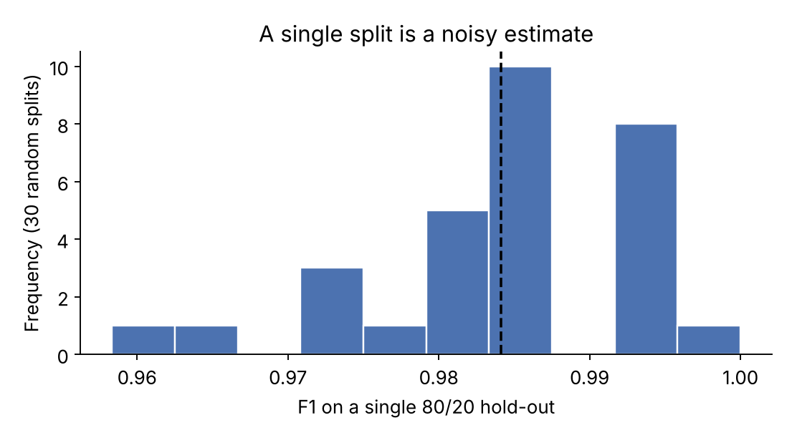
Figure 7: Distribution of F1 across 30 random hold-out splits (from Week 4).
Table 15: Different validation strategies give different views of the same model (F1, Breast Cancer data)
Strategy | F1 estimate | Spread | Comment
Single 80/20 hold-out (seed 42) | 0.986 | not available | One number; says nothing about stability
30 random hold-outs | 0.984 | ± 0.009 | Range 0.958 to 1.000
5-fold KFold | 0.982 | ± 0.007 | Every sample validated once
5-fold StratifiedKFold | 0.979 | ± 0.013 | Class proportions preserved in every fold

Overfitting and underfitting are visible in the gaps
Table 16: Training versus test R² for two regression models (Diabetes data)
Model | Train R² | Test R² | Gap | Diagnosis
Ridge regression | 0.528 | 0.454 | 0.073 | Low variance; limited by modest signal
Random forest (300 trees, unconstrained) | 0.924 | 0.424 | 0.500 | Large gap: memorises training data
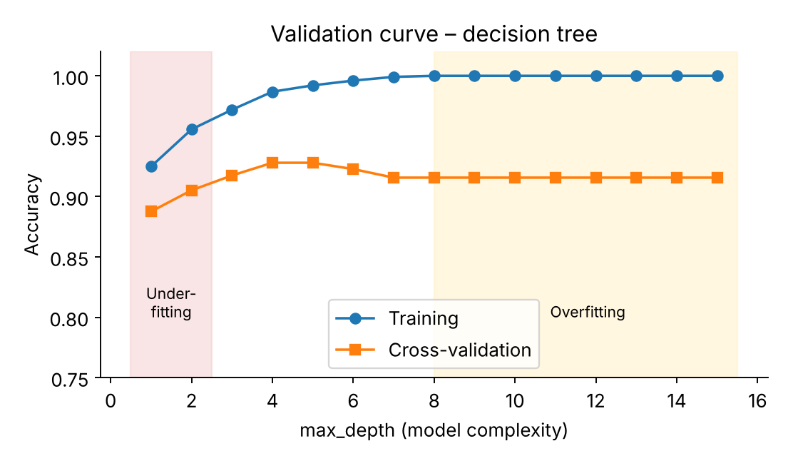
Figure 8: Validation curve for a decision tree (from Week 4). Validation accuracy peaks at depth 4 (0.928) while training accuracy reaches 1.000 at depth 15.

Accuracy can hide total failure
On a synthetic dataset with only 3.6% positives, a model that always predicts “negative” scored 96.4% accuracy and detected nothing (recall 0). A class-weighted random forest reached 97.4% accuracy but only 0.267 recall; its ROC-AUC of 0.903 looked reassuring while its PR-AUC of 0.673 showed how quickly precision falls as recall rises. For churn, with a 26.5% minority class, the effect is milder but the lesson is identical: report recall, precision, PR-AUC and the confusion matrix, not accuracy alone.

Leakage is prevented structurally
Week 4 reduced leakage prevention to one rule: put every learned step inside a Pipeline so cross-validation refits it in each training fold. This rule was already built into the Week 3 code, and it is the reason the Week 3 cross-validation numbers can be trusted.

4.6 Optimisation experiments (Week 5)

E1: the landscape of an SVM
A 9 × 9 grid over C and gamma (81 configurations, 28 s) on the Digits data showed two things. First, tuning did not beat a sensible default: the default scaled RBF-SVM reached 98.1% CV accuracy and 97.5% test accuracy, and the grid optimum (C = 3.16, gamma = 0.0133) reached 98.1% and 98.1%. The 0.6-point test difference is about two images out of 360, which is noise. Second, the landscape is highly uneven: accuracy ranged from 10.4% to 98.1% and only 26% of the grid lay within one point of the best. Tuning therefore acts mainly as insurance against bad regions, and the diagonal ridge in the heat-map shows an interaction between C and gamma that a one-parameter-at-a-time search would miss.
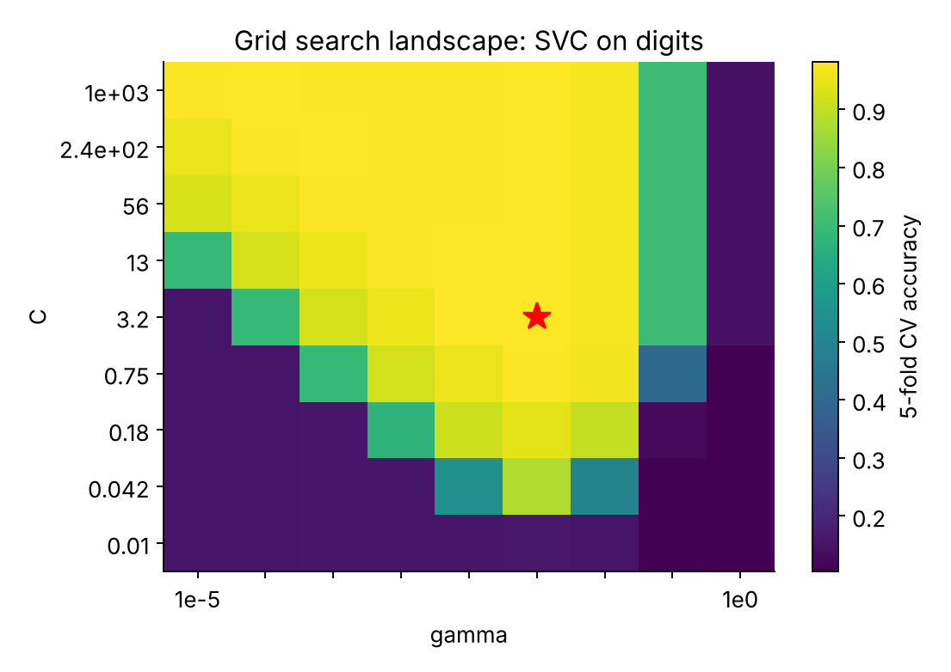
Figure 9: Cross-validated accuracy over the (C, gamma) grid; the star marks the best cell (from Week 5).

E2: comparing search strategies
A gradient-boosting regressor on the Diabetes data was tuned with five strategies under matched conditions. Table 17 reports CV RMSE (used for selection), test RMSE (held out) and cost.
Table 17: Search strategies on the Diabetes data (RMSE; mean over 3 seeds where stochastic)
Strategy | Trials | Best CV RMSE | Std (seeds) | Test RMSE | Std (seeds) | Time (s)
Default settings | 1 | 60.96 | n/a | 53.93 | n/a | <1
Grid search | 108 | 56.67 | n/a | 51.51 | n/a | 110
Random search | 30 | 56.59 | ± 0.10 | 52.98 | ± 0.75 | 29
Optuna (TPE) | 30 | 56.40 | ± 0.34 | 53.02 | ± 1.07 | 26
Hyperopt (TPE) | 30 | 56.60 | ± 0.32 | 52.10 | ± 0.46 | 29
Successive halving | 59 (mixed) | 56.52 | 1 run | 52.33 | 1 run | 19
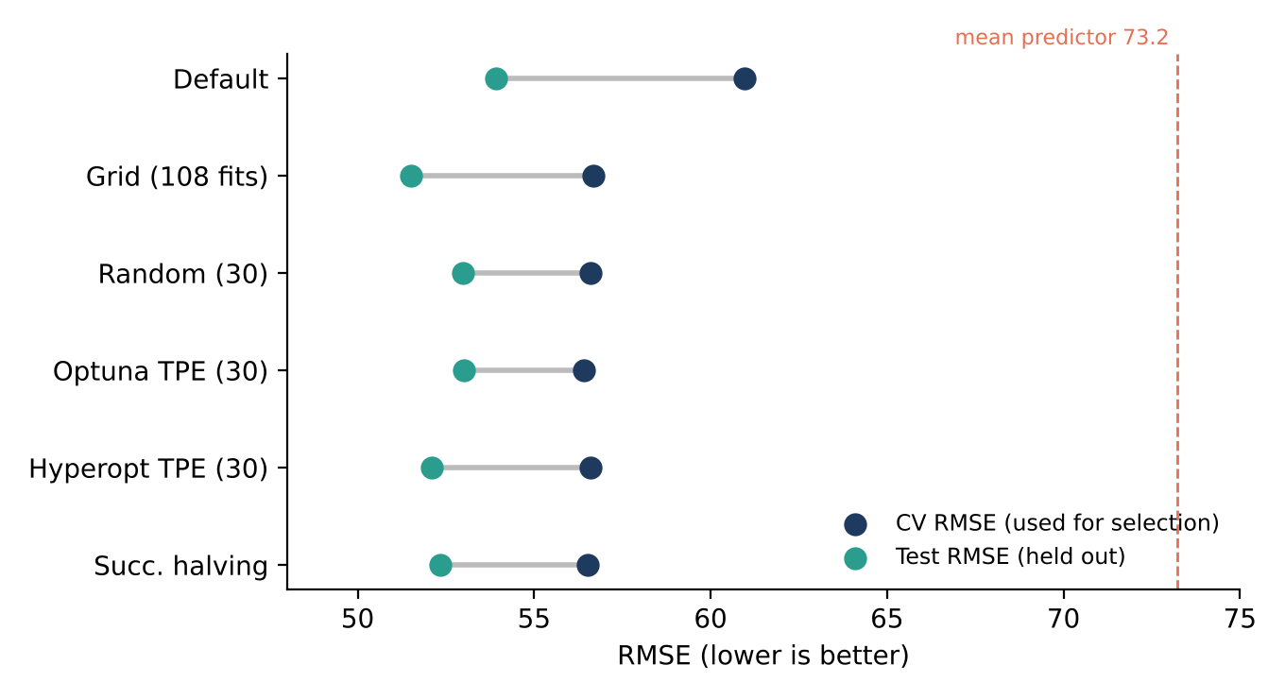
Figure 10: CV RMSE (selection) and test RMSE (held out) for each strategy. A mean predictor scores 73.2.
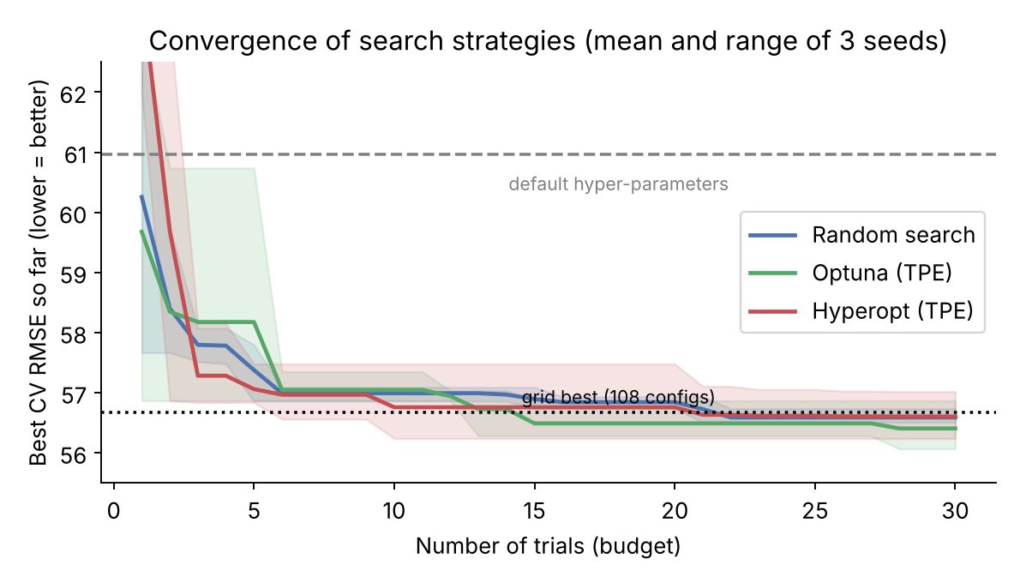
Figure 11: Best CV RMSE found as a function of the number of trials (from Week 5).
- Tuning helped on this model. Every method cut CV RMSE from 61.0 to about 56.4 to 56.7 (7.0% to 7.5%) and test RMSE from 53.93 to between 51.51 and 53.02 (1.8% to 4.5%).
- Random search matched grid search at 28% of the cost. Thirty random trials reached 56.59 against 56.67 for 108 grid fits, because the good region (low learning rate, shallow trees, strong leaf regularisation) is wide.
- Bayesian methods were competitive, not dominant. Optuna had the lowest mean CV RMSE, but the differences between Optuna, Hyperopt and random search (at most 0.2) were smaller than the seed-to-seed spread, so no ranking can be claimed from three seeds.
- Successive halving matched quality in about 63% of the random-search time, a small saving here that becomes decisive when one evaluation takes minutes or hours.

E3: how optimistic is the tuning score?
For every tuned model the CV RMSE (about 56.6) was higher than the test RMSE (about 53.0). That is a property of this particular 89-row test set, which happens to be easier than the training folds; the default model shows the same pattern. The informative comparison is relative: the improvement over default was 7.2% on the selection folds but only 1.8% to 4.5% on the test set, so part of the CV gain is selection bias. Nested cross-validation measured it directly: the whole procedure “random search with 15 trials” scored RMSE 57.92 ± 2.56, against 56.59 reported by flat CV for the winning configuration, an optimism of about 1.3 RMSE points. The fold-to-fold range (54.5 to 60.8) is itself a warning that small score differences on a dataset this size are not trustworthy.
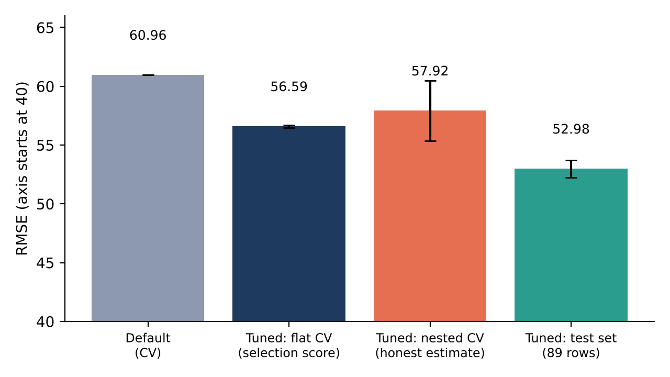
Figure 12: Four estimates of RMSE for the same tuning exercise. The nested-CV bar is the honest estimate of the procedure; error bars show standard deviation.

E4: which hyper-parameters matter?
A fANOVA importance analysis on an Optuna study showed that three of five parameters carry most of the effect: min_samples_leaf (31%), max_depth (28%) and learning_rate (28%) together explain about 87% of the variation in CV score, while n_estimators contributes only 3%. This low effective dimensionality is why random search is efficient. Grid search and Optuna selected different details (for example learning rate 0.01 versus 0.05, depth 2 versus 1) but agreed on the pattern: very shallow trees, a small learning rate and strong leaf regularisation, which signals a noisy problem that needs heavy regularisation.
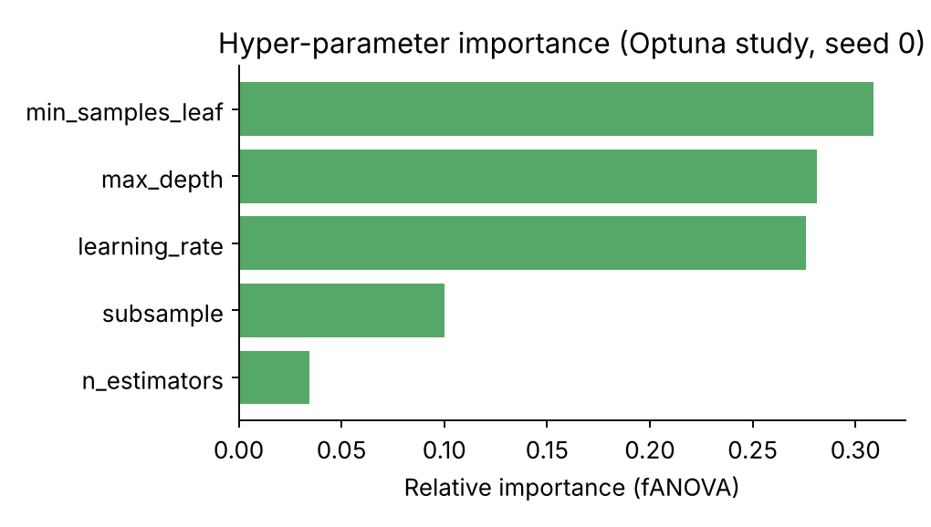
Figure 13: fANOVA importance of each hyper-parameter in an Optuna study (from Week 5).

Verdicts on the research questions
Table 18: Outcome of each Week 5 research question
ID | Result | Verdict
RQ1 Tuning versus defaults | CV RMSE fell from 61.0 to about 56.6 (7.2%); test RMSE from 53.9 to about 53.0 (1.8%). On the SVM there was no CV gain over a strong default | Supported for boosting; model-dependent
RQ2 Random versus grid | 30 random fits reached the 108-fit grid optimum within 0.1 RMSE | Supported
RQ3 Bayesian versus random | Optuna slightly better, Hyperopt equal to random; differences within seed noise | Not conclusive
RQ4 Is the CV score honest? | Flat CV was optimistic by about 1.3 RMSE against nested CV; relative gains shrank on the test set | Supported
RQ5 Which parameters matter? | Three of five carry about 87% of importance | Supported
RQ6 Multi-fidelity search | Halving matched quality at about 63% of random-search time | Supported (small effect here)
RQ7 SVM sensitivity | Accuracy ranged from 10.4% to 98.1% across the grid | Supported

5. Outcomes and Analytical Insights

5.1 Consolidated findings
Reading the five stages together, seven findings stand out. Each is supported by at least one measured experiment and, where noted, by the design of the pipeline itself.
- A simple, interpretable model is a strong starting point. Logistic regression beat a random forest on cross-validated ROC-AUC (0.787 versus 0.774) and training time, and its coefficients recovered a planted rule exactly. It also gives retention staff reasons, not just scores.
- Hidden data problems dominate early effort. The blank TotalCharges values were invisible to isna() and would have been dropped or mis-imputed without a schema check. A guarded rule, and a test that the guard fires, turned a silent risk into an explicit one.
- Leakage prevention is structural, not procedural. Placing every learned step inside a Pipeline made leakage impossible by construction and made the Week 3 and Week 5 numbers trustworthy.
- One number is never enough. Hold-out F1 moved over a 4-point range for an unchanged model, and the fold-to-fold standard deviation was often larger than the difference between candidates. Differences smaller than that noise should not drive decisions.
- Metrics must match error cost. Accuracy of 96.4% coexisted with zero recall. For churn, recall at a cost-based threshold and PR-AUC are the metrics that reflect the business problem.
- Tuning gains are real but smaller than they look. The 7.2% CV gain became 1.8% to 4.5% on held-out data, and nested CV exposed an optimism of about 1.3 RMSE points. Simple search (random, 20 to 50 trials) captured nearly all the benefit.
- Reproducibility is part of the method. Fixed seeds, pinned versions, logged trials and scripted figures meant every number in the weekly documents could be regenerated.

5.2 What the results mean for the churn use case
On the synthetic test set, a retention team using the default 0.5 threshold would contact 227 of 600 customers and reach 123 of the 182 who would have churned, at the price of 104 unnecessary contacts. Lowering the threshold to 0.4 would lift recall to 0.813 but cut precision to 0.474. Which operating point is right depends on two quantities the project did not have: the cost of a retention contact and the value of a retained customer. Until those are known, a threshold between 0.4 and 0.5 is a sensible provisional choice because it keeps recall above the 0.60 target while holding F1 near its maximum.
The scored examples show a second practical point. A two-month-old fibre customer on a month-to-month contract paying by electronic cheque scored 0.93, and a five-year DSL customer on a two-year contract scored 0.03. The ordering is what a retention manager would expect. Because class weighting inflates probabilities, those values are suitable for ranking; they should not be quoted as literal percentages unless the model is calibrated.

5.3 Confidence in each conclusion
Table 19: How much weight each conclusion can bear
Conclusion | Strength of evidence | Main caveat
Pipeline is correct and leak-free | Strong | Tests use synthetic data; real-data edge cases may differ
Logistic regression is a good primary model | Moderate | Gap to the forest is within one standard deviation; generator is additive by design
Tuning improves a boosting model | Moderate | Shown on Diabetes (353 training rows); not yet on churn
Random search is enough for cheap models | Moderate | Three seeds, two small datasets
Bayesian methods are not clearly better here | Weak | Differences within seed noise; low-cost objective
Absolute churn performance (AUC about 0.8) | Not established | Measured on synthetic data; real-data figure is an expectation from public analyses

6. Lessons Learned

6.1 Challenges faced and how they were addressed
Table 20: Challenges, responses and lessons
Challenge | Response | Lesson
Scope drift between the Week 1 plan (sentiment analysis) and later weeks (churn) | Later documents continued the plan as a churn pipeline; this report states the mismatch openly | Re-baseline the plan whenever the problem changes, and record the change
Hidden missing values in TotalCharges | Schema comparison, to_numeric(coerce), guarded zero-fill and a test for the guard | Check dtypes against the data dictionary before trusting isna()
Class imbalance (about 26.5% positives) | Stratified splits, class_weight=“balanced”, threshold analysis, recall and PR-AUC | Choose the metric before the model
No real data in the demonstration | Synthetic Telco-schema data with a known rule; known-truth recovery as a test | Synthetic data can verify code, not performance
Noisy small-sample estimates | Cross-validation, repeated splits, nested CV, reporting mean ± std | Treat differences below the noise floor as ties
Selection bias from tuning | Untouched test set and nested CV | Report the nested or held-out number, not the best CV score
Mixed evidence across weeks | Provenance table and consistent labelling in this report | State what each number was measured on, every time

6.2 Methodologies that worked best
- Baseline first. The dummy classifier and the default-settings model gave every result a meaningful scale and caught the possibility of a broken pipeline early.
- Pipelines and ColumnTransformer. One object carries preprocessing and model, so training, cross-validation, saving and scoring all behave identically.
- Configuration in one file and seeds everywhere. Experiments became repeatable with a single edit and reproducible with a single command.
- Fault injection and known-truth data. Planting defects and a known rule proved that detection code and the model work, without needing proprietary data.
- Controlled experiments. Matched budgets, fixed folds and multiple seeds made comparisons meaningful and prevented over-claiming.
- Writing the success criteria first. Setting targets before implementation made the scorecard in Table 2 possible and prevented rationalising results afterwards.

6.3 What should be done differently
- Close the plan-to-code gap. Week 2 specified six engineered features, feature selection and SMOTE; Week 3 implemented one feature and no selection. The ablation plan should have been executed, even on synthetic data, to decide which features earn their place.
- Apply the optimisation protocol to the project model. Week 5 tuned a different model on different data. The same design (matched budget, nested CV, importance analysis) should be run on the churn pipeline.
- Choose thresholds on validation data. The Week 3 sweep used the test set; the threshold should come from cross-validated predictions.
- Keep one dataset across weeks. Using the same data throughout would have allowed a single performance narrative from baseline to tuned model.
- Fill placeholders with measurements. The Week 2 ablation values and illustrative outputs should be replaced by real runs.

7. Recommendations and Future Work

7.1 Recommendations for future projects
- Re-confirm the problem statement and success criteria at every phase gate, and keep one written source of truth for scope.
- Start with the data audit. Compare loaded types to the data dictionary, quantify hidden missingness, and use fault injection to test detection code.
- Build a baseline and a leak-free pipeline before trying a complex model. Make leakage structurally impossible rather than relying on discipline.
- Define the metric from error cost, report several metrics, and select the decision threshold on validation data.
- Report uncertainty. Use stratified or structure-aware cross-validation, report mean ± standard deviation, and use nested CV when comparing tuned models.
- Spend tuning effort proportionally. Start with defaults, run 20 to 50 random or TPE trials over a space that includes regularisation, verify on held-out data, and stop when gains fall below the evaluation noise.
- Invest in features and data before more tuning. After tuning, the Diabetes model still explained only about half the variance; headroom from hyper-parameters is limited when the noise floor is high.
- Track every experiment (parameters, scores, timings, code version) in a log or a tool such as MLflow, so any result can be audited.

7.2 Improvements to the current approach
Table 21: Prioritised roadmap for the churn pipeline
Priority | Action | Rationale | Builds on
1 | Run the pipeline and the 12 tests on the real IBM Telco file; record CV and test metrics | Replace the synthetic-data expectation with evidence | Weeks 2, 3
2 | Execute the Week 2 ablation: add the five unimplemented engineered features one at a time | Keep only features that add measurable score | Week 2
3 | Add gradient boosting and compare with logistic regression on the same folds | Planned in Week 3; tests for non-additive structure on real data | Weeks 3, 5
4 | Tune the best candidates with random or TPE search (30 to 50 trials), include class_weight and regularisation in the space, validate with nested CV | Defensible gain over defaults with an honest estimate | Week 5
5 | Choose the threshold from cross-validated predictions using retention-contact cost and customer value | Turns a statistical model into a business decision | Weeks 3, 4
6 | Calibrate probabilities (CalibratedClassifierCV or isotonic regression) | Class weighting inflates probabilities; needed if risk percentages are shown | Weeks 3, 4
7 | Perform slice-based error analysis (contract, internet service, tenure group) and a fairness review of gender and senior-citizen features | Find weak sub-populations; check ethical and legal suitability | Weeks 3, 4
8 | Add MLflow or equivalent tracking and store Optuna studies in SQLite | Auditable, resumable experiments | Week 5

7.3 Deployment and monitoring plan
The Week 1 plan set out a deployment design at a conceptual level, and Week 3 delivered the components it depends on: a saved pipeline that accepts raw fields and a prediction module. The remaining steps are:
- Wrap predict.py in a lightweight service (FastAPI or Flask), containerise it with Docker, and measure single-record latency against the 200 ms target.
- Validate inputs at the service boundary with the same checks used in load_data, and log unseen categories.
- Monitor the distribution of predicted probabilities and input features for drift, and sample predictions for periodic manual review.
- Define a retraining cadence (for example quarterly, or triggered by a monitored drop in performance) and rerun the full test suite and evaluation protocol on every retrain.
- Pin library versions and rebuild the image from a clean checkout to guarantee reproducible deployments.

7.4 Longer-term extensions
- Incorporate time-based signals (usage trends, complaints, billing changes), which are often strong churn indicators and are absent from the static snapshot used here.
- Explore cost-sensitive learning and uplift modelling so the model targets customers whose behaviour a retention offer can change, not only those likely to leave.
- Add explanation tooling such as permutation importance and per-customer attributions to support retention staff.
- Evaluate AutoML systems or joint search over preprocessing and model family once the manual pipeline is mature.
- For the original Week 1 problem, extend the same lifecycle to text: TF-IDF baselines, a fine-tuned transformer, and aspect-based sentiment.

8. Limitations and Risks
The conclusions in this report should be read with the following limitations in mind.
- No real-data results for the implemented model. Week 3 performance comes from synthetic data with a simple additive rule, which is deliberately easier to model than real customer behaviour.
- Heterogeneous data across weeks. Evaluation and optimisation findings come from scikit-learn’s bundled datasets, so they illustrate method rather than describe the churn model.
- Small samples and few seeds. The Diabetes test set has 89 rows, the Week 3 test set has 600, and stochastic search methods used three seeds, so small differences are not statistically distinguishable.
- Placeholder and illustrative values. The Week 2 ablation scores and printed outputs are labelled as hypothetical or illustrative and are used here only to show design.
- Plan and implementation do not fully coincide. Several Week 2 techniques (five engineered features, feature selection, SMOTE, PCA) were not implemented, and the Week 1 sentiment-specific targets do not apply to churn.
- Static view of customers and no causal claims. The model ignores time and coefficients describe association, not the effect of an intervention.
- Fairness and privacy not yet reviewed. Features such as gender and senior-citizen status need review before any production use.

Table 22: Residual risks and mitigations
Risk | Likelihood | Impact | Mitigation
Real-data performance differs materially from synthetic results | High | High | Run the pipeline on the real file first; treat synthetic numbers as a smoke test
Optimistic tuning scores reported as final | Medium | High | Report nested CV or held-out numbers; pre-set trial budgets
Threshold chosen on the test set | Medium | Medium | Select threshold on cross-validated predictions; confirm once on test
Data drift after deployment | Medium | High | Monitor inputs and predictions; scheduled retraining
Library version drift breaks the pipeline | Medium | Medium | Pinned requirements, smoke tests, containerised builds
Biased or ethically unsuitable features | Medium | High | Fairness review before production

9. Conclusion
This project followed a machine learning problem through its whole lifecycle. The plan defined the scope, risks and success criteria. The preprocessing strategy turned raw, partly mistyped data into a leak-free feature matrix through justified, testable steps. The implementation delivered a modular, configuration-driven pipeline with 12 passing tests, an interpretable logistic regression that recovered a known rule, and a clear comparison against a baseline and a challenger. The evaluation work showed how far a single score can mislead and how to measure, validate and diagnose a model honestly. The optimisation work showed that tuning can help, that simple methods are strong, and that the gains measured on selection data are optimistic.
The most valuable output is not a single number but a repeatable way of working: baseline first, leak-free by construction, metrics matched to cost, uncertainty reported, tuning verified on data that played no part in selection, and everything logged and seeded. The honest gaps are equally part of the result: the real-data run, the unimplemented features, the threshold selection and the tuned churn model are the clearest next steps, and Section 7.2 sets them out in priority order.
For a Machine Learning Engineer, that is the central lesson of the internship: a model is only as useful as the evidence that it can be trusted, and building that evidence is the job.

References
- Pedregosa, F. et al. (2011). Scikit-learn: Machine Learning in Python. Journal of Machine Learning Research, 12, 2825–2830.
- scikit-learn documentation: Model evaluation; Cross-validation; Tuning the hyper-parameters of an estimator; Common pitfalls and recommended practices. https://scikit-learn.org/stable/
- Bergstra, J. and Bengio, Y. (2012). Random Search for Hyper-Parameter Optimization. Journal of Machine Learning Research, 13, 281–305.
- Bergstra, J., Bardenet, R., Bengio, Y. and Kégl, B. (2011). Algorithms for Hyper-Parameter Optimization. NeurIPS 24.
- Akiba, T., Sano, S., Yanase, T., Ohta, T. and Koyama, M. (2019). Optuna: A Next-generation Hyperparameter Optimization Framework. KDD 2019.
- Cawley, G. and Talbot, N. (2010). On Over-fitting in Model Selection and Subsequent Selection Bias in Performance Evaluation. Journal of Machine Learning Research, 11, 2079–2107.
- Saito, T. and Rehmsmeier, M. (2015). The Precision-Recall Plot Is More Informative than the ROC Plot When Evaluating Binary Classifiers on Imbalanced Datasets. PLoS ONE, 10(3).
- Chawla, N. et al. (2002). SMOTE: Synthetic Minority Over-sampling Technique. Journal of Artificial Intelligence Research, 16, 321–357.
- Hastie, T., Tibshirani, R. and Friedman, J. (2009). The Elements of Statistical Learning, 2nd edition. Springer.
- Géron, A. (2022). Hands-On Machine Learning with Scikit-Learn, Keras and TensorFlow, 3rd edition. O’Reilly.
- Kuhn, M. and Johnson, K. (2019). Feature Engineering and Selection: A Practical Approach for Predictive Models. CRC Press.
- IBM Telco Customer Churn sample dataset, available on Kaggle. https://www.kaggle.com/datasets/blastchar/telco-customer-churn
- Project documents: ML Pipeline Project Plan (Week 1); Data Preprocessing and Feature Engineering Strategy (Week 2); Model Implementation and Code Documentation (Week 3); Model Evaluation and Validation Techniques (Week 4); Model Optimization and Experimentation (Week 5).

Appendix A. Deliverables and Artefacts
Table 23: Inventory of project deliverables
Document or artefact | Contents | Key outputs
Project plan (Week 1) | Problem, objectives, six-phase timeline, milestones, risk register, resources, roadmap | Success-criteria framework; risk register
Preprocessing and feature strategy (Week 2) | Quality audit, cleaning rules, feature engineering, selection, PCA decision, pytest checklist, ablation plan | Leak-free pipeline design; test checklist
Implementation and documentation (Week 3) | Model selection, code for six modules, workflow, 12 tests, demonstration, error handling | churn_project package; metrics.json; saved pipeline
Evaluation and validation (Week 4) | Metrics, validation techniques, over/underfitting diagnostics, error analysis, checklist | Evaluation recipe and 11-point checklist
Optimisation and experimentation (Week 5) | Methods, experimental design, E1 to E5 results, overfitting safeguards, troubleshooting, reproduction guide | Search-strategy comparison; nested-CV estimate
This report | Consolidated vision, methodology, experiments, outcomes, lessons and roadmap | Scorecard; prioritised roadmap

Appendix B. Consolidated Experiment Log
Table 24: Experiments across all weeks
ID | Week | Experiment | Data | Headline result
E1–E3 (W3) | 3 | Dummy, logistic regression, random forest, 5-fold CV | Synthetic Telco schema, 2,400 train rows | CV ROC-AUC 0.500, 0.787, 0.774
Test (W3) | 3 | Final evaluation of logistic regression | 600 test rows | ROC-AUC 0.800; recall 0.676; precision 0.542
Thresholds | 3 | Threshold sweep 0.3 to 0.7 | 600 test rows | Best F1 0.602 at 0.5; recall 0.813 at 0.4
Learning curve | 3 | 25% to 100% of training data | Synthetic | Test AUC 0.778 to 0.800
Hold-out stability | 4 | 30 random 80/20 splits | Breast Cancer | F1 0.958 to 1.000
CV strategies | 4 | KFold versus StratifiedKFold | Breast Cancer | F1 0.982 ± 0.007; 0.979 ± 0.013
Over/underfitting | 4 | Ridge versus unconstrained forest | Diabetes | Gap 0.073 versus 0.500 in R²
Accuracy paradox | 4 | Always-negative versus weighted forest | Synthetic, 3.6% positives | Accuracy 0.964, recall 0 versus 0.267
E1 (W5) | 5 | 9 × 9 SVM grid | Digits | Accuracy 10.4% to 98.1%; default already near best
E2 (W5) | 5 | Default, grid, random, Optuna, Hyperopt | Diabetes | CV RMSE 60.96 to about 56.6
E3 (W5) | 5 | Nested versus flat CV | Diabetes | 57.92 ± 2.56 versus 56.59
E4 (W5) | 5 | fANOVA importance | Diabetes | Three parameters about 87%
E5 (W5) | 5 | Successive halving | Diabetes | CV 56.52; test 52.33; 19 s

Appendix C. Reproducibility Checklist
Compiled from Weeks 3 to 5. A result in this project is considered reproducible only if all items hold.
- Seeds fixed for the data split, cross-validator, estimators and search samplers (RANDOM_STATE = 42; TPESampler(seed=…)).
- Library and Python versions recorded and pinned in requirements.txt (for example scikit-learn 1.9.1 for the Week 3 and Week 5 runs).
- All settings read from one configuration file; no hard-coded paths, column names or seeds elsewhere.
- The same folds and metric used for every method being compared.
- All trials stored (parameters, mean and standard deviation of score, time), not only the best.
- Raw data read-only; cleaned data written by script; data source and version documented.
- Test set evaluated once, after all choices were frozen.
- Scripts run end to end from a clean checkout; figures regenerated from stored results; test suite passes.

