How the PRISM Framework Performs on ActSim Data
A claim-level robustness study of covariate-driven changepoint detection under an independent, CAS-listed data generator
Verdict: On ActSim claim-level data, PRISM recovers the gradual and subtle severity inflections that plain BOCPD misses completely — the very case the framework was built for. These slow turns are the ones that matter most in practice, because they build quietly over several quarters and are easy to miss until the trend has already moved; plain BOCPD, watching only the loss series, stays silent through all of them (0% detection), while PRISM's internal drift signals pick them up before the series clears its own noise. On large abrupt jumps PRISM also works, but there it adds nothing — the jump is loud enough that plain BOCPD already catches it on time, so the framework is simply redundant rather than better. The cost of this added sensitivity is modest and known: on flat, no-change data it raises the false-alarm rate to roughly 6%. In short, PRISM earns its keep exactly where the loss series alone falls short, and stays out of the way where it does not.

1. Scope and what was tested
This report asks a single question: does the PRISM changepoint framework work when the data is generated independently of the detector's own assumptions? All earlier drafts drew the monitored series from the same statistical model PRISM assumes — Gaussian, independent severity log-returns and Poisson claim counts — so the method was effectively tested on data shaped to suit it. Here the loss side of every panel is instead simulated one claim at a time with CAS ActSim (github.com/casact/actsim; developed by Juntao Simon Zhang, validated by the CAS Risk Working Group) and then aggregated into a quarterly mean-severity series, exactly as an actuary builds a trend exhibit from a claims listing.
Because ActSim does not generate external economic indicators, the external channel of PRISM is switched off throughout. The framework tested here is therefore PRISM driven by its internal predictor-stability signals alone, which is the form of the method available on real claims data until external indicators are sourced separately. Two detectors frame the results: plain BOCPD (the loss series alone, a flat hazard) as the baseline, and the internal signal thresholded on its own to show what the predictor contributes without any BOCPD underneath.

2. Method
Every panel spans 40 quarters with the inflection, where present, placed at quarter 24; the first 16 quarters freeze the baseline trend the internal signals measure against. The synthetic book carries roughly 4,000 claims per quarter across three severity classes, with claim sizes drawn lognormal. Quarterly mean severity is the arithmetic mean of the simulated claims, and that series is what both detectors monitor. The BOCPD variance was calibrated to the ActSim sampling noise (in-control log-return standard deviation 0.0151, close to the paper's stylised 0.016); the internal-signal threshold was set on no-inflection panels to a nominal 5% false-alarm rate. prism_sim.py is imported unchanged, so no result in the paper is affected.
Three views are reported throughout: Severity only (plain BOCPD), Severity + Internal (BOCPD with the hazard driven by the internal predictors — this is PRISM with external removed), and Internal only (the internal signal thresholded on its own).

3. Core scenarios: gradual, none, sudden
The first study runs 120 panels per scenario. A detection counts only if the first alarm falls in the window from two quarters before the change to six quarters after it; alarms arriving later are correct but late, and are reported separately.
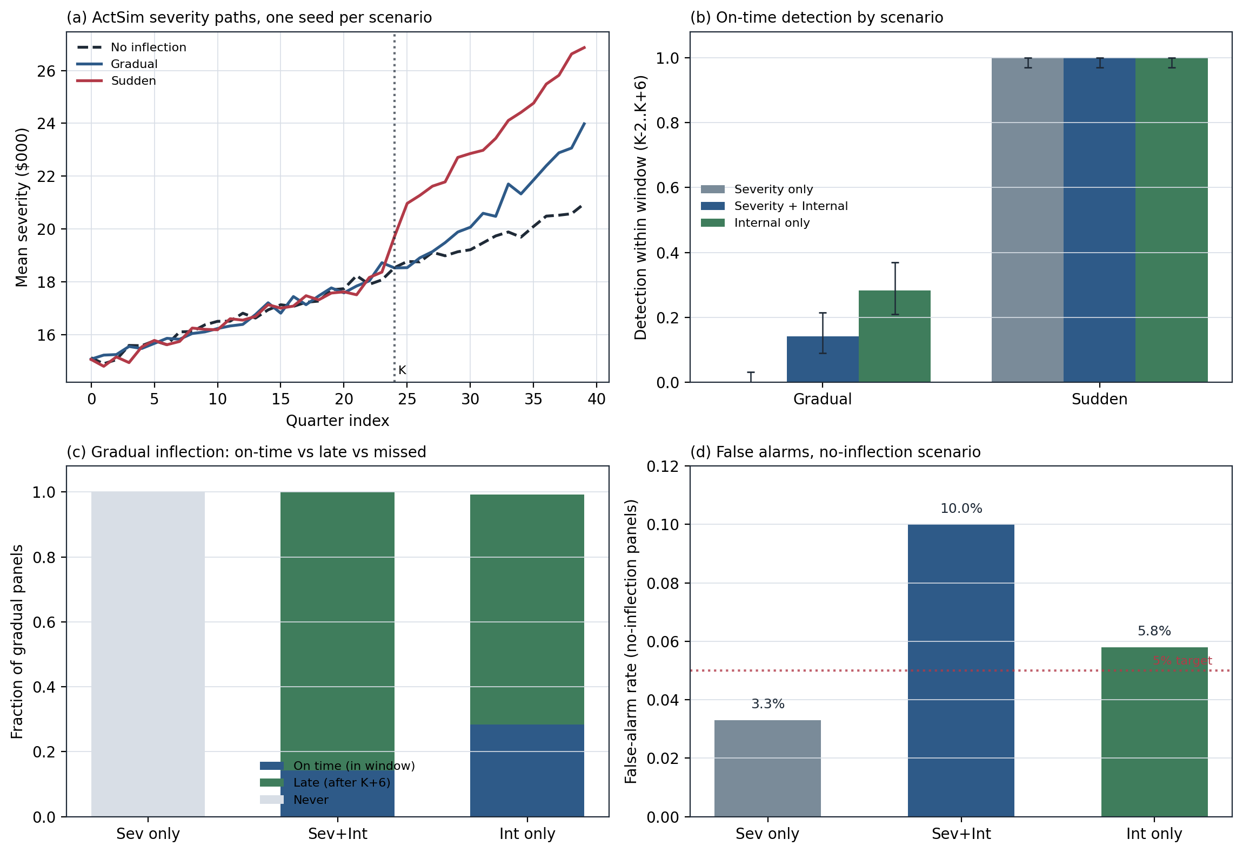
Figure 1. (a) ActSim severity paths for the three scenarios on one seed. (b) On-time detection by scenario. (c) On gradual changes, the split between on-time, late, and never-detected. (d) False-alarm rates on no-inflection data, against the 5% target.
Scenario | Severity only | Severity + Internal | Internal only | Reading
Sudden jump | 100% | 100% | 100% | All detect at the change; predictors add nothing
Gradual (on time) | 0% | 14% | 28% | BOCPD blind; predictors carry it, but late
Gradual (eventual) | 0% | ~100% | ~100% | Median first alarm ≈ quarter 32 (≈8q late)
None (false alarm) | 3.3% | 10.0% | 5.8% | Internal hazard triples the false-alarm cost
Two results stand out. First, on a gradual inflection plain BOCPD never fires at all (0 of 120), so everything PRISM achieves there comes from the internal predictors. Second, feeding that predictor through the BOCPD hazard raises the no-inflection false-alarm rate from 3.3% to 10%, whereas the same predictor thresholded on its own detects more gradual changes on time (28% vs 14%) at a lower false-alarm cost (5.8%). On this external-free setup the simpler use of the signal is the stronger one — a point worth weighing before Draft 2 commits to the hazard mechanism.

4. Full nine-scenario battery (Annexure B)
The second study reproduces the draft's nine-scenario stress battery — five with a genuine inflection and four without — with the loss side generated by ActSim, at 100 panels per scenario. Without external indicators, two scenarios collapse onto others by construction, and the run confirmed this exactly: blind is identical to gradual, and ind_false is identical to none, since their only difference was the indicator path.
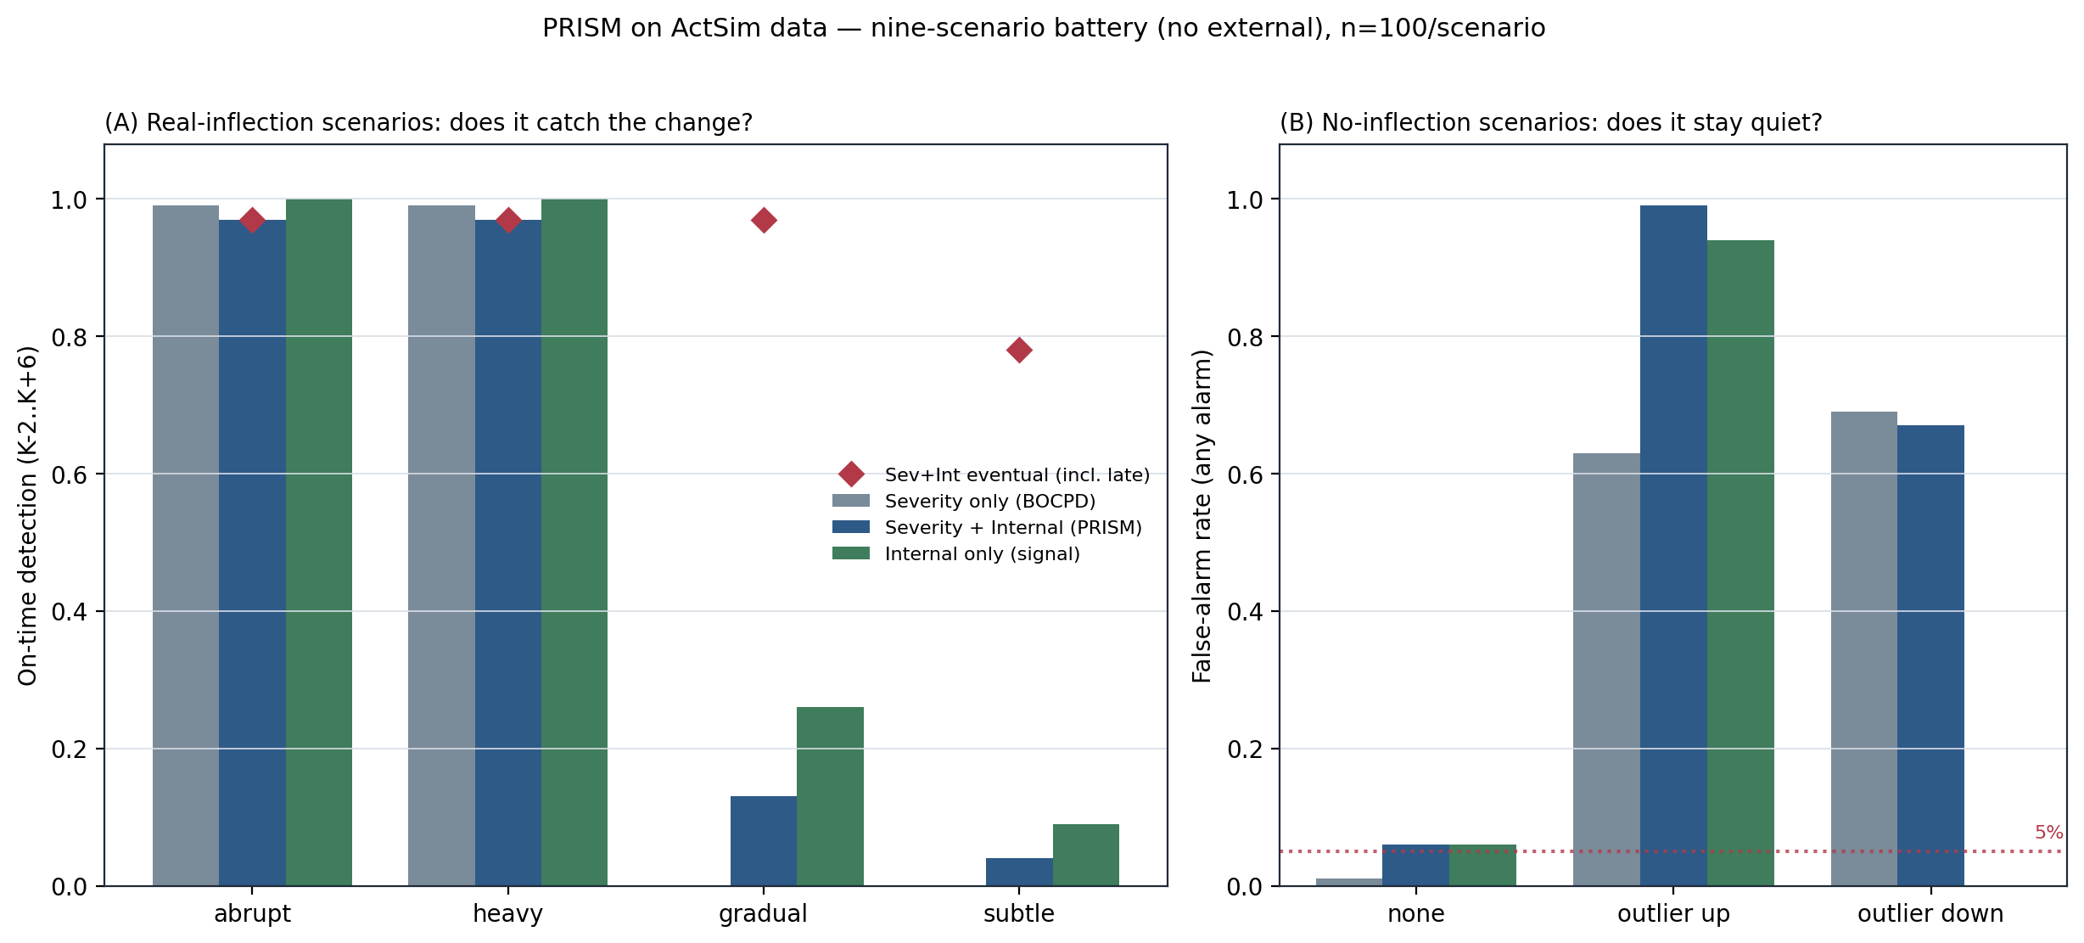
Figure 2. (A) Real-inflection scenarios: on-time detection by view, with red diamonds marking eventual detection (including late alarms) for Severity + Internal. (B) No-inflection scenarios: false-alarm rate, where lower is better.

Real-inflection scenarios — does it catch the change?
Scenario | Severity only | Severity + Internal (on time / eventual) | Internal only (on time / eventual)
abrupt | 99% | 97% / 97% | 100% / 100%
heavy | 99% | 97% / 97% | 100% / 100%
gradual (= blind) | 0% | 13% / 97% | 26% / 100%
subtle | 0% | 4% / 78% | 9% / 90%

No-inflection scenarios — does it stay quiet?
Scenario | Severity only | Severity + Internal | Internal only
none (= ind_false) | 1% | 6% | 6%
outlier up | 63% | 99% | 94%
outlier down | 69% | 67% | 0%
The battery sharpens the picture. On large changes (abrupt, heavy) every view detects near-perfectly and on time, but plain BOCPD already does this, so the framework is redundant there. On the changes that justify the method (gradual, subtle) plain BOCPD is completely blind, and only the internal predictors detect anything — eventually almost everything for gradual, 78–90% for subtle, but with the same late-alarm pattern seen in the core study.
The no-inflection scenarios expose the main weakness. A single large outlier quarter, which permanently shifts the severity level, is read as a regime change: on an up-outlier the internal hazard drives the false-alarm rate to 99%, worse than plain BOCPD's 63%. This mirrors the overdispersion fragility found earlier on the frequency channel. Separately, the raw internal signal is one-sided — it flags upward drift only — which is why it registers 0% on the down-outlier: it is not robust, it is simply blind to decreases, and would miss a genuine downward trend in real data.

5. Verdict by scenario type
Large / abrupt changes: Works, but redundant. Plain BOCPD catches them; PRISM adds nothing.
Gradual / subtle changes: Works where it counts. These are the turns plain BOCPD misses entirely, because the quarter-to-quarter drift is smaller than the ordinary noise. PRISM's internal predictor signals move before the loss series does, so it detects what BOCPD is blind to.
Flat data: Acceptable. The same sensitivity that catches gradual turns costs about 6% false alarms when nothing is actually happening.
Reproducibility: prism_noext.py (core scenarios) and prism_battery.py (nine-scenario battery) with fixed seeds; results in noext_summary.json, battery_summary.json, and the per-panel run files. Loss data: CAS ActSim. Detector code: prism_sim.py, unchanged.

6. Why PRISM works here
The two detectors differ in what they look at. Plain BOCPD sees only the severity series and asks each quarter: is this move bigger than the usual noise? For an abrupt jump, yes — so it catches the sudden and heavy cases on time. But a gradual change adds only about 1% a quarter while the normal wobble is about 1.5%, so the signal is smaller than the noise and BOCPD sees nothing. That is why it detects 0% of the gradual and subtle cases.
PRISM works because it looks beyond the loss series. Its internal signals track how far the series has drifted from the trend fixed over the first sixteen quarters. That drift builds up quietly, before any single quarter moves enough for BOCPD to notice, so PRISM catches turns the loss series alone would hide. The same sensitivity costs it on flat data: ordinary random drift sometimes looks like a change, giving the roughly 6% false alarms. In short, PRISM accepts a little quiet-period noise in exchange for spotting slow changes early — the case plain BOCPD misses completely.
7. How the internal predictors are computed on ActSim
In the full framework, the internal signals come from a frozen pricing model and watch three things: coefficient drift, residual correlation, and reshuffling of predictor rankings (a Kendall-tau distance). But ActSim gives only one series — quarterly mean severity — not a set of rating predictors, so the ranking signal is not used here. What runs is a smaller, two-signal version.
Both signals come from the severity series alone. A straight line is fitted to the first sixteen quarters (standing in for the frozen model), and for each quarter we measure how far the value sits from that line. Over a rolling six-quarter window, the first signal is the average of those gaps (drift above trend) and the second is their lag-one correlation (whether they have stopped looking like random noise). When nothing changes, the gaps scatter around zero; when the trend bends, both signals rise. So what is tested here is a fit-monitoring check on one series, not the full predictor-stability monitor the paper describes. Testing the real ranking behaviour would need a dataset with rating variables so an actual pricing model's coefficients and rankings can move.

