EcoRoads: An AI-Powered Pothole Detection and Automated Municipal Repair Reporting System
BERELLY SRI CHARAN REDDY  Roll No. 23EG105J12  Department of Computer Science and Engineering  Anurag University, Hyderabad, India | EERABOINA HANSIKA YADAV  Roll No. 23EG105J20  Department of Computer Science and Engineering  Anurag University, Hyderabad, India | PALADUGU AKSHITHA  Roll No. 23EG105J47  Department of Computer Science and Engineering  Anurag University, Hyderabad, India | GUNTI CHINNI KRISHNA  Roll No. 23EG105J27  Department of Computer Science and Engineering  Anurag University, Hyderabad, India
Under the guidance of Mr. Sadanandam Kalvala, Department of Computer Science and Engineering, Anurag University
Abstract—Potholes damage vehicles, cause accidents and raise the long-term cost of road maintenance, yet most municipalities still depend on manual inspections and citizen complaints, so repairs are delayed and severity is judged inconsistently. Existing deep-learning work detects potholes from images or video with good accuracy but usually stops at detection and display, leaving duplicate removal, office assignment and repair reporting to people. This paper presents EcoRoads, an implemented end-to-end system that carries a pothole from the moment it is seen on the road to a repair ticket for the responsible office. A smartphone mounted on the windscreen streams camera frames, GPS fixes and accelerometer readings over a local HTTPS link to a laptop edge node, where a YOLOv8n model detects potholes in real time on the GPU. Each pothole is recorded once, its severity is computed on the device from detection confidence, apparent size and the measured jolt, and the record is stored in a local database and synchronized when a network is available, so that only five fields and no images leave the vehicle. A FastAPI cloud service backed by PostgreSQL accepts only hazards on public roads inside a registered municipality, merges repeated reports with DBSCAN under a haversine metric, and uses the Haversine formula to route each pothole to its municipality, whose single office receives the case. Once a pothole has been detected a set number of times (three by default), Google Gemini automatically drafts a repair ticket for that office from structured facts, with a template fallback. A Leaflet and OpenStreetMap dashboard gives each municipality its own map of hazards, its office, the tickets it has received and repair status, and a pothole detected again after it was marked repaired is reopened. The detector, fine-tuned on about 3,000 labelled images, reached a precision of 0.882, a recall of 0.852 and an mAP@0.5 of 0.897 on 491 validation images, and the full pipeline was deployed on a free cloud tier and exercised with live phone input and a multi-vehicle simulator.
Keywords—pothole detection, YOLOv8, edge computing, smartphone sensing, DBSCAN clustering, Haversine formula, large language model, automated repair reporting, smart city

I. INTRODUCTION
Road networks carry people and goods every day, and their condition affects safety, travel time and the cost of owning a vehicle. Potholes are among the most common forms of pavement distress; they form when water enters cracks in the surface and traffic then breaks the weakened material apart. A single pothole can damage tyres and suspension, cause a rider to lose control or force sudden braking, and it grows quickly if left untreated [1], [2].
Most municipalities still learn about potholes through periodic manual inspections or complaints from citizens. Both are slow and uneven: inspections cover only part of the network, complaints arrive late and often describe a location vaguely, and the severity of a defect is judged by eye. Computer-vision research has made automatic detection far more accurate. Recent studies segment potholes with lightweight single-stage detectors [3], separate potholes from raveling using two-step detection and segmentation [4], reconstruct road elevation in bird’s eye view [1], and estimate pothole volume from a single camera [2]. A benchmark suite for intelligent road inspection has also been proposed to compare such methods fairly [5]. Real-time single-stage detectors that descend from YOLO [6], such as YOLOv8 [7], work well on images and video.
The weakness of most of this work is what happens after detection. A bounding box on a screen does not tell anyone which office should repair the road, whether the same pothole has already been reported twenty times by passing vehicles, or how urgent the repair is. A person still has to collect the detections, remove duplicates, decide who is responsible and write the complaint. EcoRoads is built to remove that manual step: it runs detection on the vehicle, filters, merges and locates the detections in the cloud, drafts the repair ticket with a language model and shows the result on a live map for each municipal team.
Contributions of this paper
- Closed-loop pipeline: joins on-device detection, GPS tagging, cloud storage, de-duplication, routing and ticketing in one automated workflow.
- Edge-first detection: a YOLOv8n model runs in real time on a laptop GPU fed by a windscreen-mounted smartphone, works offline, and sends only compact numeric records, never images.
- Geospatial filtering and routing: an OpenStreetMap road check and municipality boundaries decide who owns a hazard, DBSCAN merges repeated detections, and the Haversine formula routes each pothole to the municipality, and its office, responsible for that location.
- LLM-generated repair tickets: once a pothole is confirmed by a set number of detections, Google Gemini automatically turns structured facts into a repair request for the municipality’s office, and a per-municipality dashboard tracks repair status and reopens potholes that return after a repair.
The rest of the paper covers the motivation, problem statement, related work, methodology, results and conclusions, and reports measured results of the implemented prototype.

II. MOTIVATION
EcoRoads grew out of a practical observation: the information needed to repair a road already exists in the vehicles that drive over it, but it never reaches the people who can act on it in a usable form. Manual inspection is slow and expensive, citizen complaints are inconsistent and cannot be verified easily, and municipal offices have no real-time, network-wide view of road condition on which to base their resource allocation. The consequences are more vehicle damage, more traffic accidents and higher maintenance costs in the long run. EcoRoads therefore treats capture, detection, clean-up, routing, reporting and visualization as connected stages of one system that reduces manual inspection effort, detects potholes in real time with a phone and a laptop, removes duplicate reports so that offices see each pothole once, sends each case to the office responsible for that location, writes the repair request automatically, and gives municipal staff a live map of defects and repair status.

III. PROBLEM STATEMENT
Let a vehicle travel a road segment and record a video stream V with GPS fixes g(t). The task is to detect the set of potholes X = {x₁, …, x_n} visible in V, assign each unique pothole x_i a location ℓ_i, a severity s_i and a detection count n_i, route it to the municipality m_i whose area contains ℓ_i, and, once n_i reaches a threshold N, send a repair ticket T_i to that municipality’s single office o_m, as in Eq. (1), where M is the set of municipalities with centres c_m and radii r_m and d(·,·) is the great-circle distance. Current practice relies on manual road inspections and citizen complaints, so repairs are delayed, severity is assessed inaccurately and resources are shared inefficiently between offices. Detection-only systems do not remove duplicates, do not choose the responsible office and do not generate repair tickets, so manual intervention is still needed after detection. The system must therefore detect potholes in real time, merge repeated detections, grade severity, route each case to the responsible municipality and its office, generate the repair request automatically and present everything on a live dashboard.
m_i = argmin_{m ∈ M, d(ℓ_i, c_m) ≤ r_m} d(ℓ_i, c_m), T_i = LLM(ℓ_i, s_i, n_i, o_{m_i}) if n_i ≥ N (1)

IV. LITERATURE SURVEY
Related work falls into four areas: lightweight pothole segmentation, two-step detection and segmentation, road-surface reconstruction and volume estimation, and benchmarking of road inspection methods. Table I summarizes the studies reviewed.
TABLE I. COMPARATIVE SUMMARY OF RELATED WORK
Year and Author(s) | Title | Methodology | Limitation / Research Gap | Relation to EcoRoads
2024 Huang, Cheng, Xiang, Dong, Wu, Fan & Tang | LEPS: A Lightweight and Effective Single-Stage Detector for Pothole Segmentation | EADE module in the backbone, Gradient Contrast Attention in the neck, optimized ProtoNet mask head; AP50 mask score of 0.892 on UDTIRI | Gives 2D mask boundaries only, with no depth or volume; quality can drop under heavy noise or occlusion | Supports a lightweight, edge-friendly detector; EcoRoads adds routing, ticketing and repair tracking after detection
2024 Wang, Lang, Chen, Peng, Ding & Lu | The Two-Step Method of Pavement Pothole and Raveling Detection and Segmentation Based on Deep Learning | Modified YOLOX detection followed by DSASNet segmentation on intensity and range images; F1-score 93.65%, IoU 0.881 | Two-stage pipeline is heavier; needs 3D line-laser scanner input instead of ordinary RGB cameras | Confirms the value of YOLO-family detection; EcoRoads uses a single-stage model on a standard camera for real-time edge use
2024 Guo, Li, Feng, Zhou, Zhang, Chen, Su et al. | UDTIRI: An Online Open-Source Intelligent Road Inspection Benchmark Suite | Open benchmark suite with unified ground truth and metrics for detection, segmentation and classification | A benchmark rather than a new model; needs continual updates for new sensors | Provides a basis for comparing detectors; EcoRoads builds the operational workflow around a detector
2024 Zhao, Yang, Xie, Ding, Tomizuka & Wei | RoadBEV: Road Surface Reconstruction in Bird’s Eye View | Camera features lifted to a BEV voxel grid; mono and stereo variants classify elevation bins (1.83 cm mono, 0.50 cm stereo error) | Heavy 3D convolutions limit stereo mode on edge devices; models geometry but not colour or texture; needs precise calibration | Shows the value of geometry for severity; EcoRoads uses a lighter detector and a severity score from confidence, size and measured jolt
2026 Ali, Saeed, Buyukozturk, Lee & Cha | Monocular Computer Vision-Based Simultaneous Pothole Segmentation and 3-D Volume Prediction Using 3DpredicNet | Multi-scale convolutions with channel, spatial and criss-cross attention on a single RGB camera | Sensitive to shadows, wet roads and lighting; monocular volume depends on camera pose and scale; local assessment only | Supports use of one low-cost camera; EcoRoads adds geo-tagging, clean-up and reporting at network level

A. Analysis of Related Work
Huang et al. [3] show that a lightweight single-stage network can segment potholes accurately at a small parameter cost, which is the property needed on an edge device. Wang et al. [4] reach high accuracy by separating detection from segmentation, but their pipeline depends on laser-scanner data and extra computation. Zhao et al. [1] and Ali et al. [2] go beyond the image plane to estimate road elevation and pothole volume, which would help severity grading, but at a higher computational and calibration cost. Guo et al. [5] provide a common benchmark for these tasks rather than a deployable system. In every case the output is a detection, a mask or a measurement; none of these works describes how the result becomes a repair request for a particular municipal office.

B. Research Gap
Each of these studies improves one stage of road inspection, mainly detection or measurement. None combines real-time on-vehicle detection with GPS-tagged records, filtering by road and jurisdiction, duplicate removal, routing to the responsible office, automatic generation of repair tickets and a live municipal dashboard with repair tracking in one workflow. EcoRoads aims to close this integration gap without replacing the underlying detection techniques.

V. PROPOSED METHODOLOGY
Existing approaches mainly detect potholes with deep-learning models such as YOLOv8 variants and report accuracy on image or video datasets, while the reporting process stays manual. The proposed system follows a capture-to-ticket route: a windscreen-mounted smartphone streams video, location and motion to a laptop edge node; a YOLOv8n model detects potholes on the GPU; each pothole is logged once with an on-device severity score and synchronized to the cloud when a connection exists; the cloud keeps hazards that lie on public roads inside a registered municipality, found with the Haversine formula; DBSCAN removes duplicates; when a pothole has been detected often enough, a language model drafts the repair ticket for the municipality’s office; and a web dashboard shows the result on a map. Detection is the only step that uses the camera image, while the language model only turns structured data into text. Table II compares existing systems with EcoRoads qualitatively; it shows how the workflows differ and does not claim measured superiority.
TABLE II. EXISTING SYSTEMS VERSUS ECOROADS
Aspect | Existing Systems | EcoRoads
Inspection | Manual inspections and citizen complaints, slow to act on. | Continuous automatic capture from a windscreen-mounted smartphone (camera, GPS, accelerometer).
Detection | Models such as YOLOv8 detect potholes in images or video; focus stays on detection and display. | YOLOv8n runs in real time on a laptop GPU; only the Pothole class is logged as a hazard.
Duplicate handling | No removal of duplicate detections across repeated reports. | On-vehicle debouncing logs each pothole once; DBSCAN merges reports from repeated drives and vehicles.
Routing and office | No routing to the responsible office. | Haversine distance routes each pothole to its municipality; that municipality’s single office gets the case.
Reporting | No automatic reporting or repair workflow; manual action after detection. | Gemini API drafts the ticket automatically once a pothole reaches a detection threshold; template fallback.
Visualization | Display of detections only. | Leaflet and OpenStreetMap dashboard per municipality with its office, tickets and repair status.

A. System Architecture
The system has three tiers, shown in Fig. 1: the vehicle edge node, the cloud service and the municipal dashboards. On the vehicle, a smartphone captures data and a laptop runs the detector under PyTorch through the Ultralytics library [7] and keeps an offline queue in SQLite. The cloud service is a FastAPI application with a PostgreSQL database, deployed as a container on a free cloud tier. It filters, clusters and routes hazards, calls the Gemini API [8] only to write the ticket text from structured data, and serves the dashboard, whose map uses Leaflet [9] with OpenStreetMap data [12]. Table III lists each module’s role.
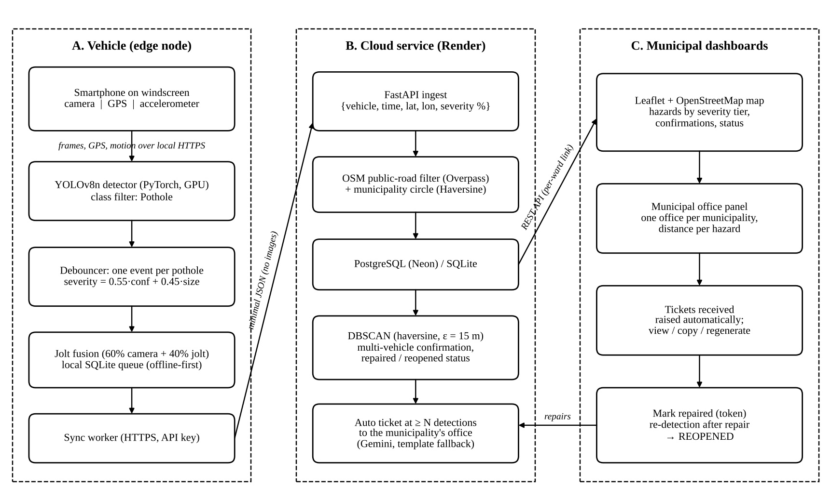
Fig. 1. System architecture of EcoRoads.
TABLE III. MODULE RESPONSIBILITIES
Module | Function
Data Capture | Smartphone on the windscreen sends camera frames (about 15 fps), GPS fixes and 60 Hz accelerometer readings to the laptop over a local HTTPS link.
AI Pothole Detection | YOLOv8n detects potholes on the laptop GPU; detections of one pothole across frames are merged into one event.
Data Packaging & Transmission | Severity is computed on the device, fused with the measured jolt and stored in SQLite; a sync worker sends {vehicle, time, lat, lon, severity} over HTTPS when online.
Cloud Backend | FastAPI service checks the vehicle key, keeps hazards on public roads (OpenStreetMap) inside a municipality, and stores them in PostgreSQL.
Intelligent Processing | DBSCAN with a haversine metric merges duplicates; severity tier, multi-vehicle confirmation and repair status are derived; Haversine distance gives the distance to the municipality’s office.
LLM Ticket Generation | When a pothole reaches N detections (default 3), Gemini drafts a ticket with subject, priority, office, location, description and action; a template is used if the API fails.
Municipal Dashboard | Leaflet and OpenStreetMap map per municipality with severity colours, offices, tickets and a private staff link.
Repair & Maintenance Action | Municipal staff review the ticket, repair the road and mark it repaired; a pothole detected again later is shown as reopened.

B. End-to-End Workflow
As Fig. 2 shows, each camera frame is checked by the detector; a confident pothole becomes an event with a severity score and is queued locally. When a network is available the record is synchronized; the cloud rejects records that are off public roads or outside every registered municipality, merges the rest with DBSCAN, and once a pothole has enough detections drafts a ticket with Gemini for the municipality’s office; every case is shown on the dashboard, where repairs are recorded and reopened cases flagged. The final output is a pothole report that states the location, severity and responsible office together with the repair ticket.
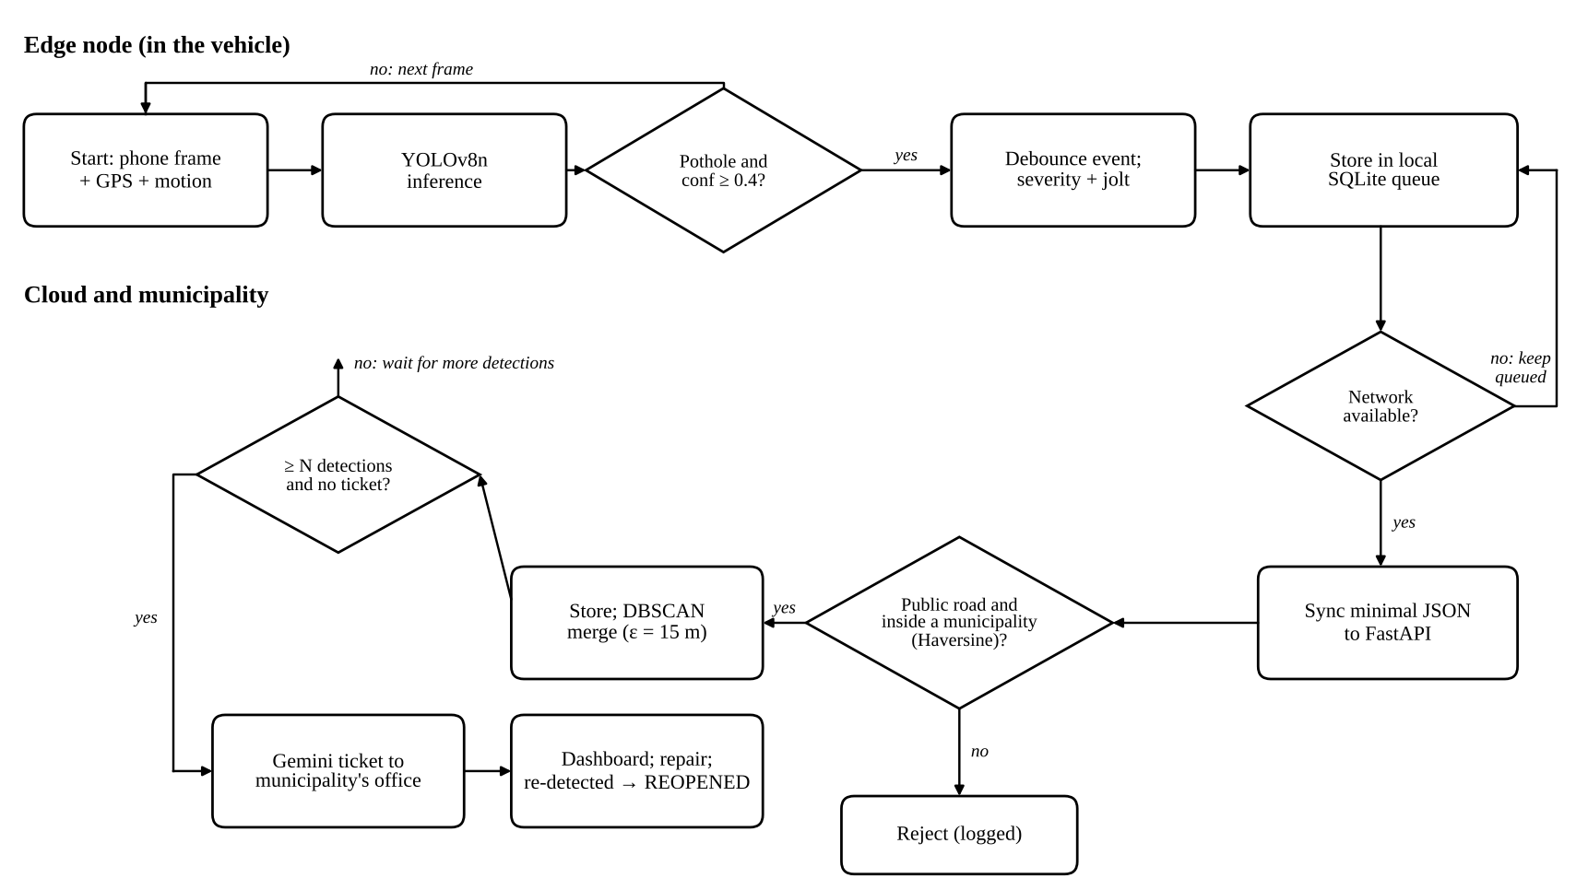
Fig. 2. End-to-end flowchart of EcoRoads.

C. Data Collection and Input
The input is road video from the rear camera of a smartphone mounted on the windscreen, together with the phone’s GPS fixes and accelerometer readings, sent to the laptop through the browser over a local HTTPS connection with clock alignment between the two devices. Each frame is passed to the detector; when a pothole is found, the system records its GPS coordinates, timestamp and severity as one record in a local SQLite database, and a separate worker uploads unsent records as JSON. Raw confidences, bounding boxes and images never leave the vehicle. The detector is a YOLOv8n model fine-tuned on a public Roboflow pothole dataset with three classes (Pothole, Drain Hole and Sewer Cover); only the Pothole class is logged, so manholes and drains are not reported as defects.

D. Geospatial Processing Formulas
Repeated detections of one pothole arise because several drives, or several vehicles, see the same defect. DBSCAN [10] groups detection points p_j of one municipality into clusters using a neighbourhood radius ε and a minimum number of points minPts; a point is a core point if its ε-neighbourhood holds at least minPts points, and each cluster is then represented by its centroid, which becomes one pothole record. The implementation uses the haversine metric so that ε is in metres (ε = 15 m, about the GPS error of a phone) and minPts = 1, so that a single report is still shown:
N_ε(p) = { q ∈ P : d(p, q) ≤ ε }, |N_ε(p)| ≥ minPts (2)
ℓ_k = (1/|C_k|) Σ_{p ∈ C_k} p (3)
The distance between a pothole at latitude φ₁ and longitude λ₁ and a point (φ₂, λ₂), such as a municipality centre or its office, is computed with the Haversine formula [11], where R is the mean Earth radius (about 6371 km):
a = sin²(Δφ/2) + cos φ₁ · cos φ₂ · sin²(Δλ/2) (4)
d = 2R · atan2(√a, √(1 − a)) (5)
The pothole is assigned to the municipality whose registered circle contains it, that is, whose centre lies within its radius by the distance d (the nearest centre wins where circles overlap). Each municipality has a single office that receives all of its tickets, and d from the pothole to that office is stated on the ticket. A ticket is raised automatically only when a cluster holds at least N detections (N = 3 by default), so that one false detection never reaches the municipality; a reopened pothole needs N new detections. On the vehicle the severity of each pothole is s = 0.55·100c + 0.45·min(8a, 100), where c is the detection confidence and a is the box area as a percentage of the frame; when the accelerometer records a jolt over the pothole, the final score blends 60% of this value with 40% of the jolt-based score. In the cloud the cluster severity is the mean score plus min(3(v − 1), 10) for v confirming vehicles, graded as Low (< 25%), Medium (25–50%), High (50–75%) or Critical (≥ 75%). These are configurable rules, not validated limits.

E. Detection Algorithm
YOLO [6] treats detection as a single regression problem solved in one forward pass, which is what makes real-time operation practical. YOLOv8 [7] is anchor-free: a decoupled head predicts, at each location, class scores and the distances to the four box edges, with no separate objectness output. It is trained with a loss that combines a complete-IoU (CIoU) box term, a distribution focal loss (DFL) on the box edges and a binary cross-entropy (BCE) classification term, Eq. (6), and predictions are filtered by confidence and non-maximum suppression based on the intersection-over-union (IoU) of two boxes A and B, Eq. (7):
L = λ_box L_CIoU + λ_dfl L_DFL + λ_cls L_BCE (6)
IoU(A, B) = |A ∩ B| / |A ∪ B| (7)
The nano model (YOLOv8n, about 3.2 million parameters) was fine-tuned from COCO-pretrained weights for 60 epochs at 640 × 640 pixels with a batch size of 16 on an NVIDIA RTX 4060 Laptop GPU, and runs with PyTorch and CUDA on the same laptop during a drive.

F. Hardware and Software Requirements
Table IV lists the hardware used for the prototype on the vehicle and on the cloud side, and Table V lists the software stack.
TABLE IV. HARDWARE REQUIREMENTS
Component | Hardware | Purpose
Camera | Smartphone rear camera | Road video capture from the windscreen
GPS and motion | Smartphone GPS and accelerometer | Location and jolt measurement
Edge device | Laptop with NVIDIA RTX 4060 GPU | Real-time detection and local storage
Communication | Phone hotspot / Wi-Fi | Phone-to-laptop link and cloud sync
Server | Render web service, Neon PostgreSQL | Data storage and processing
Computer | Laptop / PC with a browser | Municipal dashboard
Power | Vehicle charger / laptop battery | Device power
TABLE V. SOFTWARE REQUIREMENTS
Category | Tools
Programming | Python, JavaScript
AI / ML | YOLOv8n (Ultralytics), PyTorch with CUDA, OpenCV
Backend | FastAPI, Uvicorn, REST API
Database | SQLite (edge queue), PostgreSQL (cloud)
Frontend | HTML, CSS, JavaScript
Maps and location | Leaflet, OpenStreetMap, Overpass API, GPS
Data processing | DBSCAN (scikit-learn), Haversine formula
Language model | Google Gemini API for repair-ticket generation
Tools | VS Code, Git / GitHub, Roboflow, pytest
Deployment | Render (Docker), Neon (PostgreSQL)

G. Overall Algorithm
Algorithm 1: EcoRoads pothole detection and repair-ticket generation
Input: phone frames, GPS and motion, municipalities M with one office each, ε, minPts, threshold N
Output: pothole records with location, severity, responsible office, repair ticket and status
1. Receive frames, GPS fixes and accelerometer readings from the phone over local HTTPS; align clocks.
2. Run YOLOv8n on each frame; keep Pothole boxes with confidence ≥ 0.4 after non-maximum suppression.
3. for each pothole event (seen across frames) compute its severity from confidence and box size, fused with the measured jolt.
4. Store {vehicle, time, lat, lon, severity} in SQLite; the sync worker uploads it when online.
5. Keep the record only if it is on a public road and within a municipality of M (Haversine).
6. Group the records with DBSCAN (haversine, ε, minPts); keep each cluster’s centroid and severity tier.
7. If a cluster has ≥ N detections and no current ticket, take the municipality’s office and its distance.
8. Send only the structured facts to Gemini; store the ticket for that office (template if it fails).
9. Show the pothole, severity, office, ticket and status on the municipality’s dashboard map.
10. Mark the pothole repaired after work; if it is detected again later, flag it as reopened.

H. Backend, Ticketing and Dashboard
The backend exposes a REST API through which edge nodes post detection records with a vehicle key, and stores them in PostgreSQL. Each municipality is registered as a centre and radius; a hazard is accepted only if it lies inside one of them and, according to OpenStreetMap road data queried through the Overpass API, on a public road (results are cached, and the check is skipped rather than blocking when the service is unavailable). After each synchronized batch, a background task raises a ticket for every cluster that has reached the detection threshold and has no current ticket. The ticketing step sends only the facts of a cluster (location, severity tier and priority, number of detections and vehicles, dates, repair history and the municipality’s office with its distance) to the Gemini API with an instruction not to invent details; the returned text is stored with the case, and a fixed template is used when no key is set or the call fails. The language model never sees the video and never changes a detection; its output is a draft that municipal staff review. The dashboard, a single page built with Leaflet, shows each municipality only its own area through a private link with an access token, plots potholes coloured by severity, shows the office and the tickets received, and lets staff regenerate a ticket and mark repairs.

I. Evaluation Metrics
Detection quality is measured with Precision, Recall, F1-score and mean average precision (mAP). TP, FP and FN denote true positives, false positives and false negatives, and AP_c is the area under the precision–recall curve of class c over C classes; mAP@0.5 uses an IoU threshold of 0.5 and mAP@0.5:0.95 averages thresholds from 0.5 to 0.95:
Precision = TP / (TP + FP), Recall = TP / (TP + FN) (8)
F1 = 2 × (Precision × Recall) / (Precision + Recall) (9)
mAP = (1/C) Σ_c AP_c (10)
Duplicate removal is assessed by comparing the number of clusters with the number of distinct potholes found by manual survey, routing by the share of potholes sent to the correct municipality and office, and the full pipeline by the time from detection to a ticket on the dashboard.

J. Experimental Design
The evaluation has four parts: (i) the detector on the validation split of the labelled dataset; (ii) functional tests of the cloud rules (road and jurisdiction filtering, DBSCAN merging, confirmation, repair and reopening, office assignment and ticket generation) on SQLite and PostgreSQL; (iii) a multi-vehicle simulator that replays drives through two municipalities against the deployed service; and (iv) live tests with the phone on a vehicle. Field measurement of recall and GPS error on repeated drives over surveyed potholes is planned.

VI. RESULTS ANALYSIS

A. Prototype Setup
The prototype follows the architecture of Fig. 1. The on-vehicle unit is a smartphone on the windscreen connected to a laptop with an NVIDIA RTX 4060 Laptop GPU; the cloud side runs the FastAPI service with a PostgreSQL database on the Render and Neon free tiers, the Gemini-based ticket generator and the Leaflet dashboard. In a classroom setup one laptop acts as the detector and two further laptops act as municipal offices, each locked to its own area. For each pothole the system produces one output: a report that gives the location, severity, responsible municipality and office, and the repair ticket.

B. Functional Outcomes
Table VI summarizes what each stage of the implemented pipeline produces. Measured results of the detector are given in Table VII and the results of the system tests in Section VI-D.
TABLE VI. OUTPUT PRODUCED BY EACH STAGE OF THE PIPELINE
Stage | Input | Output
Detection | Phone frames on the laptop GPU | Pothole boxes with confidence
Event and severity | Boxes over consecutive frames, jolt | One record per pothole with severity
Packaging and sync | Record from the local SQLite queue | Five-field JSON record sent over HTTPS
Filtering | Record, road data, municipality areas | Accepted hazard or logged rejection
De-duplication | Hazards of one municipality | One cluster per pothole, severity tier
Ticket | Cluster with ≥ N detections, office | Repair ticket for the municipality’s office
Dashboard | Clusters, office, tickets, repairs | Map with status: open, repaired, reopened

C. Detection Model Results
The detector was trained on about 3,000 images of the Roboflow dataset and validated on a held-out set of 491 images with 1,079 labelled objects. Training ran for 60 epochs in about 28 minutes, and the best weights were obtained at epoch 51. Table VII gives the validation results for the best weights over all three classes; the F1-score follows from Eq. (9). The per-class result for Pothole alone will be reported with the field tests.
TABLE VII. DETECTION RESULTS ON THE VALIDATION SET
Metric | Value | Remark
Training data | ≈ 3,000 images, 3 classes | Pothole, Drain Hole, Sewer Cover
Validation data | 491 images, 1,079 objects | Held-out split
Training setup | 60 epochs, 640 px, batch 16 | ≈ 28 min on RTX 4060 Laptop GPU
Precision | 0.882 | Best epoch (51), all classes
Recall | 0.852 | Best epoch (51), all classes
F1-score | 0.867 | From Eq. (9)
mAP@0.5 | 0.897 | Best epoch (51), all classes
mAP@0.5:0.95 | 0.595 | Best epoch (51), all classes

D. System Tests
The phone-to-laptop link delivered about 14 frames per second with live accelerometer data, and the phone reported GPS accuracy of about ±8 m, which is within the 15 m clustering radius. The automated tests of the cloud service (28 tests, including the detection threshold, office distance and ticket generation with the language model replaced by a mock) pass. With the service deployed, a fleet simulator sent 48 hazard reports from several vehicles across two municipalities: 47 were accepted and the one report outside every municipality was rejected, repeated reports of one pothole merged into a single cluster with a raised severity, and a pothole reported again after being marked repaired was shown as reopened. In the tests, a ticket was raised automatically only when a pothole reached three detections, was addressed to the municipality’s office with its Haversine distance, and was not repeated by further detections.

E. Discussion
The design shifts the heavy work to the edge and keeps the network load small: only five fields per pothole are sent, not video. Running detection on the vehicle also means the system keeps working when the connection is poor, since records are queued and sent later. Clustering matters because a pothole passed by many vehicles would otherwise create many tickets for the same defect, and confirmation by several vehicles raises confidence and priority. Routing by the Haversine distance to municipality centres keeps a case inside the right authority with a simple and fast rule, and waiting for several detections before raising a ticket keeps single false detections away from the office. Letting a language model write the ticket saves staff time, while giving it only structured facts and keeping a template fallback limits the risk of wrong content and keeps the system working without the external service.

F. Limitations
The accuracy of the system depends on the quality and variety of the training images; shadows, wet roads, poor lighting and occlusion can cause false or missed detections, as reported in related work [3], [2]. The reported metrics cover all three classes on the validation split, not field drives. A single camera does not give depth, so severity is estimated from apparent size and the measured jolt, not from true volume, and the jolt thresholds depend on how the phone is mounted. Municipal areas are approximated by circles, the distance to the office is straight-line rather than by road, and a pothole on a rarely used road may take time to reach the detection threshold. DBSCAN parameters and severity thresholds need tuning for each city, GPS error affects both clustering and routing, and when the public OpenStreetMap service cannot be reached the road check is skipped and the hazard is marked unverified. Ticket text from the language model should be reviewed before it is sent.

VII. CONCLUSION & FUTURE SCOPE

A. Conclusion
EcoRoads is a single framework that takes a pothole from road capture to a repair ticket without manual steps. It joins real-time YOLOv8n detection on a laptop fed by a windscreen-mounted phone, on-device severity with jolt fusion, offline-first storage and synchronization, road and jurisdiction filtering, DBSCAN de-duplication, Haversine-based routing to each municipality’s office, Gemini repair tickets raised automatically after repeated detections and a live dashboard that tracks repairs and reopened potholes. The detector reached an mAP@0.5 of 0.897 on the validation set, and the deployed pipeline worked end to end with live phone input and simulated fleets. Rather than stopping at detection, it addresses the stages that decide how quickly a road is actually repaired, and its use of everyday hardware makes it practical for municipalities to scale.

B. Future Scope
- Field evaluation of recall, GPS error and severity against surveyed potholes, and pothole volume and depth estimation with stereo or monocular 3D methods for better severity grading.
- Export of the model to ONNX for low-cost embedded boards (Raspberry Pi, NVIDIA Jetson) with a 4G link, and integration with municipal work-order systems and citizen notifications.
- Exact ward boundaries as polygons instead of circles, and routing distance along the road network instead of straight-line distance.
- Repair prioritization based on traffic volume, road class and weather.
- Detection of other road defects such as cracks and raveling, and model improvement for night and wet conditions.

ACKNOWLEDGMENT
We sincerely thank the Department of Computer Science and Engineering, Anurag University, Hyderabad, for its academic guidance and facilities, and Mr. Sadanandam Kalvala for his support and guidance throughout this project.

REFERENCES
[1] Zhao, T., Yang, L., Xie, Y., Ding, M., Tomizuka, M., & Wei, Y. (2024). RoadBEV: Road surface reconstruction in bird’s eye view. IEEE Transactions on Intelligent Transportation Systems, 25(11), 19088–19099. https://doi.org/10.1109/TITS.2024.3431671
[2] Ali, R., Bin Saeed, Q., Buyukozturk, O., Lee, S., & Cha, Y.-J. (2026). Monocular computer vision-based simultaneous pothole segmentation and 3-D volume prediction using 3DpredicNet. IEEE Transactions on Industrial Informatics. https://doi.org/10.1109/TII.2026.3706348
[3] Huang, X., Cheng, J., Xiang, Q., Dong, J., Wu, J., Fan, R., & Tang, X. (2024). LEPS: A lightweight and effective single-stage detector for pothole segmentation. IEEE Sensors Journal.
[4] Wang, A., Lang, H., Chen, Z., Peng, Y., Ding, S., & Lu, J. J. (2024). The two-step method of pavement pothole and raveling detection and segmentation based on deep learning. IEEE Transactions on Intelligent Transportation Systems, 25(6). https://doi.org/10.1109/TITS.2023.3340340
[5] Guo, S., Li, J., Feng, Y., Zhou, D., Zhang, D., Chen, C., Su, S., Zhu, X., Chen, Q., & Fan, R. (2024). UDTIRI: An online open-source intelligent road inspection benchmark suite. IEEE Transactions on Intelligent Transportation Systems, 25(8). https://doi.org/10.1109/TITS.2024.3351209
[6] Redmon, J., Divvala, S., Girshick, R., & Farhadi, A. (2016). You only look once: Unified, real-time object detection. In Proceedings of the IEEE Conference on Computer Vision and Pattern Recognition (CVPR) (pp. 779–788). IEEE.
[7] Jocher, G., Chaurasia, A., & Qiu, J. (2023). Ultralytics YOLOv8 (Version 8.0.0) [Computer software]. https://github.com/ultralytics/ultralytics
[8] Gemini Team, Google. (2023). Gemini: A family of highly capable multimodal models (arXiv:2312.11805). arXiv.
[9] Agafonkin, V. Leaflet: An open-source JavaScript library for interactive maps. https://leafletjs.com
[10] Ester, M., Kriegel, H.-P., Sander, J., & Xu, X. (1996). A density-based algorithm for discovering clusters in large spatial databases with noise. In Proceedings of the Second International Conference on Knowledge Discovery and Data Mining (KDD-96) (pp. 226–231). AAAI Press.
[11] Sinnott, R. W. (1984). Virtues of the haversine. Sky and Telescope, 68(2), 159.
[12] OpenStreetMap contributors. OpenStreetMap. https://www.openstreetmap.org

