**BACKEND**

**Case 1**

Search API to return possible matches across all columns and all rows, ordered by IFSC code (ascending order) with limit and offset.

Request URL - **http://127.0.0.1:5000/api/search?q=Mumbai&limit=2&offset=1**

**OUTPUT:**

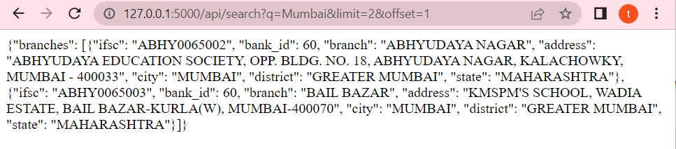

**CASE 2**

Branch API to return possible matches based on the branch name ordered by IFSC code (descending order) with limit and offset

Request URL - **http://127.0.0.1:5000/api/branch?q=LONI&limit=1&offset=1**

**OUTPUT:**

