**PLANT DISEASE DETECTION USING MODERN TECHNIQUES : A SURVEY**

Bala Vidula B1, Sri Dharshana T2

1(Department of Artificial Intelligence and Machine Learning -

Coimbatore Institute of Technology

2034011aiml@cit.edu.in)

2(Department of Artificial Intelligence and Machine Learning -

Coimbatore Institute of Technology

2034049aiml@cit.edu.in)

**Abstract: -** Plant diseases are categorized generally based on the characteristics of the principal causative agent. Plant diseases are usually caused due to wide variety of insects and external conditions. The pest occurring in plants can be detected by machine learning techniques and digital image processing and deep learning. The goal of machine learning is to analyse the structure of data and fit that data into models that can be utilized by people. Digital Image Processing in deep learning is able to use a combination of AI technologies to not only automatically classify photos, but also to explain the various aspects in photos and write short phrases summarizing them. The pests occurring in plants can be detected by means of digital image processing. The existing experimental findings displays the accuracy, predicted values, requirements, training period. Usually, the methods used are Decision tree, K-means Clustering, Naive Bayes, Artificial Neural networks (ANN), Convolutional Neural Networks (CNN). This paper focuses on the challenges that need to be handled in order to develop practical methods for detecting plant diseases in the field.

***Keywords :-*** *Convolutional Neural Networks****,*** *Decision Tree, Digital Image Processing, Machine Learning,**Plant diseases and pests*

**I. INTRODUCTION**

Agriculture is the world's most important source of food. A large amount of what is traded worldwide is agricultural raw commodities. So, the crops produced should be disease free, thus increases the productivity. When the farming drops, the percentage of agriculture in exports shrinks as well pricing changes would decrease food production that leads to starve for food which decreases the economy level all over the world. So, we need to produce healthy crops.

**Disease Issues**

Plants get affected due to many factors such as virus, fungus, parasitic flowering plant, bacterium, and viroid. Unfavourable growing conditions, such as temperature extremes, unfavourable moisture-oxygen interactions, harmful compounds in the soil or air, and an excess or lack of a mineral. These causes disease in plants like downy mildew, black spot, blight, other leaf spots, powdery mildew.

**Techniques Used**

The above-mentioned plant diseases can be pre-detected by using techniques in Machine Learning, Digital Image Processing and Neural Networks. Some techniques like Decision Tree, Naive Bayes, K- means Clustering, Random Forest are used to classify and describe the dataset. Digital Image Processing is used for segmentation, image compression, image enhancement, etc. Artificial Neural Network (ANN) is used for data modelling and Convolution Neural Networks (CNN) is a processor developed specifically for the processing of pixel data.

This paper is organized as follows: Chapter 2 describes about Literature Review. Chapter 3 gives review about the crops. Classification of plant disease is given in chapter 4 followed by Traditional Plant Disease Recognition and Resolution Methods in chapter 5. Experimental study is given in chapter 6. Finally, conclusion is given in chapter 7.

**II. LITERATURE REVIEW**

In [1], the authors have used Image Recognition Technology based on Deep Learning for finding the disease affected in maize. Through which they have extracted features of images and found the firm robustness and the exact recognition accuracy. They compared the traditional picture recognition method with deep learning methods, where in traditional methods the imaging in harsh environment requires high contrast between affected and non affected areas. But Deep Learning method has an ability to sustain with real and complex natural environment. Through Image Label Level, the location of affected part can be identified and can classify pixel by pixel by grouping many processes and techniques. Through Heat map they have identified the higher probability whether the part of the maize is affected. Using Mask R-CNN a single affected part can be exactly identified and differentiated by the learning model. Modelling with less datasets leads to critical problem when identifying the plant disease and pest identification. In reality, certain plant illnesses have a decreased risk and a high cost of disease picture collecting, resulting in just a few training data being gathered, limiting the use of deep learning methods in the diagnosis of plant diseases and pests. The aim of plant disease and pest identification using machine learning has switched from traditional image processing and machine learning techniques to deep learning approaches, which resolved complex problems that traditional methods couldn't answer.

In [2], the authors used layer Convolutional Neural Network for image acquirement , Image Processing , Optimizing algorithm ,Training model ,Visualization of Layer. As a result of analysis, they obtained the training and validating accuracy is 94.29 % and 96.28% respectively. In error or confusion matrix, the values presented in Diagonal places displays their best performance compared to other position. They concluded that this work presents a clear idea for detecting the affected leaf, and the farmers will able to get a solution, allowing them to increase their agricultural productivity. The CNN model easily differentiates and analyses the region of the leaf, and this model offers the best outcome quickly. Their future goal in detecting the plant diseases and giving remedies through a software and an open multimedia system.

In [3], the author not only focussed in dealing with Plant disease detection but also in knowing the affected part and giving to remedy to cure it. They used Faster R-CNN to recognise the thing and to know about the location of that object which has a target variable. Regional based Fully Convolutional Network(R-FCN) is used to detect an object. Single Shot Detector is used for grouping the predictions of the object with many sizes from the maps with many resolutions. As a conclusion, they finalized that they used CNN to find the disease in plants through the images of leaves and finding the solution also.

**III. CROPS REVIEW**

The categorization process is presented in this section, which helps in an improvement of the study. Further, there will be a discussion of similar existing techniques. Categorical variables or qualitative variables divide observations into groupings. We're attempting to anticipate the value of a single variable based on its interactions with other variables. In this way, we may predict whether a plant will be impacted by a disease or not.

**Threats**

Crop diseases have a significant effect on agriculture yield. Plant fungi are hard to control because they vary in time, area and genetics. Food security, food hygiene, economic systems, biodiversity, and the local ecosystem are all threatened by plant diseases. Leaf spots, fruit rots, root rots, fruit spots, and dieback are examples of plant disease symptoms that differ based on the infectious pathogen and the affected portion. Plant pests may have a direct influence on humans by lowering the amount of food available or by poisoning human food with hazardous substances. Plant disease has a significant impact on human interests, and disease control takes a lot of effort. Bacteria found in soils and bio control agents used for plant diseases can have an impact on human health. Plant diseases are widely known for reducing the amount of food accessible to humans by reducing crop yields. This can lead to a lack of food for humans and in some cases, it leads to malnutrition and death. Plants that have been cultivated in stressful environments normally send signals that attract pests.

According to the recent study, fusarium virgulifrome caused soybean disease, which leads to loss around 9% for production potential in US equals to $3.8 billion for each year. Pests are estimated to be responsible for 20 to 40% of worldwide agricultural production every year. According to the FAO, Plant diseases cost the world economy roughly $220 billion each year, whereas invading insects cost about $70 billion. Crop diseases cause large yield losses in food crops around the world, with average losses ranging approximately from 10.1 to 28.1% in wheat, 24.6 to 40.9 percent in rice, 19.5 to 41.4 percent in maize, 8.1 to 21 percent in potato, and 11 to 32.4 percent in soybean.

**IV. CLASSIFICATION OF PLANT DISEASES**

Plant pathology is the study to investigate the causes of plant illnesses, the processes by which diseases occur in plant ecosystem, and the methods for managing and controlling plant diseases. The classification of plant diseases is significant in the agriculture sector. Plant disease is split by two factors: biotic and abiotic which is given in table 1 and table 2.

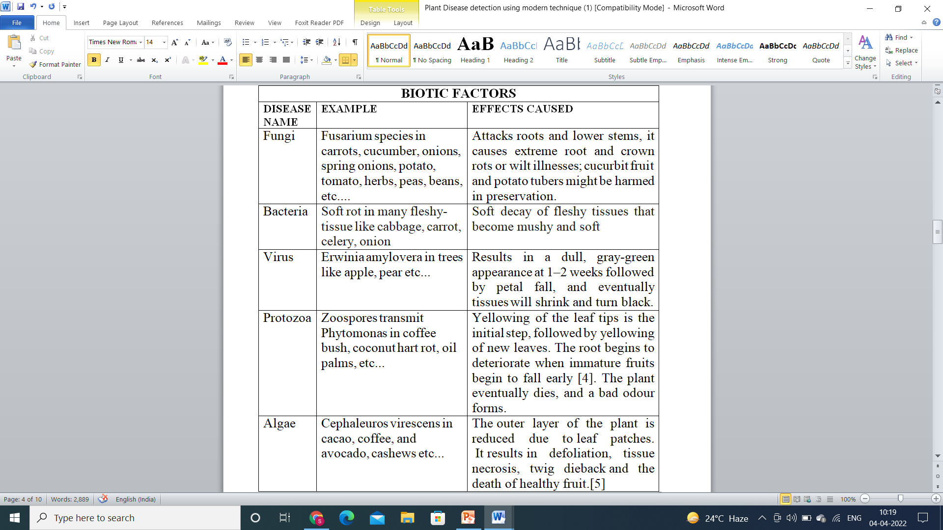

Table 1: Biotic factors in plant disease classification

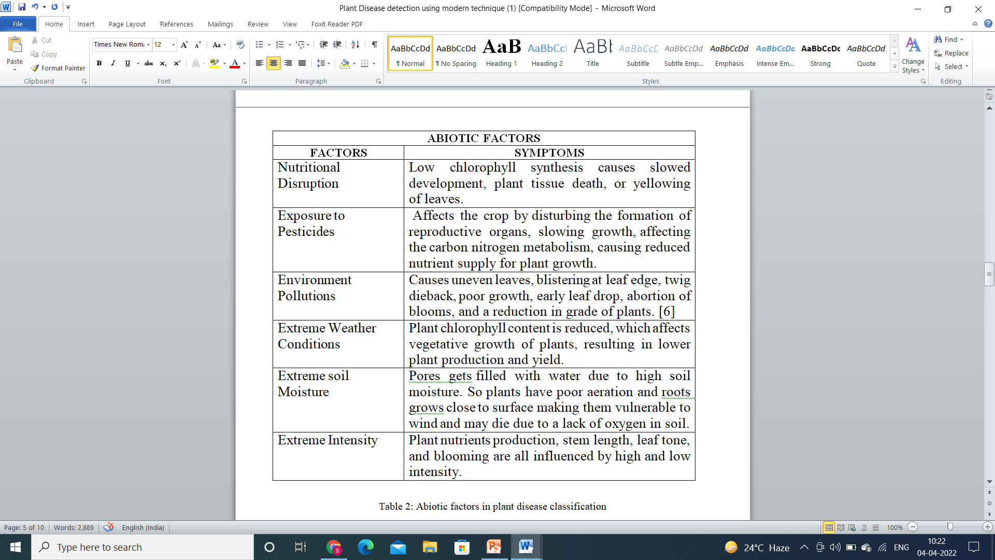

Table 2: Abiotic factors in plant disease classification

**V.TRADITIONAL PLANT DISEASE RECOGNITION AND RESOLUTION METHODS**

Cultural restrictions are one of the oldest approaches for controlling pests. However, cultural restrictions are preventive rather than therapeutic, and they require long-term management.

The process of controlling the plant diseases starts by avoiding the environment which is not favourable for plants. In this method, the treatment is done after the plant is affected but not earlier. We must choose plants based on their acceptable conditions, which should not be beneficial to pest growth. Traditional medicine is still the chosen primary health care system in many farming villages for a range of factors, like effective and cost efficient. Fig. 1 shows the controlling process of plant diseases.

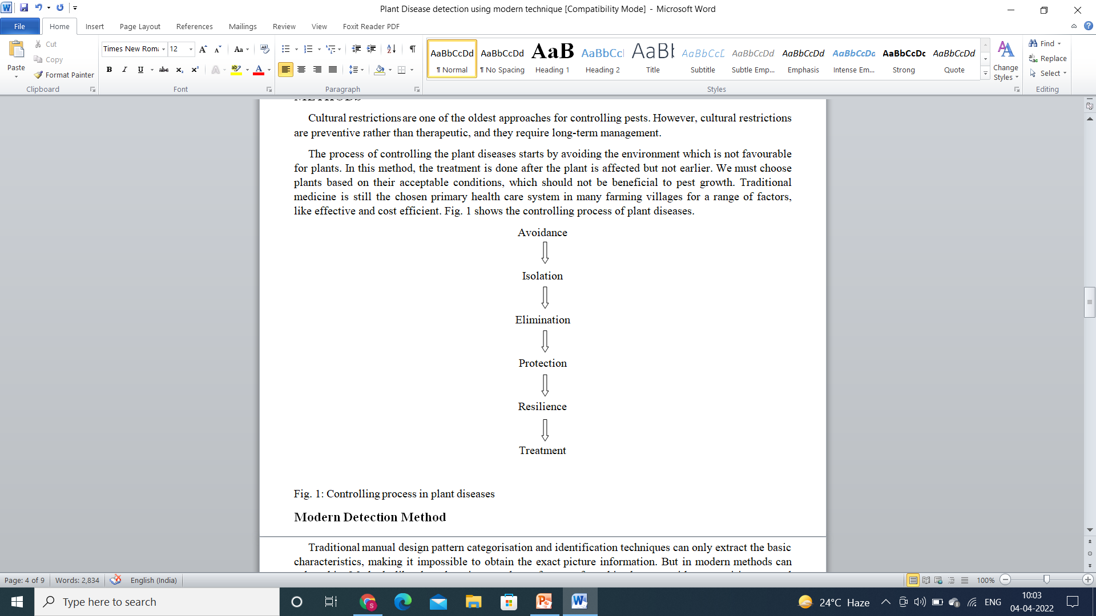

Fig. 1: Controlling process in plant diseases

**Modern Detection Method**

Traditional manual design pattern categorisation and identification techniques can only extract the basic characteristics, making it impossible to obtain the exact picture information. But in modern methods can solve this. Methods like deep learning can learn features from big datasets without requiring manual intervention. The model is made up of numerous layers and can effectively extract image features for picture detection and recognition. It also has high autonomous learning and feature expression abilities. The performance of deep learning models is consistently superior to that of existing models. Plant disease detection begins with picture acquisition, which is then accompanied by pre-processing and categorization. In modern agriculture, the best devices and procedures are used to increase production. Modern tools are being used more commonly to quickly determine appropriate situations for bigger agricultural yields.

The modern methods of detecting the plant diseases are:

* Decision Tree
* Digital Image Processing
* Convolutional Neural Network (CNN)
* K- means clustering
* Artificial Neural Network (ANN)

**VI. EXPERIMENTAL STUDY**

**Decision Tree**

The decision tree clustering algorithm is used for the segmentation of input images. The decision tree classifier is applied which will classify the input image into two classes. This leads in an improved accuracy of disease detection, moreover classifying the data into multiple classes.[7] Furthermore, based on disease detection the system sprays a fertilizers and pesticides, which reduce human work. Fig. 2 gives the decision tree for classifying the images into two classes.

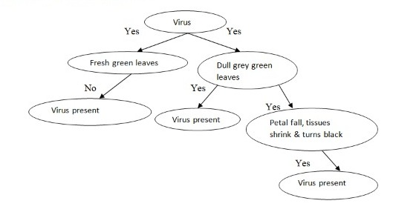

Fig. 2 : Decision Tree

**Digital Image Processing**

This method examines approaches for detecting, quantifying, and classifying plant diseases from digital photographs in light. A device is present that detects whether or not a plant is affected by a disease , with improved accuracy by assessing the optimal plant pictures and spraying the medicine remotely when disease is found . This approach used to process digital data is known as image processing.[8]. The application system developer is entirely responsible for the creation of an image dataset. The picture dataset is responsible for the classifier's increased efficiency in the detection system's completion.

**Convolutional Neural Network (CNN)**

The development of Convolutional Neural Networks (CNNs) has led to huge advancements in plant's affected image processing. A CNN's convolution layers can be created from the dataset. As a result, CNNs generate a network of pictorial representations that are specialized to a particular task. In this, affected plant's images are identified and doing a particular task. Then finally in CNN training, a model with a collection of input variables is created, which responds to the goal for which it was created. The main advantage of CNNs is their ability to generalise and to analyse data that has never seen before. CNN framework is given in fig.3.

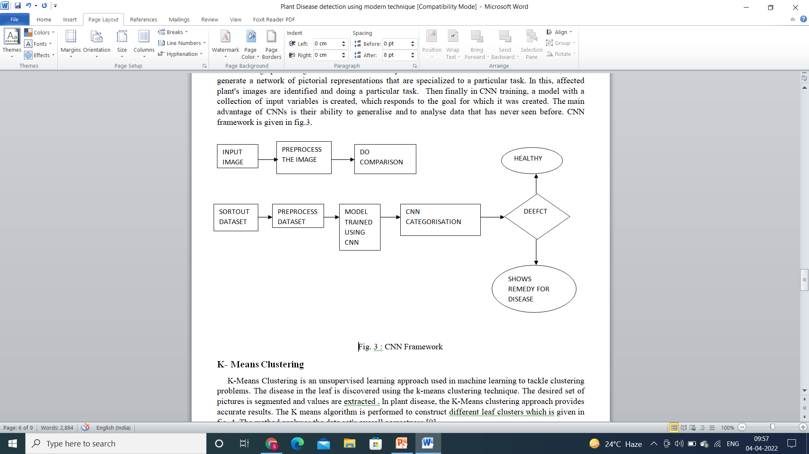

Fig. 3 : CNN framework

**K- Means Clustering**

K-Means Clustering is an unsupervised learning approach used in machine learning to tackle clustering problems. The disease in the leaf is discovered using the k-means clustering technique. The desired set of pictures is segmented and values are extracted

. In plant disease, the K-Means clustering approach provides accurate results. The K means algorithm is performed to construct different leaf clusters which is given in fig. 4. The method analyses the data set's overall correctness [9].

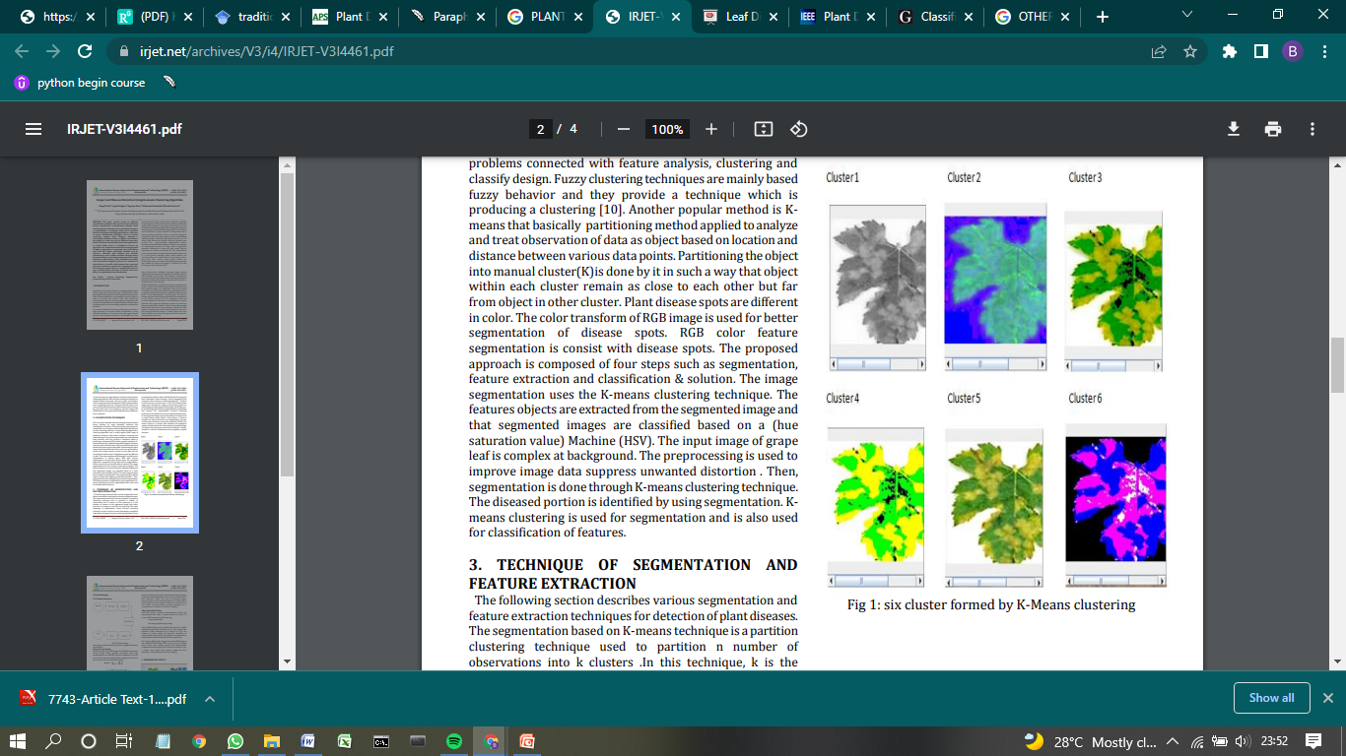

Fig. 4 : different leaf Cluster formation

**Artificial Neural Network (ANN)**

Artificial neural networks are used for a range of applications, including image recognition, speech recognition, machine translation, and medical diagnosis. The fact that ANN learns from sample data sets is a significant advantage. In plant disease detection process, Artificial Neural Network is used to categorise the healthy and unhealthy leaves. The results of the experiments showed that classification performance using an ANN is stronger, with an accuracy of 80%. The current study presents an artificial neural network-based methodology for detecting cotton leaf diseases early and correctly [10]. Fig. 5 gives the ANN-based methodology for detecting cotton leaf diseases.



Fig. 5 : ANN-based methodology for detecting cotton leaf diseases

**VII. CONCLUSION**

Timely and accurate detection of leaf diseases is essential in order to avoid production losses and the loss or decrease of agricultural goods. The paper also discusses several literature reviews that reflect diverse methods for detecting pests in crops. Machine Learning is an excellent technique for a country's agriculture wealth. Image Recognition Technology is being used by scientists to solve a variety of real-world challenges. Deep Learning methodologies and optimization techniques can solve the plant disease problem, which is the focus of current future study.

**REFERENCES**

[1] Jun Liu and Xuewei Wang, "Plant Diseases and Pests Detection based on Deep Learning: a review "

[2] Md. Tariqul Islam , "Plant Disease Detection using CNN Model and Image Processing", International Journal of Engineering Research & Technology (IJERT), Vol. 9 Issue 10, October-2020.

[3] Akila and P. Deepan, "Detection and Classification of Plant Leaf Diseases by using Deep Learning Algorithm", International Journal of Engineering Research & Technology (IJERT) ISSN: 2278-0181, 6, 7, 2018.

[4] Dollet, M (1984-09-01). "Plant Diseases Caused by Flagellate Protozoa (Phytomonas)". Annual Review of Phytopathology. **22** (1): 115–132.

[5] Nelson, Scot C. (August 2008).  Plant Disease (Report). University of Hawai'i at Manoa, College of Tropical Agriculutre and Human Resources. PD-43.

[6] Department of crop science, University of Illinois (July 2002). "Plant damage from air pollution".

[7] Nithyashree.D1, Ramya.B2, Rohith Kumar.V3, Birundha.R , “Plant Disease Detection using Decision Tree Algorithm and Automated Disease Cure”, issue 3, volume :07,2020.

[8] Birundha Ramakrishnan , Nithyashree.D , Ramya.B , Rohith Kumar .V, “Plant Disease Detection using Decision Tree Algorithm and Automated Disease Cure” (May 2020).

# [9] Rupali Patil, Sayali Udgave, Supriya More, Dhanashri Nemishte, Monika Kasture, "Grape Leaf Disease Detection Using K-means Clustering Algorithm"(April 2016).

# [10] Atul Ingole (May 2015) "Detection and Classification of leaf disease using Artificial Neural Network".

[11] Shivkumar Bagde, S.Patil , Poonam Patil, "Disease Detection" (2015).