SMART RESUME SCREENING AND JOB RECOMMENDATION SYSTEM
A Project Report Submitted in
the partial fulfillment of the requirements for the award of the degree of

BACHELOR OF TECHNOLOGY
In

DEPARTMENT OF COMPUTER SCIENCE AND ENGINEERING
By
P. Sri Durga– 2420030289
Dharani Harika – 2420030304
G. Usha Sai Bhavani – 2420030311

Under the Esteemed Guidance of

B.Prathusha
Assistant Professor
Department of Computer Science and Engineering

AY-2026–2027

Semester: Odd




K L (Deemed to be) University
DEPARTMENT OF COMPUTER SCIENCE AND ENGINEERING

Declaration

The Project Report entitled “Smart Resume Screening and Job Recommendation System” is a record of Bonafide work of P. Sri Durga – 2420030289,Dharani Harika-2420030304, G. Usha Sai Bhavani-2420030311 submitted in partial fulfillment for the award of B. Tech in Computer Science and Engineering to the K L University. The results embodied in this report have not been copied from any other departments/University/Institute.

P. Sri Durga– 2420030289
Dharani Harika – 2420030304
G. Usha Sai Bhavani – 2420030311

K L (Deemed to be) University
Department of Computer Science and Engineering

CERTIFICATE

This is certify that the mini project based report entitled “Smart Resume Screening and Job Recommendation System” is a Bonafide work done and submitted by
P. Sri Durga – 2420030289, Dharani Harika-2420030304, G. Usha Sai Bhavani-2420030311 in partial fulfillment of the requirements for the award of the degree of BACHELOR OF TECHNOLOGY in Department of Computer Science and Engineering, K L (Deemed to be University), during the academic year 2026-2027.

_____________________  Signature of the Guide  B Prathusha  Assistant Professor | _____________________  Course Coordinator  Dr. N. Sunanda  Department of CSE | _____________________  Head of the Department  Dr. P. Venkateswara Rao  Department of CSE

ACKNOWLEDGEMENT
The success in this project would not have been possible but for the timely help and guidance rendered by many people. Our wish to express my sincere thanks to all those who has assisted us in one way or the other for the completion of my project.

Our greatest appreciation to my Course Coordinator and my B Prathusha, Assistant Professor, Department of Computer Science and Engineering which cannot be expressed in words for her tremendous support, encouragement and guidance for this project.

We express our gratitude to Dr. P. Venkateswar Rao, Head of the Department of Computer Science and Engineering for providing us with adequate facilities, ways and means by which we are able to complete this project-based Lab.

We thank all the members of teaching and non-teaching staff members, and also who have assisted me directly or indirectly for successful completion of this project. Finally, I sincerely thank my parents, friends and classmates for their kind help and cooperation during my work.

P. Sri Durga– 2420030289
Dharani Harika – 2420030304
G. Usha Sai Bhavani – 2420030311

Abstract
The Smart Resume Screening and Job Recommendation System is a proposed data-driven application designed to simplify the recruitment process by automating resume analysis and recommending suitable job opportunities to candidates. In the traditional recruitment process, recruiters need to manually examine a large number of resumes to identify suitable candidates. This process requires considerable time and effort and may lead to inconsistent evaluation. Similarly, job seekers often face difficulties in finding jobs that match their qualifications, technical skills, and professional experience.
The proposed system aims to solve these problems by analyzing the information available in candidate resumes and comparing it with different job descriptions. It uses Natural Language Processing (NLP) concepts to process resume content and identify important information such as educational qualifications, technical skills, and experience. Techniques such as Term Frequency–Inverse Document Frequency (TF-IDF) and Cosine Similarity are relevant to representing and comparing resume and job-description text.
Based on the similarity scores, the system can rank suitable job opportunities and recommend the most relevant positions to candidates. Another important feature is skill-gap analysis, which identifies the skills available in the candidate's resume and the additional skills required for a particular job role. This helps candidates understand their strengths and identify areas where they need improvement.
The system is intended to provide an interactive dashboard displaying job recommendations, match scores, matched skills, and missing skills. By combining automated resume screening, job matching, personalized recommendations, and skill-gap identification, the proposed system aims to make recruitment support more efficient and provide useful career guidance to job seekers.
Keywords: Smart Resume Screening, Job Recommendation, Data Science, Natural Language Processing, TF-IDF, Cosine Similarity, Skill Extraction, Skill-Gap Analysis.

Index
S. No. | Chapters | Topics | Page.no
 |  | Acknowledgement | 4
 |  | Abstract | 5
1 | Introduction | 1.1 Background of the Project  1.2 Problem Statement  1.3 Scope of the Project  1.4 Objectives  1.5 Importance of the Application  1.6 Target Users/Audience
2 | System Requirements | 2.1 Hardware Requirements  2.2 Software Requirements  2.3 Development Tools and Frameworks
3 | Technology Stack | 3.1 Front-end – Streamlit  3.2 Application Logic – Python  3.3 Machine Learning – Scikit-learn  3.4 Image Processing – Pillow and NumPy  3.5 Data Visualization – Matplotlib  3.6 Model Storage – Joblib
4 | System Architecture | 4.1 High-Level Architecture Diagram  4.2 Description of System Modules  4.3 Application Execution Architecture
5 | Design | 5.1 User Interface Design and Screenshots  5.2 System Workflow / Data Flow Diagram
6 | Implementation | 6.1 Module-wise Implementation  6.2 User Input and Image Upload  6.3 Image Preprocessing  6.4 KNN Model Implementation  6.5 SVM Model Implementation  6.6 Prediction and Performance Analysis
7 | Features | 7.1 List of Main Features  7.2 Working of Each Feature  7.3 Interactive Drawing and Image Upload  7.4 Model Comparison Dashboard
8 | Testing | 8.1 Functional Testing  8.2 Integration Testing  8.3 Tools Used for Testing  8.4 Test Cases and Results  8.5 Model Performance Evaluation
9 | Deployment | 9.1 Steps to Run the Application  9.2 Python Environment Configuration  9.3 Local Application Execution
10 | Challenges & Limitations | 10.1 Issues Faced During Development  10.2 Solutions Applied  10.3 Current Limitations
11 | Future Enhancements | 11.1 Planned Features  11.2 Deep Learning Integration  11.3 Character Recognition and Cloud Deployment
12 | Conclusion | 12.1 Summary of the Project  12.2 Achievements  12.3 Skills Learned During Development
13 | References | Research Papers, Dataset and Technical Documentation
14 | Appendices | Application Screenshots  Sample Code Snippets  Installation and Setup Instructions  User Manual

CHAPTER 1
Introduction
1.1 Background of the Project
In today's competitive job market, organizations receive a large number of resumes for every job vacancy. Reviewing each resume manually requires considerable time and effort from recruiters. It is also difficult to identify the most suitable candidates when resumes contain different formats, layouts, and descriptions of skills and qualifications.
At the same time, job seekers often struggle to find suitable job opportunities that match their educational qualifications, technical skills, and experience. They may also be unaware of the additional skills required for their desired roles.
With the development of Data Science, Natural Language Processing (NLP), and Machine Learning, resume screening and job recommendation processes can be improved through automation. These technologies help extract useful information from resumes, identify important skills, and compare candidate profiles with job descriptions.
The Smart Resume Screening and Job Recommendation System is designed to make the recruitment process easier and more efficient. It uses techniques such as TF-IDF and Cosine Similarity to compare resumes with job descriptions, calculate matching scores, rank suitable job opportunities, and identify missing skills.
The system also provides personalized job recommendations and skill-gap information through an interactive dashboard. This helps recruiters identify suitable candidates and enables job seekers to understand their career opportunities.

1.2 Problem Statement
Traditional resume screening is mainly performed manually by recruiters. When organizations receive hundreds or thousands of applications, checking every resume individually becomes a time-consuming and difficult task. Manual screening may also lead to inconsistent decisions and the possibility of overlooking suitable candidates.
Job seekers also face difficulties in identifying job opportunities that match their qualifications, skills, and experience. They may not know which technical skills are missing from their profiles or what additional skills are needed to qualify for particular job roles.
Existing manual processes do not always provide an effective way to compare resumes with job descriptions, rank candidates based on their skills, and recommend suitable jobs automatically.

1.3 Scope of the Project
The scope of the project includes:
- Accepting candidate resume information in supported file formats.
- Extracting relevant information from resumes.
- Processing and cleaning the extracted text.
- Identifying important candidate skills.
- Comparing candidate profiles with job descriptions.
- Calculating similarity-based match scores.
- Ranking job opportunities based on similarity.
- Identifying matched and missing skills.
- Displaying recommendations through an interactive dashboard.
1.4 Objectives
The main objectives of this project are:
- To automate the resume screening process.
- To extract important information from resumes.
- To identify candidates' skills and qualifications.
- To compare resumes with job descriptions.
- To calculate matching scores using TF-IDF and Cosine Similarity.
- To recommend suitable job opportunities.
- To identify missing skills in candidates' profiles.
- To rank candidates based on their matching scores.
- To display results through an interactive dashboard.
- To reduce manual effort and improve recruitment efficiency.
1.5 Importance of the Application
The Smart Resume Screening and Job Recommendation System saves time and reduces manual work in the recruitment process. It improves job matching by connecting candidates with suitable job opportunities based on their skills and qualifications.
The application identifies skill gaps and provides personalized job recommendations to help candidates explore better career opportunities. It also supports recruiters in identifying and shortlisting suitable candidates efficiently.
1.6 Target Users/Audience
The intended users of the application include:
- Job seekers looking for suitable job opportunities.
- Students and fresh graduates searching for jobs based on their skills.
- Recruiters and HR professionals screening resumes.
- Companies and organizations hiring suitable candidates.
- Developers and researchers interested in resume analysis and job recommendation systems.
- Educational institutions demonstrating Data Science and Machine Learning applications.

CHAPTER 2
System Requirements
2.1 Hardware Requirements
The following hardware configuration is suitable for running the project.
- Processor: Intel Core i3 / i5 or equivalent.
- RAM: 4 GB minimum, 8 GB recommended.
- Storage: At least 1 GB of free space.
- Input Devices: Keyboard and Mouse.
- Display: Standard Laptop or Desktop Display.
- GPU: Optional.

2.2 Software Requirements
The software requirements used for the project are:
- Operating System: Windows 10 or Windows 11.
- Programming Language: Python 3.x.
- Development Environment: Visual Studio Code / Jupyter Notebook.
- Application Framework: Streamlit.
- Machine Learning Library: Scikit-learn.
- Natural Language Processing: NLTK / spaCy, where used.
- Numerical Processing: NumPy.
- Data Handling: Pandas.
- Text Processing: Regular Expressions (re).
- Model Storage: Joblib.

2.3 Development Tools and Frameworks
Python:
Python is the main programming language used in this project. It is used for resume processing, text extraction, data preprocessing, skill identification, job matching and application development.
Streamlit:
Streamlit is used to develop the interactive web application. It provides an interface for user registration, login, resume uploads, displaying recommended jobs and presenting skill-gap analysis.
SQLite:
SQLite is used as the database for storing user registration and login information. It provides lightweight database management for user authentication.
Pandas:
Pandas is used to organize, process and manage structured data such as extracted resume information, job descriptions and skill-related details.
Requests:
Requests is a Python library used to send HTTP requests and retrieve live job listings from the Himalayas Jobs API.
Himalayas Jobs API:
The Himalayas Jobs API is integrated to retrieve job opportunities, company information and job descriptions for generating relevant job recommendations.
PyMuPDF (fitz):
PyMuPDF is used to extract text from PDF resumes. It helps retrieve candidate information for further processing.
python-docx:
The python-docx library is used to read and extract text from DOCX resumes, allowing the application to support different resume formats.
HTML Parser:
HTML Parser is used to convert HTML-based job descriptions into readable text for further processing and comparison.
Regular Expressions (re):
Regular Expressions are used to clean extracted resume text and identify important information such as technical skills and relevant keywords.
HTML and CSS:
HTML and CSS are used for dashboard styling and improving the visual presentation of the application.
Matplotlib / Streamlit Charts:
These tools are used to generate charts and visualize skill gaps, helping users understand missing skills and areas for improvement.
Hashlib:
Hashlib is used for password hashing. It helps protect user passwords before storing authentication information in the SQLite database.
CHAPTER 3
Technology Stack
3.1 Front-end – Streamlit
Streamlit is an open-source Python framework used to develop interactive web applications.In this project, Streamlit is used to create the user interface and interactive dashboard. It allows users to register, log in, upload resumes, view extracted information and explore recommended job opportunities.HTML and CSS are used to improve the appearance and styling of the application.

3.2 Application Logic – Python
Python is used to develop the main application logic. It manages user authentication, resume processing, skill extraction, job matching and recommendation generation.Python also connects different modules and ensures smooth communication between the frontend, database and external job API.

3.3 Database Management – SQLite
SQLite is a lightweight relational database used to store user registration and login information. In this project, SQLite manages user account details and supports secure authentication, allowing users to access the application.

3.4 Data Processing – Pandas and Regular Expressions
Pandas is used for handling, organizing and processing job-related data. Regular Expressions (re) are used to process extracted resume text and identify important information such as technical skills, qualifications and relevant keywords.These tools help prepare resume information for job matching and recommendations.

3.5 Resume Processing – PyMuPDF and python-docx
PyMuPDF (fitz) is used to extract text from PDF resumes.The python-docx library is used to read and extract text from DOCX resumes.These libraries enable the system to process different resume formats and retrieve candidate information for further analysis.

3.6 API Integration – Requests and Himalayas Jobs API
The Requests library is used to send HTTP requests and retrieve job information from the Himalayas Jobs API.The API provides job listings, company details and job descriptions. This helps the application display relevant and updated job opportunities to users.

3.7 Job Description Processing – HTML Parser
HTML Parser is used to process HTML content present in job descriptions and convert it into readable text.This makes job information easier to analyze and compare with the skills extracted from resumes.

3.8 Data Visualization – Matplotlib and Streamlit Charts
Matplotlib and Streamlit Charts are used to create visual representations of skill-related information.They help display skill gaps and provide a clear understanding of the skills required for different job opportunities.

3.9 Security – Hashlib
Hashlib is a Python library used for password hashing.In this project, it is used to convert user passwords into hash values before storing them in the SQLite database, improving the security of user authentication.
CHAPTER 4
System Architecture

4.1 High-Level Architecture Diagram
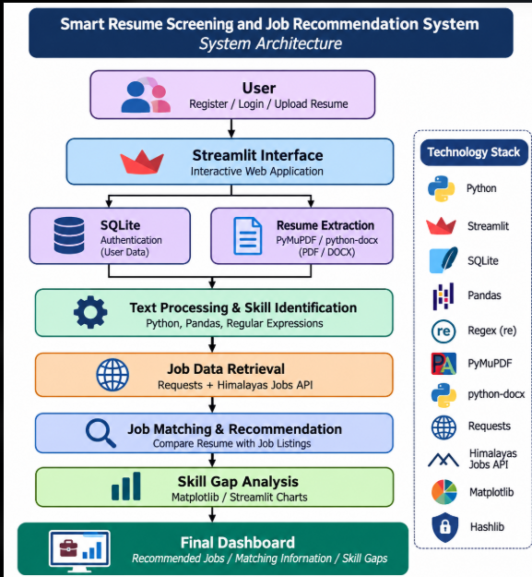
The system follows a modular architecture in which users upload resumes, the application extracts candidate information, retrieves job listings from the Himalayas Jobs API, processes the data and generates suitable job recommendations.
The overall workflow is:
User → Streamlit Interface → Resume Extraction → Text Processing → Skill Identification → Job Data Retrieval → Job Matching and Recommendation → Skill Gap Analysis → Dashboard.

4.2 Description of System Modules
1. User Input Layer
This layer allows users to register, log in and upload their resumes in supported formats such as PDF and DOCX. It provides an interactive interface for accessing the system features.
2. User Authentication Layer
This layer manages user registration and login functionality. SQLite is used to store user account information, while Hashlib is used for password hashing to improve security.
3. Resume Extraction Layer
This layer extracts text from uploaded resumes using PyMuPDF (fitz) for PDF files and python-docx for DOCX files. The extracted content is used for further processing and analysis.
4. Text Preprocessing Layer
The extracted resume text is cleaned and processed using Python and Regular Expressions. Unnecessary characters and unwanted formatting are handled to prepare the content for skill identification.

5. Skill Identification Layer
This layer identifies relevant technical skills and keywords from the extracted resume text. Pandas and Regular Expressions help organize and process the identified information.
6. Job Data Retrieval Layer
This layer connects to the Himalayas Jobs API using the Requests library. It retrieves job listings, company details and job descriptions to provide available job opportunities.
7. Job Matching and Recommendation Layer
This layer compares the candidate's extracted skills and profile information with available job descriptions. Based on the relevant information, the system identifies and displays suitable job opportunities.
8. Skill Gap Analysis Layer
This layer identifies skills that are missing or required for selected job opportunities. It helps candidates understand which additional skills they need to develop. Matplotlib and Streamlit Charts are used to visualize skill-related information.
9. Result and Dashboard Layer
This layer displays extracted resume information, recommended job opportunities and skill-gap visualizations through an interactive Streamlit dashboard.
4.3 Application Execution Architecture
The application is designed to run locally using Python and Streamlit.
The user starts the application from the project directory using the Streamlit command. Streamlit creates a local web interface that can be accessed through a web browser.
Users can register or log in and upload their resumes in PDF or DOCX format. The application extracts the resume content using the appropriate document-processing libraries.
The extracted information is processed using Python, Pandas and Regular Expressions to identify relevant skills. The application then retrieves available job listings from the Himalayas Jobs API using Requests.
The system processes job descriptions and compares relevant candidate information with available job opportunities to generate recommendations.
Finally, the application displays job listings, relevant candidate information and skill-gap visualizations on the interactive dashboard.
This architecture provides a simple and user-friendly platform for automated resume screening and job recommendation.
CHAPTER 5
Design
5.1 User Interface Design and Screenshots
The application is designed with a simple, interactive and user-friendly interface using Streamlit. It provides different sections to perform resume screening, company exploration, job recommendation and skill gap analysis.
The main interface contains the following sections:
1. Login and Registration Screen
Allows users to create accounts, log in and securely access the application.
2. Resume Upload Section
Allows users to upload their resumes in PDF or DOCX format for analysis.
3. Resume Intelligence Dashboard
Displays extracted resume information, detected skills, resume details and categorized technical and professional skills.
4. Company Intelligence Section
Allows users to search for specific skills and discover companies hiring candidates with those skills.
5. Company Job Explorer
Displays job opportunities available at selected companies, including job titles, employment types and job descriptions.
6. Job Recommendation Section
Displays relevant job opportunities along with resume matching percentages to help candidates identify suitable positions.
7. Skill Gap Analysis Dashboard
Displays matched skills and missing skills by comparing candidate skills with job requirements. It also provides graphical visualizations of skill gaps.
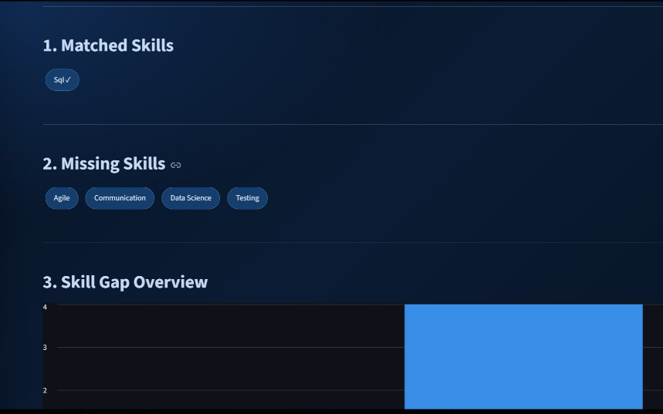
5.2 System Workflow / Data Flow Diagram
In this project, the user first registers or logs in and uploads a resume in PDF or DOCX format. The application extracts the resume text and processes it to identify relevant skills and candidate information.
The system retrieves job listings and company information from the Himalayas Jobs API. The extracted resume skills are compared with the job requirements to identify suitable job opportunities and calculate matching scores.
The system also performs skill gap analysis by identifying matched and missing skills. Finally, the results are displayed through the Streamlit dashboard using job listings, matching percentages and graphical visualizations.
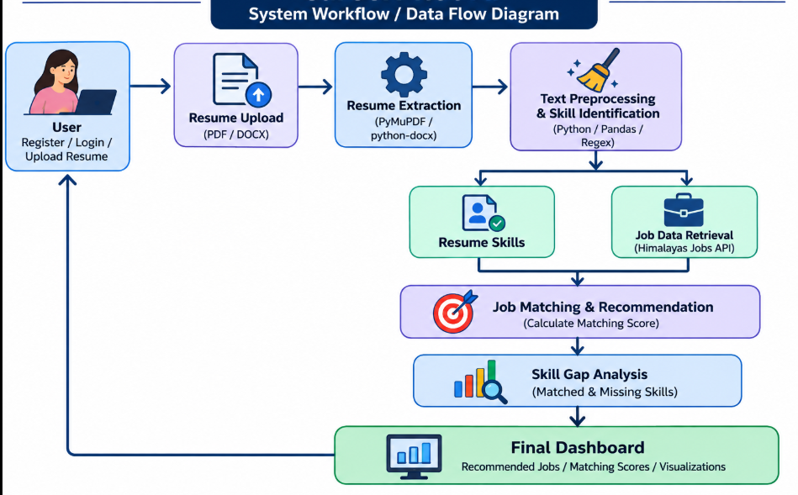

CHAPTER 6
Implementation
6.1 Module-wise Implementation
The project is divided into four major modules.
Module 1: User Input Module
This module allows users to register or log in to the system and upload their resumes in PDF or DOCX format. Users can provide their resume details for further analysis and job recommendations.
Input: User login details and resume file (PDF/DOCX).
Output: Uploaded resume ready for text extraction and processing.
Module 2: Resume Preprocessing Module
This module prepares the uploaded resume for analysis. It extracts text from PDF or DOCX files, removes unnecessary formatting and HTML content, and converts the extracted information into readable text. This processed text is then used for skill identification and job matching.
Input: Uploaded resume (PDF/DOCX).
Output: Extracted and cleaned resume text ready for skill extraction and analysis.

Module 3: Resume Skill Extraction Module
This module identifies important skills from the extracted resume text using predefined skill keywords and regular expressions. It categorizes the detected skills into relevant technical domains such as programming languages, databases, web development, and data analytics.
Input: Extracted and cleaned resume text.
Output: Identified skills and categorized skill profile ready for job matching.
Module 4: Job Matching and Recommendation Module
This module compares the skills extracted from the user's resume with the skills and requirements mentioned in available job descriptions. It calculates a resume-job match percentage, identifies matching and missing skills, and provides relevant job recommendations and learning suggestions.
Input: Extracted resume skills and job description details.
Output: Job match percentage, matched skills, missing skills, recommended jobs, and skill-gap analysis.
6.2 User Input and Resume Upload
The User Input Module allows users to register or log in to the Smart Resume Screening and Job Recommendation System. After logging in, users can upload their resumes in PDF or DOCX format through the application interface.
The uploaded resume is accepted by the system and passed to the Resume Preprocessing Module for text extraction and cleaning. The extracted information is then used for skill identification and job recommendations.
  - Resume Preprocessing
Resume preprocessing is an important step because the system needs clean and readable text to identify skills and match job requirements.
The following operations are performed:
Resume Text Extraction:
Text is extracted from uploaded PDF and DOCX resume files using PyMuPDF and python-docx.
HTML Tag Removal:
Unnecessary HTML tags and formatting are removed from job descriptions to obtain readable text.
Text Cleaning:
Unnecessary content and formatting are cleaned to make the extracted information suitable for analysis.
Skill Identification Preparation:
The cleaned resume text is prepared for identifying technical skills using predefined keywords and regular expressions.
Text Processing:
The extracted information is converted into a readable text format that can be compared with job descriptions.
After preprocessing, the resume is represented as clean text ready for skill extraction and job matching.
6.4 Resume Skill Extraction Implementation
The Resume Skill Extraction module identifies relevant skills from the uploaded resume using predefined skill keywords and Regular Expressions (Regex).
The algorithm follows these steps:
- Load the extracted and cleaned resume text.
- Compare the resume text with predefined skill keywords.
- Identify the skills present in the resume using keyword matching.
- Categorize the identified skills into relevant technical domains.
- Generate a skill profile for further job matching.
The skill extraction module helps identify the user's technical abilities and prepares the information for comparing resumes with available job requirements.
Input: Extracted and cleaned resume text.
Output: Identified technical skills and categorized skill profile.
6.5 Job Recommendation and Skill Gap Analysis Implementation
The Job Recommendation module helps users find suitable job opportunities based on their resume skills and job requirements.
The module follows these steps:
- Retrieve available job listings from the Himalayas Jobs API.
- Identify the skills required for each job.
- Compare the user's resume skills with the job requirements.
- Calculate the resume-job matching percentage using keyword-based matching.
- Identify matched skills and missing skills.
- Display suitable job recommendations and learning suggestions.
The module helps users understand how well their resumes match available job opportunities and identify the skills they need to improve.
  - Job Matching and Performance Analysis
After skill extraction, the system compares the user's resume skills with the skills required by available job listings.
The application displays the matching results to help users understand their suitability for different job opportunities.
The analysis dashboard displays:
- Resume-job matching percentage.
- Matched skills.
- Missing skills.
- Recommended job listings.
- Company-wise job opportunities.
- Skill gap analysis.
- Learning recommendations.
The system uses keyword-based matching to calculate compatibility between the resume and job descriptions.

CHAPTER 7
Feature
  - List of Main Features
The major features of the application are:
1.User Registration and Login.
2.Resume Upload (PDF and DOCX formats).
3.Automatic Resume Text Extraction.
4.Resume Text Preprocessing and Cleaning.
5.Technical Skill Identification.
6.Skill Categorization.
7.Company Exploration.
8.Skill-Based Job Search.
9.Company-Wise Job Listings.
10.Resume-Job Matching Percentage.
11.Matched and Missing Skills Identification.
12.Skill Gap Analysis.
13.Job Recommendations.
14.Learning Recommendations.
15.Interactive Dashboard.

7.2 Working of Each Feature
User Registration and Login:
The user creates an account by entering the required details and logs in using their credentials. The system verifies the login information using the SQLite database and provides access to the application after successful authentication.
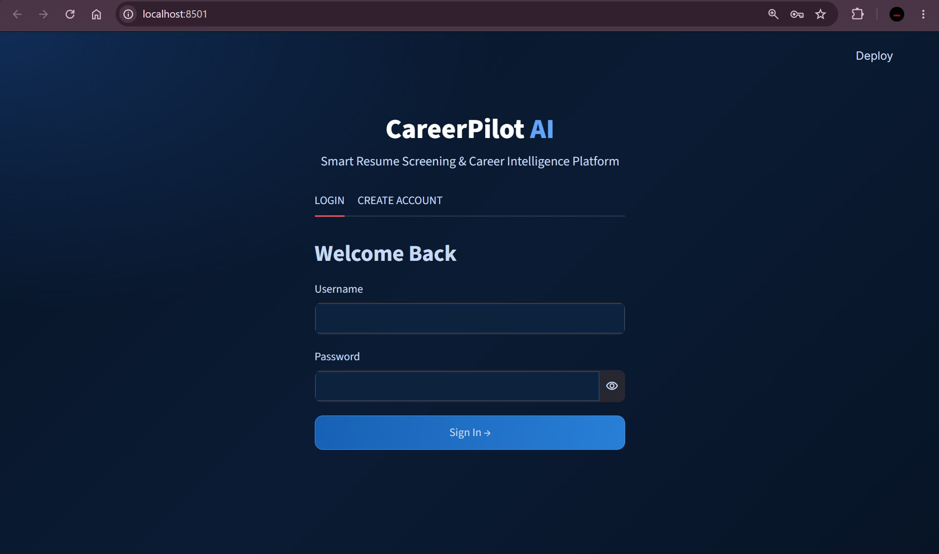
Resume Upload:
The user selects a resume file from their computer in PDF or DOCX format. The application reads the uploaded file and sends it to the resume preprocessing module for text extraction and cleaning.
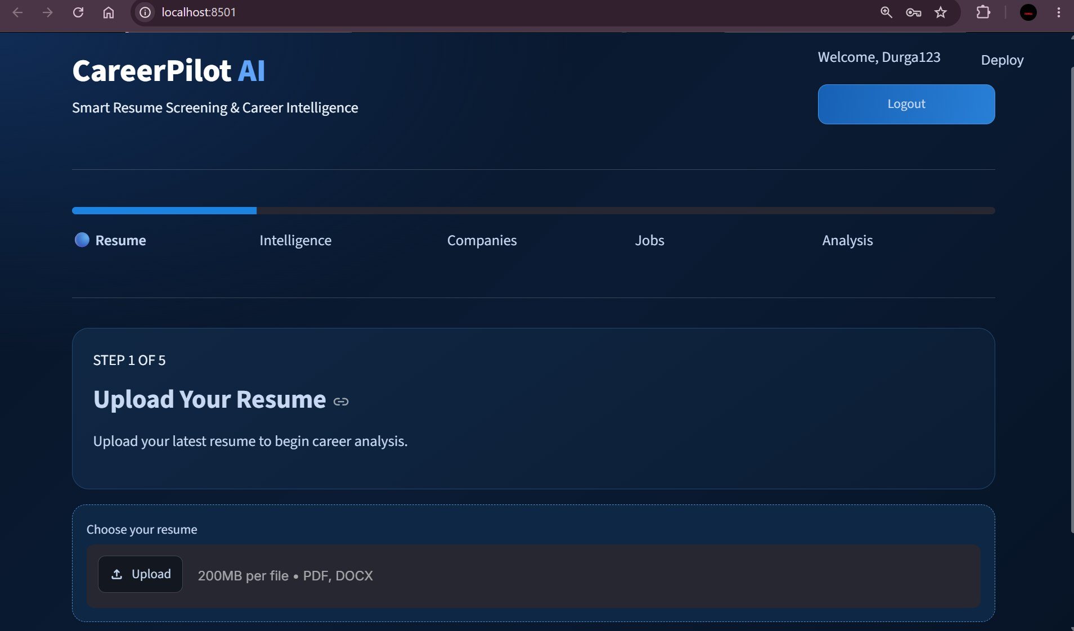
Resume Preprocessing:
The uploaded resume is processed to extract readable text. The system removes unnecessary HTML tags and formatting, cleans the extracted content, and prepares the text for skill identification and job matching.
Resume Skill Extraction:
The system analyzes the extracted resume text and identifies technical skills using predefined keywords and regular expressions. The detected skills are categorized and prepared for comparison with available job requirements.
Company and Job Exploration:
The application retrieves available companies and job listings from the Himalayas Jobs API. Users can search for opportunities based on skills and explore job openings offered by different companies.
Resume-Job Matching:
The system compares the skills extracted from the user's resume with the skills required in job descriptions. It calculates a matching percentage and displays the matched and missing skills.
Job Recommendation and Skill Gap Analysis:
The application displays suitable job opportunities based on resume skills. It also identifies missing skills and provides learning recommendations to help users improve their job compatibility.
7.3 Resume Upload and User Authentication
The application provides a secure login and registration system for users to access the platform.
After logging in, users can upload their existing resumes in PDF or DOCX format. The uploaded resume is processed by the system to extract relevant
information, identify technical skills, and provide suitable job recommendations.

7.4 Resume Analysis and Job Matching Dashboard
The application provides an interactive dashboard to display resume analysis and job matching results.
The dashboard displays:
Extracted technical skills from the resume.
Available companies and job openings.
Resume-job matching percentage.
Matched and missing skills.
Skill gap analysis.
Job recommendations.
Learning suggestions.
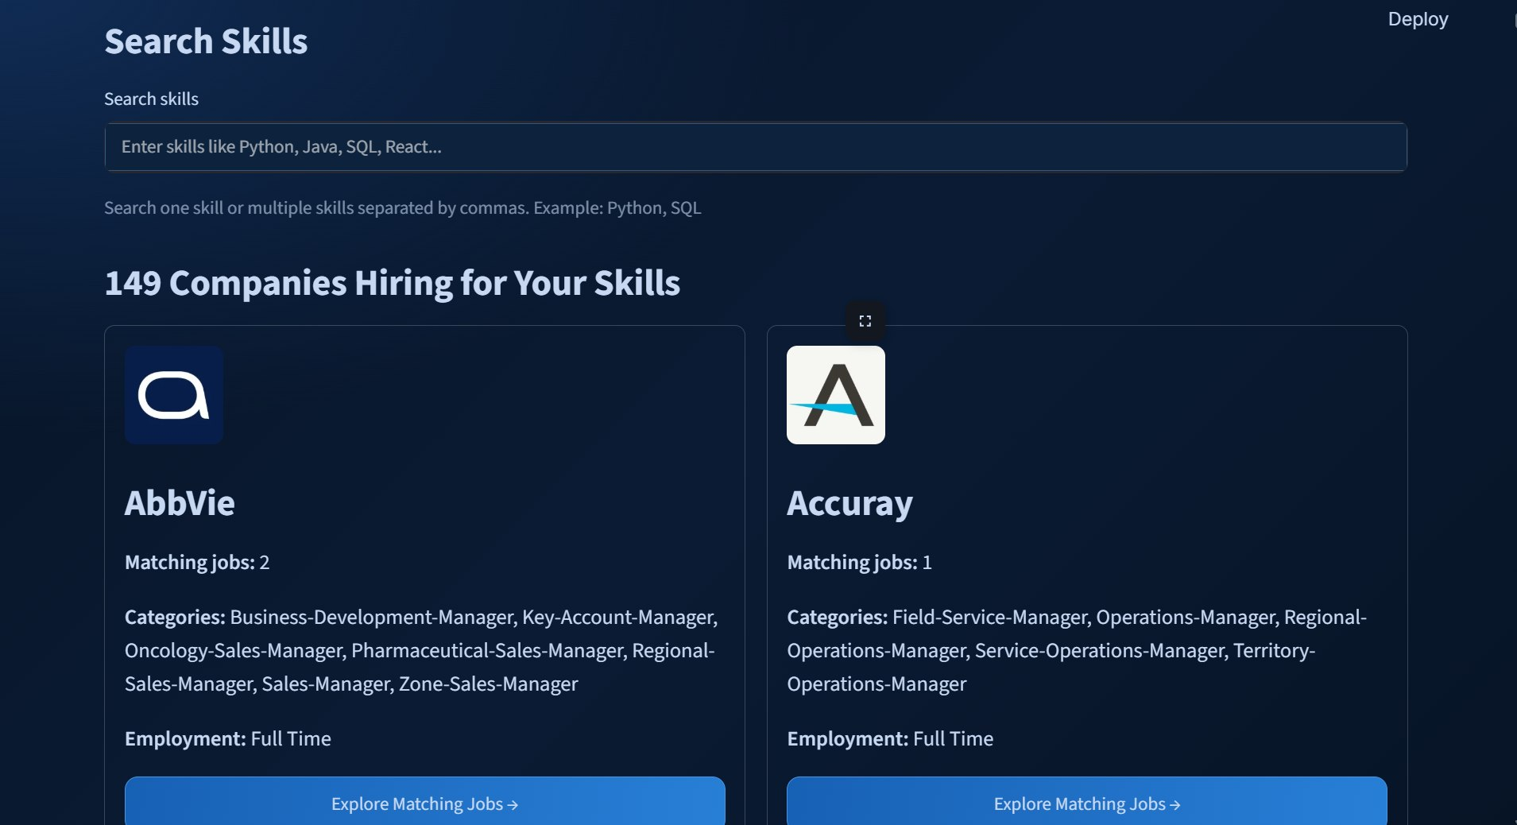

CHAPTER 8
Testing
8.1 Functional Testing
Functional testing is performed to verify whether the main features of the Smart Resume Screening and Job Recommendation System work as expected.
The following operations are tested:
- User registration with valid details.
- User login with correct credentials.
- Uploading a resume in PDF format.
- Uploading a resume in DOCX format.
- Extracting text from the uploaded resume.
- Preprocessing and cleaning resume text.
- Identifying technical skills from the resume.
- Displaying categorized skills.
- Loading company and job listings from the Himalayas Jobs API.
- Searching for jobs based on skills.
- Viewing company-wise job openings.
- Calculating resume-job matching percentage.
- Displaying matched and missing skills.
- Viewing skill gap analysis.
- Displaying job and learning recommendations.

8.2 Integration Testing
Integration testing checks whether the different modules of the Smart Resume Screening and Job Recommendation System work together correctly.
The following sequence is verified:
The user registers or logs in to the application.
The user uploads a resume in PDF or DOCX format.
The resume preprocessing module extracts and cleans the text.
The skill extraction module identifies technical skills from the resume.
The application retrieves company and job listings from the Himalayas Jobs API.
The system compares the extracted resume skills with job requirements.
The job matching module calculates the matching percentage.
The results, including matched skills, missing skills, and job recommendations, are displayed on the dashboard.
8.3 Tools Used for Testing
  - Python: Application execution.
  - Streamlit: User interface testing.
  - SQLite: Database testing.
  - Pandas: Data processing.
  - Requests: API testing.
  - PyMuPDF: PDF text extraction testing.
  - python-docx: DOCX text extraction testing.
  - VS Code: Development and debugging.

8.4 Test Cases and Results
Test Case | Expected Result | Status
User Registration | Account created successfully | Pass
User Login | User logged in successfully | Pass
PDF Resume Upload | Resume uploaded successfully | Pass
DOCX Resume Upload | Resume uploaded successfully | Pass
Text Extraction | Resume text extracted | Pass
Skill Identification | Technical skills detected | Pass
Company Search | Matching companies displayed | Pass
Job Listings | Available jobs displayed | Pass
Resume-Job Matching | Match percentage calculated | Pass
Skill Gap Analysis | Matched and missing skills displayed | Pass
Job Recommendations | Relevant jobs displayed | Pass

SVM achieved 97.67% accuracy, while KNN achieved 97.05% accuracy.
Therefore, SVM performed slightly better on the evaluated MNIST test dataset.
CHAPTER 9
Deployment
The application can be executed locally using the following steps:
The application can be executed locally using the following steps:
- Install Python on the computer.
- Open the project folder in Visual Studio Code.
- Create a Python virtual environment.
- Activate the virtual environment.
- Install the required Python libraries.
- Ensure that the app.py file is available in the project folder.
- Run the Streamlit application
- Command to execute the application:
python -m streamlit run app.py
- After executing the command, Streamlit displays a local URL in the terminal.
- Open that URL in a web browser to access the Smart Resume Screening and Job Recommendation System.

9.2 Python Environment Configuration
The project uses a Python virtual environment to manage the required libraries and dependencies.
The environment includes the necessary packages for resume text extraction, data processing, skill identification, API integration, and application development.
The required libraries are installed using the following command:
pip install streamlit pandas requests pymupdf python-docx
The virtual environment helps maintain the project dependencies separately.

9.3 Local Application Execution
The application runs locally using Streamlit. The user interface and application logic are handled within the same Python environment.
The application retrieves job listings through the Himalayas Jobs API and displays resume analysis and job recommendations in the browser.
Separate frontend and backend hosting are not required for the current implementation.

CHAPTER 10
Challenges and Limitations
10.1 Issues Faced During Development
During the development of this project, we faced several challenges.
Different Resume Formats:
Resumes are available in different formats, such as PDF and DOCX. Extracting information consistently from different layouts can be challenging.
Unstructured Resume Content:
Candidates use different writing styles, layouts, and formats to describe their qualifications, skills, and experience.
Skill Identification:
Identifying technical skills, professional skills, and qualifications accurately from resume text can be difficult.
Different Job Descriptions:
Job descriptions may use different words and terms to represent similar skills and requirements.
Resume and Job Matching:
Comparing candidate profiles with job descriptions and generating relevant matching scores requires proper text processing and similarity calculations.
Data Availability:
Collecting updated job descriptions and maintaining accurate information about required skills can be challenging.
10.2 Solutions Applied
The following solutions were applied:
- Resume text extraction is performed using suitable PDF and DOCX processing libraries.
- Text preprocessing is used to remove unwanted characters and unnecessary words.
- Skill identification is performed using predefined skill lists and text-matching techniques.
- Similar skills and keywords are standardized to improve matching.
- TF-IDF is used to convert resume and job-description text into numerical vectors.
- Cosine Similarity is used to calculate similarity scores between resumes and job descriptions.
- Matching scores are used to rank suitable job opportunities.
- Skill-gap analysis is used to identify missing skills.
- Streamlit is used to display results through an interactive dashboard.
10.3 Current Limitations
The current system has the following limitations:
- The system mainly supports PDF and DOCX resume formats.
- Scanned resumes may require OCR technology for text extraction.
- Incorrectly formatted resumes may affect information extraction.
- The system may not identify every skill mentioned in a resume.
- Job recommendations depend on the availability and quality of job descriptions.
- TF-IDF and Cosine Similarity mainly focus on text similarity and may not fully understand the meaning of sentences.
- Similarity scores do not guarantee that a candidate is suitable for a job.
- The system may not fully understand synonyms and technical abbreviations.
- The accuracy of recommendations depends on the quality of resume and job data.
- The system requires regular updates to include new job roles and changing skill requirements.

CHAPTER 11
Future Enhancements

11.1 Planned Features
The project can be extended with additional features to improve resume analysis and job recommendations.

11.2 AI and NLP Integration
In future development, advanced AI and Natural Language Processing (NLP) techniques can be implemented to improve resume analysis, skill extraction, and job matching accuracy.

11.3 Advanced Job Recommendations and Cloud Deployment
The application can be extended to provide personalized job recommendations based on users' skills, qualifications, and experience. Cloud deployment can also be introduced to make the application accessible online without requiring local installation.
CHAPTER 12
Conclusion
12.1 Summary of the Project

Conclusion

12.1 Summary of the Project
The project "Smart Resume Screening and Job Recommendation System" was developed as an interactive web application using Python and Streamlit.
The system allows users to upload resumes in PDF and DOCX formats. It extracts resume information, identifies technical skills, and compares them with available job requirements retrieved through the Himalayas Jobs API.
The application calculates resume-job matching percentages and displays matched skills, missing skills, job recommendations, and skill gap analysis.
The project demonstrates how resume processing, skill identification, and job data integration can help users explore suitable career opportunities.

12.2 What Was Achieved
The major achievements of the project include:
- Developed an interactive resume screening application.
- Implemented user registration and login.
- Added PDF and DOCX resume upload functionality.
- Implemented resume text extraction and preprocessing.
- Identified and categorized technical skills.
- Integrated the Himalayas Jobs API.
- Implemented skill-based job searching.
- Developed resume-job matching functionality.
- Displayed matched and missing skills.
- Provided job and learning recommendations.

12.3 Skills Learned During Development
Through this project, we gained practical experience in:
- Python programming.
- Streamlit application development.
- SQLite database management.
- Resume text extraction.
- Text preprocessing.
- Regular Expressions.
- API integration.
- Data processing using Pandas.
- Job matching techniques.
- Dashboard development and documentation.

CHAPTER 13
References
1. Python Software Foundation, Python Documentation. Available at: https://docs.python.org/3/
2. Streamlit Documentation. Available at: https://docs.streamlit.io/
3. SQLite Documentation. Available at: https://www.sqlite.org/docs.html
4. Pandas Documentation. Available at: https://pandas.pydata.org/docs/
5. Requests Library Documentation. Available at: https://requests.readthedocs.io/
6. PyMuPDF Documentation. Available at: https://pymupdf.readthedocs.io/
7. python-docx Documentation. Available at: https://python-docx.readthedocs.io/
8. Himalayas, Remote Jobs API Documentation. Available at: https://himalayas.app/docs/remote-jobs-api
Himalayas+1
9. Python Regular Expression Documentation. Available at: https://docs.python.org/3/library/re.html
10. Visual Studio Code Documentation. Available at: https://code.visualstudio.com/docs
CHAPTER 14
Appendices
14.1 Application Screenshots
The following screenshots demonstrate the working of the application:
- Main application interface.
- User registration and login page.
- Resume upload section.
- Resume text extraction and preprocessing.
- Extracted resume skills display.
- Company exploration page.
- Skill-based job search.
- Company-wise job listings.
- Resume-job matching results.
- Skill gap analysis dashboard.
- Job recommendations and learning suggestions.

14.2 Sample Code Snippets
The following is a simplified example of resume skill extraction and job matching.
import redef extract_skills(text, skill_terms): found_skills = [] for skill in skill_terms:
if re.search(r"\b" + re.escape(skill) + r"\b",
text, re.IGNORECASE found_skills.append(skill)
return
found_skillsdef calculate_match(resume_skills, job_skills):
matched = set(resume skills) & set(job skills)
if len(job skills) == 0: return 0
percentage = (len(matched) / len(job skills)) * 100
return round(percentage, 2)

14.3 Installation and Setup Instructions
Step 1: Install Python 3.x.
Step 2: Open the project folder in Visual Studio Code.
Step 3: Activate the virtual environment.
venv\Scripts\activate.bat
Step 4: Install the required libraries.
python -m pip install streamlit pandas requests pymupdf python-docx
Step 5: Run the application.
python -m streamlit run app.py
Step 6: Open the local URL displayed in the terminal.

14.4 User Manual
The application can be used through the following steps:
- Open the Streamlit application in a browser.
- Register or log in to the application.
- Upload a resume in PDF or DOCX format.
- View the extracted resume information.
- Check the identified technical skills.
- Explore available companies.
- Search for jobs using required skills.
- Select a company to view its job openings.
- View resume-job matching percentages.
- Check matched and missing skills.
- View job recommendations and learning suggestions.

14.5 Team Contributions
G. Usha Sai Bhavani
- Developed the user interface.
- Worked on user registration and login.
- Implemented resume upload functionality.
P. Sri Durga
- Worked on resume text extraction.
- Implemented resume preprocessing.
- Developed technical skill identification.
Dharani Harika
- Worked on Himalayas Jobs API integration.
- Implemented job matching and recommendations.
- Worked on skill gap analysis and testing.
All team members contributed to project integration, debugging, testing, and documentation according to their actual work.

