–
Document ID: 126
Author(s): N Sathyaraj
Version: 1.0
Date: April 27, 2024

- Abstract…………………………………………………………………………………………………………..3
- Objective and Scope………………….………………………………………………………………………3
- Functional Requirements……………….………………………………………………………………….4
3.1 Login to the System………………………………………………………………………………………………………………….4
3.2 Search Bar…………………………………………………………………………………………………………………………………4
3.3 Filter Option………………………………………………………………………………………………………………………………4
3.4 Whish List………………………………………………………………………………………………………………………………… 4
3.5 Checkout Process………………………………………………………………………………………………………………………5
3.6 Payment Process……………………………………………………………………………………………………………………….5
3.7 Transaction Details……………………………………………………………………………………………………………………5
3.8 Order Tracking…………………………………………………………………………………………………………………………..6
3.9 Reporting……………………………………………………………………………………………………………………………………6
- Non-Functional Requirements……….……………………………………………………………………7
4.1 Security……………………………………………………………………………………………………………………………………7
4.2 Performance…………………………………………………………………………………………………………………………...7
4.3 Maintainability…………………………………………………………………………………………………………………………7
- Design……………………………………..….………………………………………………………………….8
5.1 High level design …………………………………………………………………………………………………………………….8
5.2 Low level design……………………………………………………………………………………………………………………….9
- Design…………………………………..….…………………………………………………………………..11
4.1 Flow Chart Diagram……………………………………………………………………………………………………………….11
6.2 Sequence Diagram…………………………………………………………………………………………………………………12
6.3 Class Diagram……………………………………………………………………………………………………………………….13
6.4 Use Case Diagram…………………………………………………………………………………………………………………14
- Test Cases………………………………..….………………………………………………………………..15

Abstract
Online shopping malls have become an important part of e-commerce, providing customers with convenience, accessibility, and choice that they have never had before. This abstract traces the origins, development, and influence of online shopping marts on contemporary consumer behaviour. Online shopping platforms started out as straightforward websites where customers could explore and buy goods. But as cell phones have become more common and technology has advanced, online shopping malls have developed into complex ecosystems with a wide range of features and services. These platforms constantly innovate to improve the buying experience, offering everything from virtual try-on experiences and personalised recommendations to secure payment channels and quicker delivery alternatives. The success of online shopping marts can be attributed in part to their capacity to operate beyond geographic boundaries. Allowing customers to quickly and easily access products from all over the world with a few clicks.

Objective and Scope
An online shopping app's primary goal is to provide consumers with a smooth, customised experience for easily perusing and buying goods. Enhancing customer satisfaction, streamlining operations, and utilising user feedback for ongoing improvement are its main objectives. It also plays a crucial role in brand promotion and business expansion.

The scope of the product includes the following basic features:
- The current system can be extended to allow the users to create accounts and save products in to wish list.
- The users could subscribe for price alerts which would enable them to receive messages when price for products fall below a particular level.
- The current system is confined only to the shopping cart process. It can be extended to have a easy to use check out process.
- Users can have multiple shipping and billing information saved. During checkout they can use the drag and drop feature to select shipping and billing information.
- Providing personalized suggestions based on user preferences and behaviour to boost engagement and promote recurring business.
- Delivering a streamlined and user-friendly interface featuring simple navigation, fast searches, and efficient checkout procedures.

Functional Requirements

Login to the system
Users of the Online Shopping System must have the ability to log in securely to access their accounts. This login functionality requires users to provide their username/email and password. Confidential 3 Aspire Systems SRS-Sathyaraj Additionally, the system should include a "Forgot Password" feature to enable users to reset their passwords if they forget them. Moreover, for user convenience, there may be an option for users to stay logged in using a "Remember Me" feature.

Search Bar
Online shopping apps' search bars act as users' personal assistants, assisting them in finding things with ease and speed. Users may find exactly what they need and stop scrolling endlessly by typing keywords. Search efficiency is further increased by features like auto-suggestions and filters, and voice search is more convenient—especially for users on mobile devices.

Filter Options
Users can filter their search results in online shopping carts according to particular parameters like price, brand, size, and colour. By streamlining the browsing process, this feature enables customers to locate products that suit their interests more rapidly. Filter choices improve customer satisfaction, lead to increased engagement and conversion rates, and shorten search times by making product selection simpler.

Whish List
By just clicking a button, users can add things to their wish list while perusing the online store. The chosen item is usually added to a customized list linked to the user's account in this manner. It gives consumers a central place to track items they want to buy in the future. Users can quickly return to their wish list to examine products they have saved, saving them from having to recall or search for individual items again.

Checkout Process
Users usually examine the things they have placed to their shopping basket before checking out. They can confirm each product's number, size, colour, and other details in this phase. Users click a "Checkout" or "Proceed to Checkout" button to begin the checkout process after examining their shopping cart.

They are taken to the checkout page by this action. Users are required to provide their shipping address and choose a preferred shipping method on the checkout page. Customers can be able to select from a variety of delivery and shipping alternatives, each with a price tag.

Payment Process
When a customer is ready to make a purchase, they proceed to the payment page where the online store's website connects with a payment gateway. This intermediary facilitates communication between the merchant's site and the payment processor. After selecting a payment method and entering necessary details like card information or accessing a digital wallet, the payment processor evaluates the transaction. If approved, the payment gateway notifies the merchant to process the order.

If declined, customers are informed and may try another payment method or seek assistance from their bank.

Transaction Details
Transaction data are essential for users to comprehend their completed purchases when buying online. Among them are:
3.7.1 Order Summary:
A synopsis of the products you've bought.

3.7.2 Total Cost:
The total amount paid, which takes into account discounts, shipping costs, and taxes.
3.7.3 Payment Information:
Specifics regarding the chosen mode of payment.
3.7.4 Shipping Details:
Address of delivery, time of arrival anticipated, and mode of transportation
3.7.5 Order Status:
Information about the order's current state, from processing to delivery.
3.7.6 Receipts/Invoices:
Digital records are available for record-keeping. These specifics guarantee openness and provide effective order tracking for users, making for a seamless online buying experience.

Order Tracking
Customers can track their orders in real-time, staying informed at every stage of delivery. The order tracking tool provides updates on confirmation, processing, shipping, and delivery status. Users can monitor their shipment's current location and estimated arrival time as it traverses the shipping network. Upon delivery, they receive confirmation, often including time, date, and recipient signature. Alerts notify customers of order status changes or delivery delays. Customer support is available for inquiries. With comprehensive tracking data, users prepare for shipments and address delivery concerns swiftly, ensuring convenience and peace of mind.
Transparent tracking features enhance the overall customer experience, fostering trust and satisfaction in online shopping platforms.

Reporting
Store administrators require access to reports and analytics to track sales performance, monitor inventory levels, and analyze customer behavior. The Online Shopping System should provide administrators with the capability to generate sales reports that detail performance metrics such as total revenue, number of orders, and top-selling products. Additionally, administrators should have access to inventory reports that provide insights into current stock levels, low-stock items, and product trends. Furthermore, the system should offer customer analytics reports that analyze behavior such as repeat purchases, average order value, and demographics to inform strategic decision-making.

Non-Functional Requirements

Security
For user data and transactions to be shielded from malicious activity, unauthorised access, and security breaches, security criteria are essential. These specifications cover authorization, encryption, authentication, and threat mitigation for typical security vulnerabilities.

To avoid interception or unwanted access, sensitive data, such as user passwords, payment information, and personal information, should be encrypted.User authorization and authentication should be implemented by the system to regulate access to particular capabilities according to user roles and permissions. It is important to take precautions against typical security risks including SQL injection, cross-site scripting (XSS) attacks, and other weaknesses that can jeopardise the system's confidentiality and integrity.

Performance
Performance standards make sure the Online Shopping System runs smoothly and offers a positive customer experience. These specifications centre on how quickly the system loads, how responsive it is, and how scalable it is to accommodate different user traffic volumes.

When a user clicks a link, adds anything to their basket, or completes the checkout process, the system ought to react quickly.In order to minimise waiting times for consumers and improve their browsing and buying experience, pages and content should load rapidly. It should be possible for the system to grow in size to handle spikes in user traffic during busy times, like holidays or special occasions, without noticeably degrading performance.

Maintainability
Platforms for online shopping are frequently built using a modular architecture, in which various parts and modules are rationally arranged and divided. Since modifications to individual modules don't impact the system as a whole, this modular architecture makes maintenance and updates easier.

Developers can successfully communicate, monitor changes to the software, and roll back to earlier versions as needed by implementing version control systems like Git. This guarantees that changes and updates may be handled methodically and that rollback processes are available in case they are required. Detailed documentation helps developers, administrators, and other stakeholders understand the platform's functionality, operation, and structure. This documentation includes code documentation, system architectural diagrams, and user manuals. Systems with thorough documentation are simpler to maintain and debug.

Design

High level design
An outline of the main parts and architecture of the online shopping system is given in the High-Level Design (HLD). It focuses on the system's general structure and the interactions between its many modules.

1 System architecture:
It describes the system's general architecture, including the placement of its parts and their interactions. Recognises the use of architectural patterns or styles, such as layered architecture, client-server architecture, or micro services architecture.

2 Data Flow and Control Flow:
It shows the data flow through the system from input to output and processing.
Defines the control flow, which includes the steps in the system's decision-making process and order of actions.

3 External Interfaces:
It describes the interfaces that connect to outside services, systems, or users. Describes the way the system communicates with outside resources including databases, user interfaces, and APIs.

4 Scalability and Performance Considerations:
Focuses on scalability needs, like the capacity to support future expansion or handle growing loads. Takes into account speed optimisations such load balancing, parallel processing, and caching techniques.
5 Security and Reliability:
It describes the security steps that are taken to guard the system from risks like unauthorised access and data leaks. Focuses on aspects of reliability that are necessary, like redundancy, fault tolerance, and disaster recovery plans.

6 Technology stack:
It describes the tools, frameworks, and technologies that will be utilised to put the system into place. Explains why each technology was chosen in light of the restrictions and requirements of the system.

7 Development approach:
It specifies the technique or development methodology to be used, such as DevOps, Waterfall, or Agile. Describes the stages, deliverables, and milestones of the development lifecycle.

8 Documentation and Communication:
It makes certain that the high-level design is thoroughly documented and shared with development teams, architects, and stakeholders in an efficient manner.

Low level design
Low-Level Design (LLD), which focuses on the internal operations of specific components defined in the high-level design, goes deeper into the implementation specifics of the system. It offers thorough specifications that programmers can utilise as a guide for creating and implementing code.

1 Module Details:
It divides each significant element included in the high-level design into more manageable modules or sections. Describes the functions, inputs, outputs, and processing logic of each module.

2 Data Structures and Algorithms:
It describes the data structures that will be utilised by the system to store and handle data. Explains algorithms and algorithms for basic tasks like data manipulation, sorting, and searching. Maximises the performance and efficiency of data structures and algorithms.

3 Database Design:
Creating the tables, columns, constraints, and relationships that make up the database structure. Outlines triggers, stored procedures, and SQL queries for retrieving and manipulating data. Describes the many kinds of data, indexing schemes, and normalisation methods that are used to guarantee data performance and integrity.

4 Class Design:
It show the classes and objects in the system. Creates interfaces and class hierarchies to encourage reusability and encapsulate behaviour.

5 Sequence Diagrams:
It shows how data and control are transferred across objects or components in a variety of contexts. Describes how parameters and messages are passed between objects in both synchronous and asynchronous communication.

6 Interfaces and APIs:
Creating the APIs and interfaces to allow external users to communicate with the system. Details each API endpoint's parameters, error handling, return types, and method signatures.

7 Security and Implementation:
It implements the security mechanisms in places to guard the system against typical security flaws and attacks. Uses security best practices to stop security breaches, like parameterized queries, output encoding, and input validation.

Implementations

Flow Chart Diagram
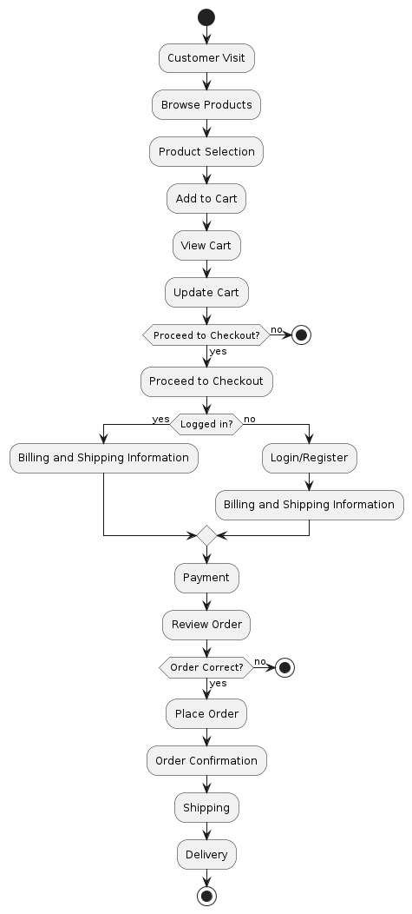

Sequence Diagram
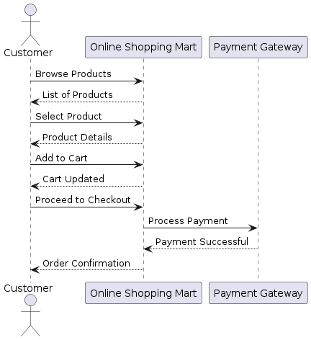

Class Diagram

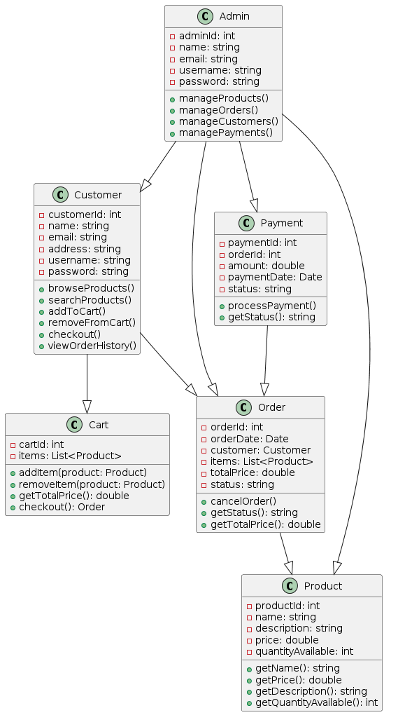

Use Case Diagram
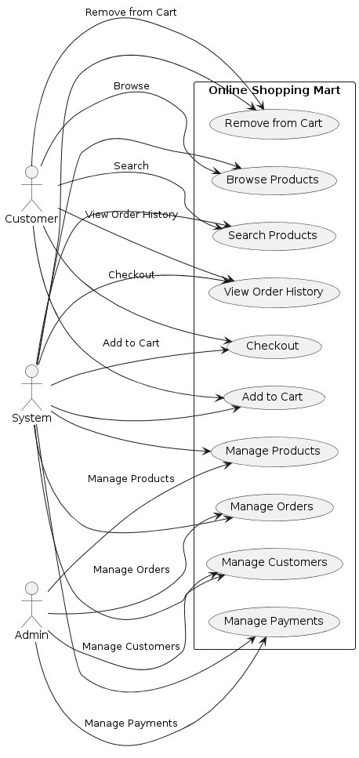

Test Cases
1.User Registration:
Test case 1: Verify successful registration with valid credentials.
Test case 2: Verify registration failure with an invalid email format.
Test case 3: Verify registration failure with a weak password.
Test case 4: Verify registration failure with an existing username.
2.User Login:
Test case 5: Verify successful login with correct credentials.
Test case 6: Verify login failure with incorrect password.
Test case 7: Verify login failure with a non-existing username.
Test case 8: Verify login failure for a deactivated account.
3.Product Browsing:
Test case 10: Verify users can view the list of available products.
Test case 11: Verify users can filter products by category.
Test case 12: Verify users can sort products by price or popularity.
Test case 13: Verify users can view product details by clicking on a product.
Test case 14: Verify users can view product reviews and ratings.
4.Shopping Cart:
Test case 15: Verify users can add products to the shopping cart.
Test case 16: Verify users can remove products from the shopping cart.
Test case 17: Verify users can update the quantity of products in the shopping cart.
Test case 18: Verify the shopping cart retains items after user logout/login.
5.Checkout Process:
Test case 19: Verify users can proceed to checkout with items in the shopping cart.
Test case 20: Verify users can enter shipping details.
Test case 21: Verify users can select a payment method.
Test case 22: Verify users receive an order confirmation after successful checkout.
6.Order Management:
Test case 26: Verify users can view their order history.
Test case 27: Verify users can track the status of their orders.
Test case 28: Verify users can cancel an order before shipment.
Test case 29: Verify users receive email notifications for order updates.
Test case 30: Verify users can contact customer support for order-related inquiries.

