Retail Sales Analytics & Customer Intelligence System
(Roadmap)

Title: Retail Sales Analytics & Customer Intelligence System

Domain Retail Analysis Dataset
I recommend using three benchmark datasets together:
- Superstore Sales Dataset (Kaggle) (retail sales, customer, product, and profit analysis)
https://www.kaggle.com/datasets/vivek468/superstore-dataset-final
- Sample Superstore Dataset (Tableau) (business intelligence and dashboard analysis)
https://www.tableau.com/support/sample-data
- Global Superstore Dataset (Kaggle) (large-scale retail sales across multiple regions for advanced analytics)
https://www.kaggle.com/datasets/apoorvaappz/global-super-store-dataset
All the 3 are famous Valid Datasets. All are to be considered in the Project.

Abstract
The Retail Sales Analytics & Customer Intelligence System is an end-to-end data science project designed to analyze retail transactions, predict sales, identify valuable customers, evaluate business scenarios, and support data-driven decision-making. Retail organizations collect large volumes of transactional data on customers, products, sales, profits, discounts, and regional performance, but this raw data provides value only when it is cleaned, analyzed, and converted into actionable insights.
The project uses the Global Superstore dataset. Data preprocessing is carried out in Python using Pandas and NumPy, covering inspection, missing-value and duplicate checks, date conversion, and outlier analysis. A detailed Exploratory Data Analysis (EDA) follows, covering univariate, bivariate, and multivariate analysis, correlation, sales trends, customer behavior, product, regional, profit, and discount analysis, and customer segmentation analysis. Feature engineering and feature selection then prepare the final predictor set.
Machine learning models (Linear Regression, Decision Tree, Random Forest, and XGBoost) and deep-learning models (LSTM and GRU) are trained for sales prediction. Four hybrid configurations (LSTM + XGBoost, LSTM + Random Forest, GRU + XGBoost, and GRU + Random Forest) are evaluated, and the feature-level temporal-fusion model TATFF-XGBLSTM (LSTM + XGBoost) is selected as the proposed model based on its MAE, RMSE, and R² results among the hybrids. Models are compared using MAE, MSE, RMSE, R², MAPE, and SMAPE.
Beyond prediction, the project performs RFM-based customer analysis, K-Means customer segmentation, Customer Lifetime Value (CLV) analysis, and discount and quantity scenario analysis. SHAP and LIME explain the standalone XGBoost sales-prediction model. The data is stored and queried in a MySQL database (sales_data table in the retail_analytics database), and the findings are presented in a seven-page Power BI dashboard.
The project does not claim that combining LSTM and XGBoost is entirely new. Its contribution is the implementation and systematic evaluation of a feature-level temporal-fusion approach on the Global Superstore dataset, with comparisons across multiple alternative hybrid configurations.
Architecture Diagram (Complete Project Flow)

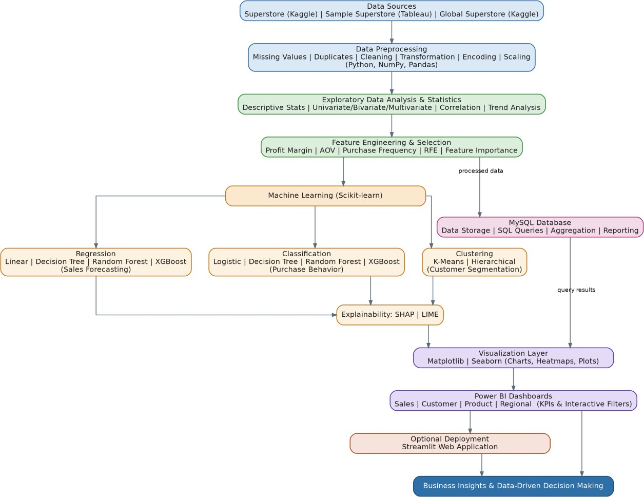
Approach:

Data Analytics
- EDA
- Raw Retail Sales Dataset
│
▼
Dataset Overview
│
▼
Data Quality Assessment
│
▼
Descriptive Statistics
│
▼
Missing Value Analysis
│
▼
Duplicate Record Detection
│
▼
Outlier Detection
│
▼ Univariate Analysis

│
▼
Bivariate Analysis
│
▼
Multivariate Analysis
│
▼
Correlation Analysis
│
▼
Sales Trend Analysis
│
▼
Customer Behavior Analysis
│
▼
Product Performance Analysis
│
▼
Regional Performance Analysis
│
▼
Profit & Discount Analysis
│
▼

Customer Segmentation Analysis

│
▼

Feature Engineering
│
▼ Feature Selection
│
▼
Machine Learning Models

- Dataset Overview and Descriptive Statistics
- Univariate Analysis
- Bivariate Analysis
- Multivariate Analysis
- Correlation Analysis
- Sales Trend Analysis
- Customer Behavior Analysis
- Product Performance Analysis
- Regional Performance Analysis
- Profit Analysis
- Discount Analysis
- Customer Segmentation Analysis
Preprocessing
- Dataset Loading (Pandas) and Structure Inspection
- Data Type Inspection
- Missing Value Analysis
- Duplicate Record Detection
- Date Type Conversion (Order Date and Ship Date)
- Descriptive Statistics
- Outlier Analysis (transaction records retained)
- Preprocessed Dataset Saved in Excel Format
Feature Engineering
- Date Features (Order Year, Month, Quarter, Week, Day of the Week, Weekend Indicator)
- Sales Features (derived variables and order-value measures)
- Customer Features (purchasing frequency and behavioral indicators)
- Product Features (product and category-related variables)
- Profit Features (derived variables and margin measures)
Feature Selection
- Correlation Analysis
- Numerical Feature Screening
- Categorical Feature Screening
- Feature Importance Analysis
ML Models
Regression
- Linear Regression
- Decision Tree Regressor
- Random Forest Regressor
- XGBoost Regressor
Deep Learning (Monthly Sales Forecasting)
- LSTM
- GRU
Hybrid Models
- LSTM + XGBoost (Proposed: TATFF-XGBLSTM)
- LSTM + Random Forest
- GRU + XGBoost
- GRU + Random Forest

Recommended Research Pipeline:
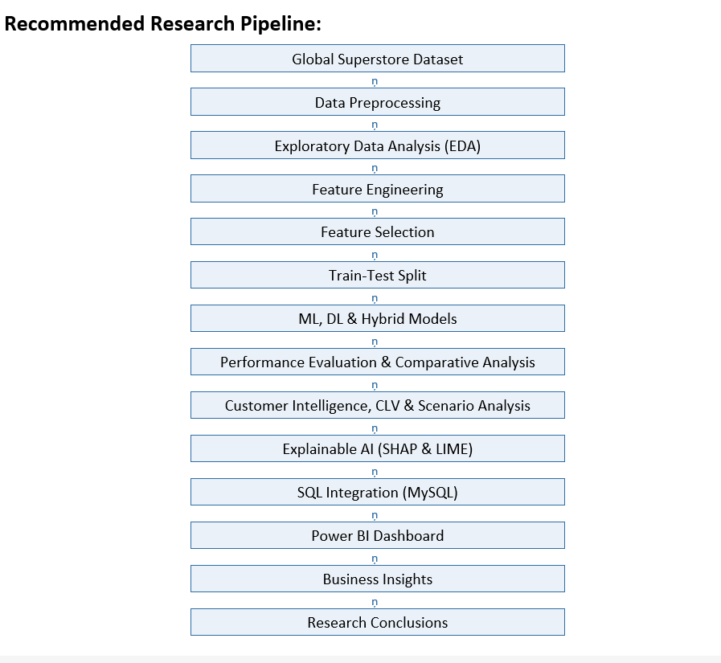

Tools Used
- Python
- Jupyter Notebook / Visual Studio Code (VS Code)
- NumPy

- Pandas
- Matplotlib
- Seaborn
- Scikit-learn
- MySQL
- MySQL Workbench
- Power BI
- Git
- GitHub

Group No:9
Name: SriHansika Roll No:2420030556 Name: J.Madhura Roll No:2420030535 Name: R.Lokesh Roll No:2420030534 Name: G.Charan Roll No:2420080042

