CB.EN.U4CSE22511  
Ehtesham Ali Haidar

**VERTEX AI - LAB PRACTICE**

**Enabling Vertex AI API**

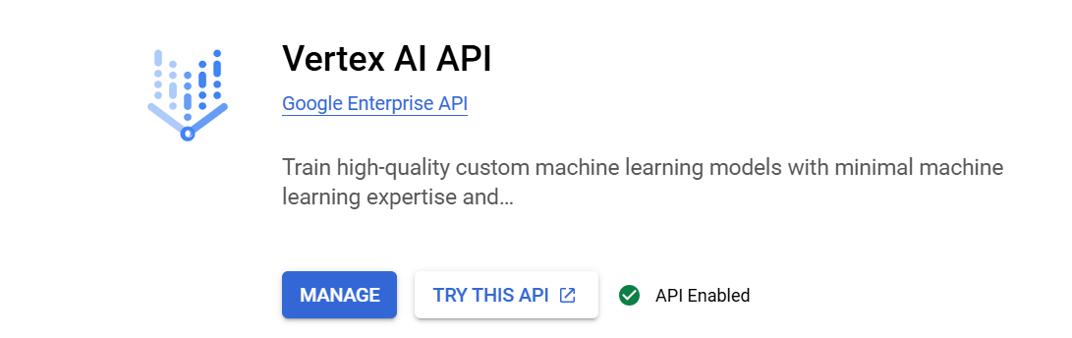

**Create a Service Account & Download JSON Key**  
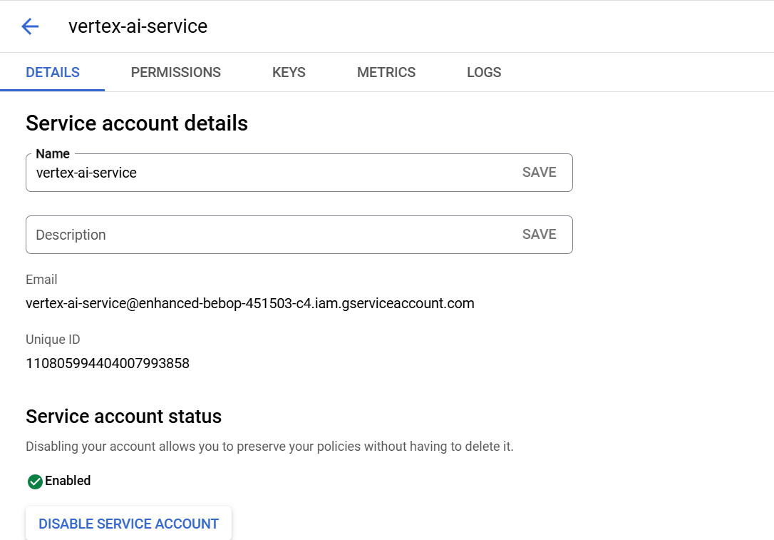

Key Generation



**Install Required Python Libraries**

bash

pip install google-auth google-auth-oauthlib google-auth-httplib2 google-auth-requests vertexai

**Python Script**

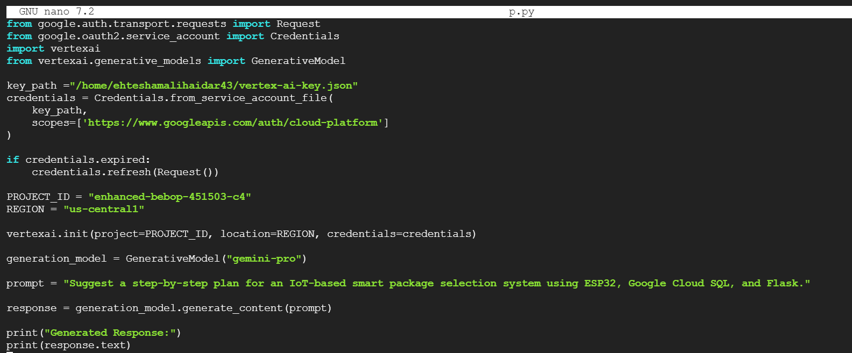

**Output**  
