VechileCount Documentation

- We need to install ffmpeg : https://www.gyan.dev/ffmpeg/builds/

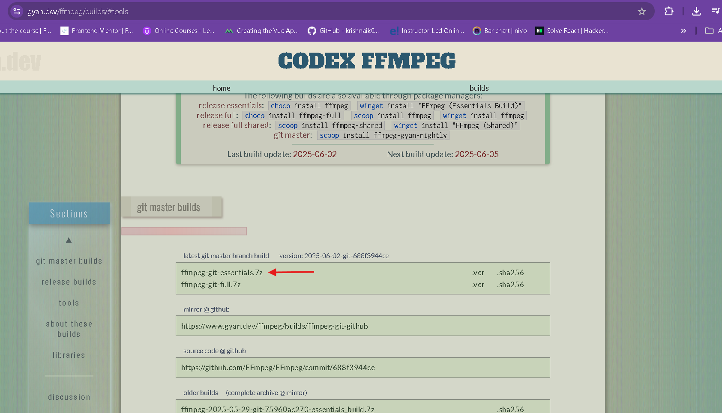

- After downloading it is in zip file extract the zip rename to ffmpeg and move the folder to C drive > program files (x86)
- Add to System PATH:
  - Open the ffmpeg folder and open bin in it then copy the location of it.
  - Press Win + S, type: environment and open Edit the system environment variables.
  - Click Environment Variables.
  - Under System variables, select Path and click Edit.
  - Then click ok to save.

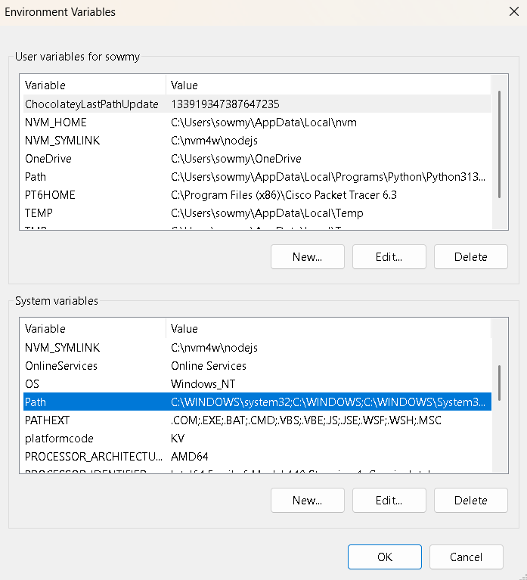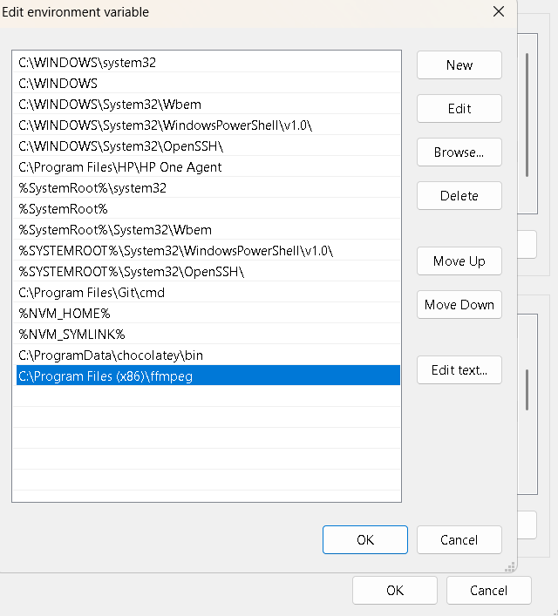

- Verify Installation
  - Open Command Prompt ( Win + R, type cmd and press enter)
ffmpeg -version run these command
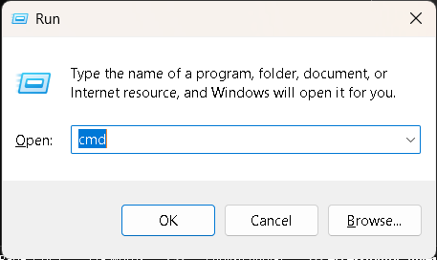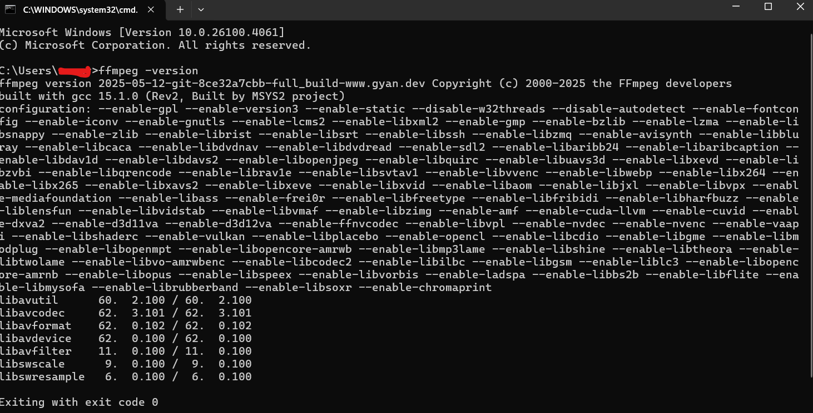

- Now open the dist folder then you will see the ProductKeyValidator.exc file double click it to run after running if have the product key it will run other wise it will ask for license key

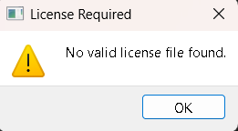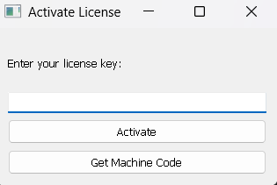
- After entering the license key it opens like
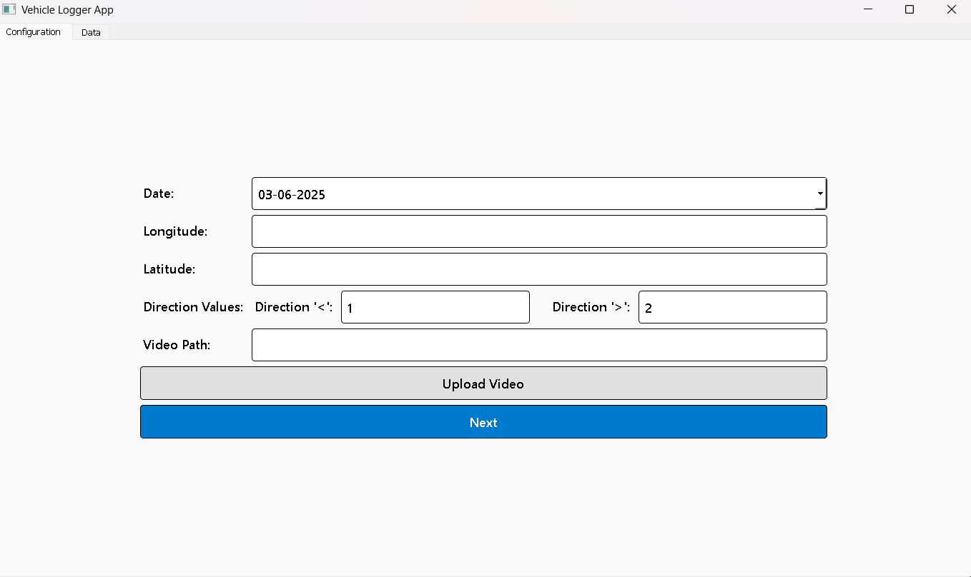

- Upload the video if the video size is >15mb its will take some time to compress the video after compressing the video it will add the file name to path as below
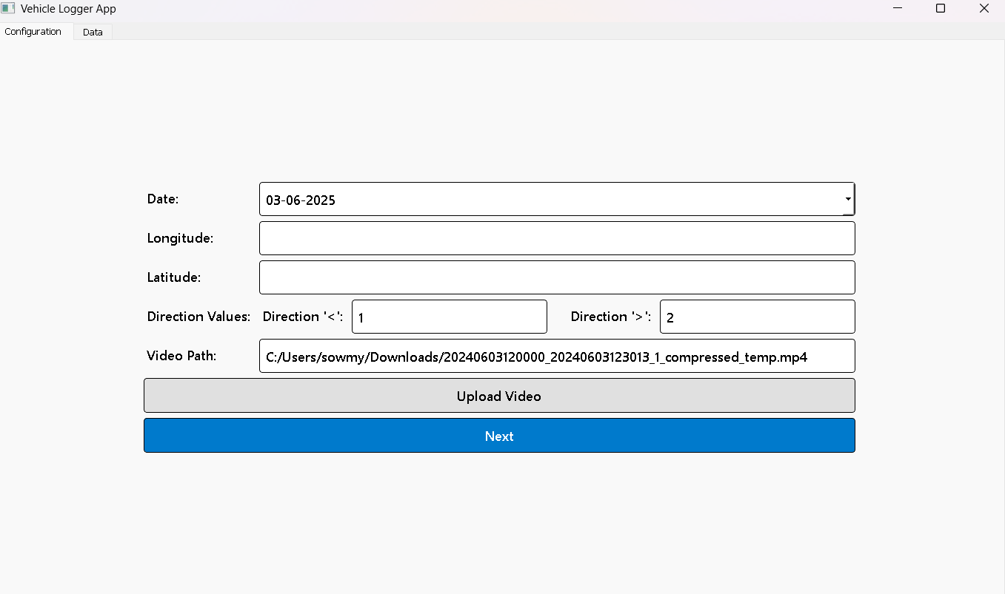

- Then click the next button the interface be like below
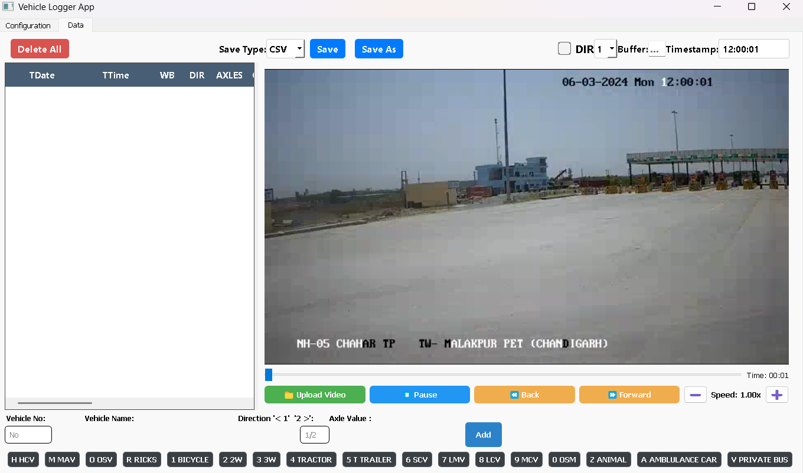

- It has features Like:
  - We can delete all the table data by clicking the Delete All button
  - We can save the logs in two type default CSV and other is EXCEL.
  - DIR indicates vehicle direction (by 1 or 2)
  - Buffer is meant to handle time delay

  - Timestamp: real-time video timestamp display (12:00:01)
  - Upload Video is used to upload new video by compressing if it > 15mb
  - The Forward and Back buttons in your Vehicle Logger App appear to control video scrubbing — jumping forward or backward by a few seconds.
  - The Vehicle No field is used to select the vehicle. After that, the focus moves to the Vehicle Name. Once a name is selected, the focus shifts to the Direction input. If the vehicle has an axle type, the focus then moves to the Axle input; otherwise, it moves directly to the Add button. Pressing Enter will add the log to the table.
Shortcut Vehicle Type
1 Bicycle
2 2 Wheeler
3 3 Wheeler Passenger, 3 Wheeler Goods
4 Tractor
5 Tractor with Trailer
6 SCV, Taxi, Shared Passenger
7 Light Motor Vehicle
8 LCV (4W), LCV (6W), Mini Bus
9 2 Axle Truck (MCV), 2 Axle Bus (MCV)
h / H 3 Axle Truck (HCV), 3 Axle Bus (HCV)
m / M MAV
o / O OSV
r / R Ricks
c / C Cons
0 OSM, OFM
z / Z Animal, Hand Drawn
a / A Ambulance Car, Ambulance Bus, Police Bus, Army Truck
v / V Private Bus, State Bus, School Bus

