**TITLE:**

**COLLEGE NETWORK HARDWARE DATABASE**

**Abstract:**

The database is designed to store information about network hardware connections. It maintains a comprehensive record of the various devices and their connections within the network infrastructure, including switches, routers, servers, and storage devices. The database also tracks configuration details, such as IP addresses, VLAN assignments, and port mappings, to ensure accurate and up-to-date documentation of the network topology. With this information, network administrators can quickly troubleshoot connectivity issues, plan for network expansion, and optimize performance.

**List of design requirements(Tables):**

DEVICE:

1. MAC address - CHAR(14)
2. IP address - CHAR(15)
3. Model - VARCHAR2(8)
4. Manufacturer - VARCHAR2(10)

CONNECTION:

1. From IP address - CHAR(15)
2. To IP address - CHAR(15)

USER:

1. User ID - VARCHAR2(10)
2. Department - VARCHAR(10)
3. IP address - CHAR(15)

SERVICE:

1. Type of service - VARCHAR(20)
2. Date of service - DATE
3. Serviced by - VARCHAR(20)
4. MAC address - CHAR(14)

WARRANTY:

1. MAC address - CHAR(14)
2. Expiry date - DATE
3. Installation date - DATE
4. Warranty Period - TINYINT(80)

**ER DIAGRAM:**

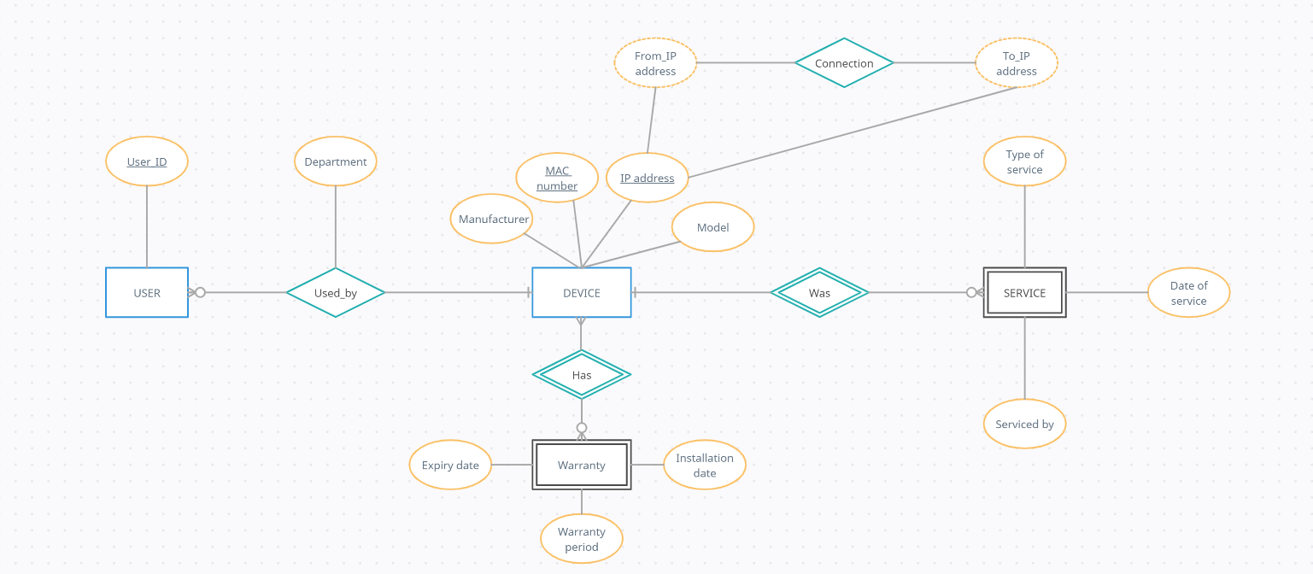

**Logical database design- DDL operations:**

**Syntaxes:**

CREATE TABLE DEVICE( mac_address CHAR(14),

ip_address CHAR(15),

model VARCHAR2(8),

manufacturer VARCHAR2(10) NOT NULL,

PRIMARY KEY(mac_address,ip_address));

CREATE TABLE CONNECTION( from_ip_address CHAR(15),

to_ip_address CHAR(15));

CREATE TABLE WARRANTY( mac_address CHAR(14),

expiry_date DATE,

installation_date DATE,

warranty_period int);

alter table device drop primary key;

alter table device add primary key(mac_address);

alter table warranty ADD CONSTRAINT mac_for FOREIGN KEY(mac_address) REFERENCES DEVICE(mac_address);

alter table warranty ADD CONSTRAINT warr_check CHECK(warranty_period<=80 AND expiry_date>installation_date);

alter table device add unique(ip_address);

CREATE TABLE USERS( ip_address CHAR(15),

user_id VARCHAR(10) PRIMARY KEY,

department VARCHAR2(10),

FOREIGN KEY(ip_address) REFERENCES DEVICE(ip_address));

CREATE TABLE SERVICE(

mac_address char(14),

serviced_by VARCHAR2(20),

date_of_service DATE,

type_of_service VARCHAR(20),

FOREIGN KEY(mac_address) REFERENCES DEVICE(mac_address));

alter table service modify date_of_service date NOT NULL;

alter table service modify serviced_by varchar2(20) NOT NULL;

**OUTPUTS:**

