CS 5950 Programming for Graduate Students (with Python)

Western Michigan University
Instructor: Ajay K Gupta
TA: Maisha maliha
Sri Harsha Godavarthi

Aim:
This Project is to Construct Parse Tree on for basic c programming using ply module in python.
PHASE 1: SPECIFICATION
- Create a tokenizer class and properties
- Create a Parser class and properties using yacc
- Write regular expressions for Each Token
- Write CFG for parser
- Pass this to lexer and create lexer(build)
- Send Source Code For analysis to above build lexer
- Pass the build lexer to Parser
- Display AST Tree(AST – abstract syntax tree)
Test program by performing the following steps:
    - Install required packages (re, ply) using pip package manager
    - Check if source file(input.txt) is available
    - If not found create one and write code for compiling
    - Then run using python main.py

Command to install packages:
Pip install <packagename>
Packages - code written by other developers for specific functionality

PHASE 2: DESIGN
2.1 Modules:
This Project has 2 module
2.1.1 Tokenizer:
i) identifier holds regular Expression for each token
ii) methods for doing lexical analysis
iii) create lexical analyzer using ply
iv) display token and it’s type for each one in source code
2.1.2 Parser:
i) pass tokens, source code, lexer (i.e. build during before lexical analysis)
ii) create grammar for parsing the input source code
iii) build the parser
iv) display shift and reduce steps based on grammar
v) call display_ast to display each level of Parse Tree
2.1.3 AstNode:
i) Assign nodetype,children,value which are properties of node for Ast Tree
ii) call the class constructor and pass the aurguments
2.1.3 Main:
where everything is integrated
  - Pseudocode for Modules:
- Tokenizer:
Fields: tokens, tokensFound, t_KEYWORD, t_IDENTIFIER, t_CONSTANT, t_LOGICAL_OPERATOR, t_ARITHMETIC_OPERATOR, t_SEPARATOR, t_COMMENT, t_ignore
Constructor: Initialize tokensFound
Methods:
def t_IGNORE – function tells to ignore tab, newline while lexical analysis
def build – create lexical analyzer based on regular expressions given
def t_error – print the error and for which it encountered
def test – perform lexical analysis
- Parser:
Fields: tokens,lexer,input,parser,precedence
Constructor: initialize tokens,lexer,input,parser
Methods:
# the mentioned function is for defining grammar rules
def p_ruleName:
‘’’
Non-Treminal: Non-Terminal
| Non-Terminal (or) terminal
’’’
P[0]=ASTNode(‘nodeType’,[children1,children2],value=p[‘number’])
def build_parser – build the parser and print Ast tree (or) shift-reduce stages
def print_ast – displays each levels of parse tree
- AstNode:
Constructor: initialize type, children, value
PHASE 3: RISK ANALYSIS
There are no risks associated with this application. There is a possible risk of a file not found exception if the source code file is missing while reading. There is another possibility the grammar may become ambiguous if you want to add more productions to CFG

PHASE 4: CODING
The code of this program is included in the zip file submitted in drop box. The code is explained by in line comments.

PHASE 5: FUTURE ENHANCEMENT
The enhancement can be done by adding or further creating new token types (i.e. functions, classes etc.) and grammar can be optimized

PHASE 6: RESULT
ScreenShot:

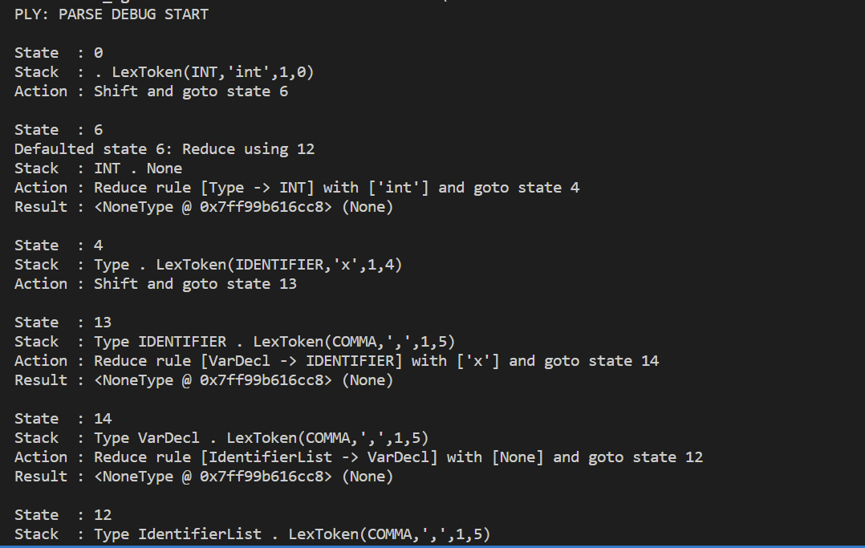
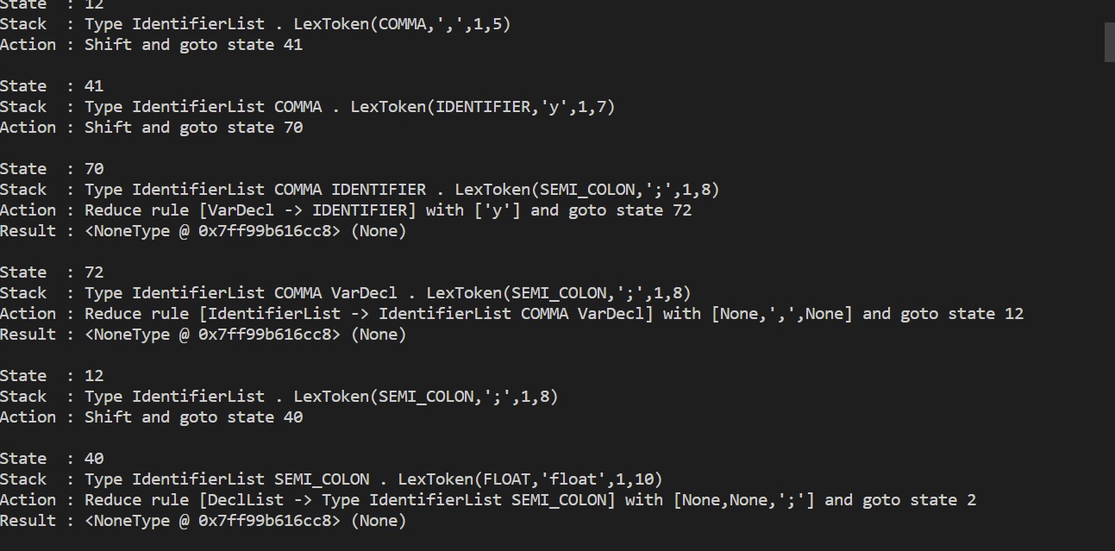
AST Tree levels
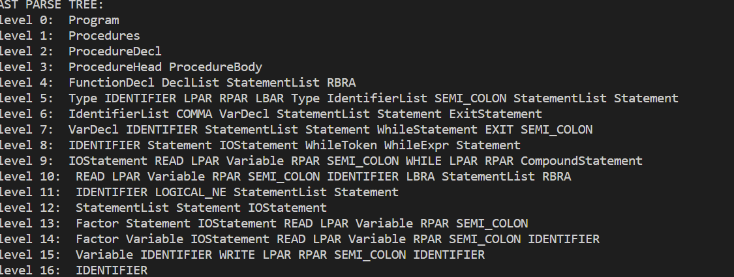

Reference:
Chatgpt
https://www.dabeaz.com/ply/ply.html#ply_nn34

