CS5800 – theory of foundations

Western Michigan University
Instructor: Dr. Elise de Doncker
TA: Edwin Jose
Team: Sri Harsha Godavarthi, Venu Modugula
Sathish Kumar madiga Mallayolla

- Aim:
Construction of a mini Java compiler built using Python 3 and the PLY library. The compiler will be able to analyze and understand a predefined subset of the Java programming language.
2. Tools and Technologies
- Programming Language: Python 3
- Library: PLY (Python Lex-Yacc)
  - Lexical Analyzer (Lexer): Processes input code into tokens (keywords, identifiers, operators, etc.) using regular expressions.
  - Parser: Analyzes tokens based on grammar rules to determine the code's structure. This project will utilize the LALR(1) parsing method.
3. Grammars and Definitions
- Context-Free Grammar (CFG): A set of rules defining valid structures within the mini Java language.

- Abstract Syntax Tree (AST): A tree-like representation of the parsed code, capturing its hierarchical structure.
4. Lexical and Syntactical Analysis:
- Lexical Analysis (Lexer): This process decomposes the input text into a series of meaningful elements known as tokens. These elements include keywords, identifiers, operators, delimiters, and literals. The lex.py module in PLY aids in developing regular expressions that establish the patterns for identifying these tokens.
Types of tokens: It includes
i) keywords - reserved words for the programming language
ii) identifiers – user defined variables/ functions
iii) operators( Arthimatic and logical Operators)
iv) delimiters(separator’s )
v) literals (constants ).
- Parsing (Parser): This step analyzes the tokens produced by the lexer, employing grammar rules to ascertain the input's syntactic arrangement. The yacc.py module in PLY is instrumental in defining this grammar, utilizing Backus-Naur Form (BNF) notation. Through aligning these rules with the stream of tokens, the parser constructs an Abstract Syntax Tree (AST), which depicts the input's hierarchical organization

PHASE 1: SPECIFICATION
- Create a tokenizer class and properties
- Create a Parser class and properties using yacc
- Write regular expressions for Each Token
- Write CFG for parser
- Pass this to lexer and create lexer(build)
- Send Source Code For analysis to above build lexer
- Pass the build lexer to Parser
- Display AST Tree(AST – abstract syntax tree)
Test program by performing the following steps:
    - Install required packages (re, ply) using pip package manager
    - Check if source file(input.txt) and input2.txt is available
    - If not found create one and write code for compiling
    - Then run using python java_main.py

Command to install packages:
Pip install <packagename>
Packages - code written by other developers for specific functionality

Possible Approaches for parsing
there are two different methods for parsing
- Top-down parsing techniques:
- Recursive Descent Parsing: A method that transforms grammar rules into recursive functions, with each function dedicated to a particular non-terminal symbol and recursively invoking other functions for the associated productions
- LL(k) Parsing: This method employs left recursion and leftmost derivation, along with a k-token lookahead. By utilizing a lookahead of k tokens, it makes parsing decisions that ensure the selection of the appropriate path while preventing the need for backtracking.
- Predict-Lookahead Parsing: This method merges aspects of recursive descent and LL(k) parsing, aiming to anticipate the upcoming token by considering the current state of parsing and conducting lookahead only as required.

- Bottom-up:
- Shift-Reduce Parsing: This basic method involves the parser transferring tokens from the input to a stack through a process known as "shifting," and then attempting to "reduce" these tokens by merging them into bigger constructs according to grammar rules. It continues to shift and reduce until it has fully parsed the input and arrives at the starting symbol on the stack.
- LR(k) Parsing: This technique, which is more potent and relies on Lookahead, employs Rightmost derivation with k lookahead. It constructs the parse tree from the bottom up, utilizing lookahead to guide decisions regarding reductions.
- LALR(K) parsing: The LALR parser is a bottom-up parsing method. It constructs the parse tree from the leaves (the input tokens) upwards towards the root. This approach involves combining tokens into larger units according to the grammar rules, progressively building up the structure of the parse until the entire input is reduced to a single start symbol that represents the entire program or input phrase

Research Summary

This research delves into the world of compiler construction, specifically focusing on parsing techniques.
One paper explores how Lex and Yacc, powerful tools for pattern recognition and parser generation, can be used to build a compiler for a simple calculator. This demonstrates how to translate a high-level language into machine code for execution.
Other papers delve into different parsing techniques. One explores bottom-up parsing, a method that analyzes source code from the ground up, suitable for specific grammar types and handling potential conflicts that might arise. Another focuses on recursive-descent parsing, a technique for processing grammars, highlighting its capabilities and potential challenges. By understanding these parsing approaches, compiler developers can choose the most appropriate method for their specific language and grammar

PHASE 2: DESIGN
Lexical Analysis:
- Token Identification: Define regular expressions using PLY's tokens function to identify various tokens like keywords, identifiers, operators, delimiters, and literals.
- Lexer Implementation: Develop the lexer module using java_lexer.py in PLY to perform tokenization based on the defined regular expressions.
Parsing / syntactical analysis:
- Grammar Specification: Define the mini Java grammar using PLY's java_parser.py module, employing Backus-Naur Form (BNF) notation. This grammar will specify valid syntax constructs within the mini Java language.

- Parser Implementation: Develop the parser module to analyze the token stream generated by the lexer and verify if it adheres to the defined grammar rules. The LALR(1) built-in parsing method will be used for this purpose.
- Error Handling: Integrate error handling mechanisms within the parser to identify and report syntax errors encountered during the parsing process.
Abstract Syntax Tree Generation
Parser Tree: This is the syntax tree the parser generates for further optimization and transformation of source code to machine code. (the tree generated here is called Abstract Syntax Tree)

- AST Node Creation: Define classes for different AST node types representing various language constructs (e.g., expressions, statements, declarations).

- AST Building: During parsing, construct the AST by creating appropriate AST nodes based on the matched grammar rules and attaching them in a hierarchical manner reflecting the code structure.

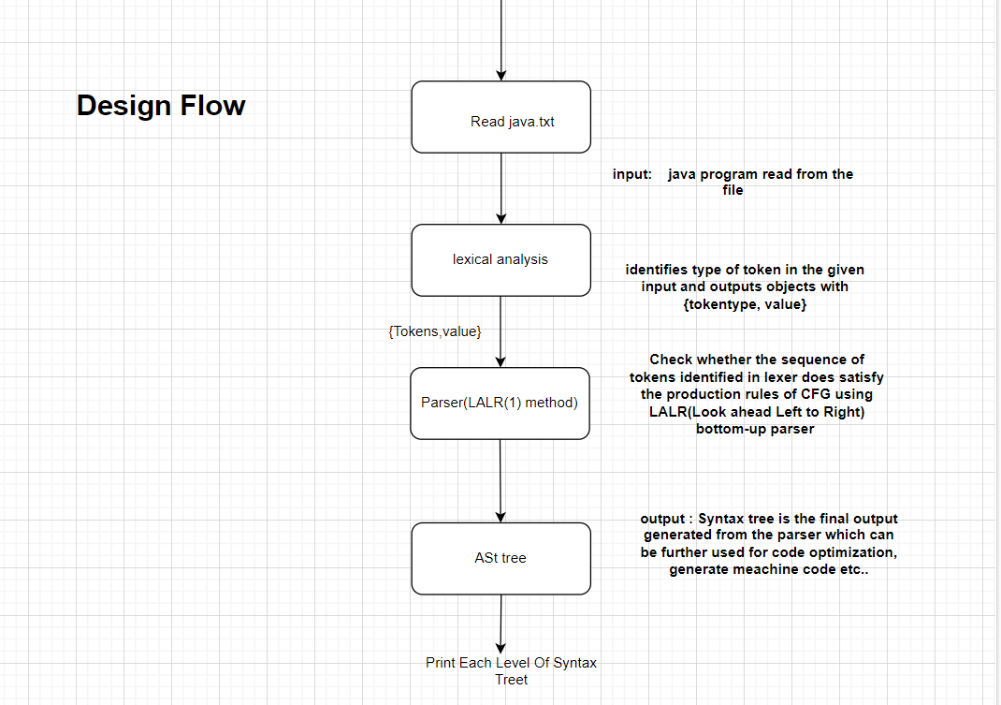

2.1 Modules:
This Project has 2 module
2.1.1 Tokenizer:
i) identifier holds regular Expression for each token
ii) methods for doing lexical analysis
iii) create lexical analyzer using ply
iv) display token and it’s type for each one in source code
2.1.2 Parser:
i) pass tokens, source code, lexer (i.e. build during before lexical analysis)
ii) create grammar for parsing the input source code
iii) build the parser
iv) display shift and reduce steps based on grammar
v) call display_ast to display each level of Parse Tree
2.1.3 AstNode:
i) Assign nodetype,children,value which are properties of node for Ast Tree
ii) call the class constructor and pass the aurguments
2.1.3 Main:
where everything is integrated
  - Pseudocode for Modules:
- Tokenizer:
Fields: tokens, tokensFound, t_KEYWORD, t_IDENTIFIER, t_CONSTANT, t_LOGICAL_OPERATOR, t_ARITHMETIC_OPERATOR, t_SEPARATOR, t_COMMENT, t_ignore
Constructor: Initialize tokensFound
Methods:
def t_IGNORE – function tells to ignore tab, newline while lexical analysis
def build – create lexical analyzer based on regular expressions given
def t_error – print the error and for which it encountered
def test – perform lexical analysis
- Parser:
Fields: tokens,lexer,input,parser,precedence
Constructor: initialize tokens,lexer,input,parser
Methods:
# the mentioned function is for defining grammar rules
def p_ruleName:
‘’’
Non-Treminal: Non-Terminal
| Non-Terminal (or) terminal
’’’
P[0]=ASTNode(‘nodeType’,[children1,children2],value=p[‘number’])
def build_parser – build the parser and print Ast tree (or) shift-reduce stages
def print_ast – displays each levels of parse tree
- AstNode:
Constructor: initialize type, children, value
PHASE 3: RISK ANALYSIS
There are no risks associated with this application. There is a possible risk of a file not found exception if the source code file is missing while reading. There is another possibility the grammar may become ambiguous if you want to add more productions to CFG

PHASE 4: CODING
The code of this program is included in the zip file submitted in drop box. The code is explained by in line comments.

PHASE 5: FUTURE ENHANCEMENT
The enhancement can be done by adding or further creating new token types (i.e. functions, classes etc.) and grammar can be optimized , data structure for constructing parse tree can be choose so that the insert and traversal may take more time

PHASE 6: RESULT Analysis
All Goals were reached in this project got reduce – reduce conflicts while using shift reduce parser then changed the parsing method to LALR(1) which is extended version of shift reduce
ScreenShot:

AST Tree levels
Error Test Case For lexical analysis: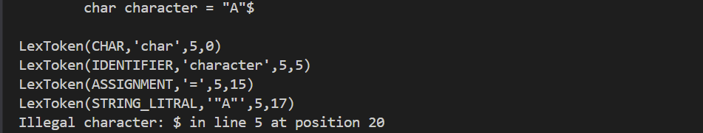

Tokens identified through lexical analysis
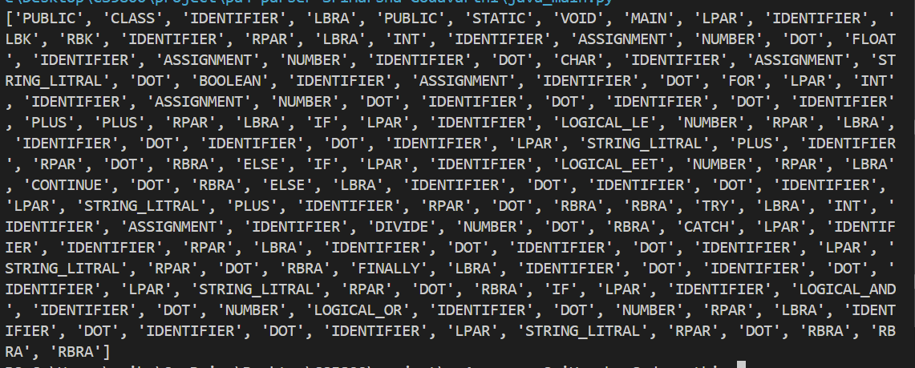

Parser Shift Reduce Steps and AST tree level wise
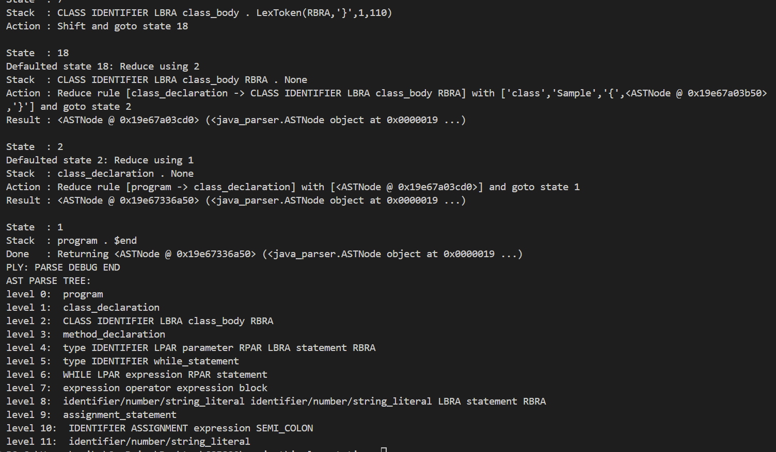

Reference:
Chatgpt
https://www.dabeaz.com/ply/ply.html#ply_nn34

Jordan, W., Bejo, A., & Persada, A. G. (2019, December). The Development of Lexer and Parser as parts of compiler for GAMA32 processor’s instruction-set using Python. In 2019 International Seminar on Research of Information Technology and Intelligent Systems (ISRITI) (pp. 450-455). IEEE.
Ireland, S. M., & Martin, A. C. (2020). atomium—a Python structure parser. Bioinformatics, 36(9), 2750-2754.
Metsker, S. J. (2001). Building parsers with Java. Addison-Wesley Professional.
Hosseini, R., & Brusilovsky, P. (2013, January). Javaparser: A fine-grain concept indexing tool for java problems. In CEUR Workshop Proceedings (Vol. 1009, pp. 60-63). University of Pittsburgh.
- https://ieeexplore.ieee.org/document/5942077
- https://ieeexplore.ieee.org/xpl/ebooks/bookPdfWithBanner.jsp?fileName=6382043.pdf&bkn=6381794&pdfType=chapter
- https://ieeexplore.ieee.org/document/6382048
- https://ieeexplore.ieee.org/document/6382040
- https://ieeexplore.ieee.org/document/6382042

