## CS 5950 Programming for Graduate Students (with Bash)

## Western Michigan University

Instructor: Ajay K Gupta

TA: Maisha maliha

Sri Harsha Godavarthi

Aim:

This Project is to get familiar with shell scripting for system Administration for optimizing time consuming tasks in programming.

PHASE 1: SPECIFICATION

1. Create a scripts for each of the given tasks
2. Give permission execution permission for each script

Using the command (.i.e. chmod +x filename)

**Test program by performing the following steps:**

* + 1. Open linux terminal
    2. Change to directory where the scripts are stored.
    3. Run the scripts using the following command (**.i.e.** ./{script_filename}.sh arguments1 arguments2 etc)
    4. Read the readme file for more information how to run the script

PHASE 2: Linux Commands

**2.1 Commands:**

This Project has 5 Scripts

* If arguments are needed for any script at starting of script check if any arguments are passed
* # Check if directory path is provided as an argument
* if [ $# -eq 0 ]; then
* # $# will store no of command line arguments passed
* # $0 first word of entered command
* echo "Usage: $0 <directory_path>"
* # exit the script execution
* exit 1
* fi
* # pass
* **$# -eq 0** – means check if no of arguments passed is equal to zero
* **pwd** – present working directory
* **ps -e** – To List all processes
* **execute <processname>** - start the process
* **ls** -l – list all files (to see hidden files use -a)
* **date** – will give the current date and time
* **id <username>** - check if user exists or not

Go through the shell scripts to find about other commands

PHASE 3: RISK ANALYSIS

There are no risks associated with this application. There is a possible risk of a wrong filename is given as input while executing the script.

PHASE 4: CODING

The code of this program is included in the zip file submitted in drop box. The code is explained by in line comments.

PHASE 5: FUTURE ENHANCEMENT

No Future Enhancement is needed

PHASE 6: RESULT

ScreenShot:

*UserInfo*



*healthcheck*

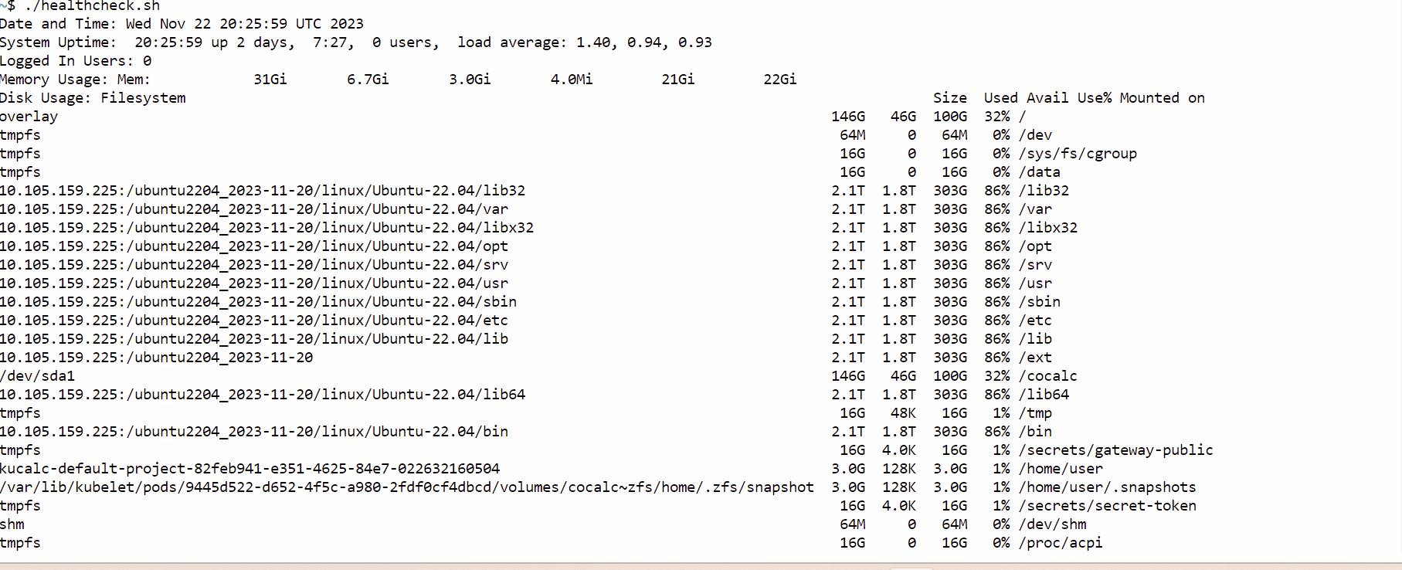

*Backup directory*

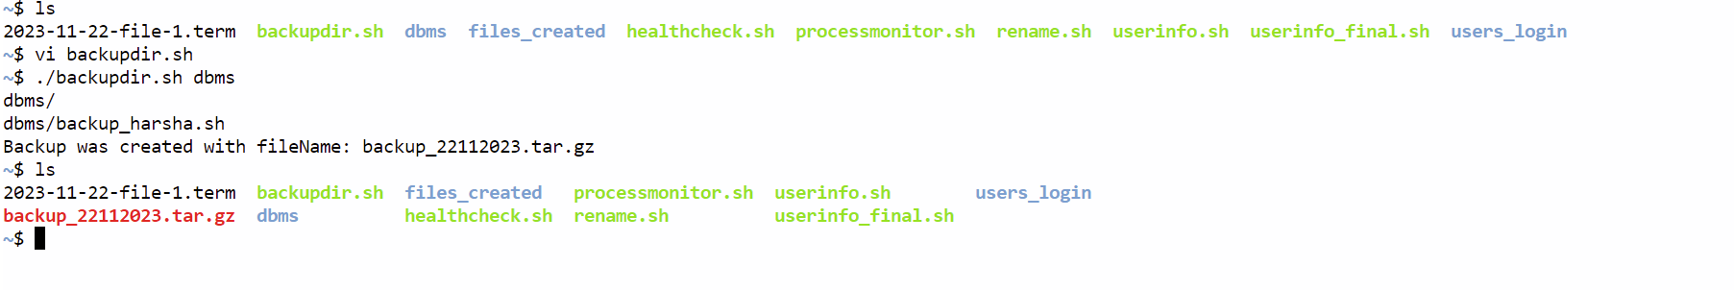

*Rename*

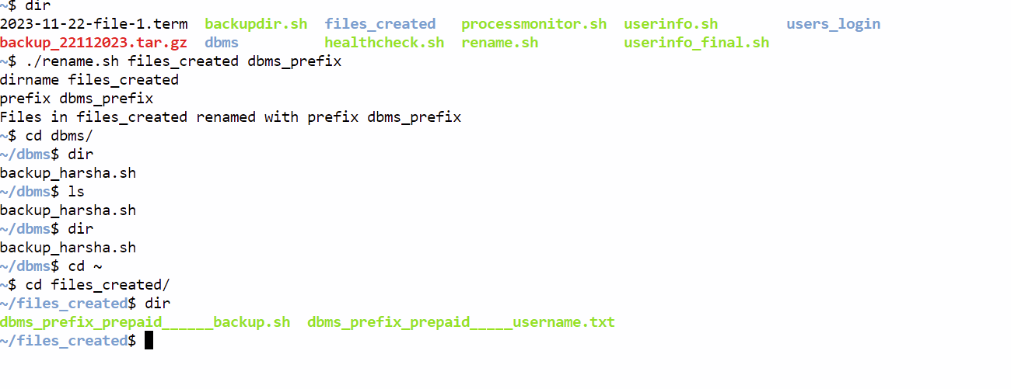

*ProcessMonitoring*

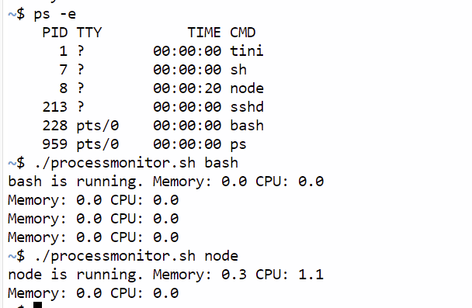

References:

chat gpt

greeks for greeks - https://www.geeksforgeeks.org/linux-commands/

stack overflow