Q1) - Define: expression graph

An expression graph is a labeled directed graph in which the arcs are labeled by regular expressions. It like state diagram it has distinguishable start and accepting nodes

E (alphabet) – has lambda and expressions

Language is union of regular expressions from start to accepting nodes

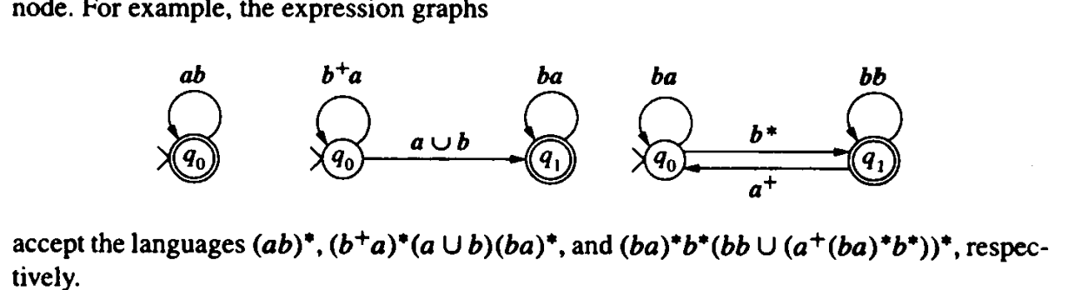

Deletion of intermediate node used to find regular expression which will have start and end nodes (start and end can’t be deleted)

