Q1) Define**: standard PDA as a 6-tuple; explain each element, include how the transition maps and give an example of a "standard" transition.**

Ans: 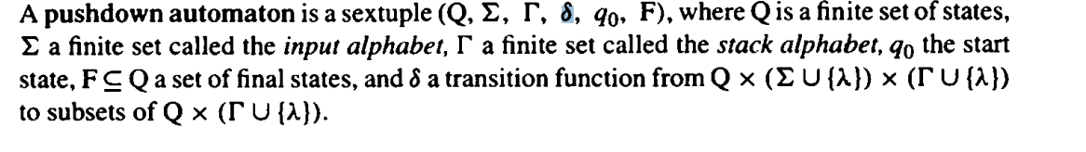

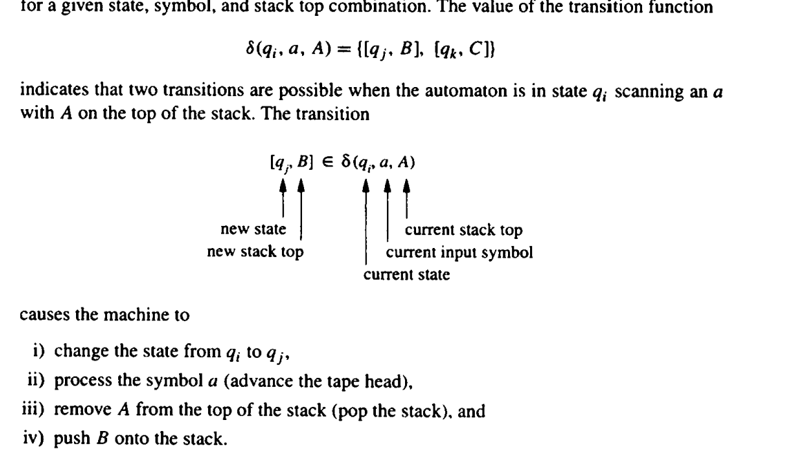

**Q2) - Define: acceptance in a PDA (by final state and empty stack).**

**Answer:**

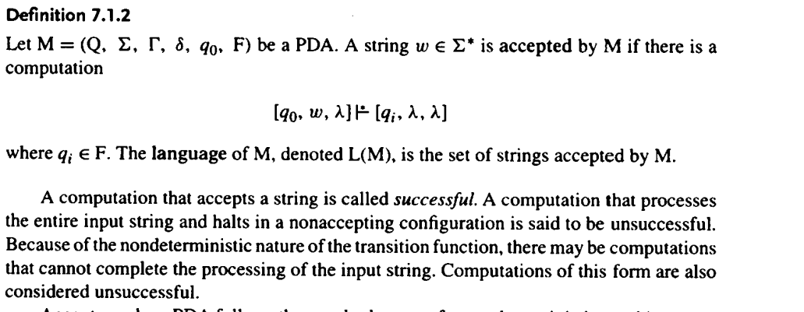

**Q3)**

**i) Computation: [q0, w, lambda] |- ...**

**sequence of configurations**



**ii) Configuration: [state, what's left of the string, stack contents]**

