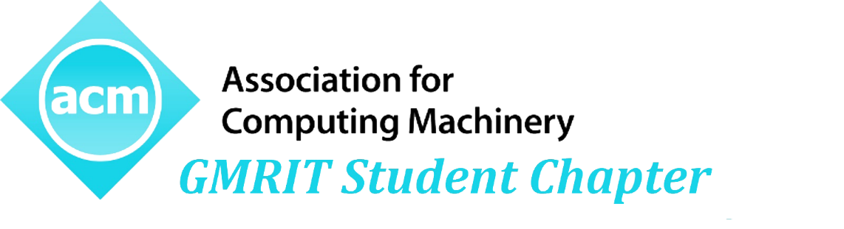



**Mr. Harsha Vardhan N**

Chair

GMRIT ACM Student Chapter

**Dr. A Venkata Ramana**

Professor & HOD

Dept. of CSE

*in recognition of successful completion of a Five-Day workshop on*

*Awarded to*

*hii*

*held at GMR Institute of Technology, Rajam during 09th -13th October 2019.*

**Mr. SOMESH K**

Faculty Sponsor

GMRIT ACM Student Chapter

ANDROID APPLICATION DEVELOPMENT

  