Code explanation

We can used below code to convert python Mobile Net model to android compatible model called ‘tensor flow lite model.

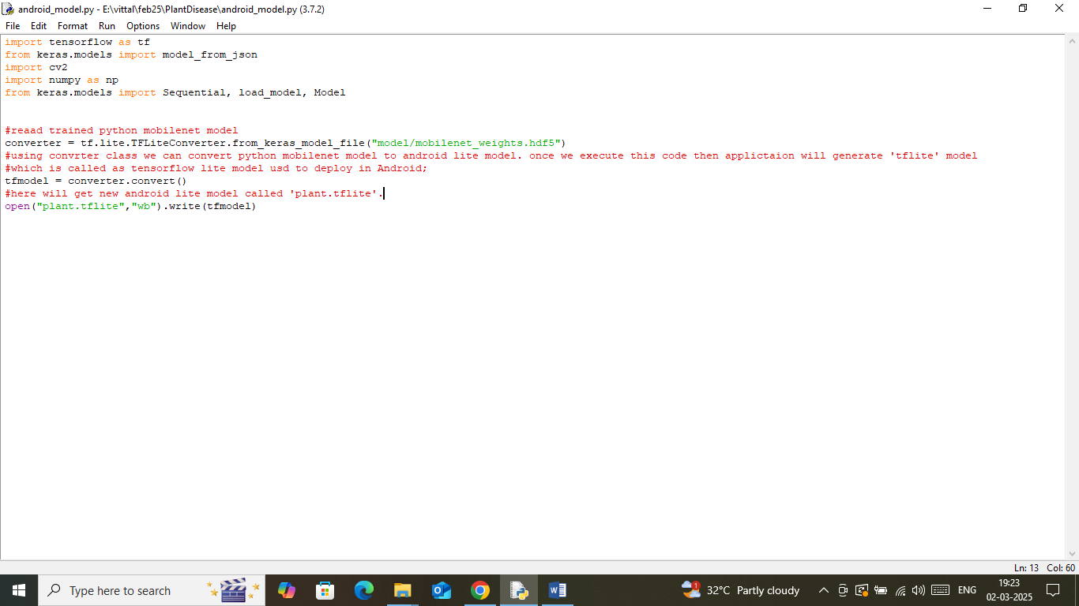

In above screen read red color comments to know about converting python model to android model.

Above generated model we can load to android using below code and this loaded model can be used to predict plant disease from android app

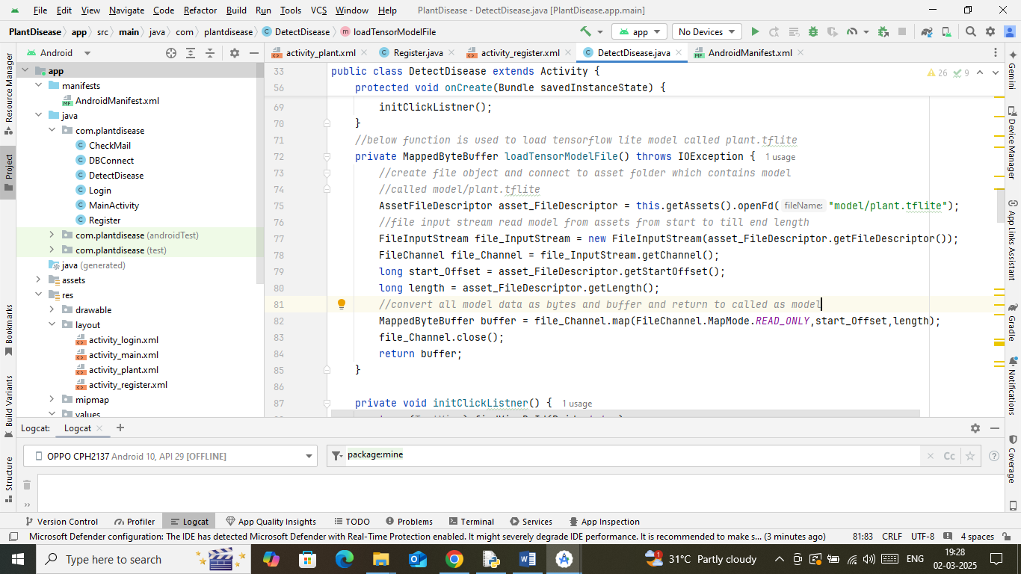

In above screen read comments with ‘//’ to know about loading tflite model to android device and loaded model send to caller

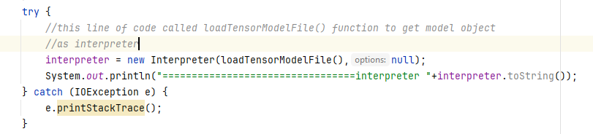

Above code is responsible to called ‘load Tensor Model File()’ function to load model and assigned referenced to ‘interpreter’ object. Interpreter object will be used in below line of code to perform disease prediction

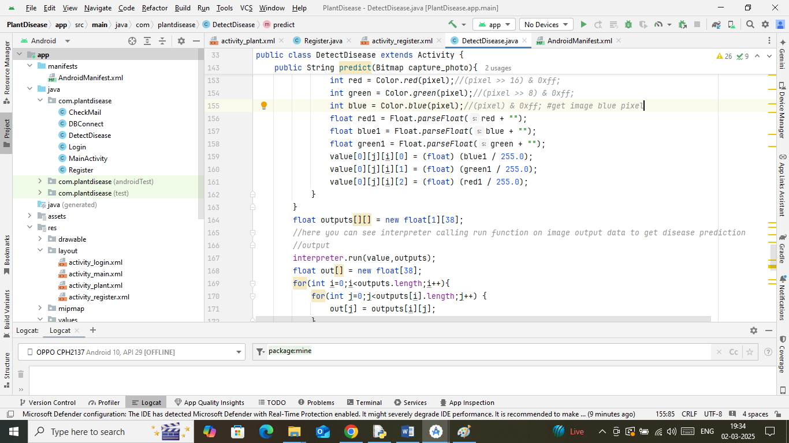

In above screen you can see we are utilizing ‘interpreter’ object on image pixels red, blue and green to detect disease. So above is the android code to perfrom disease prediction