**Company Lockers**

This project is created for **LockedMe.com** and developed by **“Sri Harshita Tata”.** This displaysbelow3 options for the user to selecton performing the operations.

* The first option returns the current file names in ascending order.
* The second option should return the details of the user interface such as options displaying the following:
* Add a file to the existing directory list
* Delete a user specified file from the existing directory list
  + Return a message if FNF (File not found)
* Search a user specified file from the main directory
  + Display the result upon successful operation
  + Display the result upon unsuccessful operation
* Option to navigate back to the main context
* Third option to close the application

**Git Link of the project:**

<https://github.com/SriHarshita95/SimplilearnAssignments/blob/master/LockedMeProject1/src/com/Lockers/LockedMe.java>

**Complete Locked Me project link :**

<https://github.com/SriHarshita95/SimplilearnAssignments/tree/master/LockedMeProject1>

**All projects git link:**

<https://github.com/SriHarshita95/SimplilearnAssignments/tree/master>

**Clone the above link using:**

<https://github.com/SriHarshita95/SimplilearnAssignments.git>

**Output screenshots of the project:**

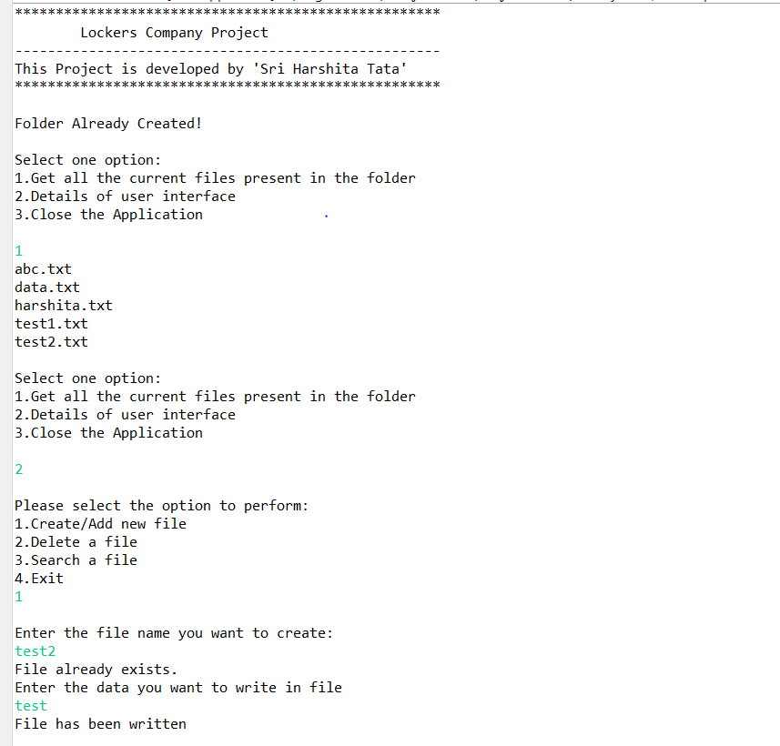

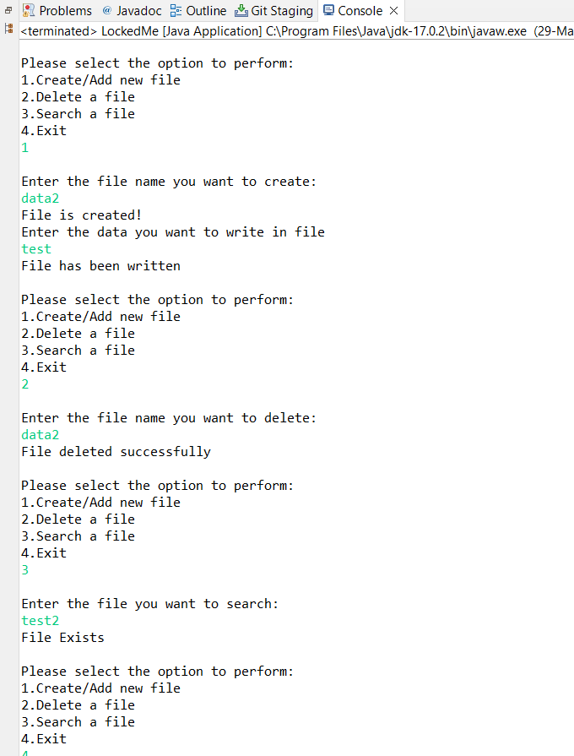

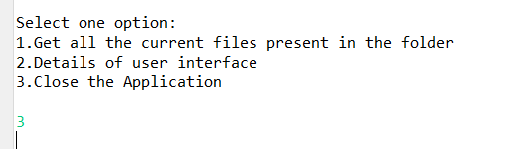

**Flow chart for the project:**

