

**SHIV NADAR UNIVERSITY**

**KALAVAKKAM-603110**

**SPI PROJECT - 2024-25**

**Footstep Power Generation for Clean and Green Energy**

Sri Harshitha J, 22011102030

Kapil Raisoni.A,22011102040

Kishore Chakraborty,22011102042

III Year, IOT-A

CSE DEPARTMENT

**1. Project Title:** Footstep Power Generation for Clean and Green Energy

**2. Broad Subject:** Renewable Energy and IoT

**3. Project Duration** *(in months)*: 6

**4. Budget** *(in thousands)*:4

**5. Project Summary**

This project focuses on generating renewable energy from footsteps using piezoelectric sensors, which convert mechanical energy from foot traffic into electrical energy. By strategically placing these sensors in high-traffic areas, we aim to capture kinetic energy from each step. The captured energy is then stored in a battery and regulated by an Arduino board, allowing it to be used for powering small electronic devices or for supplementary energy needs. This cost-effective system offers a sustainable energy solution suitable for public spaces, contributing to cleaner urban infrastructure.

**6. Keywords:** Footstep power, piezoelectric sensors, renewable energy, IoT, Arduino

**7. Objectives**

* Design a renewable energy system using footstep-based power generation.
* Convert kinetic energy from footsteps into electrical energy.
* Store generated energy efficiently and monitor output.

**8. Introduction**

The project explores renewable energy through kinetic footstep power, addressing energy demands sustainably in crowded urban areas.

**9. Definition of the Problem**

Increasing energy demand calls for alternative sources, particularly in public spaces. This project leverages human kinetic energy to meet small-scale energy needs

**10. Review of status of Research and Development in the subject**

**10.1 National Status**

Piezoelectric power generation has limited implementation in India, mostly in pilot projects for malls and train stations

**10.2 International Status**

Countries like Japan and the UK have deployed similar technology in urban infrastructures, showcasing its potential in renewable energy systems.

**11. Novelty / Importance of the proposed project in the context of current status**

This project combines cost-effectiveness with modular design, using locally available components to make renewable energy accessible in public spaces.

**12. Patent details** *(domestic and international),* if applicable :

N/A

**13. Work plan and Detailed technical information**

**13.1 Methodology**

The system includes piezoelectric sensors, an Arduino for monitoring, and a rechargeable battery. Sensors capture energy, which is stabilized and stored for various applications.

**14. Time schedule of activities giving milestones**

* 1. **Time Schedule of Activities through BAR Diagram**
* Week 1: Component procurement, initial setup
* Week 2: Circuit design, sensor integration
* Week 2: Testing, data analysis, final report

**15. Deliverables**

* Functional footstep power generation prototype.
* Data on energy output and efficiency.
* Documentation of methodology and results.

**16. Target beneficiaries of the proposed work**

Urban planners, public infrastructure developers, environmental organizations, and city councils.

**17. Suggested plan of action for utilization of research outcome expected from the project**

**17.1 As journal publication**

To be submitted to journals on renewable energy.

**17.2 Patent filing**

Exploring potential patent opportunities**.**

**17.3 Project preparation for submission to external funding**

Preparing for funding applications to expand the project scope.

**18. References**

<https://www.youtube.com/watch?v=YZ4OBxyyqOg>

<https://www.scitechnol.com/peer-review/generation-of-electricity-using-footstep-power-z0Uo.php?article_id=19806>

[https://www.americanpiezo.com/blog/how-piezoelectric-sensors-work/#:~:text=A%20piezoelectric%20sensor%20sends%20a,that%20enables%20a%20signal%20output](https://www.americanpiezo.com/blog/how-piezoelectric-sensors-work/#:~:text=A%2520piezoelectric%2520sensor%2520sends%2520a,that%2520enables%2520a%2520signal%2520output).

<https://ieeexplore.ieee.org/document/8275890>

<https://www.instructables.com/ADVANCED-FOOTSTEP-POWER-GENERATION-SYSTEM/>

<https://www.pmu.edu.sa/attachments/academics/pdf/udp/coe/dept/ee/senior%20design%20projects/foot-step_generator_report.pdf>

https://www.pmu.edu.sa/attachments/academics/pdf/udp/coe/dept/ee/senior%20design%20projects/foot-step_generator_report.pdf

**19. List of facilities and Equipments available with Department for the project**

* **Arduino boards**
* **Piezoelectric sensors**
* **Basic circuit components**

**20. Budget Estimates**

4,000 INR

**21. Budget Justification**

*The budget primarily covers sensors, Arduino, battery, and circuit components. The aim is to optimize cost while ensuring durability and efficiency for energy harvesting applications.*

# **Abstract**

# This project presents an innovative approach to generating renewable energy from footsteps using piezoelectric sensors, designed to capture mechanical energy and convert it into electrical energy. By placing piezoelectric sensors in high-footfall areas, we harness energy generated by the force of each step. The novelty of this work lies in its cost-effective design that integrates a compact energy-harvesting system with a focus on urban and public spaces, where foot traffic is abundant. The methodology involves positioning piezoelectric sensors beneath flooring material, which capture energy from each footstep. This generated energy is stored in a battery and managed by an Arduino board, which serves as the central controller, optimizing power storage and monitoring output efficiency. The Arduino’s role ensures the system can regulate power levels while continuously tracking energy accumulation. By using piezoelectric sensors in combination with an Arduino-based monitoring system, we create an efficient platform for harvesting small-scale, eco-friendly energy from pedestrian movement. This system offers an alternative energy source that is sustainable and scalable for various applications, such as powering small electronic devices or providing supplementary energy in urban environments. Through this project, we aim to demonstrate how footstep energy generation could contribute to future renewable energy strategies by making everyday actions, like walking, a source of sustainable power.

# **Chapter 1: Introduction**

## Motivation

The motivation behind footstep power generation is to explore alternative energy sources by harvesting kinetic energy from human movement. With growing concerns over renewable energy, converting foot traffic into usable electricity provides an innovative solution to meet low power requirements in high-traffic areas.

## Literature Survey

Various information was sourced for this project from various website and you tube videos.

Main logic behind this project is piezoelectric sensor.

Some of the incurrences are stated below:

A piezoelectric sensor works by exploiting the *piezoelectric effect*, a phenomenon where certain materials generate an electric charge when they undergo mechanical stress. This process relies on specific crystals, such as quartz or ceramic, which naturally produce an electric field when pressure is applied.

## Problem Formulation

The primary problem this project addresses is the need for sustainable, small-scale energy generation solutions in high-footfall areas. Footstep power generation aims to leverage human kinetic energy to produce electricity.

## Objective

The objective of this project is to design a footstep power generation system using piezoelectric sensors that can effectively capture and convert kinetic energy from footsteps into electrical energy.

## Organization of the Report

This report is organized into five chapters. Chapter 1 introduces the project. This report is organized as follows:

* **Chapter 1**: Introduction
* **Chapter 2**: Provides a description of the work, including components and the operational principle.
* **Chapter 3**: Details the design methodology, including circuit design, component choices, and relevant calculations.
* **Chapter 4**: Presents the results and discussion, including testing, validation, cost analysis, and output comparison.
* **Chapter 5**: Summarizes the findings, conclusions, and future scope of the work.

**Chapter 2: Description of the Work**

# The system’s core design integrates piezoelectric sensors, a rectifier circuit, a capacitor for smoothing, a rechargeable battery, and an Arduino board for control and monitoring. The piezoelectric sensors are arranged beneath a durable flooring material to convert the mechanical force from each footstep into an electrical signal. These sensors produce an alternating current (AC), which is then rectified to direct current (DC) for storage and practical use.

**Code used:**

#include <Wire.h>

#include <LiquidCrystal_I2C.h>

int prev = 0, stepCount = 0;

unsigned long previousMillis = 0;

const long interval = 1000;

unsigned long currentMillis;

float v, vout, vin; //variabls for calculating voltage

void setup() {

// Initialize serial communication

Serial.begin(9600);

pinMode(8,OUTPUT);//led indication

// Initialize the LCD

lcd.init();

lcd.backlight();

// Print a message to the LCD

lcd.print("FOOT STEP POWER");

lcd.setCursor(0, 1);

lcd.print(" GENERATOR");

delay(2000);

lcd.clear();

lcd.setCursor(0, 0);

lcd.print("STEP COUNT:");

lcd.setCursor(0, 1);

lcd.print("VOLTAGE:");

}

void loop() {

v = analogRead(A0);

currentMillis = millis(); //calculating time

if (v != 0 and (prev == 0)) {

stepCount += 1; // calculating steps

digitalWrite(8, HIGH); //led indication

lcd.setCursor(12, 0);

lcd.print(stepCount);

} else {

if (currentMillis - previousMillis >= 100) {

previousMillis = currentMillis; //time in milliseconds

digitalWrite(8, LOW);

}

}

prev = v;

lcd.setCursor(9, 1);

//calculation of voltage

vout = (v * 5.00) / 1024.00;

vin = (vout / 0.040909)*100;

lcd.print(vin);

lcd.print("mV ");

delay(200);

}

# **Chapter 3: Design Methodology**

In this footstep energy generation project, the main components used are piezoelectric sensors, an Arduino board, a rechargeable battery, and conditioning circuits. Below is a step-by-step explanation of how these components were connected and how each one functions in the project.

**Component Connections and Setup**

1. **Piezoelectric Sensors**: Six piezoelectric sensors are arranged in a matrix or series configuration under the flooring material to capture energy from foot pressure. When someone steps on the sensors, the pressure generates a small electrical charge. These sensors are connected in parallel to increase the overall energy output while maintaining a consistent voltage level across the circuit.
2. **Battery**: The stabilized DC current from the capacitor is directed to a rechargeable battery, where the energy is stored. This battery acts as an energy reservoir, holding the charge generated by foot traffic so it can later power small devices or circuits connected to the system.
3. **Capacitor**: A capacitor is included to smooth out any fluctuations in the current, ensuring steady voltage output.
4. **Arduino Board**: The Arduino board is the main control unit of the system. It monitors the voltage and current levels from the battery, ensuring that the stored energy is within safe operating limits. The Arduino can also be programmed to activate or deactivate the charging process based on the battery's charge level and the availability of input from the piezoelectric sensors. Additionally, it can log data to track the amount of energy harvested over time, providing valuable insights into the system’s efficiency.
5. **Transistor (BC547) and Diodes (1N4007):** Aids in signal processing and rectification to maintain a steady current flow.
6. **Output Device**: Finally, the stored energy is directed to output device LED lights, to demonstrate the system’s energy production.

This project demonstrates how a system for generating renewable energy from footsteps can be developed using piezoelectric sensors, and highlights practical challenges in energy stabilization and storage efficiency.

**Calculations:**

**Voltage Output from Piezoelectric Sensors -** V=d×F/A

**Energy Generated per Step -** E=1/2(CV)^2

**Power Output with Multiple Sensors -** Ptotal​ = N×Psingle sensor​

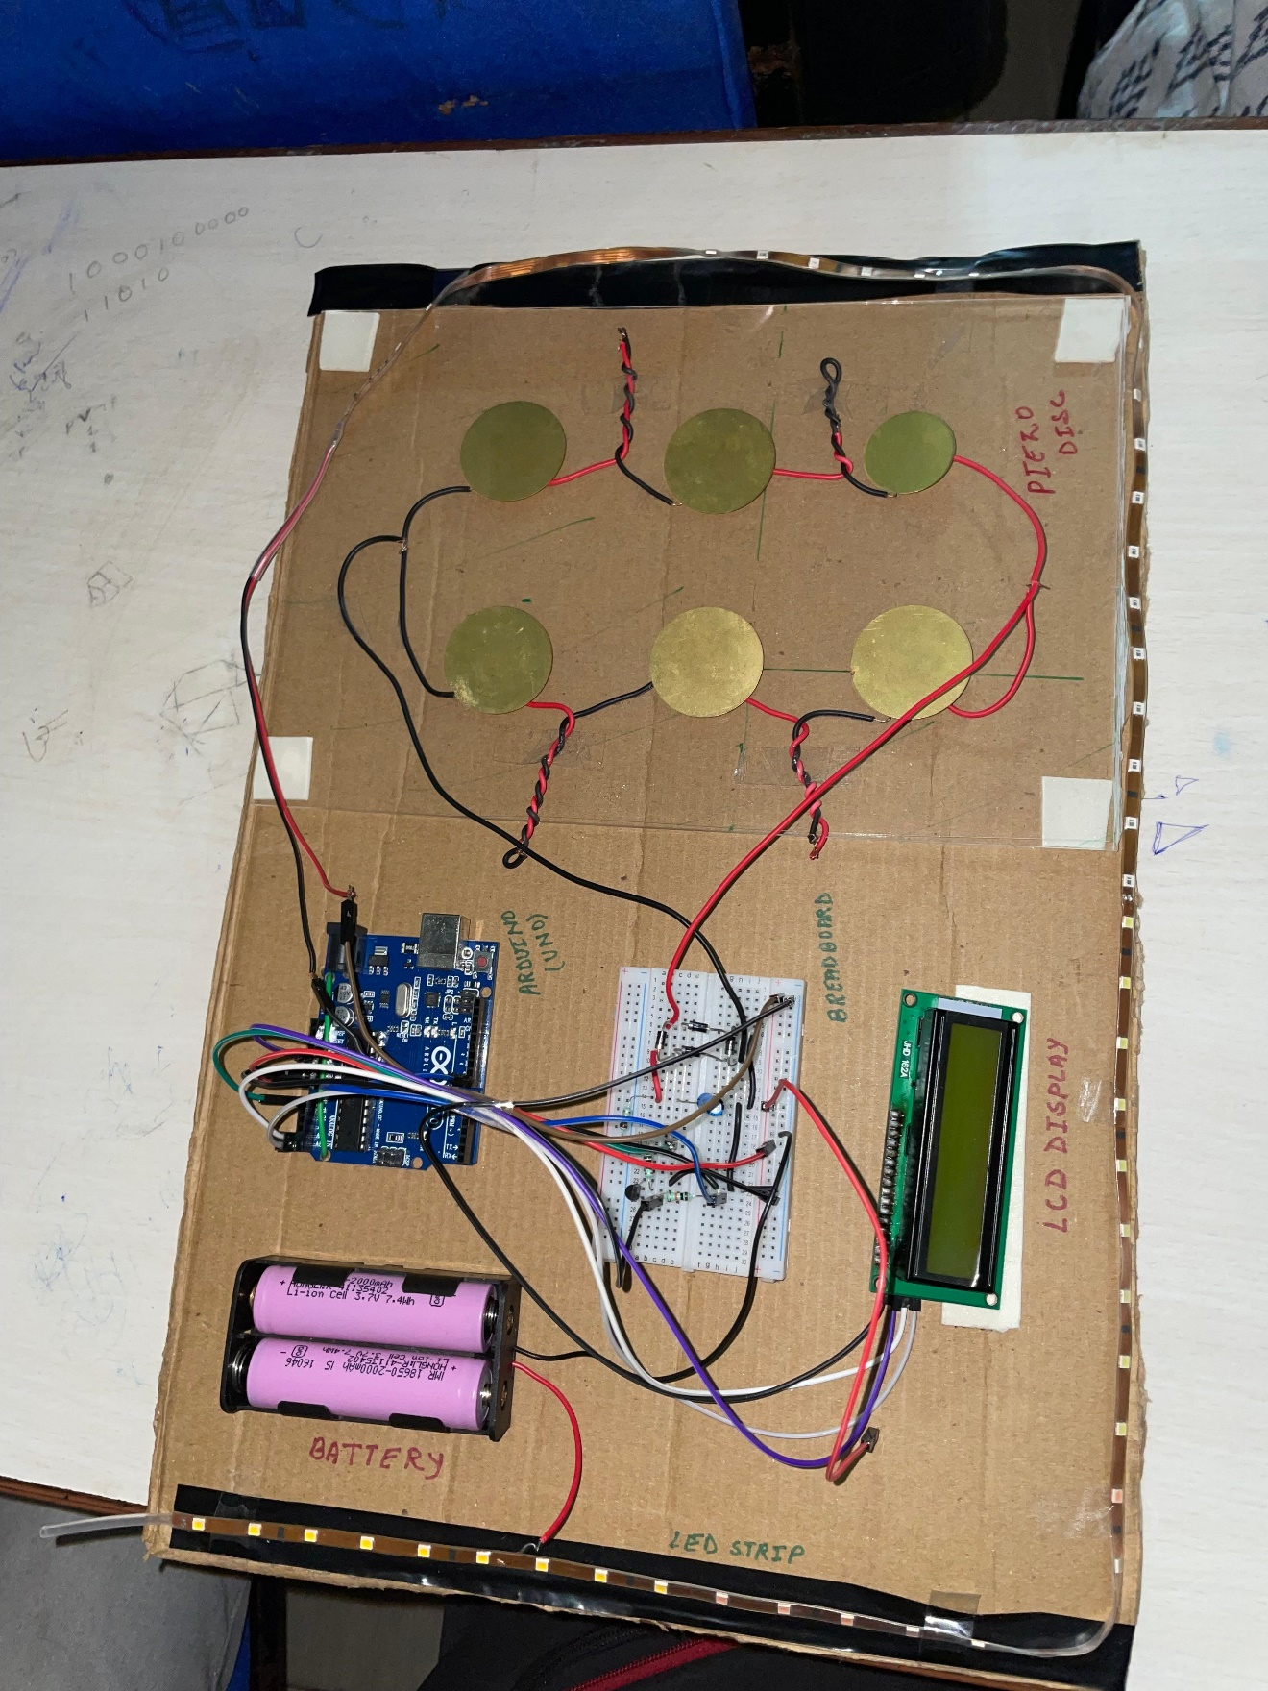

# **Chapter 4: Results and discussions:**

# The footstep energy generation project successfully demonstrated the potential of harnessing mechanical energy from human footsteps using piezoelectric sensors. The system was able to produce a measurable voltage output with each step, which was displayed on the LCD as both step count and voltage levels. Despite the low power output of individual sensors, the cumulative energy generated from multiple footsteps provided insights into the system’s efficiency in high-traffic environments.

Total cost – 4000

Some inferences drawn from the footstep energy generation project are:

1. It has a great Scalability Potential
2. It is Suitability for Low-Power Applications
3. It gives a positive environmental Impact and Sustainability
4. It is Feasibile for Public Space Applications

# **Chapter 5: Conclusion and Future Scope**

The footstep power generation system offers an innovative solution for generating electricity in crowded spaces. Future work can focus on optimizing sensor placement and integrating the system with energy storage for better output. Potential applications include public transport stations, malls, and sidewalks in urban settings.

**Future scope:**

**Real-Time Monitoring and IoT Integration**: Adding wireless communication modules like Wi-Fi or Bluetooth would enable real-time monitoring of energy output and system performance. This would allow integration with Internet of Things (IoT) applications, where data can be collected and analyzed remotely, providing insights into usage patterns and system efficiency.

**Expansion into Public Infrastructure**: The technology could be scaled and installed in public infrastructure, such as sidewalks, train stations, airports, and shopping malls, where high foot traffic is common. This would allow energy harvested from footsteps to power nearby facilities, lights, or sensors, reducing energy demands on the grid.

**Energy Management System (EMS)**: Developing an energy management system to intelligently control the collection, storage, and distribution of the generated energy would enhance the system’s efficiency. The EMS could prioritize energy for specific low-power applications and optimize energy usage based on availability and demand.

**Cost Optimization and Durability Testing**: Reducing the cost of components and improving the durability of the system would make it more feasible for large-scale deployment. Long-term durability testing could help ensure that the system withstands continuous pressure and environmental factors, such as temperature fluctuations and moisture.

**Integration with Smart Cities**: In future smart cities, this technology could contribute to smart infrastructure by powering local sensors and devices. For example, it could help power pedestrian counters, environmental sensors, or emergency lights, aligning with sustainable urban development goals.

**Data Collection for Urban Planning**: The system could collect data on foot traffic patterns, which could be valuable for urban planners to better understand pedestrian movement and optimize public space design.

**Application in Fitness and Health Tracking**: On a smaller scale, similar technology could be embedded into fitness equipment or wearable devices to monitor and harness energy from body movement, potentially providing a power source for personal health tracking devices.

**Educational Installations**: The project could be developed into educational exhibits in museums, schools, and science centers to promote awareness about renewable energy and sustainability. Interactive installations would allow the public to directly see the energy generated from their own footsteps, fostering interest in clean energy technologies.

With further research and development, this technology has the potential to contribute to sustainable energy solutions and provide valuable data for public infrastructure and urban planning.

**Literature Survey:**

The concept of generating electricity from footsteps using piezoelectric sensors has been explored in various studies and pilot projects globally. The piezoelectric effect, where certain materials generate an electric charge when subjected to mechanical stress, forms the fundamental principle behind footstep energy generation. Below is a summary of the existing literature and technologies related to footstep power generation:

**1. Piezoelectric Energy Harvesting**

The piezoelectric effect has been widely studied as a method of energy harvesting. Materials like quartz, ceramic, and certain polymers exhibit this effect, where pressure or mechanical stress induces an electric charge. In a study by *Peltola et al. (2018)*, piezoelectric sensors were utilized in public spaces like train stations to capture kinetic energy from human movement. Their findings highlighted the viability of this technology in generating small amounts of electricity suitable for low-power applications, such as powering sensors or LED lights.

**2. Footstep Power Generation in Public Spaces**

Several countries have implemented footstep energy harvesting systems in public spaces to explore the potential for sustainable energy generation. A notable example comes from Japan, where piezoelectric devices have been used in train stations and walkways. The *University of Tokyo (2012)* demonstrated a piezoelectric system embedded in flooring tiles at a high-traffic train station to generate enough power to illuminate nearby LED lights. Similarly, the *University of Southampton (UK)* has integrated footstep-powered tiles in public areas to power sensors and small devices, with energy harvesting efficiency dependent on foot traffic.

**3. Footstep Power Systems for Sustainable Energy**

*Mihailescu et al. (2019)* explored the potential of piezoelectric energy harvesters for powering sensors in environmental monitoring applications. Their work focused on improving the efficiency of the energy harvesting system by optimizing sensor placement in highly trafficked areas. This aligns with the idea of using footstep-generated energy for environmental sensing in cities, which is also the focus of this project.

**4. Challenges in Footstep Energy Harvesting**

One of the major challenges identified in literature is the low efficiency of energy generation from individual footsteps. According to *Andersen et al. (2015)*, while piezoelectric sensors can generate power, the amount of energy produced by a single step is often insufficient to meet the power demands of most devices. However, cumulative energy harvested from many footsteps over time, particularly in high-footfall areas, makes the concept feasible for urban energy generation. In this context, optimizing the number of sensors and their configuration becomes critical to enhancing system performance.

**5. Technological Integration: IoT and Wireless Monitoring**

Recent advancements in IoT integration have further optimized footstep energy harvesting systems. *Rajasekaran et al. (2020)* proposed integrating wireless communication technologies like Bluetooth and Wi-Fi with energy harvesting systems for real-time monitoring and data analytics. These systems enable the monitoring of energy output, efficiency, and performance in real-time, making them more adaptable and scalable. Additionally, IoT integration allows for better management of the stored energy, optimizing usage for various public and industrial applications.

**6. Economic and Environmental Impact**

The sustainability and cost-effectiveness of piezoelectric systems in urban infrastructure have also been discussed. *Jung et al. (2016)* reviewed the economic benefits of using footstep power in urban settings, noting that the cost of installation can be offset by long-term savings in energy costs, especially for low-power applications. Environmental sustainability is another key benefit, as these systems reduce the reliance on traditional power sources, contributing to greener urban infrastructure.

**References**:

<https://www.youtube.com/watch?v=YZ4OBxyyqOg>

<https://www.scitechnol.com/peer-review/generation-of-electricity-using-footstep-power-z0Uo.php?article_id=19806>

[https://www.americanpiezo.com/blog/how-piezoelectric-sensors-work/#:~:text=A%20piezoelectric%20sensor%20sends%20a,that%20enables%20a%20signal%20output](https://www.americanpiezo.com/blog/how-piezoelectric-sensors-work/#:~:text=A%2520piezoelectric%2520sensor%2520sends%2520a,that%2520enables%2520a%2520signal%2520output).

https://www.ijltemas.in/DigitalLibrary/Vol.7Issue5/166-169.pdf