Software Requirements Specification

For

Online Cab Booking System

**Technical Story Card**

**Revision History**

|  |  |  |  |
| --- | --- | --- | --- |
| **Version No.** | **Date** | **Prepared by / Modified by** | **Significant Changes** |
| 1.0 | 23/10/2021 | S.Venkateswaran |  |
|  | 23/10/2021 | L.Sri Jyothi |  |
|  | 23/10/2021 | Sonu kumar |  |

**Glossary**

|  |  |
| --- | --- |
| **Abbreviation** | **Description** |
|  |  |
|  |  |
|  |  |
|  |  |
|  |  |
|  |  |

### Table of Content

1. Introduction 4
2. Scope of Change 5
3. Design and detailed technical updates 5
   1. Process Model
      1. Sign-up flow chart
      2. Sign-in flow chart
      3. Use case model
   2. Proposed user Interface Design
      1. Sign-up page .
      2. Sign-in page.
4. Minimum Requirements for cab management 12
   1. Hardware and Software Requirements.
5. Non-Functional related changes 13
6. Additional details 14
   1. Security Mechanisms.
   2. Advantages of cab booking system.
7. Conclusion 15
8. References 16

# 1 Introduction

Online Cab Booking System specializing in Hiring cabs to customers. It is an online system through which customers can view available cabs; register the cabs, view profile and book cabs.Cab booking service is a major transport service provided by the various transport operators in a particular city. Mostly peoples use cab service for their daily transportations need. The company must be a registered and fulfils all the requirements and security standards set by the transport department. Online Cab Booking System is a web based platform that allows your customers to book their taxi's and executive taxis all online from the comfort of their own home or office. The platform should offer an administration interface where the taxi company can manage the content, and access all bookings and customer information.

More and more Taxi companies are looking for integrated taxi booking systems as it makes life much easier for (1) The traveler - this is highly important and in today's internet age people should be able to book taxis online without having to pick up the phone and (2) the taxi company as all their bookings are now managed via an automated system which means they have an electronic record of future and historic bookings

A Cab Booking/Hiring is a system that can be used temporarily for a period of time with a fee. Hiring a car assists people to get around even when they do not have access to their own personal vehicle or don't own a vehicle at all. The individual who want to hire/rent a car must first contact the cab hiring company for the desire vehicle. This can be done online. At this point, this person has to supply some information such as: dates of rental, and type of car. After these details are worked out, the individual renting the car must present a valid Identification Card. Most companies throughout the industry make a profit based of the type of cars. The hiring cabs are categorized into economy, compact, compact premium; premium and luxury & customers are free to choose any car of their choice based on their purse and availability of such car at the time of reservation.

Here the traveler can book a cab/ taxi/ car by viewing all the cab details and pricing details available, according to selected city and area. It is the reliable service provided to both customers and travel agencies. This provides service with well-conditioned new vehicles, with experience drivers for a happy journey of the customers. This project intends to introduce more user friendly in the various activities such as record updating, maintenance, and searching.

# 2 Scope of Change

Every Edition of a book comes with new topics and modifications if any errors are present. In the similar way, in near future, our application will overcome the flaws if occurred, and attains new features offered to employees for the Flexible and easy Transportation.

Following are the Enhancements to the application. Providing Good User Interface.

Providing access permissions to the employees Try to Implement the GPS system in the Cabs.

# 3 Design and Detailed technical updates

### Process model

##### Following are the Processes-

##### Cab Search:

Users can search cab for a particular location here. Users required to enter source, Destination, & place where he wants to go.

##### Login Search:

In the customers has to give out the login details i.e. user’s id and password and then only he can be logged on. The user id and password given by the customers are checked from the data stored in the database.

##### Registration Process:

User must be registered before booking a cab. Proper validations will be provided to keep only authenticated users. i.e. those users who will provide correct information. All the data supply by the user will be stored in database and it will be used for further validations and authenticated. During registration, users have to give login and password of their choice. Login names and password will be stored in the databases so that the users can directly login without registration again and again.

##### SIGN-UP FLOW CHART

### SIGN-IN FLOWCHART

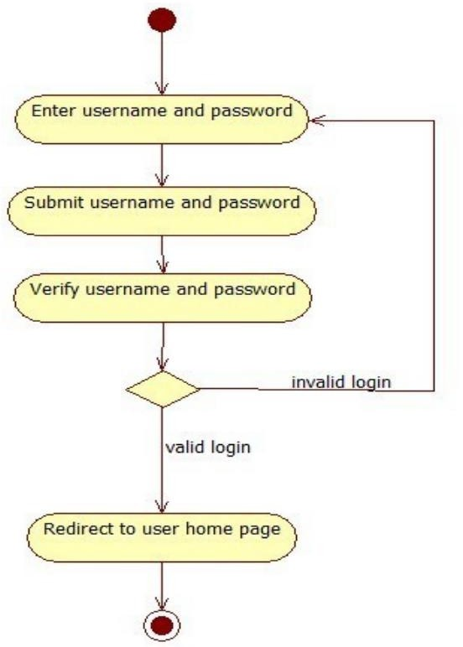

### Use case Model

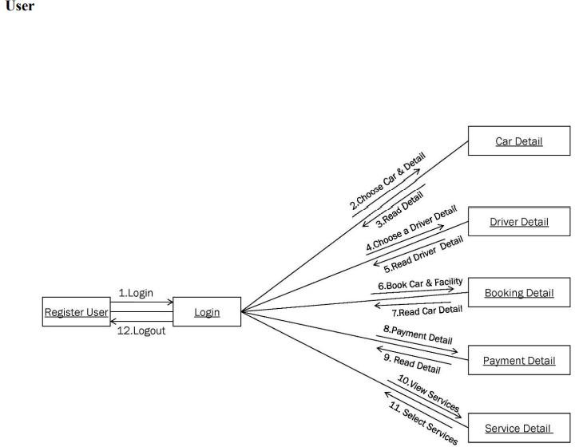

**Use Case Template**

## Source / Destination: - Use case specification

## **Brief Description:** - The main use of this use case is to provide the details about source and the destination of the user of the cab.

**Flow of Events: -**

## Basic Flow: -

## User books a cab by providing the details of source and destination. Booking clerk check the database.

## 3.On successful traveler makes the booking of the cab.

**Pre conditions:**

## The traveler should have a cab for a destination place.

**Post conditions:**

## The database must be modified after the booking transaction takes place**.**

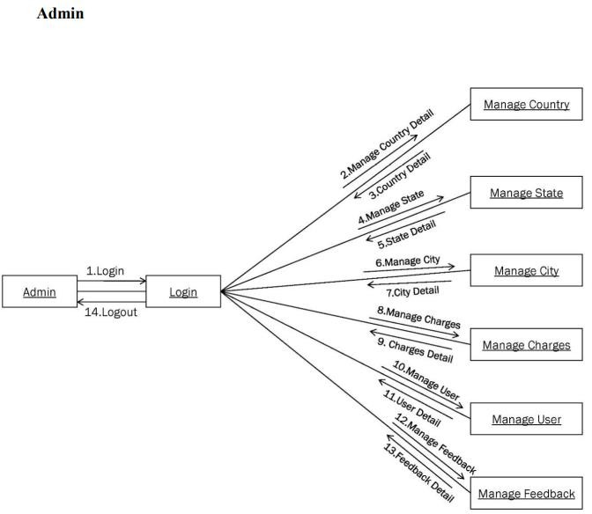

### Proposed user Interface design

SIGN-UP PAGE

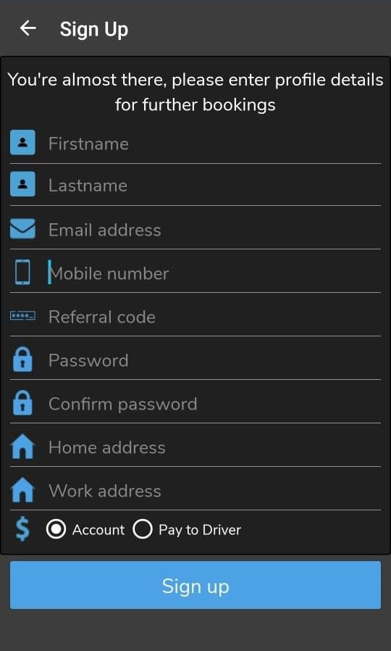

LOG-IN PAGE

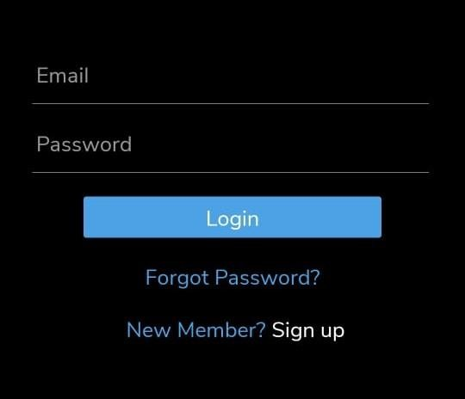

DESTINATION DETAILS

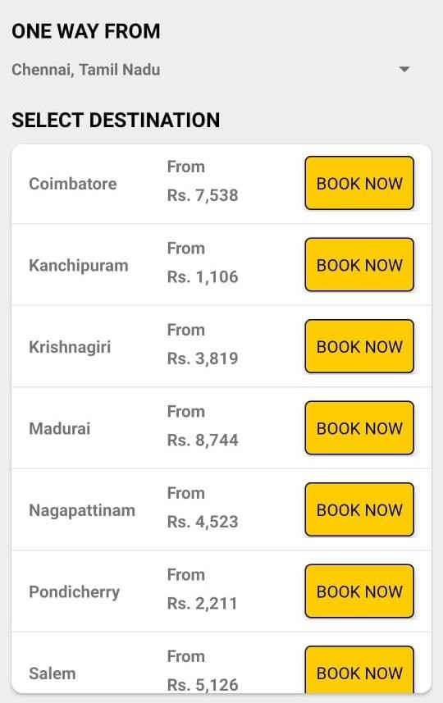

##### BOOKING DETAILS-REFERENCE

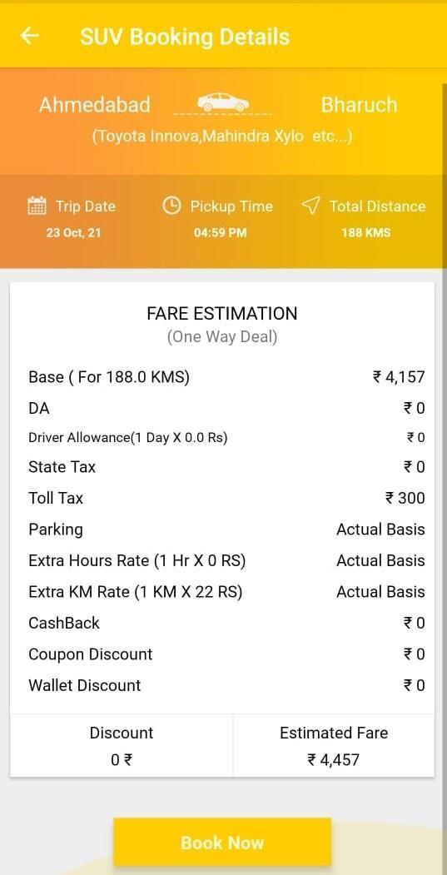

##### DATA-BASE FLOW

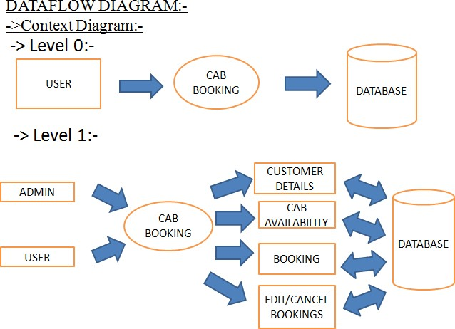

**4 Minimum Requirements for cab management**

##### Processor:

ARM Processor, 1Gz or better

##### RAM:

2GB

##### HDD:

160 GB.

##### Operating system:

Windows 7.

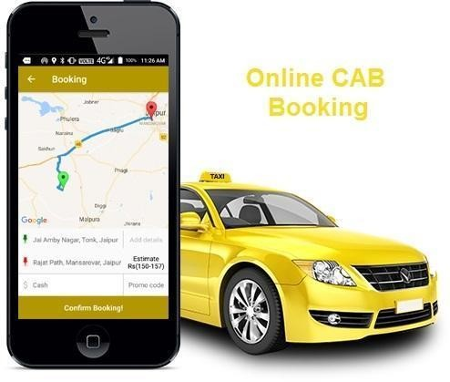

**4.1 Hardware and Software Requirments**

##### Hardware Requirement:

* 1. Developer PC with 2GB Ram

##### Software Requirement

* 1. Git
  2. JDK 1.8
  3. Eclipse IDE for Enterprise Java Developers 2019-03 R
  4. Apache Tomcat 9
  5. sublime Text editor.

**5 Non-functional related changes**

1. **Enhance Business Processes:** To be able to use internet technology to project the rental company to the global world instead of limiting their services to their local domain alone, thus increase their Return on Investment (ROI).
2. **Traveler’s registration:** A registration portal to hold traveler’s details, monitor their transaction and used same to offer better and improve services to them.
3. **Group bookings:** Allows the customer to book space for a group in the case of weeding or corporate parties or meetings.
4. **Eco-friendly:** The monitoring of the vehicle activity and the overall business becomes easy and includes the least of paper work.
5. **Availability:** The software acts as an office that is open 24/7.
6. **Efficient**: It increases the efficiency of the management at offering quality services to the customers.
7. **User friendly:** It provides custom features development and support with the software’s. **8.Security:** The subsystem should provide a high level of security and integrity of the data held by the system, only authorized personnel of the company can gain access to the company’s secured page on the system; and only users with valid password and username can login to view user’s page.

**6 Additional details**

### Security Mechanisms

#### Some of the factors that are identified to protect the software from accidental or malicious access, use, modification, destruction, or disclosure are described below. Specific requirements in this area could include the need to:

#### Utilize certain cryptographic techniques

#### Keep specific log or history data sets

#### Assign certain functions to different modules

#### Restrict communications between some areas of the program

#### Check data integrity for critical variables

#### Later version of the software will incorporate encryption techniques in the user/license authentication process.

### Advantages of Cab Booking System

#### Now one can easily plan the journey comfortably as the process is efficient nd fast with being easy to access. Bookings can be made through the cab booking site or by the phone call. This being a big step in terms of improvement in the cab system it is widely accepted across the country.A route-based booking system that facilitates the issue of journey-cumbooking cab, which can be issued from any station to any station.

#### Passenger journey to multiple laps of booking can be handled from a single terminal window.The booking facility is offered round-the-clock (24 hours uninterrupted).Changes in cab profiles (cab addition, replacement, de-allocation), route structures, etc., can be made effective immediately with the appropriate contingency handling

#### Dynamic definition of the advance booking period is possible. This feature facilitates defining different advance booking periods for different cabs. Any cab running schedule can be accommodated. Provides on-line aggregation of EIS figures such as revenue, cab utilization, etc., and presentation of the summarized data in the form of visual analytics from the operational system's information store. The data aggregation is done incrementally, to inflict minimal impact. Provides automatic database recovery against all kinds of hardware and software failures.

**7 Conclusion**

Information Technology plays a vital role not only in a particular field, it provides various kinds of solutions and services to the various problems prevailing in many fields. Cabs exploits information technology at the maximum extent. It uses the information technology in an efficient way for providing better passenger services. The online booking system helps to solve the everyday problems of the world biggest Indian.

**8 References**

* + 1. [www.google.com](http://www.google.com/)
    2. <http://www.javaworld.com/javaworld/jw-12-1996/jw-12-sockets.html>
    3. <http://pont.net/socket/java/>
    4. <http://msdn.microsoft.com/en-us/library/ms130214>
    5. <http://www.chambers.com.au/glossary/software_requirements_specification.php>