# WFM - Project

**Manager Flow**

**LogIn Page :**

**New User Registration Form**

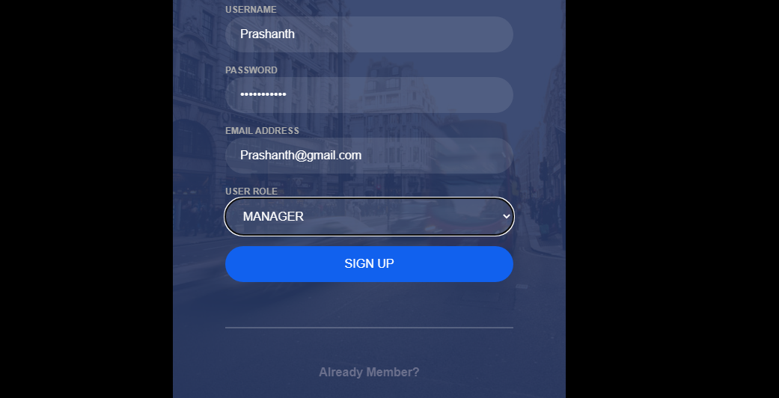

**Empty - Login Page**

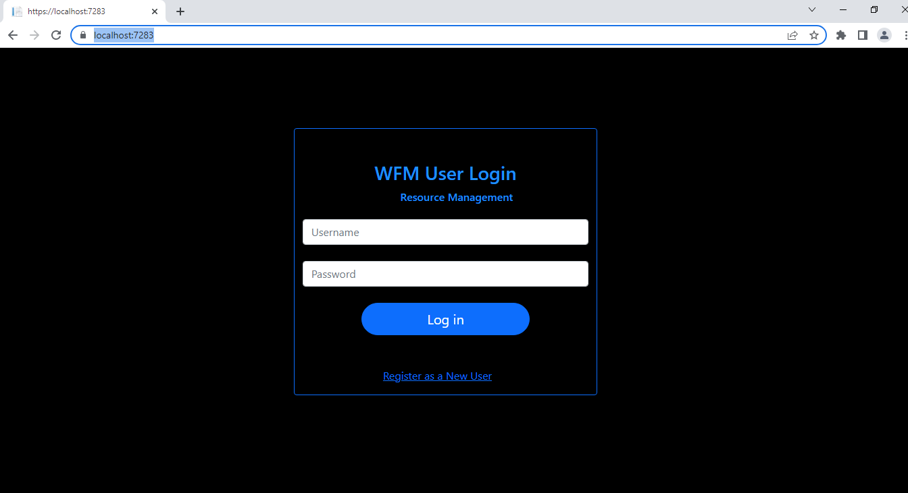

**LogIn Page With User Details - UserType -> MANAGER**

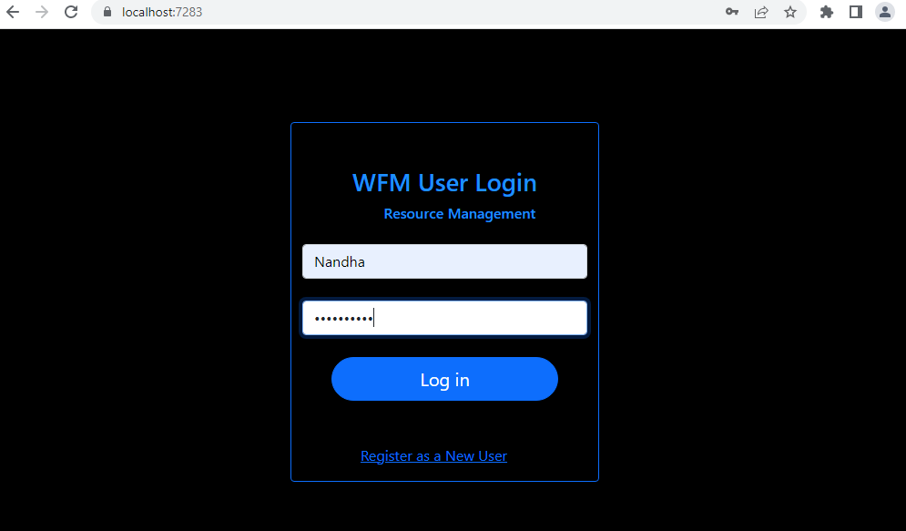

**UserType -> Manager Landing Page**

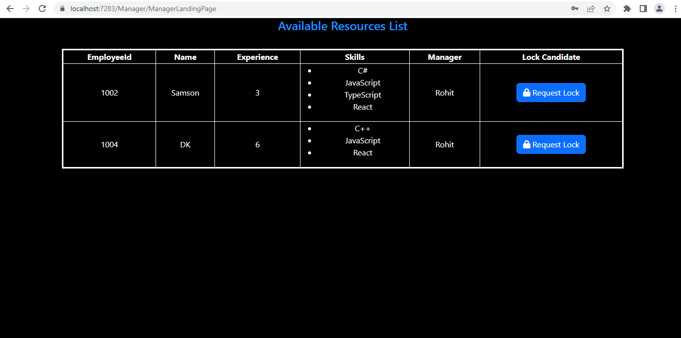

**Not_Requested Status Employee in Employee Table**

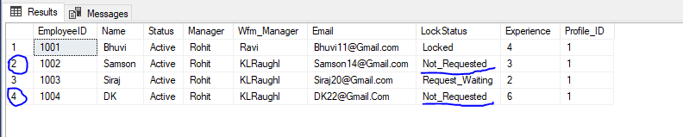

**Request Lock PopUp-Empty**

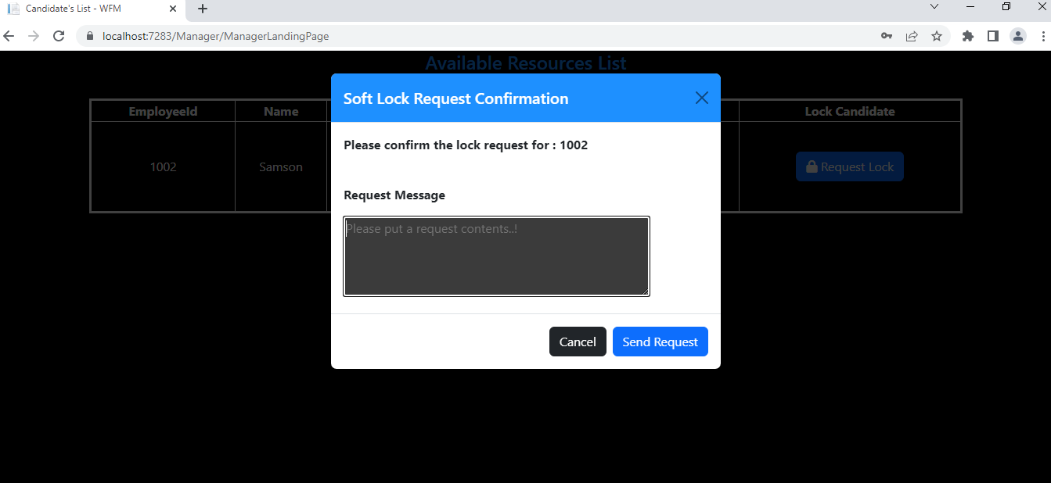

**Request Lock PopUp- With Req Content**

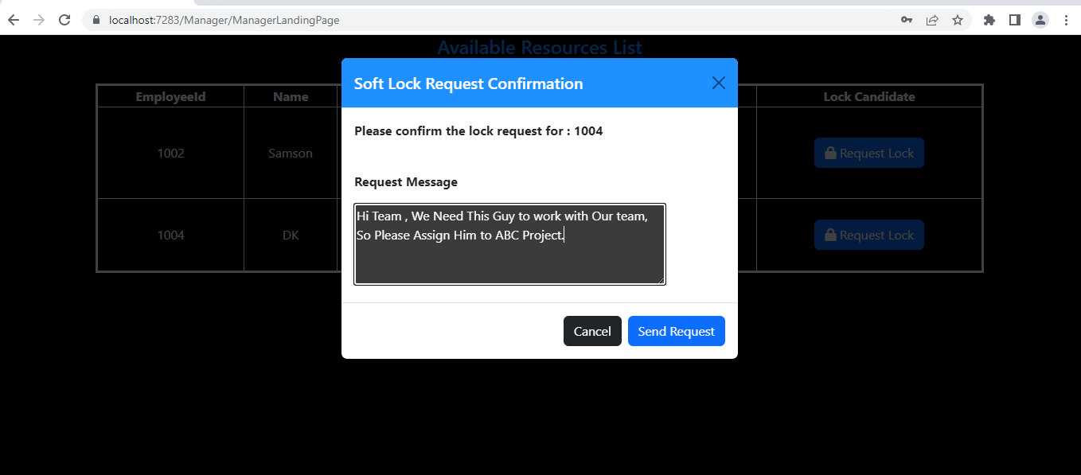

**Request Successfully Created - Alert**

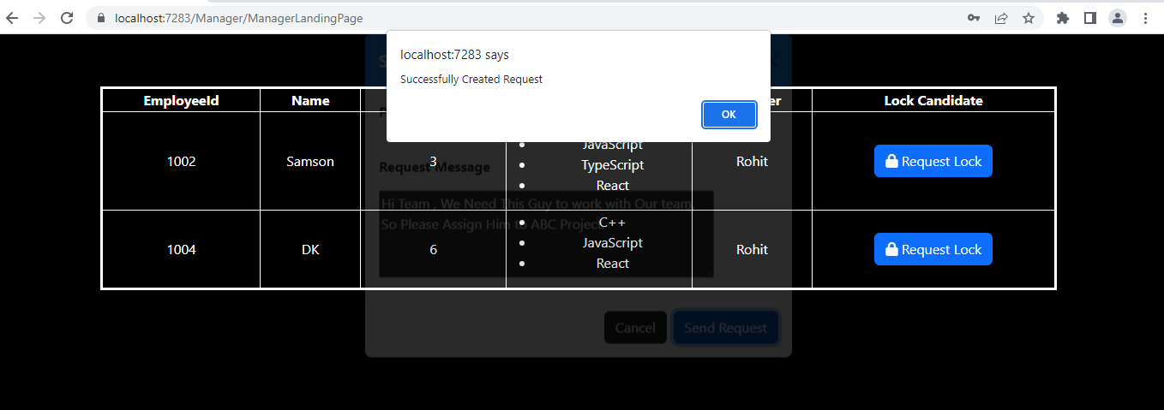

**After Lock Request Successfully Created Emp-Status Updated**

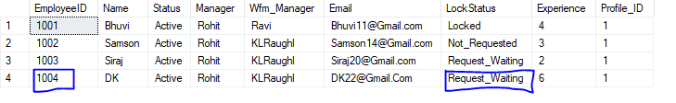

**Pending Available Resources List**

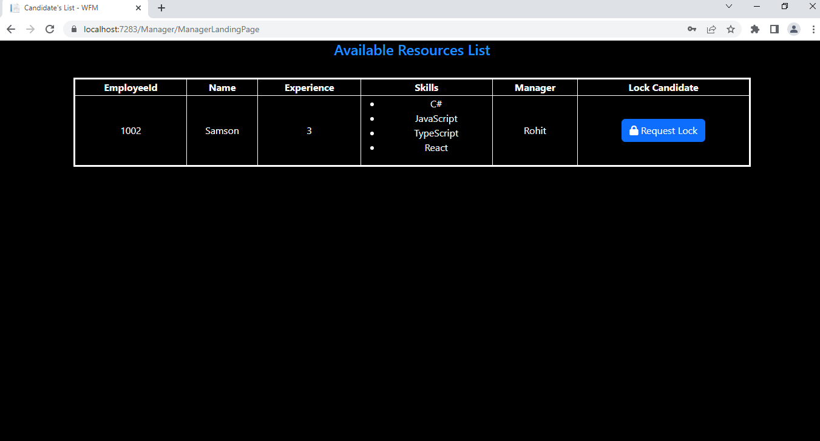

**SoftLock Table ReqLock Emp Details Inserted**



**------------------------------------------------------------------------------------------------**

**WFM Member Flow**

**LogIn Page UserType -> Member**



**WFM-Member Landing Page**

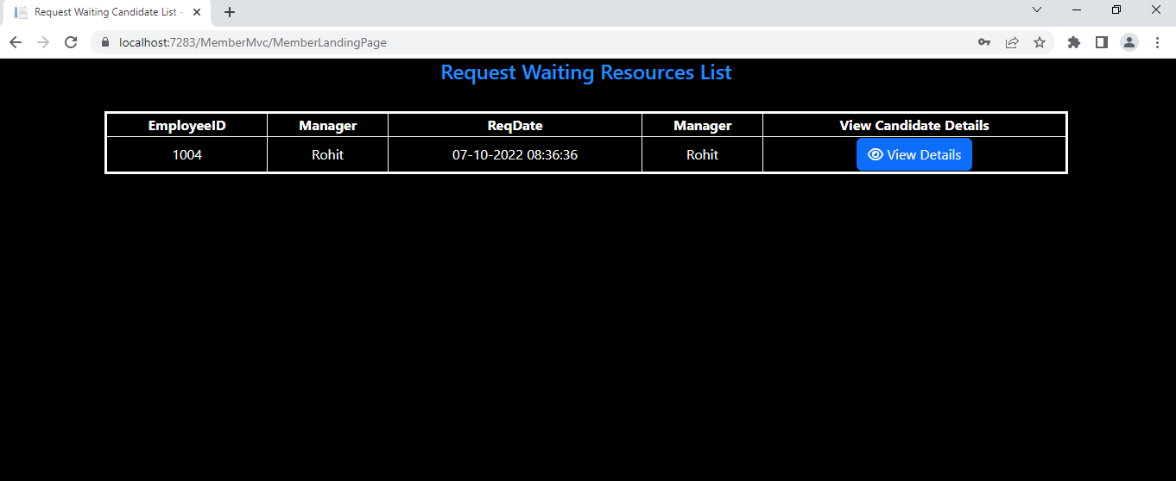

**WFM-Member View Details PopUp**

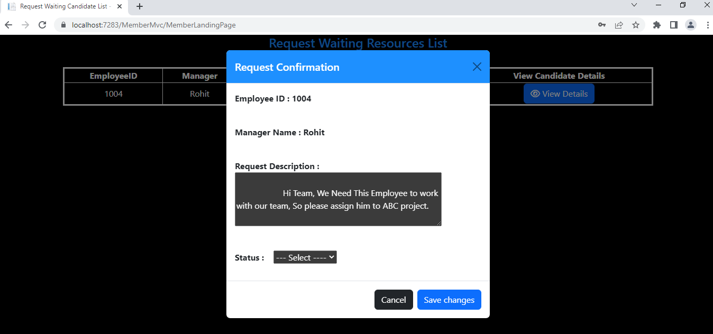

**Request Approve Confirmation alert**

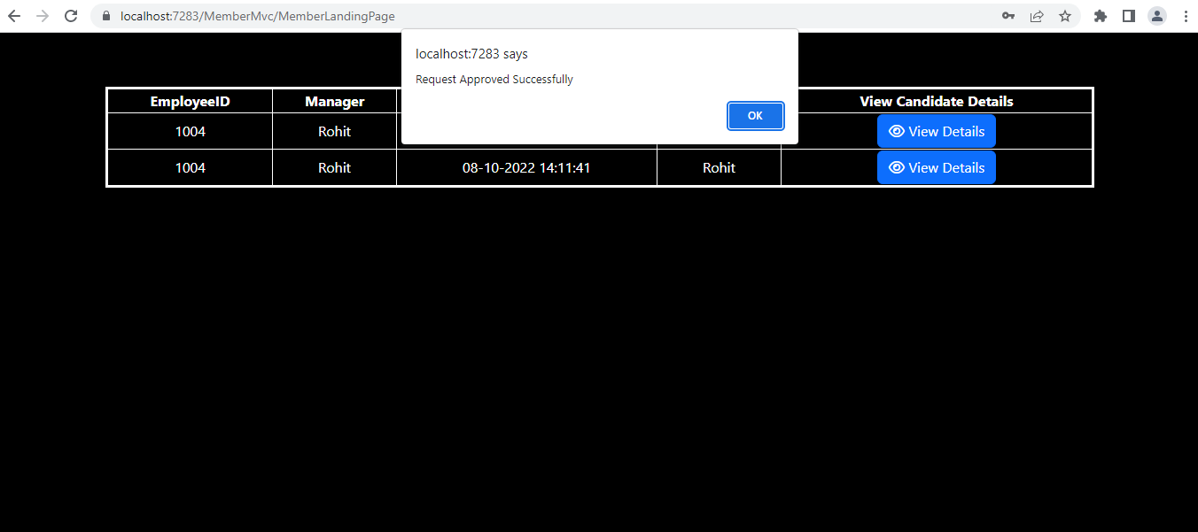

**SoftLock Table Status After Confirm Request**



**Employee Table Status Updated After Request Approved**

