**Day 4**

1. Find out the mail servers of the following domain:

* Ibm.com
* Wipro.com

Open PenTester VMware workstation

Open Command Prompt

Type

ipconfig

nslookup

www.Ibm.com

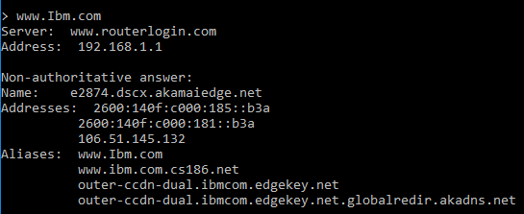

www.Wipro.com

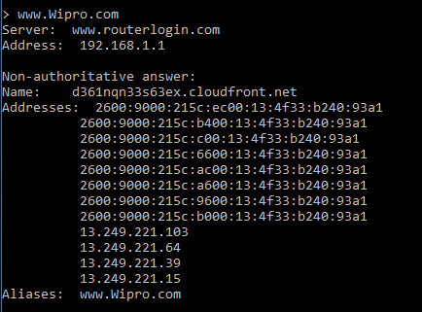

1. Find the locations, where these email servers are hosted.

Cont. of Question 1

Type:

set type=mx

Ibm.com

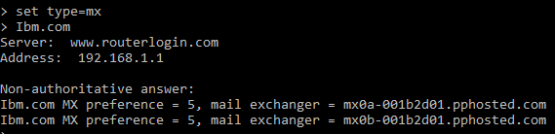

Open google chrome

Open IP Location Finder

Copy paste the url and find the location

**Address 1:**

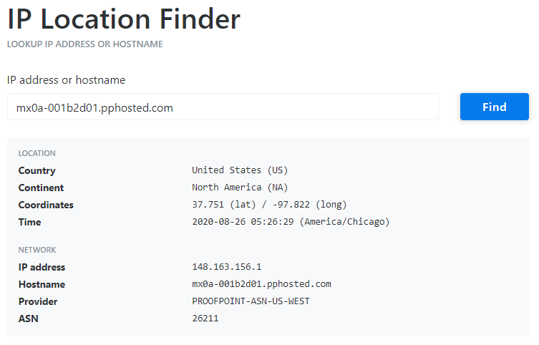

**Address 2:**

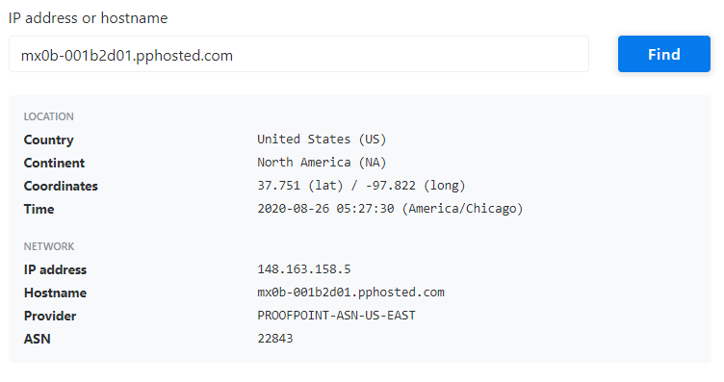

Wipro.com

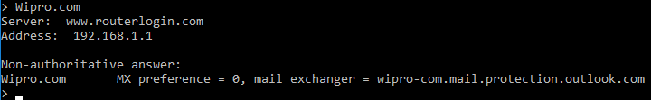

Open google chrome

Open IP Location Finder

Copy paste the URL and find the location

**Address:**

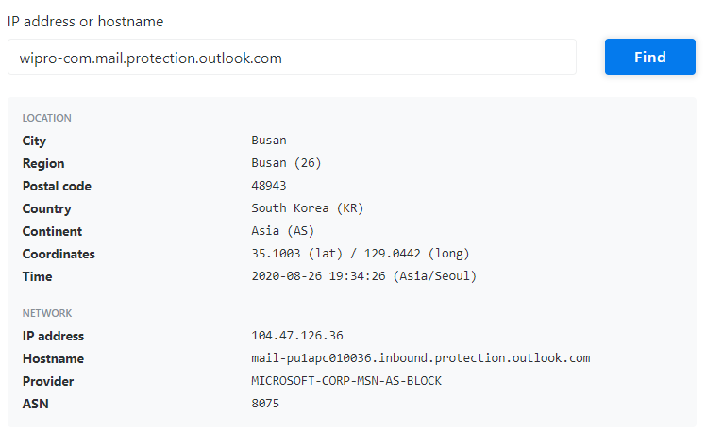

3)Scan and find out port numbers open 203.163.246.23

Open Kali-pc

Right click on the screen and Open Terminal

Type:

sudo su –

Enter password

Enter – nmap –Pn –sS 203.163.246.23

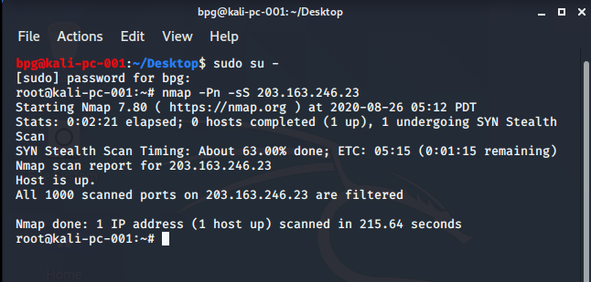

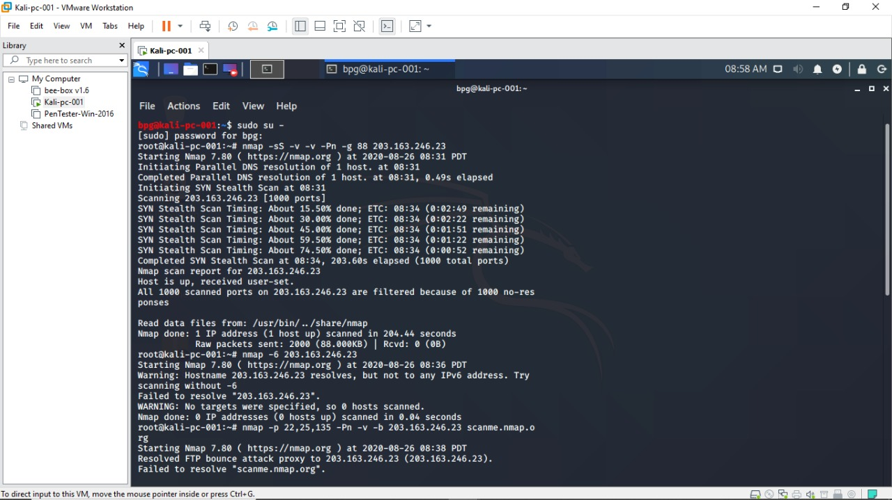

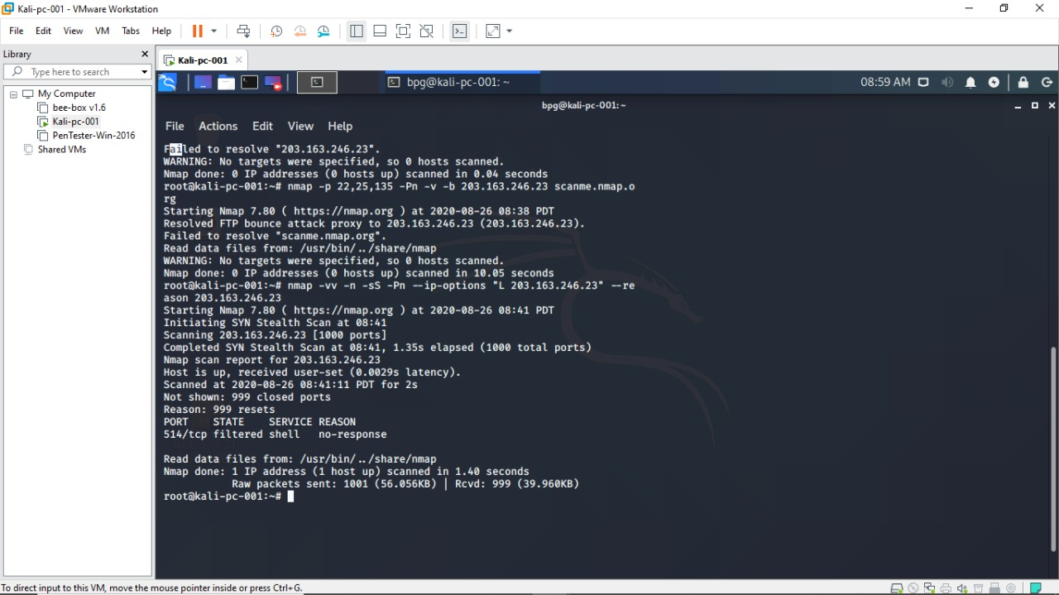

1. Install nessus in a VM and scan your laptop/desktop for CVE

Open PenTester VMware workstation

Install Google Chrome

Install Nessus

Click on All scansCreate a new scan Advance settingsWindows Fill the required blanks in credentials as well Launch

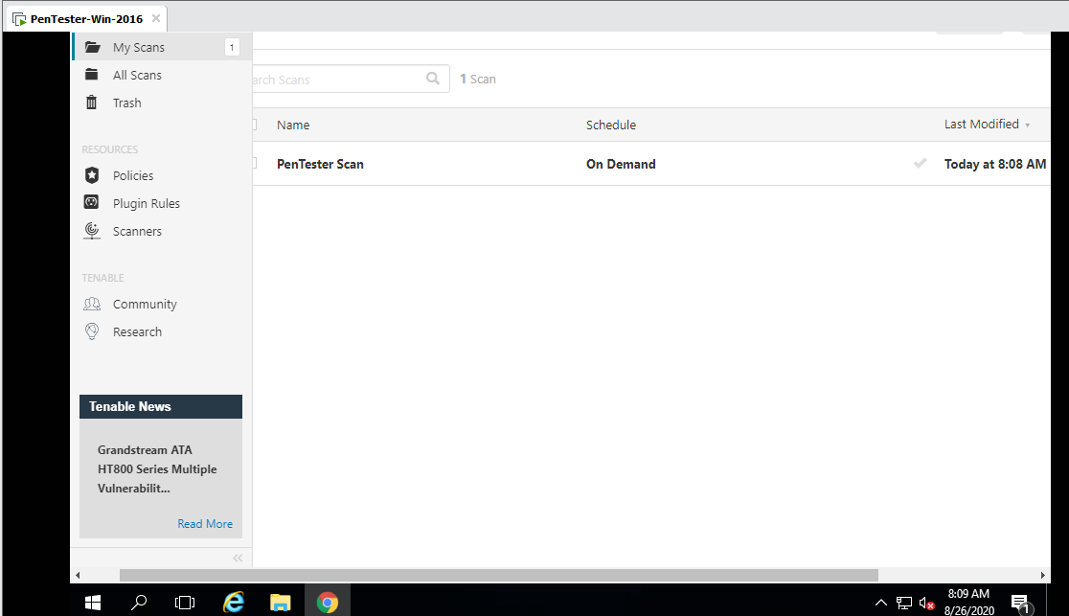

Report

