Virtual Reality in Gaming: Shaping the Future of Entertainment

INTRODUCTION:

Virtual Reality (VR) in gaming has revolutionized the way we experience entertainment, offering an immersive and interactive experience that blurs the lines between the physical and digital worlds. As VR technology continues to evolve, it's poised to shape the future of gaming and entertainment in numerous ways. Virtual Reality has significantly transformed the gaming landscape by providing immersive and interactive experiences that traditional gaming setups can't match.

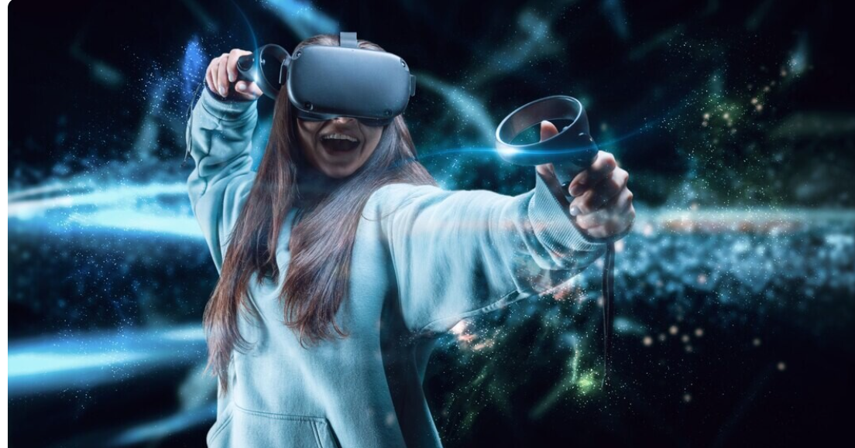

1.Enhanced Immersion :

VR gaming allows players to step into the game world, feeling as if they're actually part of the action. With a VR headset and controllers, players can explore virtual environments, interact with virtual objects, and engage in immersive gameplay experiences. This level of immersion can lead to increased engagement, longer play sessions, and a deeper emotional connection with the game.

2.New Gameplay Mechanics :

VR technology has enabled the development of new gameplay mechanics that were previously impossible. For example, VR games can incorporate hand tracking, allowing players to manipulate virtual objects with their hands. This has opened up new possibilities for gameplay, such as interactive puzzles, hand-to-hand combat, and precision-based challenges.

3.Increased Accessibility :

VR gaming has also made gaming more accessible to people with disabilities. For example, VR games can be designed with accessibility features such as text-to-speech functionality, audio descriptions, and customizable controls. This has opened up the gaming world to a broader audience, including those who may have previously been unable to participate due to physical or cognitive limitations.

4.Social Interactions :

VR gaming has also changed the way we interact with others. Social VR platforms allow players to connect with friends and strangers in virtual environments, enabling social interactions that are both entertaining and educational. For example, VR games can facilitate language learning, cultural exchange, and social skills development.

5.Cross-Platform Play :

The rise of VR gaming has also led to the development of cross-platform play, where players can seamlessly play together across different devices and platforms. This has opened up new opportunities for gamers to connect with others worldwide, regardless of their hardware or software setup.

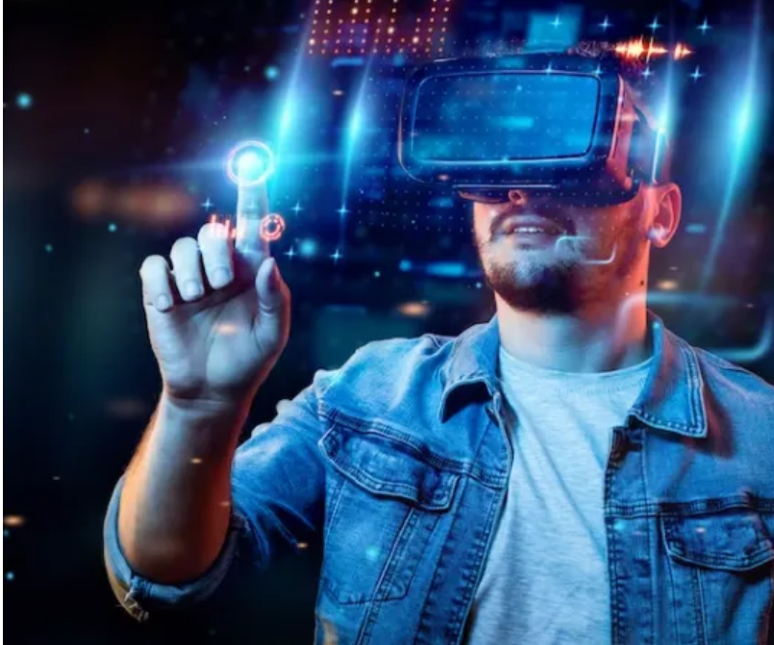

CONCLUSION :

The growth of VR gaming has also had an impact on traditional gaming. The rise of cloud gaming and game streaming services has made it easier for players to access high-quality games without the need for expensive hardware or large game downloads. This shift towards cloud-based gaming has also led to the development of new business models, such as subscription-based services and free-to-play games. VR in gaming continues to evolve, offering new ways to experience and interact with digital worlds. As technology advances and becomes more accessible, it’s likely that VR will play an increasingly significant role in the future of gaming .

