Rural vs. Urban Poverty: A Comparative Study in the Indian Context:

**INTRODUCTION:**

Poverty is a pervasive issue in India, affecting both rural and urban areas. However, the nature and extent of poverty vary significantly between the two regions. Poverty is a complex issue that affects individuals, communities, and societies around the world. It is a state of being that is characterized by a lack of basic necessities, such as food, shelter, clothing, and access to education and healthcare. Poverty can be acute or chronic, and it can be caused by a variety of factors, including economic downturns, lack of education and job opportunities, discrimination, and natural disasters.

**CHARACTERISTICS OF RURAL POVERTY:**

Rural poverty is characterized by a lack of access to basic amenities such as clean water, sanitation, and healthcare. Many rural communities are trapped in a cycle of poverty, with limited economic opportunities, low levels of education, and poor infrastructure. The rural poor often rely on traditional agriculture and small-scale farming, which are vulnerable to climate change, crop failures, and market fluctuations. This can lead to food insecurity, malnutrition, and poor health outcomes.

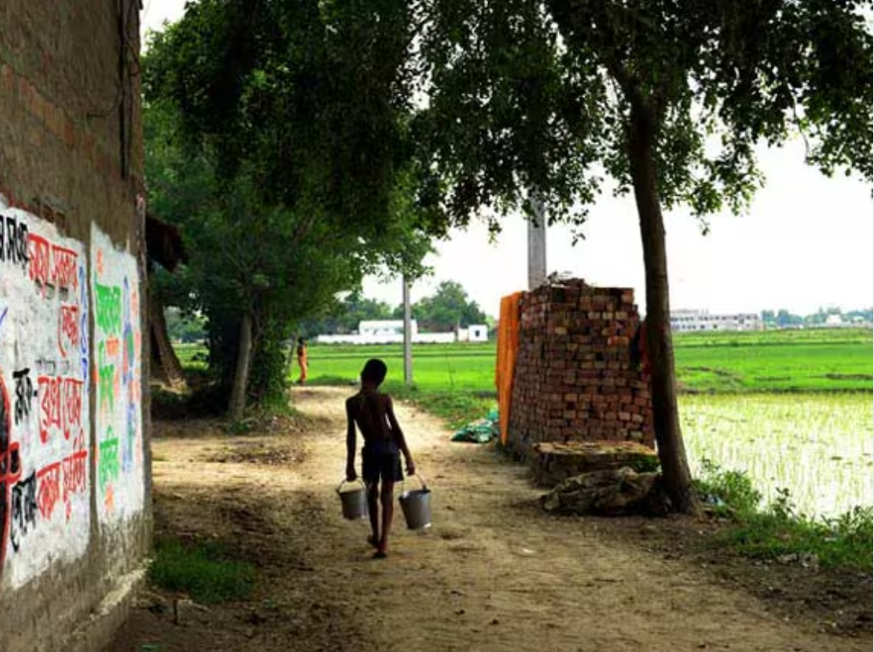

**CAUSES OF RURAL POVERTY:**

The causes of rural poverty are multifaceted and complex. Poor agricultural practices, lack of access to credit and markets, and dependence on monsoon rainfall are some of the key factors contributing to rural poverty. Additionally, the lack of infrastructure, including roads, telecommunications, and electricity, makes it difficult for rural communities to access services and markets. The dominance of traditional agriculture and the limited diversification of crops also limit the economic opportunities available to rural communities.

**CONSEQUENCES OF RURAL POVERTY:**

The consequences of rural poverty are far-reaching and devastating. Rural poverty is often linked to poor health outcomes, including high rates of infant mortality, malnutrition, and preventable diseases. It also contributes to low levels of education, limited access to healthcare, and limited social mobility. Rural poverty can also lead to social exclusion, with marginalized groups such as Dalits and women facing significant barriers to accessing resources and services.

**CHARACTERISTICS OF URBAN POVERTY:**

Urban poverty is a significant issue in India, characterized by a lack of access to basic amenities such as affordable housing, healthcare, and education. Urban poverty is often associated with overcrowding, poor living conditions, and limited access to social services. Many urban poor households live in slums or informal settlements, with inadequate infrastructure, including poor sanitation, lack of piped water, and inadequate waste management. This can lead to poor health outcomes, including high rates of respiratory diseases, skin infections, and water-borne diseases.

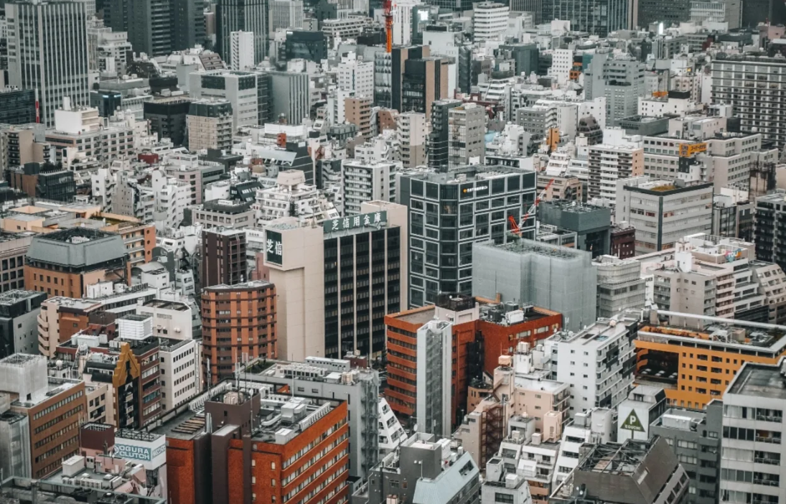

**CAUSES OF URBAN POVERTY:**

The causes of urban poverty are complex and multifaceted. Urban poverty is often linked to the lack of formal employment opportunities, irregular income, and limited access to education and skills training. Many urban poor households rely on informal or unorganized employment, such as street vending, begging, or working as domestic help. This can lead to a lack of job security, low wages, and limited access to social services. Additionally, urban poverty is often linked to the lack of affordable housing, with many urban poor households forced to live in substandard housing or share small apartments with multiple families.

**CONSEQUENCES OF URBAN POVERTY:**

The consequences of urban poverty are far-reaching and devastating. Urban poverty is often linked to poor health outcomes, including high rates of infant mortality, malnutrition, and preventable diseases. It also contributes to low levels of education, limited access to healthcare, and limited social mobility. Urban poverty can also lead to social exclusion, with marginalized groups such as women and Dalits facing significant barriers to accessing resources and services. Furthermore, urban poverty can contribute to social unrest and political instability, as marginalized groups may feel that they are being excluded from the benefits of economic growth.

**CONCLUSION:**

Despite these differences, both rural and urban poverty in India are often intertwined with issues of social exclusion, inequality, and lack of access to resources. For example, rural poverty is often linked to the exploitation of marginalized groups by powerful landlords and moneylenders, while urban poverty is often linked to the lack of access to affordable housing and social services.

To address these issues, policymakers have implemented a range of initiatives aimed at reducing poverty and improving living standards in both rural and urban areas. These include programs aimed at increasing access to basic services such as healthcare and education, as well as initiatives aimed at promoting entrepreneurship and job creation in rural areas. However, more needs to be done to address the root causes of poverty and inequality in India.