**TEST PLAN**

In software testing, documentation is very important. Testing should be documented to provide efficient resource control monitoring

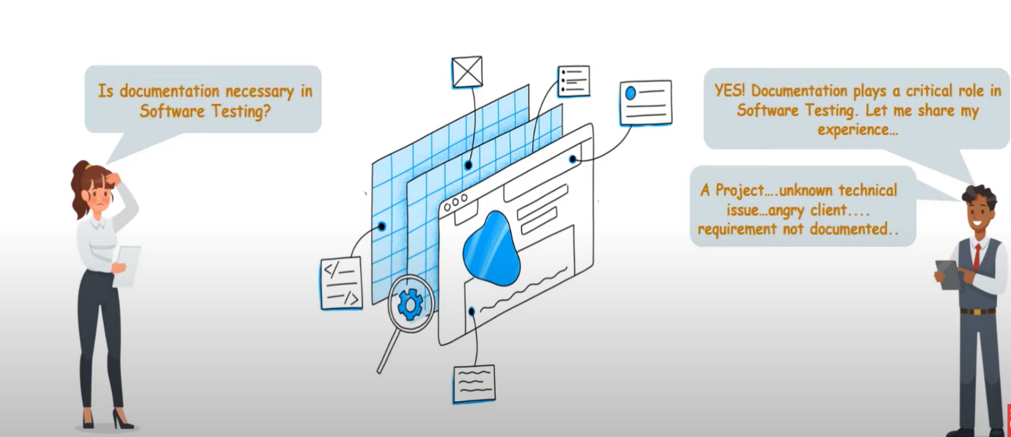

Here, Let’s assume that there’s a company ABC. It delivered a project to it’s client with an unknown issue to one of it’s client and the issue was then found in the client end. This becomes a bad situation for the company and the blame was put on the company. The issue was regarding the compatibility of one website with the other. The company has shown a written proof that there’s no requirement to check the compatibility of the website. So, the issue was solved peacefully.   
  
Hence documentation of testing is really necessary.  
  
Testing should be documented to provide efficient resource control, monitoring and allocation.

COMMON DOCUMENTED ARTIFACTS IN SOFTWARE TESTING:

1. Test plan
2. Test Case
3. Test Scenario
4. Traceability matrix
5. Test Plan: Test plan is a document prepared at a project level. In general, it defines work products to be tested, how they will be tested and test type distribution among testers. It also includes test environment tools and many other details.
6. Test Case: Test case is a complexity of inputs, series of steps and conditions that can be used during the process of testing. The main purpose of writing a test case is to make sure whether a software plan passes or fails in terms of functionality and many other aspects. They are written to keep a track of testing coverage of a product that we are testing. There are different types of test cases like functional, negative, logical, physical, user interface etc.
7. Test Scenario: Test Scenario can be considered as a single line statement which notifies the area in which the application will be experimented. This artifact is needed for ensuring the overall procedure tested from start to finish.
8. Traceability matrix: Also referred as Requirement Traceability Matrix (RTM). It is a table that can be used to trace the requirements during SDLC. It can be applied in various usages like **forward tracing** i.e., requirements to design or coding, **backward tracing** which is from coding to requirements.

**TEST PLAN**

A test plan is a document describing the scope, approach, objectives, resources and schedule of a software testing effort. It is the document that outlines the what, when, how, who and more of a testing project.

It is the first thing that should happen in Software Testing Life Cycle. It summarizes the testing process.

The plan is broken down into manageable pieces so that we can know how to deal with each aspect of the process.

As the changes to the test plan are made, the test plan document should be updated to reflect the decisions that we made. Thus, test plan is not a fixed document instead, it keeps changing based on the requirements and the test process that we follow.

**WHAT HAPPENS WHEN THERE IS NO TEST PLAN?**

* Misunderstandings about roles and responsibilities
* Test team will not have clear objectives
* No surety about when test process ends
* Undefined test scope misleads testers and users

There are 6 simple steps to write a test plan:

