**Activity 2** : Data-Centric Routing and Proactive Routing

1. Determine the MPR for the network shown in Figures 1 and 2 by considering the current node as 8 and 6
2. Construct the routing table of OLSR and describe the path for transmitting information from node 7 to 2

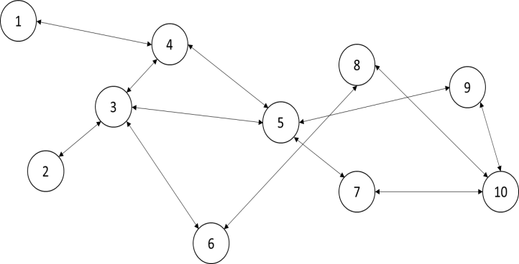

Figure 1. Network topology of 10 nodes

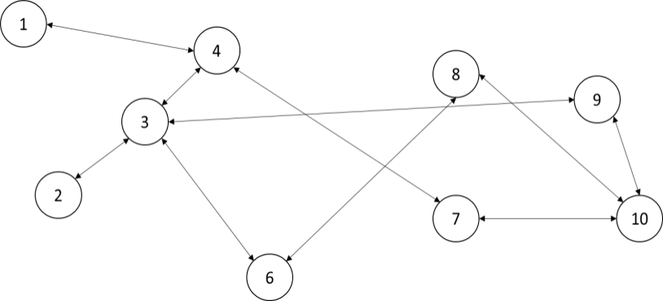

Figure 2. Network with discarded nodes

**Data centric routing:** In data-centric routing, the sink which is responsible for gathering data and sending to the base station, issues a query for finding target data stored in the other nodes of WSN.

Data-centric routing protocols are composed of two phases.

**Proactive Routing:**

In proactive routing protocol, each node of the network maintains a single or multiple routing tables that are regularly updated. Each node will send a broadcasting message to all the other nodes in the network in order to detect the changes in their network topology.

# MPR:multiple provider router

A component of the Microsoft Windows NT operating system that supports the Workstation service by enabling access to shared folders and printers using standard Win32 network application programming interfaces (APIs).

**How It Works:**

When an application tries to access a shared resource using a Universal Naming Convention

(UNC) path, the request first goes to the I/O Manager, which forwards it to the Multiple UNC Provider (MUP). The MUP then queries the installed redirectors to determine which one can access the shared resource. These queries are passed to each redirector through a provider dynamic-link library (DLL) that is designed to communicate with that vendor’s redirector but presents a common programming interface to the multiple provider router (MPR). Once the appropriate redirector has been selected, the MPR forwards the request to the redirector.

**Optimized Link State Routing Protocol** (**OLSR**) is an IP routing protocol optimized for mobile ad hoc network, which can also be used on other wireless ad hoc networks. OLSR is a proactive link state routing protocol, which uses hello and topology control (TC) messages to discover and then disseminate link state information throughout the mobile ad hoc network. Individual nodes use this topology information to compute next hop destinations for all nodes in the network using shortest hop forwarding paths.

