Multiple_year_stock_data ->2018 Worksheet after running the VBA script.

Please Note - Conditional formatting applied via VBA script on yearly change column and percent change column which highlight positive change in green and negative change in red.

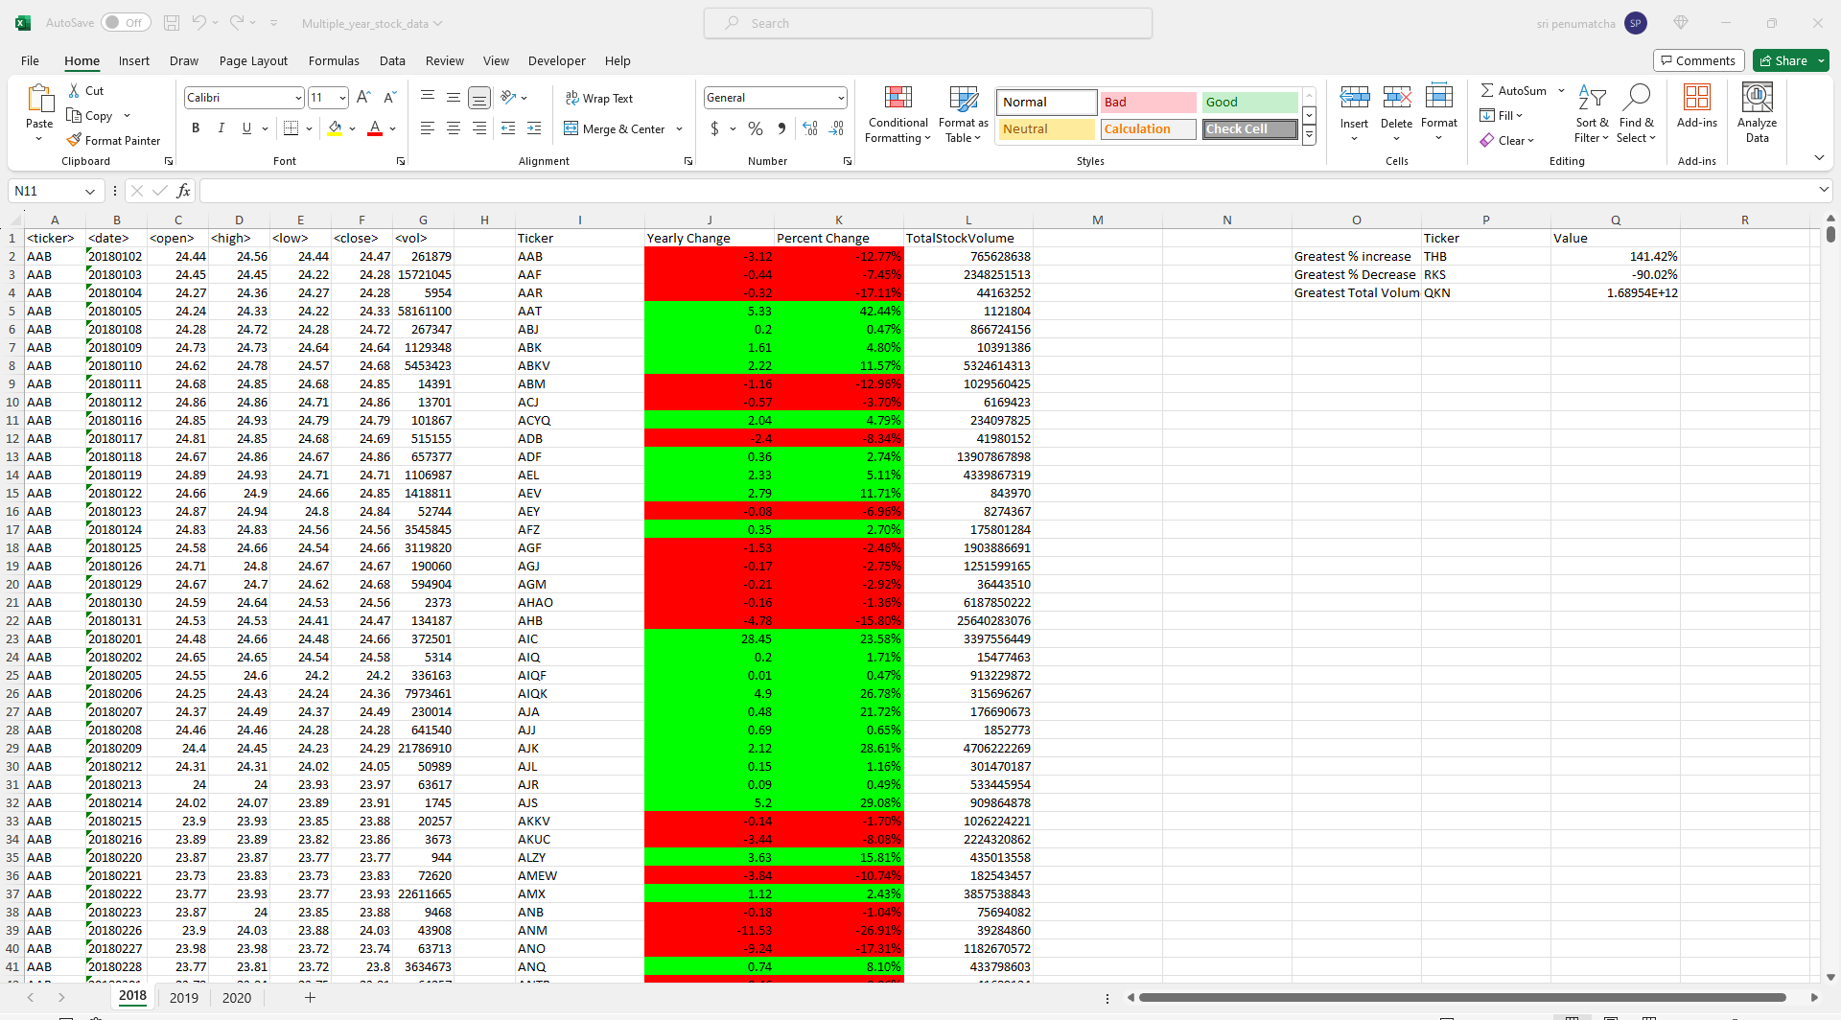

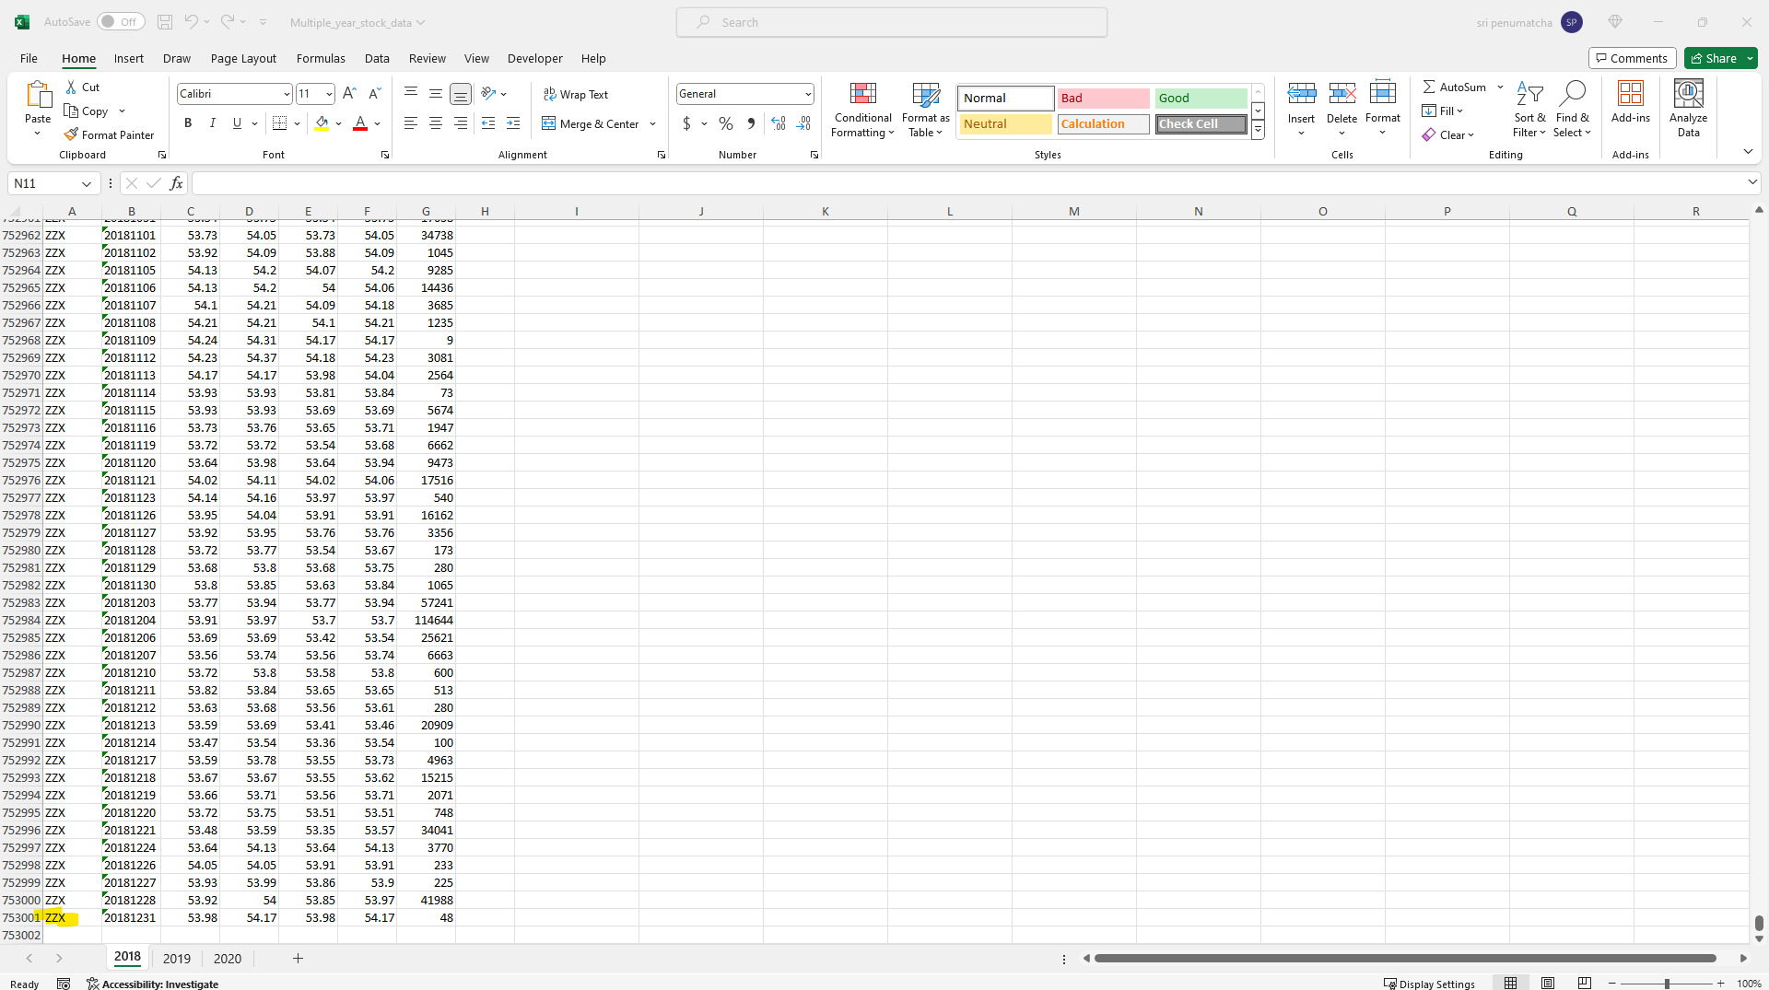

2019-Worksheet

2020 – Worksheet



