Folder structure

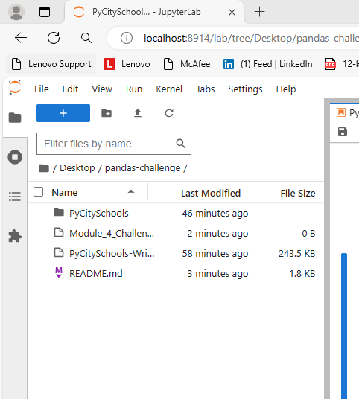

**Local Government Area Summary**

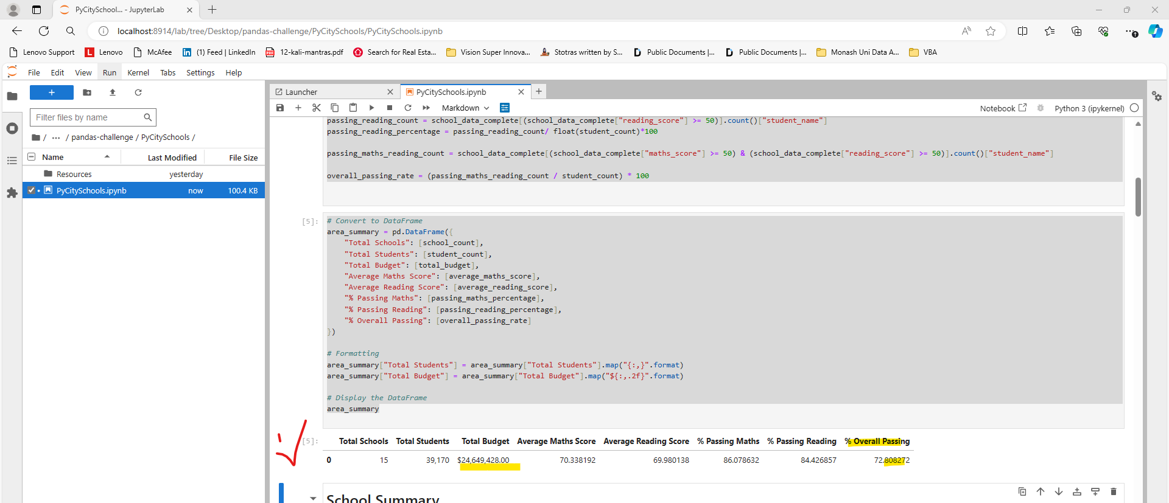

**School Summary**

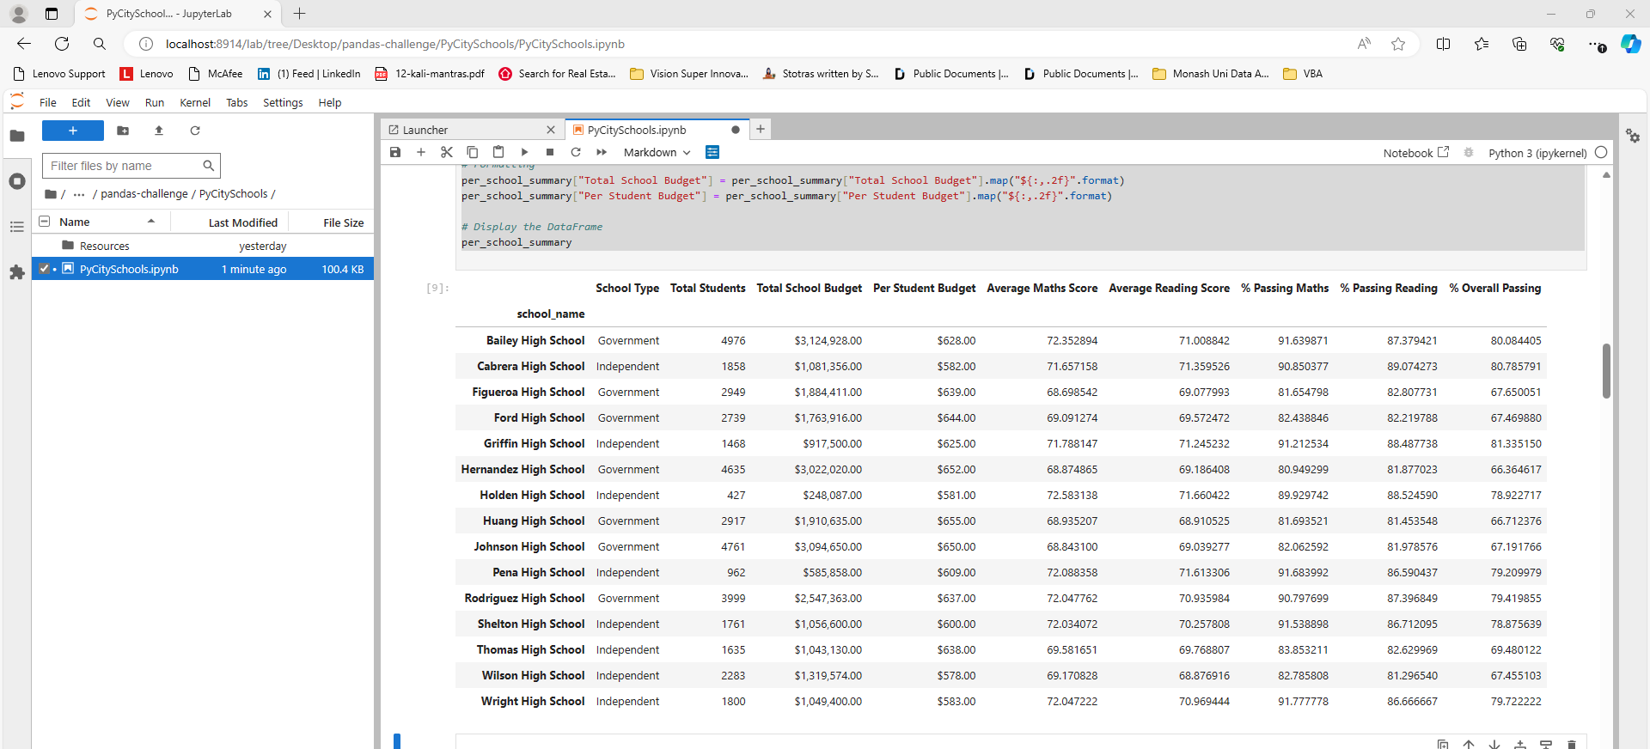

**Highest-Performing Schools (by % Overall Passing)**

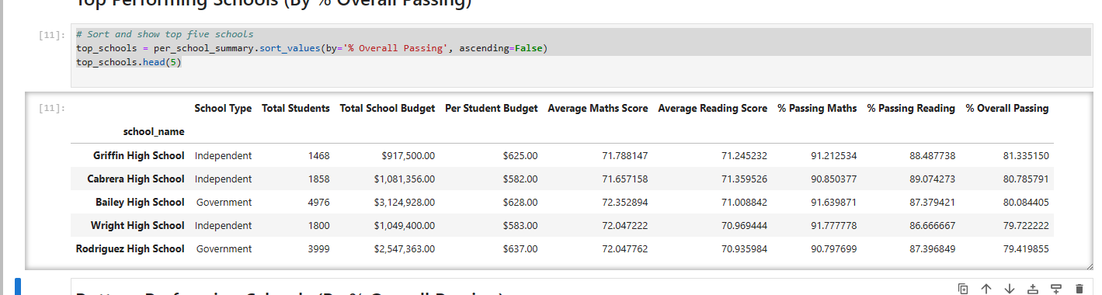

**Lowest-Performing Schools (by % Overall Passing)**

**Maths Scores by Year**

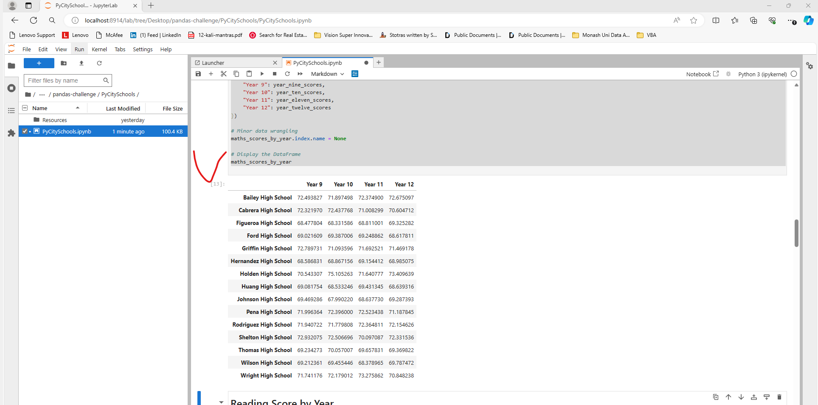

**Reading Scores by Year**

**Scores by School Spending**

**Scores by School Size**

**Scores by School Type**

