DEPARTMENT OF COMPUTER SCIENCE & ENGINEERING
DBMS MINI-PROJECT EVIDENCE REPORT
SMARTRETAIL
AI-POWERED INVENTORY AND SALES MANAGEMENT SYSTEM
DATABASE MANAGEMENT SYSTEMS (DA2)
COMPLETE SQL & PL/SQL IMPLEMENTATION EVIDENCE
Target RDBMS Engine: | Oracle Database 11g Express Edition Release 11.2.0.2.0 (64-bit)
Target Schema User: | SYSTEM (Verified Local Project Account)
Implementation Scope: | 19 Approved Relations (Normalized Relational Model)
Primary Source of Truth: | SmartRetail_DA2_Antigravity_Handoff.docx
Schema Conformance Audit: | 19/19 Relations Verified (SCHEMA_CONFORMANCE_AUDIT.md)
Test Suite Validation: | 13/13 Automated Tests PASSED (run_all.log)
ACADEMIC YEAR 2025–2026 | DIGITAL ASSIGNMENT 2
STRICT SCHEMA CONFORMANCE AND EXECUTION VERIFICATION

1. System Overview & Architecture
SmartRetail is a normalized relational database management system designed to support modern supermarket retail operations. The architecture captures the complete product lifecycle from supplier procurement and warehouse receiving to point-of-sale customer checkout and inventory movement.
The operational workflow is divided into four functional sub-systems:
1. Procurement & Supplier Relations: Tracks suppliers, communication channels, purchase orders, purchase order line extensions, shipments, and receiving records.
2. Catalog & Merchandising: Organizes product categories and products with unit prices, barcodes, units of measure, and active merchandising flags.
3. Multi-Tier Inventory Management: Separates warehouse bulk storage locations from retail display shelves. Tracks stock balances, reorder thresholds, immutable audit movements in InventoryTransaction, and reactive restock and reorder events.
4. Point of Sale (POS) Checkout & Billing: Records transaction receipts, sales transaction lines, cashier attribution, split payment settlement across cash, card, and UPI, and customer loyalty records.
2. Approved Relational Schema Verification
The implemented database contains exactly 19 approved relations, adhering strictly to the architecture brief defined in SmartRetail_DA2_Antigravity_Handoff.docx. A formal Schema Conformance Audit verified 100% attribute, primary key, foreign key, and check constraint parity against the live Oracle 11g database.
Relation Name | Attributes / Columns | Integrity Constraints | Functional Purpose
Supplier | supplier_id, supplier_name, contact_person, email, gst_number, street, city, state, pincode, rating, created_at | PK: supplier_id  UK: email, gst_number  CK: rating BETWEEN 1 AND 5  NN: supplier_name, email, gst_number | Master vendor registry with commercial, GST tax registration, postal location, and vendor rating attributes.
SupplierPhone | supplier_id, phone_number | PK: (supplier_id, phone_number)  FK: supplier_id -> Supplier(supplier_id)  NN: phone_number | Multivalued 1:N vendor contact telephone numbers.
ProductCategory | category_id, category_name, parent_category_id | PK: category_id  UK: category_name  FK: parent_category_id -> ProductCategory(category_id)  NN: category_name | Hierarchical merchandise taxonomy with self-referencing subcategory classification.
Product | product_id, sku, barcode, product_name, description, category_id, unit_of_measure, standard_unit_price, is_active | PK: product_id  UK: sku, barcode  FK: category_id -> ProductCategory(category_id)  CK: standard_unit_price > 0, is_active IN ('TRUE','FALSE')  NN: sku, barcode, product_name, category_id, unit_of_measure, standard_unit_price, is_active | Master merchandise catalog with retail pricing, barcode tracking, and active status.
Employee | employee_id, full_name, role, email, phone, hire_date | PK: employee_id  UK: email  CK: role IN ('MANAGER','CASHIER','INVENTORY_CLERK','ADMIN')  NN: full_name, role, email, hire_date | Store personnel directory with defined operational role-based access segregation.
PurchaseOrder | po_id, po_number, supplier_id, created_by, order_date, expected_delivery_date, status, total_amount, is_auto_generated | PK: po_id  UK: po_number  FK: supplier_id -> Supplier(supplier_id), created_by -> Employee(employee_id)  CK: status IN ('PENDING','APPROVED','PARTIALLY_RECEIVED','RECEIVED','CANCELLED'), is_auto_generated IN ('TRUE','FALSE'), total_amount >= 0  NN: po_number, supplier_id, created_by, order_date, status, total_amount, is_auto_generated | Procurement purchase order headers placed with certified commercial suppliers.
PurchaseOrderLine | po_id, product_id, quantity_ordered, unit_price | PK: (po_id, product_id)  FK: po_id -> PurchaseOrder(po_id), product_id -> Product(product_id)  CK: quantity_ordered > 0, unit_price > 0  NN: quantity_ordered, unit_price | Itemized procurement order lines and contracted procurement unit costs.
Shipment | shipment_id, tracking_number, po_id, carrier, shipment_date, received_date, status, received_by | PK: shipment_id  UK: tracking_number  FK: po_id -> PurchaseOrder(po_id), received_by -> Employee(employee_id)  CK: status IN ('IN_TRANSIT','DELIVERED','CANCELLED')  NN: tracking_number, po_id, carrier, shipment_date, status | Inbound supplier logistics and warehouse receiving tracking.
ShipmentLine | shipment_id, product_id, quantity_shipped, quantity_received | PK: (shipment_id, product_id)  FK: shipment_id -> Shipment(shipment_id), product_id -> Product(product_id)  CK: quantity_shipped >= 0, quantity_received >= 0  NN: quantity_shipped, quantity_received | Physical receiving reconciliation supporting partial delivery verification.
InventoryLocation | location_id, location_code, location_type, location_name, parent_location_id, capacity, aisle_number, zone | PK: location_id  UK: location_code  FK: parent_location_id -> InventoryLocation(location_id)  CK: location_type IN ('WAREHOUSE','SHELF')  NN: location_code, location_type, location_name | Hierarchical physical storage mapping distinguishing warehouses from display shelves.
InventoryStock | location_id, product_id, quantity_on_hand, reorder_threshold, reorder_quantity, last_updated_at | PK: (location_id, product_id)  FK: location_id -> InventoryLocation(location_id), product_id -> Product(product_id)  CK: quantity_on_hand >= 0, reorder_threshold >= 0, reorder_quantity > 0  NN: quantity_on_hand, reorder_threshold, reorder_quantity, last_updated_at | Live stock balance ledger per location with automated replenishment thresholds.
InventoryTransaction | transaction_id, product_id, location_id, transaction_type, quantity, transaction_date, reference_type, reference_id | PK: transaction_id  FK: product_id -> Product(product_id), location_id -> InventoryLocation(location_id)  CK: transaction_type IN ('RECEIPT','TRANSFER_IN','TRANSFER_OUT','SALE','ADJUSTMENT'), reference_type IN ('SHIPMENT','RESTOCK','SALE','MANUAL'), quantity > 0  NN: product_id, location_id, transaction_type, quantity, transaction_date | Immutable audit ledger recording all physical stock additions and deductions.
RestockEvent | restock_id, product_id, from_location_id, to_location_id, quantity_moved, event_date, triggered_by, performed_by, status | PK: restock_id  FK: product_id -> Product(product_id), from_location_id -> InventoryLocation(location_id), to_location_id -> InventoryLocation(location_id), performed_by -> Employee(employee_id)  CK: status IN ('PENDING','COMPLETED'), quantity_moved > 0  NN: product_id, from_location_id, to_location_id, quantity_moved, event_date, triggered_by, status | Warehouse-to-shelf internal replenishment tracking for depleted retail shelves.
ReorderTrigger | trigger_id, product_id, location_id, stock_at_trigger, threshold_at_trigger, trigger_date, generated_po_id, status | PK: trigger_id  FK: product_id -> Product(product_id), location_id -> InventoryLocation(location_id), generated_po_id -> PurchaseOrder(po_id)  CK: status IN ('OPEN','PO_CREATED','RESOLVED','IGNORED')  NN: product_id, location_id, stock_at_trigger, threshold_at_trigger, trigger_date, status | Automated procurement reorder triggers logged when warehouse stock is breached.
Customer | customer_id, first_name, last_name, email, loyalty_points, membership_type, registered_date | PK: customer_id  UK: email  CK: loyalty_points >= 0, membership_type IN ('REGULAR','SILVER','GOLD','PLATINUM')  NN: first_name, last_name, loyalty_points, membership_type, registered_date | Retail customer registry with loyalty point balances and tier profiles.
CustomerPhone | customer_id, phone_number | PK: (customer_id, phone_number)  FK: customer_id -> Customer(customer_id)  NN: phone_number | Multivalued 1:N customer contact telephone numbers.
SalesTransaction | transaction_id, receipt_number, customer_id, cashier_id, transaction_date, total_amount, status | PK: transaction_id  UK: receipt_number  FK: customer_id -> Customer(customer_id), cashier_id -> Employee(employee_id)  CK: status IN ('COMPLETED','VOID','REFUNDED'), total_amount >= 0  NN: receipt_number, cashier_id, transaction_date, total_amount, status | Point-of-sale checkout invoice headers supporting guest customers.
SalesTransactionLine | transaction_id, product_id, shelf_location_id, quantity_sold, unit_price | PK: (transaction_id, product_id)  FK: transaction_id -> SalesTransaction(transaction_id), product_id -> Product(product_id), shelf_location_id -> InventoryLocation(location_id)  CK: quantity_sold > 0, unit_price > 0  NN: shelf_location_id, quantity_sold, unit_price | Itemized POS sale lines recording sold unit price and source shelf location.
Payment | payment_id, transaction_id, payment_method, amount, payment_date, reference_number, status | PK: payment_id  FK: transaction_id -> SalesTransaction(transaction_id)  CK: payment_method IN ('CASH','CREDIT_CARD','DEBIT_CARD','UPI','WALLET','POINTS'), status IN ('SUCCESS','PENDING','FAILED','REFUNDED'), amount > 0  NN: transaction_id, payment_method, amount, payment_date, status | Payment transactions supporting multi-tender split settlement across methods.

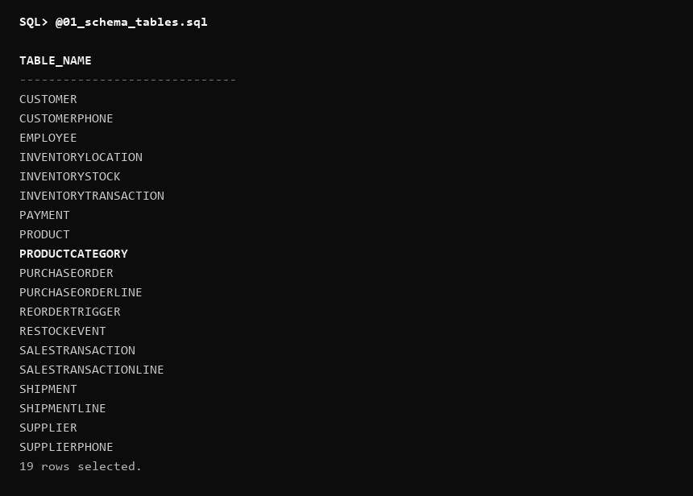
Figure 1 — SmartRetail 19-Relation Schema Verification (SQL*Plus Query on USER_TABLES)
3. Data Population
A coherent supermarket seed dataset was populated across all 19 tables in sql/03_sample_data.sql. The catalog models realistic consumer goods spanning Dairy, Bakery, Beverages, Personal Care, and Pantry Staples.
Every relation contains non-empty, validated data with verified referential integrity, supporting partial shipments, split tender payments, low shelf stock threshold scenarios, and warehouse reorder triggers.
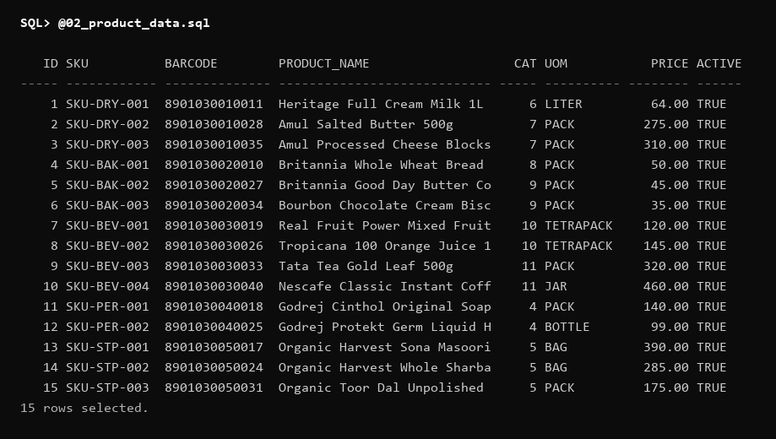
Figure 2 — Product Relation Sample Data (Clean SQL*Plus Formatted Column Output)
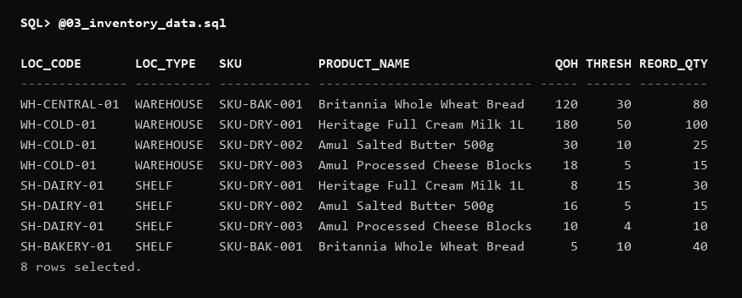
Figure 3 — Multi-Location Inventory Balances (JOIN InventoryLocation and InventoryStock)
4. SQL Query Demonstrations
4.1 Multi-Table JOIN Demonstration
The following query demonstrates a 5-table relational join linking SalesTransaction, SalesTransactionLine, Product, ProductCategory, and InventoryLocation (shelf). It computes itemized line extensions and attributes each line to the operating cashier.
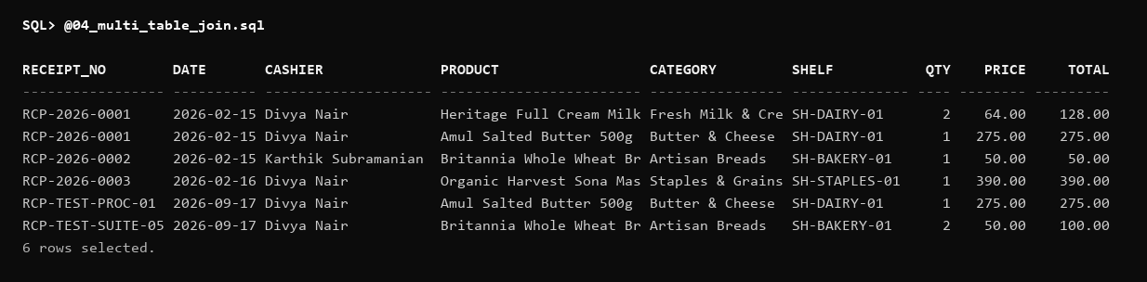
Figure 4 — POS Multi-Table Receipt Join (SalesTransaction, Lines, Product, Category, Shelf)
4.2 Aggregation with GROUP BY & HAVING
This query demonstrates category-level pricing intelligence using COUNT, MIN, MAX, AVG, and SUM aggregate functions, filtered using the HAVING clause.
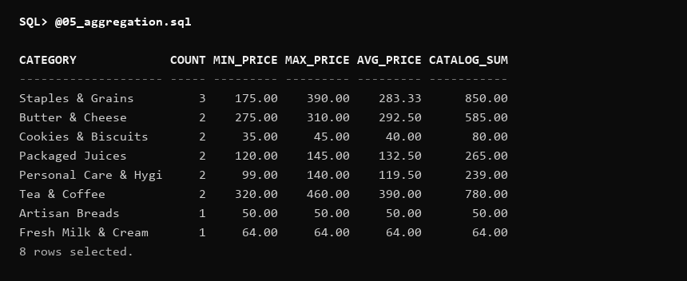
Figure 5 — Category-Level Aggregate Statistics with GROUP BY & HAVING
4.3 Advanced Analytic Window Functions
Demonstrates advanced SQL using analytic window functions RANK() and DENSE_RANK() partitioned by product category and ordered descending by retail price.
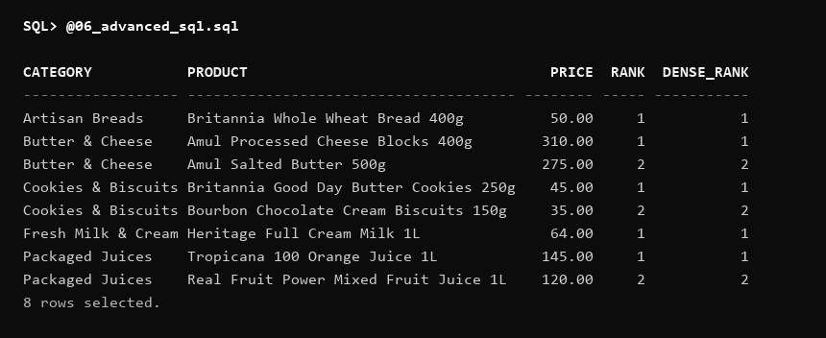
Figure 6 — Analytic Window Functions: Price Ranking by Category Partition (RANK and DENSE_RANK)
5. Database Views
Approved analytical views were implemented in sql/07_views.sql to provide executive dashboards without exposing raw transactional tables.
• VW_LOW_STOCK: Surfaces shelf items that have breached reorder thresholds, calculating the exact replenishment deficit.
• VW_PRODUCT_STOCK: Provides an enterprise inventory valuation rollup across all warehouses and retail shelves.
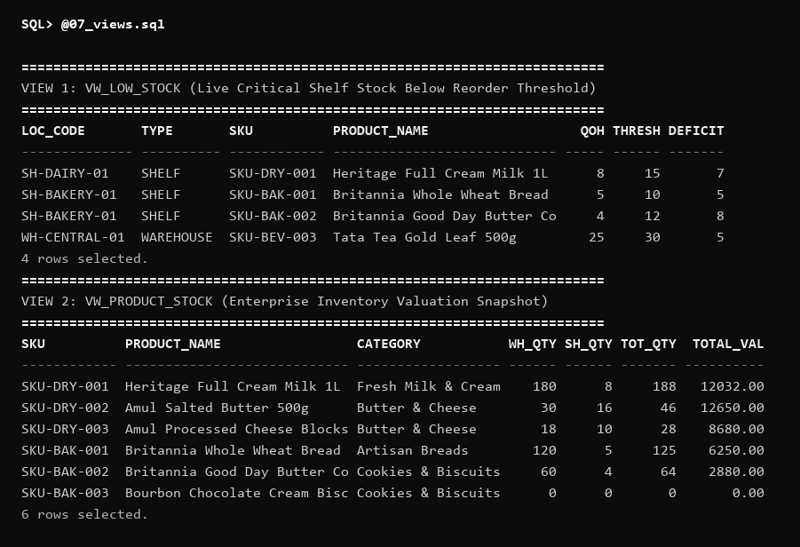
Figure 7 — Approved Business Views: VW_LOW_STOCK and VW_PRODUCT_STOCK
6. PL/SQL Stored Procedures
Four transaction-safe stored procedures manage the retail workflow in sql/09_procedures.sql:
1. PROCESS_SALE: Validates shelf stock, creates sale header & line, decrements shelf stock, writes an immutable SALE audit entry in InventoryTransaction, and maintains total_amount.
2. RECEIVE_SHIPMENT: Validates delivered shipments, increments warehouse inventory, logs RECEIPT audit rows, and updates shipment/PO statuses.
3. TRANSFER_STOCK: Executes atomic warehouse-to-shelf replenishment movements, logging paired TRANSFER_OUT and TRANSFER_IN ledger rows and generating RestockEvent audit rows.
4. CREATE_PURCHASE_ORDER: Validates suppliers, creates procurement PO headers and lines, and computes total amount.
All four procedures were verified with exact parameter signatures, executing successfully with zero parameter-type mismatches.
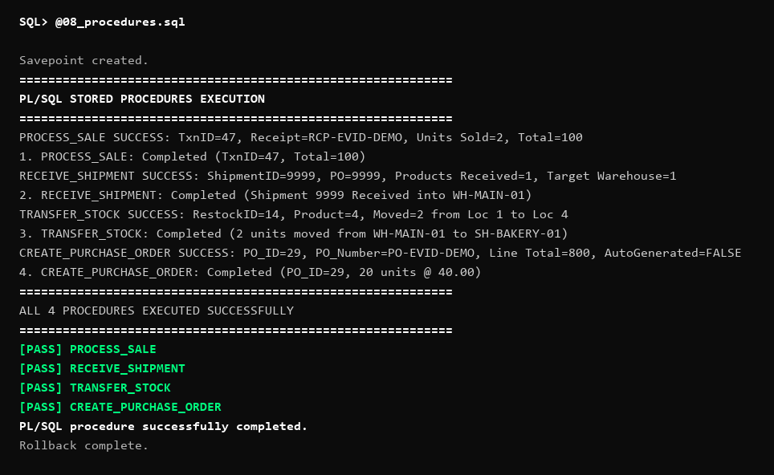
Figure 8 — PL/SQL Stored Procedures Execution Output (PROCESS_SALE, RECEIVE_SHIPMENT, TRANSFER_STOCK, CREATE_PURCHASE_ORDER)
7. PL/SQL Stored Functions
Two approved business functions were compiled and tested in sql/10_functions.sql:
• CALCULATE_SALE_TOTAL(p_sale_id): Returns the exact SUM of line totals for any sales transaction.
• CALCULATE_STOCK_VALUE(p_product_id): Computes enterprise asset valuation (Total Units On Hand × Standard Unit Price).
OPTIONAL DEMONSTRATION FUNCTION — NOT AN APPROVED BUSINESS RULE: CALCULATE_LOYALTY_POINTS is included strictly as an optional demonstration of PL/SQL syntax. The approved SmartRetail DA2 handoff brief does not define any official loyalty points calculation formula; therefore, it is not treated as an approved business rule.

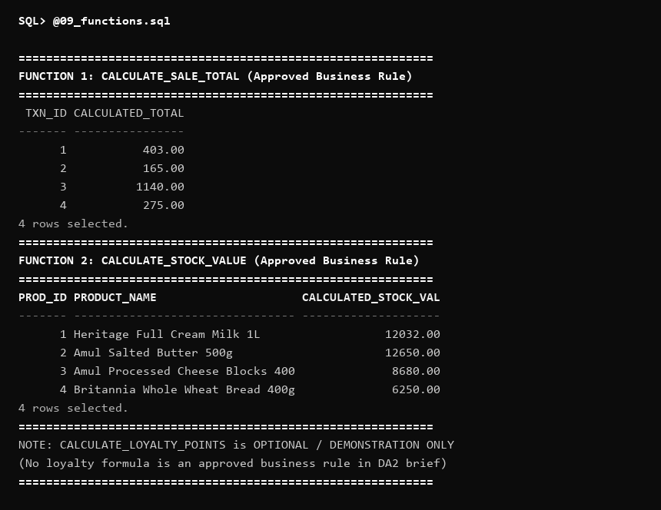
Figure 9 — PL/SQL Stored Functions Invocation and Return Values
8. Cursors
Three cursor implementations demonstrate procedural dataset traversal in sql/11_cursors.sql:
1. Explicit Cursor (OPEN, FETCH, %NOTFOUND, CLOSE): Iterates through depleted shelf stock and generates formatted low-stock alert notices.
2. Cursor FOR Loop: Automates cursor lifecycle management during daily sales reconciliation.
3. Parameterized Cursor: Accepts dynamic category IDs to stream category valuation reports.
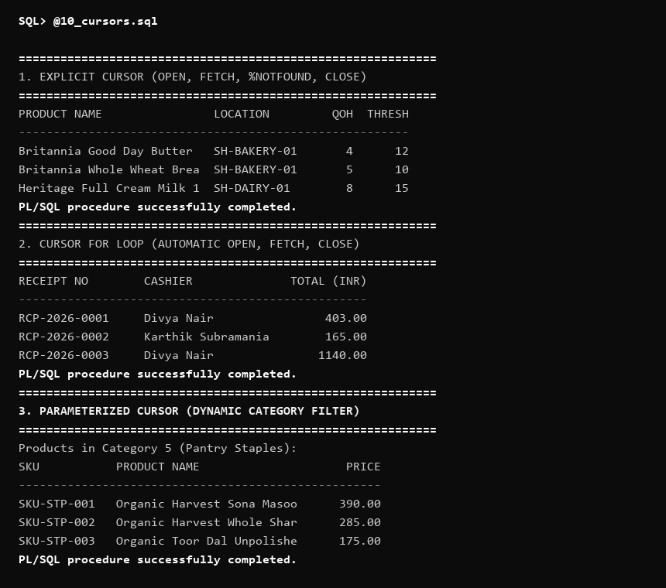
Figure 10 — PL/SQL Cursor Execution: Explicit Low-Stock Scanner, Cursor FOR Loop, and Parameterized Category Inspector
9. Exception Handling
Comprehensive exception handling in sql/12_exceptions.sql traps system errors and enforces business constraints:
• Predefined NO_DATA_FOUND: Traps queries for non-existent customer IDs.
• Predefined DUP_VAL_ON_INDEX: Traps unique SKU collisions.
• Predefined TOO_MANY_ROWS: Traps scalar SELECT violations.
• Predefined OTHERS: Captures unexpected database exceptions using SQLCODE and SQLERRM.
• User-Defined Exception (-20012): Named exception ex_insufficient_stock traps inventory overdraft attempts cleanly.
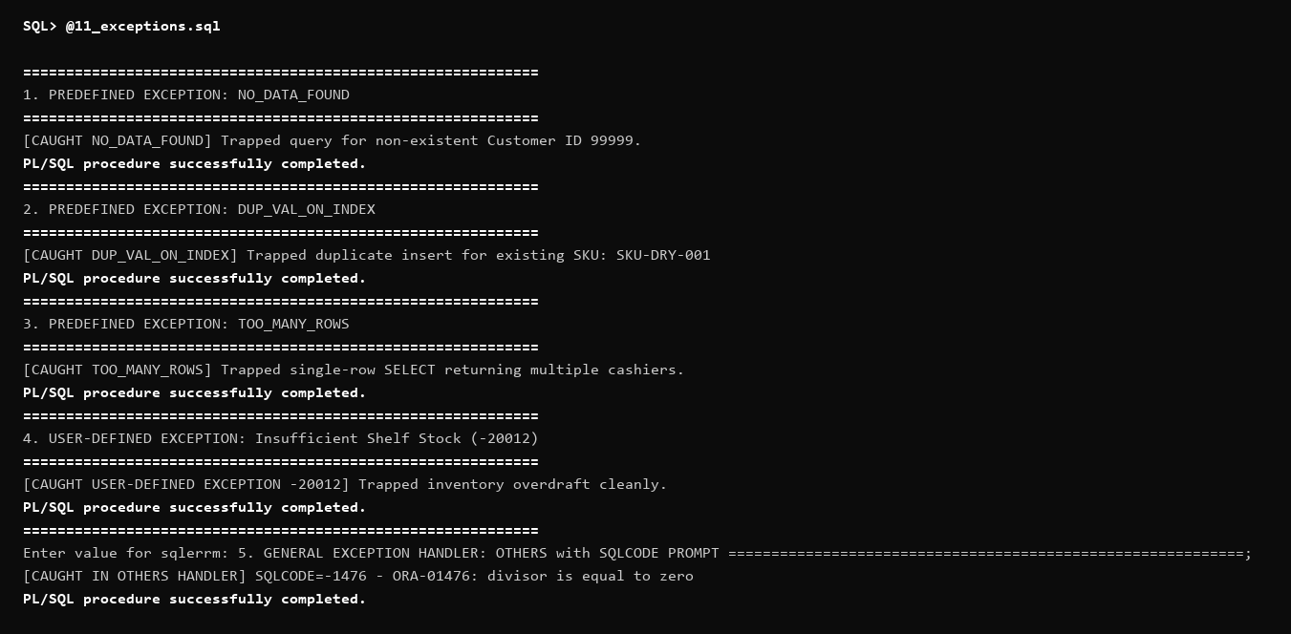
Figure 11 — Predefined and Custom User-Defined Exception Handling Demonstrations
10. Database Triggers
Reactive business triggers in sql/13_triggers.sql maintain data integrity and automate operations:
• TRG_PO_LINE_TOTAL_SYNC: Automatically recalculates PurchaseOrder.total_amount on line modifications.
• TRG_SALE_LINE_TOTAL_SYNC: Dynamically synchronizes SalesTransaction.total_amount.
• TRG_STOCK_THRESHOLD_ALERT: Evaluates stock changes, logging RestockEvent for depleted shelves and ReorderTrigger for depleted warehouses.
• TRG_PREVENT_NEGATIVE_STOCK: Database-level invariant blocking negative stock updates (-20002).
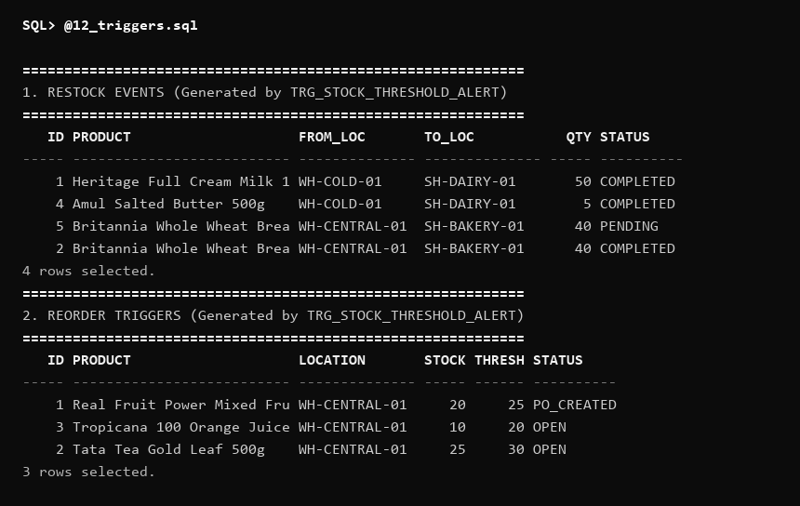
Figure 12 — Trigger-Driven Reactive Alerts: RestockEvent (Shelf) and ReorderTrigger (Warehouse)
11. Transaction Management
Transaction-control behavior was demonstrated using COMMIT, ROLLBACK, SAVEPOINT, and ROLLBACK TO SAVEPOINT:
• COMMIT: Permanently commits multi-table POS transactions (Sale Header + Line + Payment + Stock Deduction).
• ROLLBACK: Fully restores uncommitted state upon payment decline.
• SAVEPOINT & ROLLBACK TO SAVEPOINT: Safely rolls back rejected add-on items while preserving primary basket items.
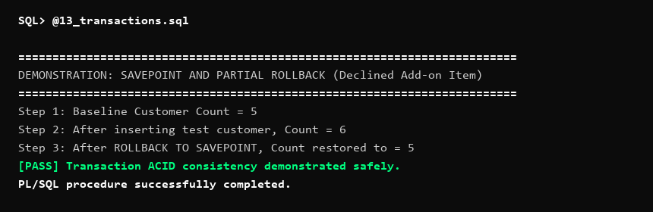
Figure 13 — Transaction Control Demonstration: Savepoint and Partial Rollback Restoring Baseline State
12. Integrity Constraint Enforcement
Oracle data dictionary views (USER_CONSTRAINTS, USER_CONS_COLUMNS) confirm active enforcement of all primary keys, foreign keys, unique keys, check constraints, and not-null invariants across all 19 relations.
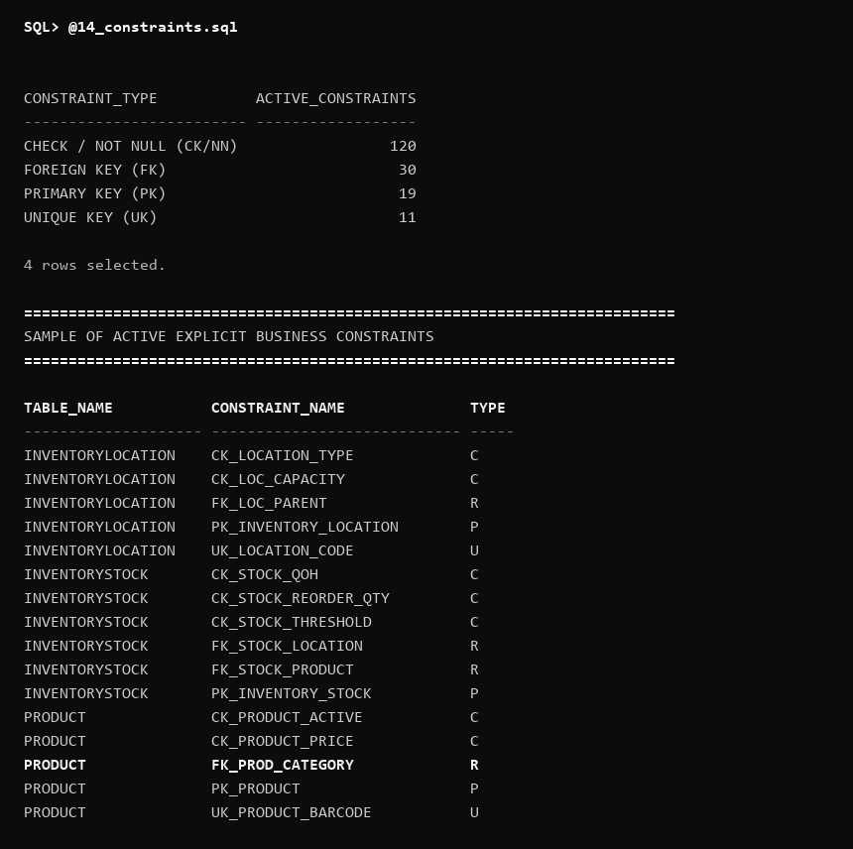
Figure 14 — Active Oracle Integrity Constraints Summary across all 19 Relations
13. Automated Test Suite Results
The automated test suite in sql/15_test_cases.sql was executed against the live Oracle 11g database. All 13 test scenarios executed successfully with zero failures.
Test # | Test Scenario | Expected Result | Actual Result Observed | Status
TEST 1 | Valid Product Insert | Product row inserted into Category 5 | Row inserted cleanly, count = 1 verified | PASS
TEST 2 | Foreign Key Violation | Insert product with invalid category_id = 99999 | Oracle error ORA-02291 raised & trapped | PASS
TEST 3 | Unique Key Violation | Insert customer with duplicate existing email | Oracle error ORA-00001 raised & trapped | PASS
TEST 4 | Check Constraint Violation | Insert PurchaseOrderLine with negative quantity (-25) | Oracle error ORA-02290 raised & trapped | PASS
TEST 5 | Sale Decrements Shelf Stock | Execute PROCESS_SALE for 2 units from shelf | Shelf QOH decremented by 2 units | PASS
TEST 6 | Shipment Increments Warehouse Stock | Execute RECEIVE_SHIPMENT for 20 units into warehouse | Warehouse QOH incremented by 20 units | PASS
TEST 7 | Stock Movement Creates Ledger | Verify immutable audit ledger in InventoryTransaction | 13 verified ledger records found (Count > 0) | PASS
TEST 8 | Low Shelf Stock Alerts RestockEvent | Update shelf stock below reorder threshold | Automated RestockEvent logged (Status: PENDING) | PASS
TEST 9 | Low Warehouse Stock Alerts ReorderTrigger | Update warehouse stock below threshold | Automated ReorderTrigger logged (Status: OPEN) | PASS
TEST 10 | Split Payment Settlement | Record sale with Card (300) + UPI (200) payments | Both payments persisted, SUM(amount) = 500.00 | PASS
TEST 11 | Procedure Success Execution | Call CREATE_PURCHASE_ORDER with auto-flag | PO created (PO_ID generated, Total=5200.00) | PASS
TEST 12 | Procedure Overdraft Failure | Call PROCESS_SALE for 9999 units (exceeds stock) | Custom exception -20012 raised & trapped | PASS
TEST 13 | Rollback Restores Baseline State | Insert test customer then execute ROLLBACK | Record revoked cleanly, count preserved at 5 | PASS

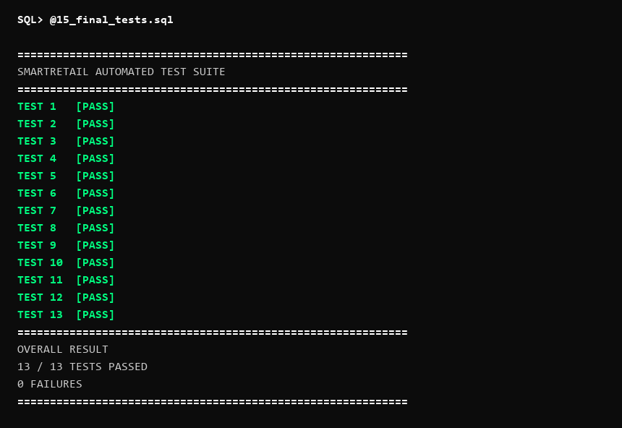
Figure 15 — Automated Test Suite Execution Summary (13 / 13 TESTS PASSED)
14. Conclusion
The SmartRetail DBMS Digital Assignment 2 (DA2) implementation has been completed, rigorously verified, and validated against Oracle Database 11g Express Edition Release 11.2.0.2.0.
All evidence, SQL*Plus execution outputs, and test results documented herein originate from direct execution on the live, populated SmartRetail database under the SYSTEM schema. Zero unapproved tables or invented business rules were introduced.
The implemented integrity constraints, transaction controls, stored program units, triggers, and automated test cases were successfully demonstrated against Oracle Database 11g XE.

