**MERGE:**

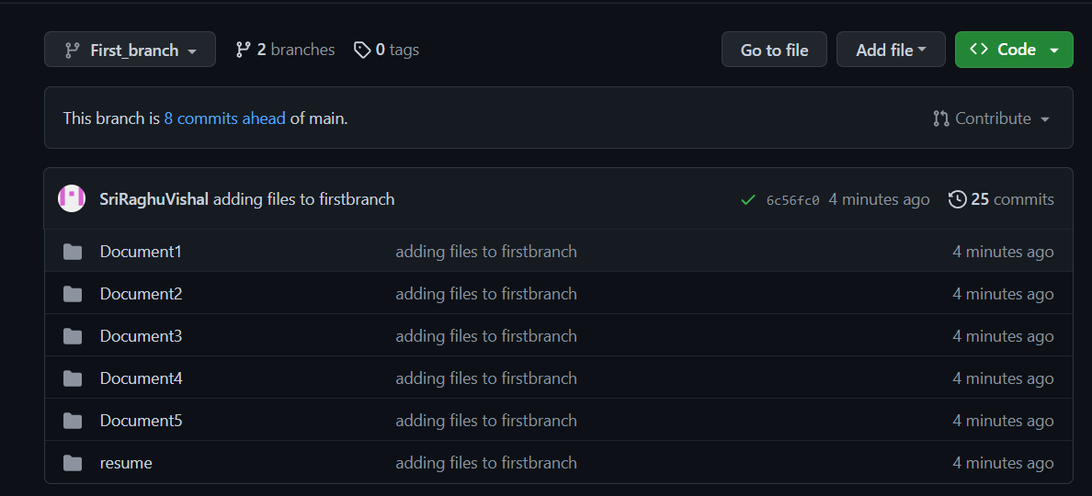

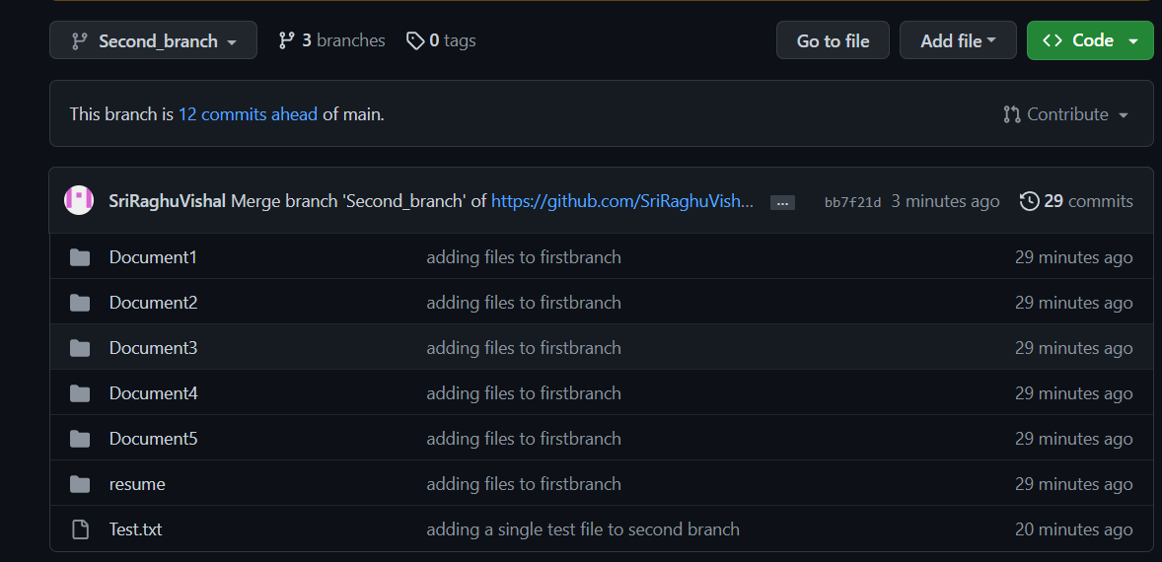

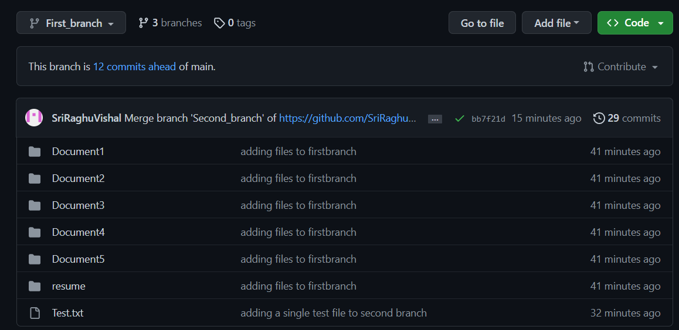+

Commands used:

git checkout “First_branch” – To target the branch where merge to be made

git merge “Second_branch” – To merge the content

git push origin “First_branch” – to push contents from local dir to remote repository

**REVERT:**

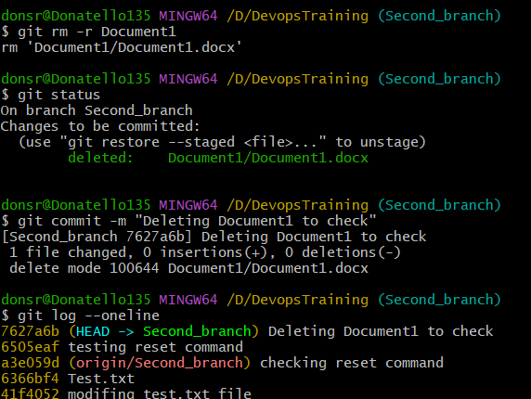

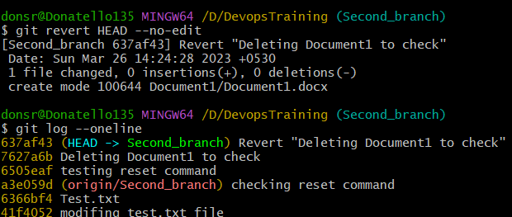

git revert command is used when we take previous commit as new commit without changing the log of commit history and keeping it intact.

Here I deleted the Document1 and checked the log for commit history and after using revert command, it can be seen that commit history log remains intact and it also shows commit is reverted.

**RESET:**

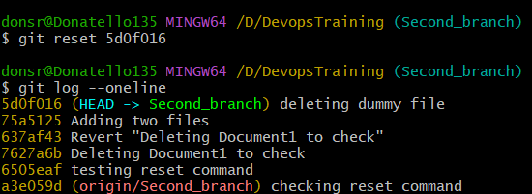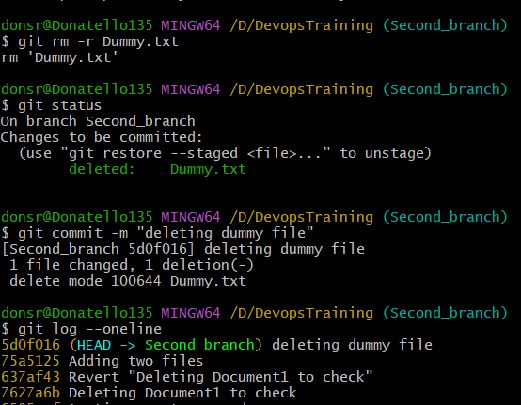

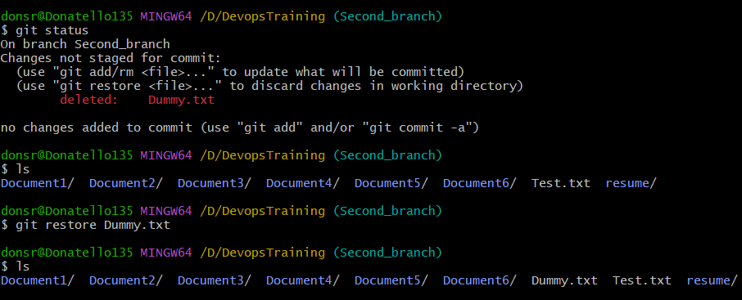

git reset command is used when we want to move the repository back to the previously done commits, which also removes all the changes happened after the chosen commit.

Here I have created a Dummy.txt file and deleted it. Next I have reset the commit and restored the file.

**FORK:**

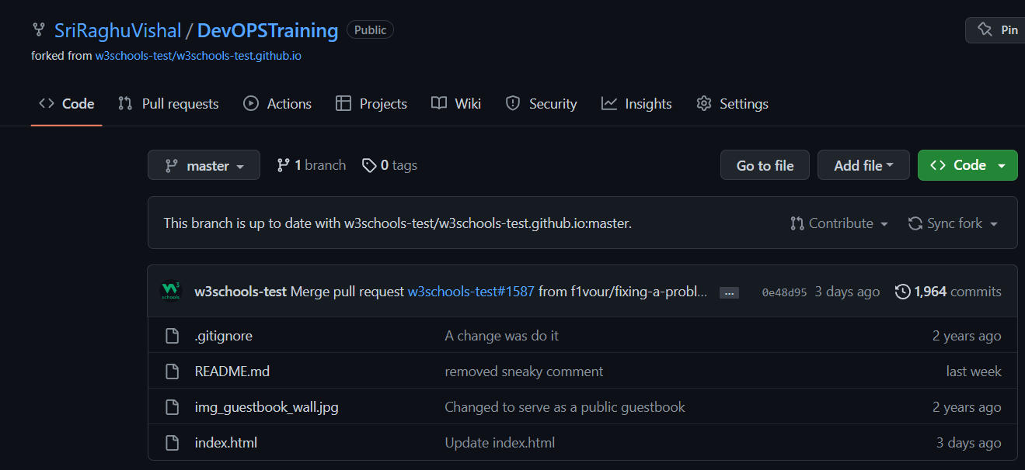

Fork is used when we collaborate with others work in their repository. Fork help us to create a repository in our account and make changes which will not be reflected in the owner of the repository until our pull request has been accepted by the owner.

Here I have forked a repository from w3schools.

**CLONE:**

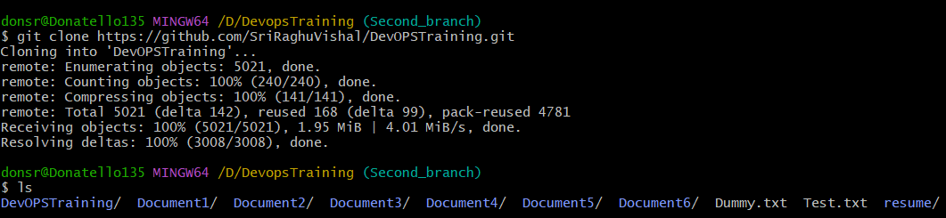

Clone enables us to clone the repository to our local directory. Here I have cloned the fork repository from w3schools.

**PULL:**

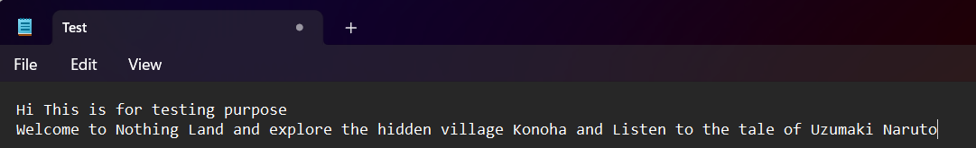

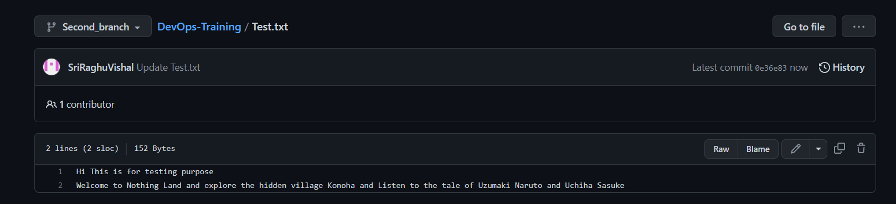

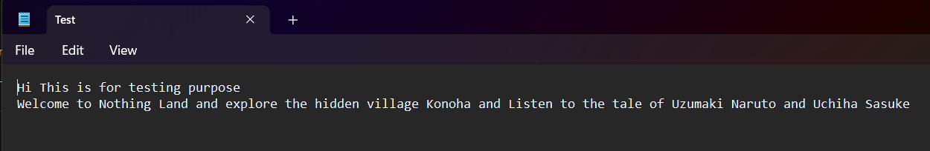

Pull command is a combination of both fetch and merge command. Here I have done changes to the Test.txt file in GitHub repository and pulled the changes to be reflected in my local directory Test.txt file.

**GITIGNORE:**

Using **touch .gitignore** command create .gitignore file and open it in notepad,

Enter the files or files extension that are to be ignored.

For example,

I have entered *.txt in .gitignore and now any changes that happens to any .txt file will be ignored and will not be staged and committed.