**RESET:**

**RESET SOFT:**

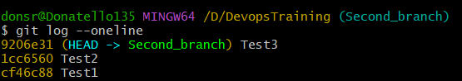

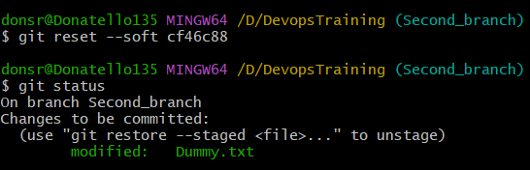



git reset --soft cf46c88

makes the HEAD pointer to cf46c88 and the commits done after that commit is preserved and re-added to staging area.

**RESET HARD:**

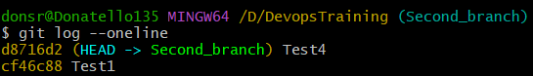

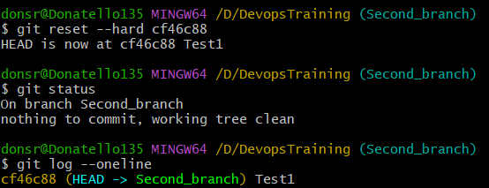

git reset -- hard cf46c88

makes the HEAD pointing to cf46c88 and the commits done after will not be either in the staging area or even seen as untracked files.