Analyzing and Visualizing Regional Sales Performance
Excel Mini Project Report
Submitted by: Sri Rajakavika Palanivel
Course: Data Verse Pro
Institute: Vinsup Skill Academy

Introduction
ABC Electronics operates across multiple regions and product categories. This project analyzes 4,000 sales records using Microsoft Excel to evaluate regional sales performance. The work included data cleaning, formula-based analysis, Pivot Tables, charts and an interactive dashboard that helps management monitor key metrics, compare regional performance and identify product category trends for better business decisions.

Objectives
- To clean and organize the sales dataset.
- To standardize text values using Excel functions.
- To calculate important business metrics using formulas.
- To analyze sales by region and product category.
- To create Pivot Tables for summarizing data.
- To build an interactive dashboard using charts and slicers.
- To generate useful business insights from the dataset.

Dataset Description
The dataset contains Order ID, Order Date, Region, Product Category, Sales Amount, Quantity Sold, Discount (%) and Profit. The data consisted of 4,000 records in CSV format.

Dataset Columns
Column Name | Description
Order ID | Unique order number
Order Date | Date when the order was placed
Region | Sales region
Product Category | Product type
Sales Amount | Total sales value
Quantity Sold | Number of products sold
Discount (%) | Discount given
Profit | Profit earned

Data Cleaning and Pre-processing
- The first step of the project was to clean the data.
- The following tasks were performed:

Removing Extra Spaces
The TRIM() function was used to remove unnecessary spaces from text values.

Standardizing Text
The UPPER() and LOWER() functions were used to make Region and Product Category names consistent throughout the dataset. And also SUBSTITUTE(), FIND AND REPLACE functions to correct the inconsistent data in region and product category columns.

Filtering Data
The dataset was filtered to find orders placed in the South region under the Electronics category during the last year.

Data Validation
The dataset was checked for blank values, formatting issues, and duplicate records to ensure accurate analysis.
After completing these steps, the dataset became clean and ready for analysis.
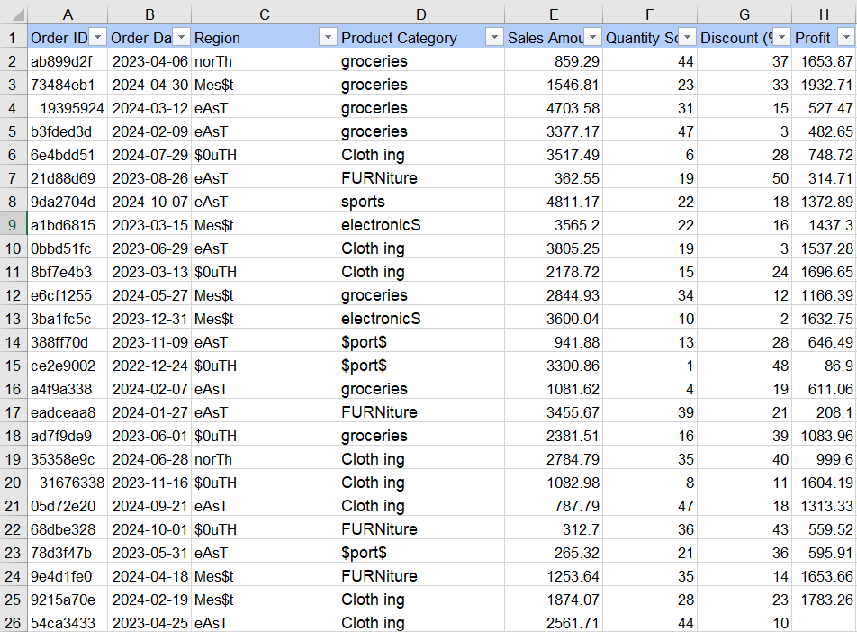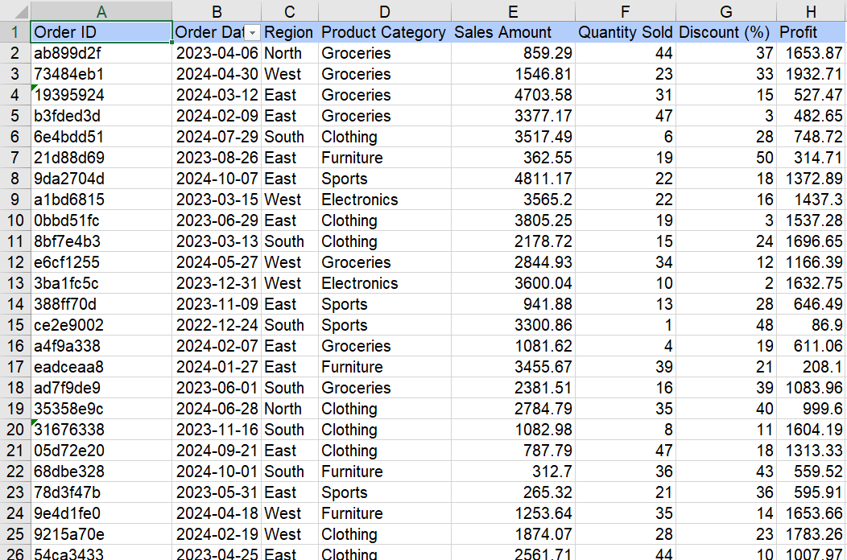

Data Analysis
SUMIF, AVERAGEIFS, COUNTIF, FILTER and UNIQUE functions were used. Pivot Tables summarized sales and profit by region and category. Charts were created to visualize sales distribution and trends.
SUMIF()
Used to calculate the total sales for each region.
AVERAGEIFS()
Used to calculate the average discount percentage and average profit for the Furniture category.
FILTER()
Used to extract specific records based on conditions.
UNIQUE()
Used to identify unique values in the dataset.
COUNTIF()
Used for counting records that satisfy specific conditions.
These formulas helped summarize the sales data effectively.

Pivot Tables
Pivot Tables were created to summarize the dataset without changing the original data.
The following Pivot Tables were prepared:
- Sales by Region
- Profit by Region
- Sales by Product Category
- Sales by Region and Product Category
Slicers were added so that the dashboard could be filtered dynamically by Region and Product Category.
- The pivot tables were used to create charts based on summarization available in pivot tables.
- Each pivot chart represents different types of charts created.
- Slicers were created to change the values in all charts according to the data we select in slicer.
- This helps to analyze dynamically on each category and region.
The pivot tables and their respective charts are given below:
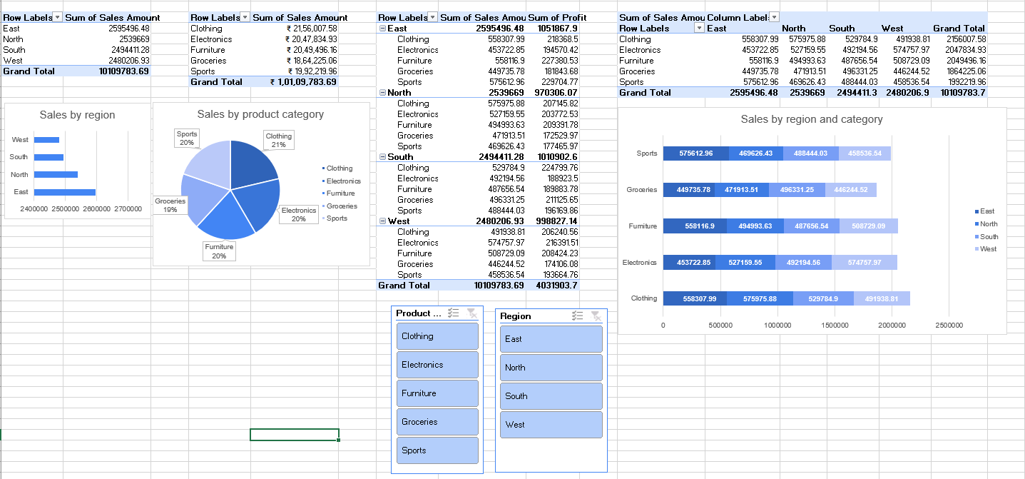

Dashboard
The dashboard includes KPI cards (Total Sales, Total Profit, Total Orders and Highest Selling Category), Sales by Region, Sales by Product Category, Region vs Category chart, Year-wise Sales Trend, Profit by Region and interactive slicers.
The final dashboard was designed using a pastel pink color theme with a clean layout.
The dashboard contains four KPI cards:
- Total Sales
- Total Profit
- Highest Selling Category
- Total Orders
It also includes different charts to represent the data visually.

Sales by Region
A horizontal bar chart compares sales among East, West, North, and South regions.

Sales by Product Category
A pie chart displays the percentage contribution of each product category to total sales.

Sales by Region and Product Category
A stacked bar chart compares sales distribution across different regions.

Year-wise Sales Trend
A line chart shows sales performance of different categories over multiple years.

Profit by Region
A doughnut chart displays the contribution of each region to the overall profit.
Region and Product Category slicers were added to make the dashboard interactive and user-friendly.
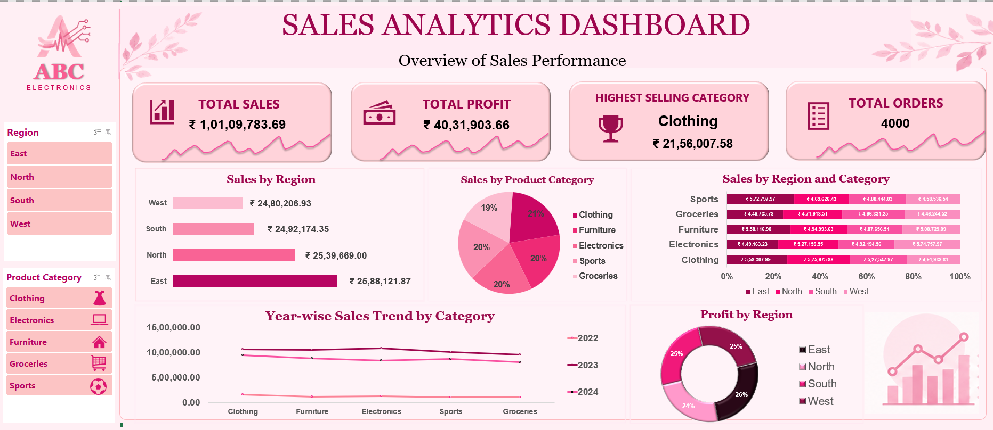
Figure 1: Interactive Sales Performance Dashboard

Business Insights
- The East region recorded the highest sales, indicating strong market performance.
- Clothing emerged as the highest-selling product category, contributing the maximum revenue.
- The company achieved a total sales of ₹1.01 Crore and a total profit of ₹40.32 Lakhs from 4,000 orders.
- Sales and profit were distributed across all regions, showing a stable business presence.
- The interactive dashboard enables quick analysis of sales performance using Region and Product Category slicers, supporting better business decisions.

Recommendations
- Maintain adequate inventory for high-demand product categories like Clothing.
- Focus marketing efforts on lower-performing regions to improve sales.
- Use the dashboard regularly to monitor sales trends and support data-driven decision-making.

Challenges Faced
Cleaning inconsistent text, organizing Pivot Tables and designing a clean dashboard layout were the main challenges. These were resolved through careful data pre-processing and repeated testing.

Conclusion
This project improved my understanding of Excel-based data analysis and dashboard development. It demonstrated how raw data can be transformed into meaningful business insights for decision-making.

