**Wanderlust: A Personalized Travel Planning and Tracking App**

**DESCRIPTON:**

These apps can help you research destinations, book transportation and accommodations, create itineraries, and even provide suggestions for activities and attractions based on your interests. These apps can help streamline the planning process and ensure that you have a memorable and stress-free trip.

**Purpose:-**

Its help travelers with every aspect of their trip planning, from researching destinations to booking accommodations and activities.

These apps aim to simplify the planning process and make it more efficient, allowing travelers to create detailed itineraries and explore new destinations with ease.

By providing suggestions based on the traveler's interests and preferences, these apps can also help enhance the overall travel experience and ensure a stress-free trip.

**Problem Definition & Design Thinking:-**

**Empathy Map:-**

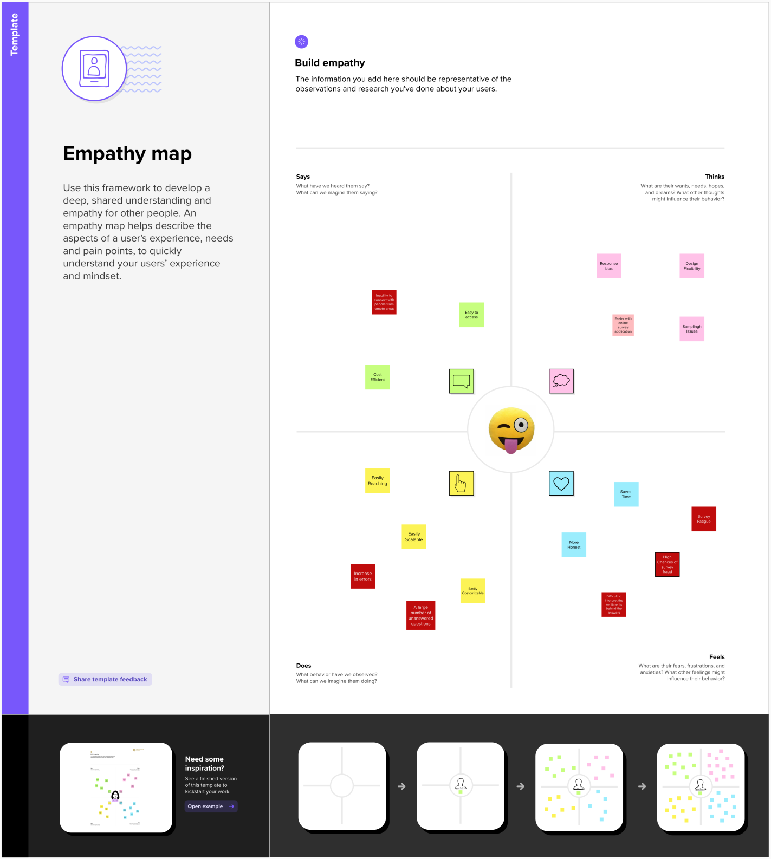

**Brainstorming Map:-**

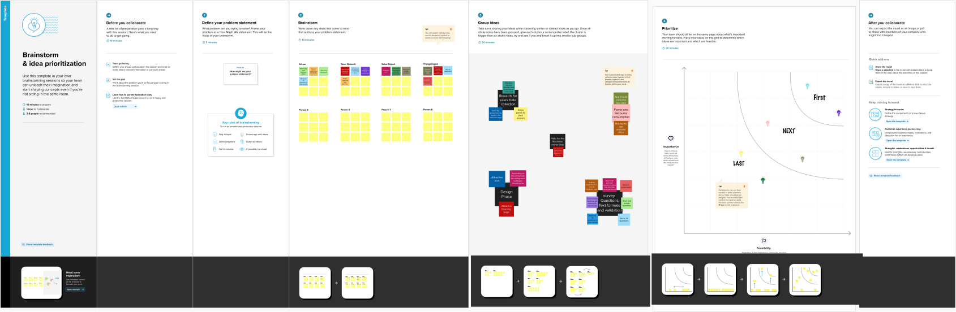

**RESULT­­­:-**

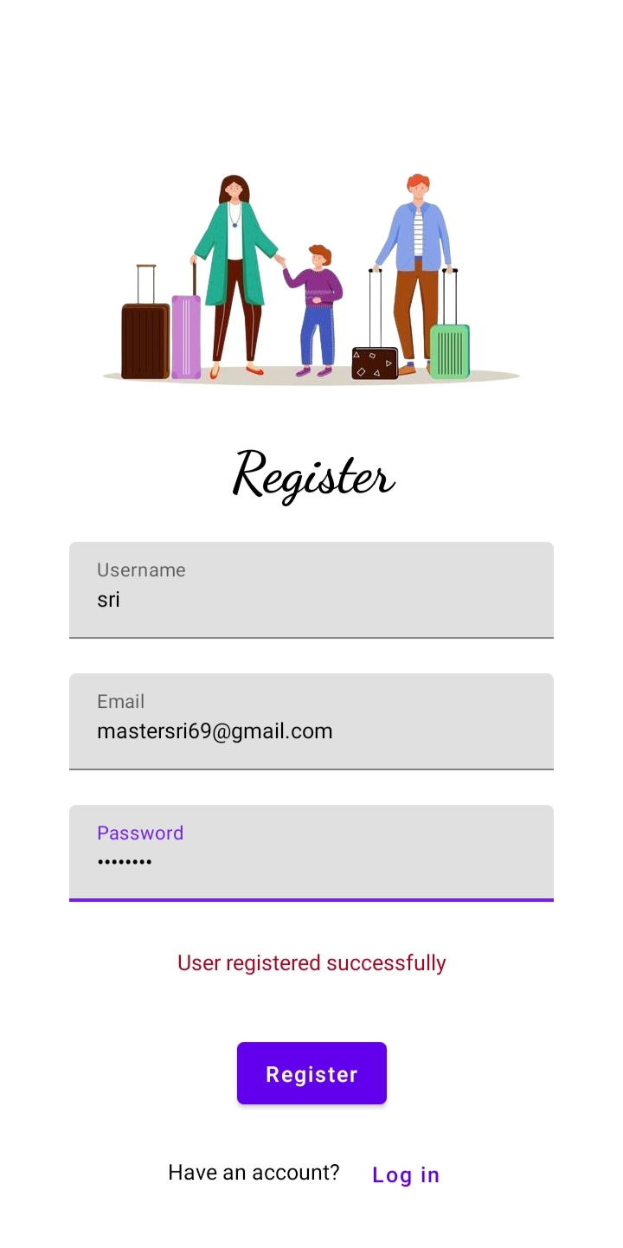

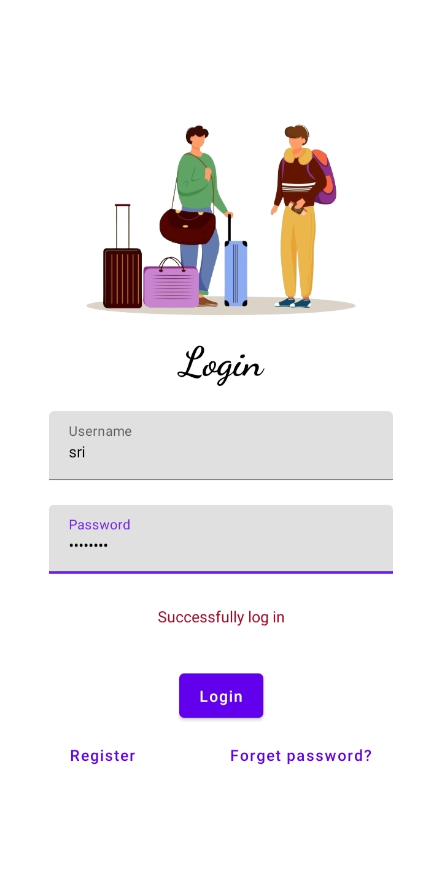

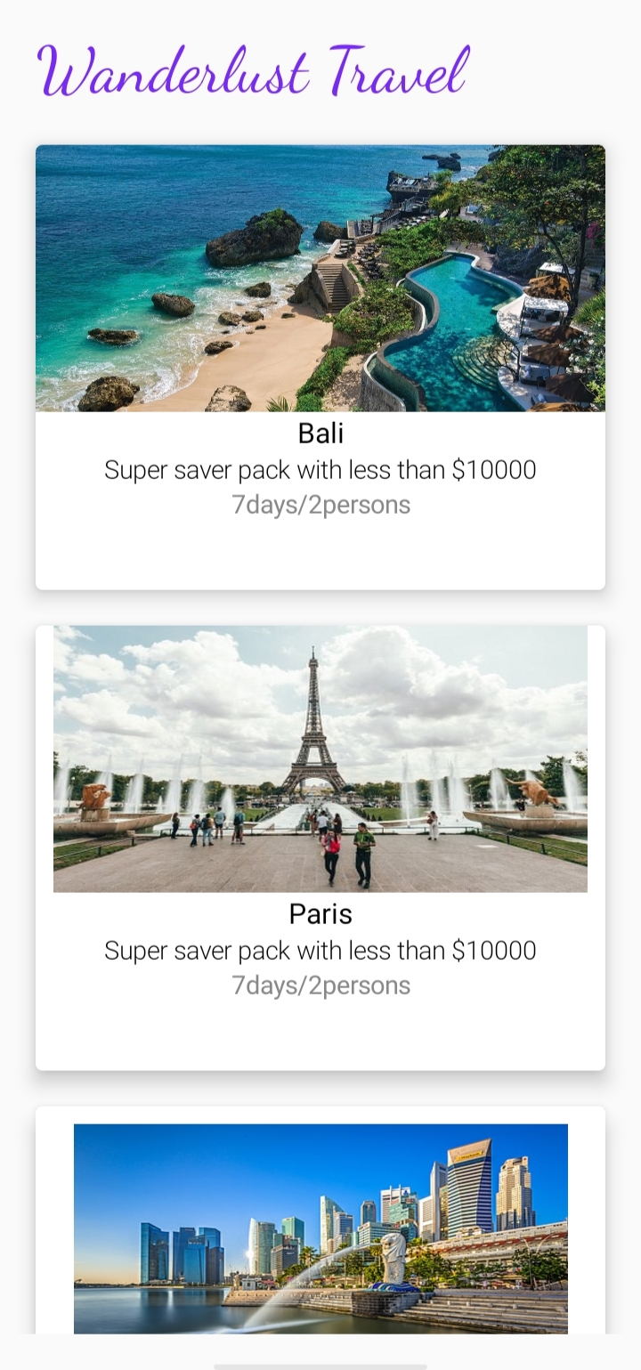

**ADVANTAGE:-**

1. Convenience: Travel plan apps make it easy for travelers to plan their trips from anywhere and at any time, without the need for a travel agent or physical guidebook.
2. Time-saving: These apps save time by providing all the necessary information in one place, including flight and hotel bookings, travel routes, and local activities.
3. Personalized recommendations: Many travel plan apps use algorithms and machine learning to provide personalized recommendations based on the traveler's interests and preferences, making it easier to plan a trip that meets their needs.

**DISADVANTAGE:-**

1. Limited options: Some travel plan apps may have limited options for accommodations, activities, and transportation, which could limit the traveler's choices.
2. Lack of personal touch: While travel plan apps can provide personalized recommendations based on the traveler's preference .such as crashes or slow loading times, which can be frustrating for users.

**APPLICATION:**

**1. Travel Itinerary Generator:**

Travel itinerary generator is one of the most demanding features in the [travel industry](https://colorwhistle.com/online-travel-marketing-techniques/). This feature helps users to create a complete travel plan by just adding the location they want to visit.

With this feature, admin can add existing tourist attractions or even add custom landmarks to generate a tour plan for users accordingly. Adding such a complex algorithm feature may sound difficult. Therefore, you need to get the help of professional travel app developers.

### 2. Geo-Tracking Services:

The integration of GPS based location service is one of the important features of travel application development. Tracking services can lock the current location of users and quickly fetch the nearest results. By including this feature you can offer all kinds of services a tourist can avail on a trip.

### 4. In-App Language Translator:

An in-app language translator is one of the tricky features to implement in your travel application. In most of the cases, tourist people are not familiar with the regional language of places that they would like to visit. Including this feature can enhance user-experience and let travelers scan texts for visual translation, translate voice, and text messages as well.

### 5. Currency Rate Converter:

Currency converter is one of the essential travel application features. Tourist people suffer a lot while exchanging their currencies. Including this feature can help tourists to know the currency exchange rates. It can also track the current and past variations in currency rates.

**Conclusion:**

It allows users to organize their itinerary, book accommodations and activities, track expenses, and share their plans with others. With the increasing popularity of travel and the need for convenience in planning, a travel plan app is a valuable addition to the travel industry. It not only saves time but also provides a seamless experience for travelers. As technology continues to advance, we can expect more innovative features and enhancements in travel plan apps, making it even easier for people to plan and enjoy their trips

**Future Scope:-**

In this way, Android app developers will provide a more enhanced personalized experience to users. Future applications may integrate different AI features such as text, image classification, voice recognition, predictive maintenance, face detection, etc. The activities and items covered by the survey or inspection was the major role in survey.

**Appendix**

**Source CODE:-**

[**https://github.com/SriRam142002/Travel-plan.git**](https://github.com/SriRam142002/Travel-plan.git)

**LoginActivity.kt**

package com.example.travelapp

import android.content.Context

import android.content.Intent

import android.os.Bundle

import androidx.activity.ComponentActivity

import androidx.activity.compose.setContent

import androidx.compose.foundation.Image

import androidx.compose.foundation.background

import androidx.compose.foundation.layout.*

import androidx.compose.material.*

import androidx.compose.runtime.*

import androidx.compose.ui.Alignment

import androidx.compose.ui.Modifier

import androidx.compose.ui.graphics.Color

import androidx.compose.ui.layout.ContentScale

import androidx.compose.ui.res.painterResource

import androidx.compose.ui.text.font.FontFamily

import androidx.compose.ui.text.font.FontWeight

import androidx.compose.ui.text.input.PasswordVisualTransformation

import androidx.compose.ui.tooling.preview.Preview

import androidx.compose.ui.unit.dp

import androidx.compose.ui.unit.sp

import androidx.core.content.ContextCompat

class LoginActivity : ComponentActivity() {

private lateinit var databaseHelper: UserDatabaseHelper

override fun onCreate(savedInstanceState: Bundle?) {

super.onCreate(savedInstanceState)

databaseHelper = UserDatabaseHelper(this)

setContent {

LoginScreen(this, databaseHelper)

}

}

}

@Composable

fun LoginScreen(context: Context, databaseHelper: UserDatabaseHelper) {

var username by remember { mutableStateOf("") }

var password by remember { mutableStateOf("") }

var error by remember { mutableStateOf("") }

Column(

modifier = Modifier.fillMaxSize().background(Color.White),

horizontalAlignment = Alignment.CenterHorizontally,

verticalArrangement = Arrangement.Center

) {

Image(painterResource(id = R.drawable.trav), contentDescription = "")

Text(

fontSize = 36.sp,

fontWeight = FontWeight.ExtraBold,

fontFamily = FontFamily.Cursive,

text = "Login"

)

Spacer(modifier = Modifier.height(10.dp))

TextField(

value = username,

onValueChange = { username = it },

label = { Text("Username") },

modifier = Modifier.padding(10.dp)

.width(280.dp)

)

TextField(

value = password,

onValueChange = { password = it },

label = { Text("Password") },

visualTransformation = PasswordVisualTransformation(),

modifier = Modifier.padding(10.dp)

.width(280.dp)

)

if (error.isNotEmpty()) {

Text(

text = error,

color = MaterialTheme.colors.error,

modifier = Modifier.padding(vertical = 16.dp)

)

}

Button(

onClick = {

if (username.isNotEmpty() && password.isNotEmpty()) {

val user = databaseHelper.getUserByUsername(username)

if (user != null && user.password == password) {

error = "Successfully log in"

context.startActivity(

Intent(

context,

MainActivity::class.java

)

)

//onLoginSuccess()

}

else {

error = "Invalid username or password"

}

} else {

error = "Please fill all fields"

}

},

modifier = Modifier.padding(top = 16.dp)

) {

Text(text = "Login")

}

Row {

TextButton(onClick = {context.startActivity(

Intent(

context,

RegisterActivity::class.java

)

)}

)

{ Text(text = "Register") }

TextButton(onClick = {

})

{

Spacer(modifier = Modifier.width(60.dp))

Text(text = "Forget password?")

}

}

}

}

private fun startMainPage(context: Context) {

val intent = Intent(context, MainActivity::class.java)

ContextCompat.startActivity(context, intent, null)

}

**ParisActivity.kt**

package com.example.travelapp

import android.os.Bundle

import androidx.activity.ComponentActivity

import androidx.activity.compose.setContent

import androidx.compose.foundation.Image

import androidx.compose.foundation.background

import androidx.compose.foundation.layout.*

import androidx.compose.foundation.rememberScrollState

import androidx.compose.foundation.verticalScroll

import androidx.compose.material.MaterialTheme

import androidx.compose.material.Surface

import androidx.compose.material.Text

import androidx.compose.runtime.Composable

import androidx.compose.ui.Modifier

import androidx.compose.ui.draw.scale

import androidx.compose.ui.graphics.Color

import androidx.compose.ui.res.painterResource

import androidx.compose.ui.res.stringResource

import androidx.compose.ui.text.font.FontFamily

import androidx.compose.ui.tooling.preview.Preview

import androidx.compose.ui.unit.dp

import androidx.compose.ui.unit.sp

import com.example.travelapp.ui.theme.TravelAppTheme

class ParisActivity : ComponentActivity() {

override fun onCreate(savedInstanceState: Bundle?) {

super.onCreate(savedInstanceState)

setContent {

TravelAppTheme {

// A surface container using the 'background' color from the theme

Surface(

modifier = Modifier.fillMaxSize(),

color = MaterialTheme.colors.background

) {

Greeting()

}

}

}

}

}

@Composable

fun Greeting() {

Column(

modifier = Modifier.background(color = Color.White)

.padding(20.dp)

.verticalScroll(rememberScrollState())

) {

Text(

fontSize = 40.sp,

color = Color(android.graphics.Color.rgb(120, 40, 251)),

fontFamily = FontFamily.Cursive,

text = stringResource(id = R.string.place_2),

)

Image(

painterResource(id = R.drawable.paris), contentDescription = "",

modifier = Modifier

.padding(16.dp)

.fillMaxWidth()

.height(200.dp)

.scale(scaleX = 1.2F, scaleY = 1F)

)

Text(

color=Color.Black,

text = "Day 1: Arrival and Introduction\n" +

"Check into your accommodation and freshen up\n" +

"Take a stroll around the neighborhood to get acquainted\n" +

"Visit the Eiffel Tower, preferably in the evening when it is lit up\n" +

"Have a relaxing dinner at a nearby restaurant\n" +

"\n" +

"Day 2: Art and History\n" +

"Visit the Louvre Museum to see some of the world's most famous art pieces\n" +

"Stroll through the Tuileries Garden and the Place de la Concorde\n" +

"Visit the Orsay Museum, which houses a large collection of impressionist art\n" +

"Have dinner at a local French restaurant\n" +

"\n" +

"Day 3: French Culture and Food\n" +

"Visit the Montmartre neighborhood to see the famous Basilique du Sacré-Cœur and Place du Tertre\n" +

"Explore the historic neighborhood of Le Marais\n" +

"Try some delicious French pastries at a local bakery\n" +

"Have dinner at a brasserie to taste some classic French cuisine\n" +

"\n" +

"Day 4: Architecture and Gardens\n" +

"Visit the Palace of Versailles, a UNESCO World Heritage site, and explore its beautiful gardens\n" +

"Walk along the Champs-Elysées and stop at the Arc de Triomphe\n" +

"Visit the Sainte-Chapelle, a beautiful Gothic chapel with stunning stained-glass windows\n" +

"Have dinner at a local restaurant in the 7th arrondissement\n" +

"\n" +

"Day 5: Shopping and Sightseeing\n" +

"Visit the Notre-Dame Cathedral and climb up to the top for a stunning view of the city\n" +

"Explore the Latin Quarter and visit the Panthéon\n" +

"Go shopping at the famous Galeries Lafayette or Printemps department stores\n" +

"Have dinner at a local bistro\n" +

"\n" +

"Day 6: Parisian Parks and Museums\n" +

"Visit the Musée Rodin and explore its beautiful gardens\n" +

"Stroll through the Luxembourg Gardens and visit the Luxembourg Palace\n" +

"Visit the Centre Pompidou, a modern art museum in the Marais neighborhood\n" +

"Have dinner at a local restaurant in the Latin Quarter\n" +

"\n" +

"Day 7: River Cruise and Farewell\n" +

"Take a boat cruise along the Seine River to see the city from a different perspective\n" +

"Visit the Musée de l'Orangerie, which houses Monet's famous water lilies paintings\n" +

"Have a farewell dinner at a Michelin-starred restaurant"

)

}

}

**RegisterActivity.kt**

package com.example.travelapp

import android.content.Context

import android.content.Intent

import android.os.Bundle

import androidx.activity.ComponentActivity

import androidx.activity.compose.setContent

import androidx.compose.foundation.Image

import androidx.compose.foundation.background

import androidx.compose.foundation.layout.*

import androidx.compose.material.*

import androidx.compose.runtime.*

import androidx.compose.ui.Alignment

import androidx.compose.ui.Modifier

import androidx.compose.ui.graphics.Color

import androidx.compose.ui.layout.ContentScale

import androidx.compose.ui.res.painterResource

import androidx.compose.ui.text.font.FontFamily

import androidx.compose.ui.text.font.FontWeight

import androidx.compose.ui.text.input.PasswordVisualTransformation

import androidx.compose.ui.tooling.preview.Preview

import androidx.compose.ui.unit.dp

import androidx.compose.ui.unit.sp

import androidx.core.content.ContextCompat

class RegisterActivity : ComponentActivity() {

private lateinit var databaseHelper: UserDatabaseHelper

override fun onCreate(savedInstanceState: Bundle?) {

super.onCreate(savedInstanceState)

databaseHelper = UserDatabaseHelper(this)

setContent {

RegistrationScreen(this, databaseHelper)

}

}

}

@Composable

fun RegistrationScreen(context: Context, databaseHelper: UserDatabaseHelper) {

var username by remember { mutableStateOf("") }

var password by remember { mutableStateOf("") }

var email by remember { mutableStateOf("") }

var error by remember { mutableStateOf("") }

Column(

modifier = Modifier.fillMaxSize().background(Color.White),

horizontalAlignment = Alignment.CenterHorizontally,

verticalArrangement = Arrangement.Center

) {

Image(painterResource(id = R.drawable.tra), contentDescription = "")

Text(

fontSize = 36.sp,

fontWeight = FontWeight.ExtraBold,

fontFamily = FontFamily.Cursive,

text = "Register"

)

Spacer(modifier = Modifier.height(10.dp))

TextField(

value = username,

onValueChange = { username = it },

label = { Text("Username") },

modifier = Modifier

.padding(10.dp)

.width(280.dp)

)

TextField(

value = email,

onValueChange = { email = it },

label = { Text("Email") },

modifier = Modifier

.padding(10.dp)

.width(280.dp)

)

TextField(

value = password,

onValueChange = { password = it },

label = { Text("Password") },

visualTransformation = PasswordVisualTransformation(),

modifier = Modifier

.padding(10.dp)

.width(280.dp)

)

if (error.isNotEmpty()) {

Text(

text = error,

color = MaterialTheme.colors.error,

modifier = Modifier.padding(vertical = 16.dp)

)

}

Button(

onClick = {

if (username.isNotEmpty() && password.isNotEmpty() && email.isNotEmpty()) {

val user = User(

id = null,

firstName = username,

lastName = null,

email = email,

password = password

)

databaseHelper.insertUser(user)

error = "User registered successfully"

// Start LoginActivity using the current context

context.startActivity(

Intent(

context,

LoginActivity::class.java

)

)

} else {

error = "Please fill all fields"

}

},

modifier = Modifier.padding(top = 16.dp)

) {

Text(text = "Register")

}

Spacer(modifier = Modifier.width(10.dp))

Spacer(modifier = Modifier.height(10.dp))

Row() {

Text(

modifier = Modifier.padding(top = 14.dp), text = "Have an account?"

)

TextButton(onClick = {

context.startActivity(

Intent(

context,

LoginActivity::class.java

)

)

})

{

Spacer(modifier = Modifier.width(10.dp))

Text(text = "Log in")

}

}

}

}

private fun startLoginActivity(context: Context) {

val intent = Intent(context, LoginActivity::class.java)

ContextCompat.startActivity(context, intent, null)

}

**SingaporeActivity.kt**

package com.example.travelapp

import android.os.Bundle

import androidx.activity.ComponentActivity

import androidx.activity.compose.setContent

import androidx.compose.foundation.Image

import androidx.compose.foundation.background

import androidx.compose.foundation.layout.*

import androidx.compose.foundation.rememberScrollState

import androidx.compose.foundation.verticalScroll

import androidx.compose.material.MaterialTheme

import androidx.compose.material.Surface

import androidx.compose.material.Text

import androidx.compose.runtime.Composable

import androidx.compose.ui.Modifier

import androidx.compose.ui.draw.scale

import androidx.compose.ui.graphics.Color

import androidx.compose.ui.res.painterResource

import androidx.compose.ui.res.stringResource

import androidx.compose.ui.text.font.FontFamily

import androidx.compose.ui.tooling.preview.Preview

import androidx.compose.ui.unit.dp

import androidx.compose.ui.unit.sp

import com.example.travelapp.ui.theme.TravelAppTheme

class SingaporeActivity : ComponentActivity() {

override fun onCreate(savedInstanceState: Bundle?) {

super.onCreate(savedInstanceState)

setContent {

TravelAppTheme {

// A surface container using the 'background' color from the theme

Surface(

modifier = Modifier.fillMaxSize(),

color = MaterialTheme.colors.background

) {

Greeting2()

}

}

}

}

}

@Composable

fun Greeting2() {

Column(

modifier = Modifier.background(color = Color.White)

.padding(20.dp)

.verticalScroll(rememberScrollState())

) {

Text(

fontSize = 40.sp,

color = Color(android.graphics.Color.rgb(120, 40, 251)),

fontFamily = FontFamily.Cursive,

text = stringResource(id = R.string.place_3),

)

Image(

painterResource(id = R.drawable.singapore), contentDescription = "",

modifier = Modifier

.padding(16.dp)

.fillMaxWidth()

.height(200.dp)

.scale(scaleX = 1.2F, scaleY = 1F)

)

Text(

color = Color.Black,

text = "Day 1:\n" +

"Morning: Visit Gardens by the Bay and marvel at the Supertree Grove and the Flower Dome and Cloud Forest conservatories.\n" +

"Afternoon: Explore the Marina Bay Sands complex, which includes a casino, luxury shopping mall, and observation deck with a stunning view of the city.\n" +

"\n" +

"Day 2:\n" +

"Morning: Explore the historic district of Chinatown, including the Buddha Tooth Relic Temple and Museum and the Sri Mariamman Temple.\n" +

"Afternoon: Visit the nearby Clarke Quay for lunch and to explore its waterfront restaurants, bars, and shops.\n" +

"\n" +

"Day 3:\n" +

"Morning: Take a tour of the UNESCO-listed Botanic Gardens, one of the world's most famous and significant tropical gardens.\n" +

"Afternoon: Head over to the National Museum of Singapore, which houses a vast collection of historical and cultural artifacts.\n" +

"\n" +

"Day 4:\n" +

"Morning: Visit the Singapore Zoo and admire the wildlife, including orangutans, tigers, and elephants.\n" +

"Afternoon: Head over to Sentosa Island and relax at one of its many beaches or try some of the many attractions such as Universal Studios Singapore or Adventure Cove Waterpark.\n" +

"\n" +

"Day 5:\n" +

"Morning: Go on a nature walk at MacRitchie Reservoir, which offers hiking trails and stunning views of the city skyline.\n" +

"Afternoon: Visit Little India, a vibrant and colorful neighborhood, and explore the shops, temples, and food stalls.\n" +

"\n" +

"Day 6:\n" +

"Morning: Explore the trendy neighborhood of Tiong Bahru, known for its hip cafes and boutiques, as well as its Art Deco architecture.\n" +

"Afternoon: Visit the National Gallery Singapore, which houses the largest public collection of modern art in Singapore and Southeast Asia.\n" +

"\n" +

"Day 7:\n" +

"Morning: Take a day trip to the nearby island of Pulau Ubin, where you can rent a "

)

}

}