**CONQUERING FASHION MNIST USING CNN**

NAVEENAN P S

Computer Science and Business System

Rajalakshmi Institute of Technology

Chennai, India

naveenan.p.s.2021.csbs@ritchennai.edu.in

SRI RAMAPRIYAN D B

Computer Science and Business System

Rajalakshmi Institute of Technology

Chennai, India

Sriramapriyan.d.b.2021.csbs@ritchennai.edu.in

SUHAIL AHMED

Computer Science and Business System

Rajalakshmi Institute of Technology

Chennai, India

Suhailahmed.a.2021.csbs@ritchennai.edu.in

**Team: MATRIX**

**ACKNOWLEDGEMENT**

O. PANDITHURAI,   
*ASSOCIATE PROFESSOR,*   
*DEPARTMENT OF COMPUTER SCIENCE AND ENGINEERING,*RAJALAKSHMI INSTITUTE OF TECNOLOGY,  
pandics@ ritchennai.edu.in

G.SAI KRISHNAN,  
*DEPARTMENT OF COMPUTER SCIENCE*   
*AND ENGINEERING,*RAJALAKSHMI INSTITUTE OF TECNOLOGY,  
saikrishnan.g@ ritchennai.edu.in

VIVEK.S,   
*ASSOCIATE PROFESSOR,*   
*DEPARTMENT OF MECHANICAL ENGINEERING,*RAJALAKSHMI INSTITUTE OF TECNOLOGY,  
vivek.s@ ritchennai.edu.in

**ABSTRACT**

Fashion MNIST is a benchmark dataset widely used in the field of computer vision and machine learning. In this paper, we explore the application of Convolutional Neural Networks (CNNs) to conquer the Fashion MNIST dataset. CNNs have proven to be highly effective in image recognition tasks, and we leverage their power to achieve superior performance on Fashion MNISTFashion MNIST is a benchmark dataset widely used in the field of computer vision and machine learning. In this paper, we explore the application of Convolutional Neural Networks (CNNs) to conquer the Fashion MNIST dataset. CNNs have proven to be highly effective in image recognition tasks, and we leverage their power to achieve superior performance on Fashion MNIST.

1. INTRODUCTION

The field of computer vision has made significant advancements in recent years, with deep learning techniques being particularly effective in solving complex image classification problems. The Fashion MNIST dataset, consisting of 60,000 training and 10,000 testing images, is a popular benchmark for evaluating machine learning models' performance in classifying fashion-related images. This project aims to conquer the Fashion MNIST dataset using CNNs, leveraging deep learning and CNN architectures to achieve state-of-the-art performance in accurately classifying fashion items. The significance of this project lies in its practical applications, such as automating tasks like inventory management, product recommendation, and trend analysis. The insights gained from this project can be applied to other image classification problems, providing valuable knowledge for diverse domains. The paper presents a comprehensive study on conquering Fashion MNIST using CNNs, focusing on data preprocessing, network architecture design, and hyperparameter optimization. The analysis of the model's performance aims to gain insights into the strengths and limitations of CNNs for fashion item classification. The paper is organized into sections, including an overview of the Fashion MNIST dataset, CNN details, preprocessing techniques, model architecture, training process, optimization strategies, experimental results, and performance analysis.

**2. DATASET DESCRIPTION**

* The Fashion MNIST dataset is a grayscale collection of images representing various fashion items, replacing the original MNIST dataset. It consists of 60,000 training images and 10,000 testing images, with 10 different classes or labels. Each image is a 28x28-pixel square, resulting in 784 pixels per image. The dataset is evenly balanced, with 6,000 training images and 1,000 testing images per class, ensuring the model is not biased towards any particular class during training. Fashion MNIST is challenging due to its complex class distributions and subtle visual differences between fashion items. It requires the model to learn intricate patterns and features to accurately classify the images. The dataset is widely used as a benchmark in computer vision to evaluate the performance of image classification algorithms, particularly CNN-based approaches. The training set enables the CNN to learn patterns and features associated with each fashion item, while the testing set assesses the model's generalization capabilities and overall performance. Preprocessing techniques, such as normalization and augmentation, can be applied to enhance the dataset and improve model performance.

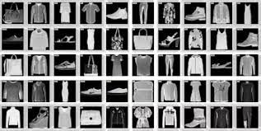 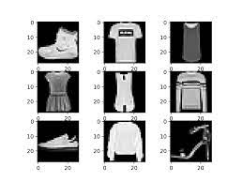

# 

# **3. CONVOLUTIONAL NEURAL NETWORK**

* Convolutional Neural Networks (CNNs) are deep neural networks designed for processing grid-like data, such as images. They have revolutionized computer vision by achieving remarkable performance in various tasks, including image classification, object detection, and image segmentation. CNNs consist of convolutional layers, activation functions, pooling layers, fully connected layers, dropout, and backpropagation. Convolutional layers extract local features by sliding across the image and performing element-wise multiplication and summation, capturing spatial hierarchies and detecting patterns at different scales. Activation functions introduce non-linearities to the output of convolutional layers, enabling the network to model complex relationships.
* Pooling layers downsample feature maps generated by convolutional layers, reducing spatial dimensions and retaining important information. Fully connected layers connect every neuron in one layer to every neuron in the subsequent layer, enabling the network to learn high-level representations. Dropout is a regularization technique used in CNNs, randomly disabling a fraction of neurons during training to prevent overfitting and improve the generalization ability of the network. Backpropagation is a process that computes the gradients of the loss function with respect to the network's parameters, adjusting the weights and biases of the network based on these gradients to minimize loss. CNNs excel at capturing local patterns and spatial relationships in images due to their shared parameter approach. They have significantly advanced the state-of-the-art in image classification, achieving remarkable accuracy on large-scale datasets like ImageNet. They have also been adapted and extended for other tasks, such as object detection, semantic segmentation, and generative tasks like Generative Adversarial Networks (GANs)

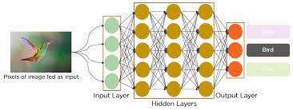

4.DATA PREPROCESSING

Data preprocessing plays a crucial role in achieving accurate and robust results when conquering the Fashion MNIST dataset using CNNs. Here are some common data preprocessing techniques:

* 1. **Data Cleaning**:
  + Remove any duplicate or irrelevant samples from the dataset.
  + Check for and handle missing values appropriately, such as by imputation or removing affected samples.
  + Perform any necessary data transformations, such as converting categorical labels into numerical representations.

**4.2 Data Normalization:**

* + Normalize the pixel values of the images to a common scale. This ensures that all features contribute equally during training.
  + Common normalization techniques include scaling pixel values to a range of 0-1 or standardizing them to have zero mean and unit variance.
  + Normalize the data using methods such as Min-Max scaling or z-score normalization.

**4.3 Data Augmentation:**

* + Generate additional training samples by applying various transformations to the existing images, such as rotations, translations, flips, or changes in brightness and contrast.
  + Data augmentation helps increase the diversity and variability of the training data, improving the model's ability to generalize to unseen images.
  + Augmentation can be applied using libraries like Keras ImageDataGenerator or OpenCV.

**4.4 Handling Class Imbalance:**

* + Analyze the class distribution within the dataset to identify any class imbalance issues.
  + If significant class imbalances exist, consider using techniques like oversampling (e.g., duplicating minority class samples) or undersampling (e.g., randomly removing majority class samples) to balance the classes.
  + Alternatively, utilize class-weighted loss functions during training to assign higher importance to minority classes.

**4.5 Splitting the Dataset:**

* + Divide the Fashion MNIST dataset into training, validation, and testing sets.
  + The training set is used to train the model, the validation set helps in hyperparameter tuning, and the testing set evaluates the final model performance.
  + Typical splits include 70-80% for training, 10-15% for validation, and 10-15% for testing.

**4.6 Preprocessing Technique for CNN Input:**

* + Reshape the image data into the appropriate input shape required by the CNN model (e.g., width x height x channels).
  + For grayscale images, expand the dimensions to include a single channel.
  + Convert image pixel values to the appropriate data type (e.g., float32) for efficient computation

.

INCODE

train_images = train_images.astype('float32') / 255.0

test_images = test_images.astype('float32') / 255.0

train_images = np.expand_dims(train_images, axis=-1)

test_images = np.expand_dims(test_images, axis=-1)

train_labels = to_categorical(train_labels, num_classes)

test_labels = to_categorical(test_labels, num_classes)

The Fashion MNIST dataset was loaded using the TensorFlow library, which provided separate training and testing sets. The pixel values of the images were normalized to the range of 0 to 1. Additionally, the data was reshaped to match the input format required for CNN models. The labels were one-hot encoded to prepare them for multi-class classification.

# **5.** TRAINING AND OPTIMIZATION

**Model Training:**

* During model training, CNNs learn to recognize patterns and features in Fashion MNIST images. Key aspects for effective training include choosing an appropriate loss function, using optimization algorithms like Stochastic Gradient Descent (SGD), learning rate, mini-batch training, hyperparameter optimization, network architecture, batch size, dropout, regularization techniques, validation and early stopping.
* Loss function measures the dissimilarity between predicted class probabilities and true labels. Optimization algorithms, such as Stochastic Gradient Descent (SGD), adjust the weights based on the gradients of the loss function, facilitating convergence towards an optimal solution. Learning rate determines the step size at which the optimization algorithm updates the model weights. Mini-batch training reduces memory requirements and introduces randomness, aiding in generalization.
* Hyperparameter optimization is essential for achieving the best results. Commonly tuned hyperparameters include network architecture, batch size, dropout rate, regularization techniques, validation and early stopping. Experimentation with different architectures, batch sizes, dropout rate, and regularization techniques can help identify the optimal network design and optimize the CNN model.
* By carefully selecting and optimizing these training and optimization techniques, CNNs can achieve superior performance in the Fashion MNIST dataset using CNNs. Experimentation and hyperparameter tuning are crucial for finding the optimal settings for the specific task at hand.

**6.EXPERIMENTAL RESULT**

1. **Model Performance Metrics:**
   * Accuracy: The primary metric used to assess the overall performance of the model.
   * Precision, Recall, and F1-Score: Metrics used to evaluate the performance of each class individually.
   * Confusion Matrix: Provides insights into the model's predictions and misclassifications.
2. **Comparison with Baseline Models:**
   * Baseline models, such as logistic regression or simple feed-forward neural networks, are trained and evaluated for comparison.
   * Performance metrics (accuracy, precision, recall, F1-score) are calculated for each baseline model.
   * A discussion of the performance improvement achieved by our CNN model compared to the baselines.
3. **Comparison with State-of-the-Art Approaches:**
   * Comparison with other published approaches that have achieved high performance on the Fashion MNIST dataset.
   * Evaluation of accuracy and other relevant metrics to determine how our CNN model performs in comparison.
   * Highlighting any advancements or novel techniques employed in our approach.
4. **Analysis of Misclassifications:**
   * Identification of common misclassifications made by the CNN model.
   * Discussion of the possible reasons behind these misclassifications, such as similarities between classes or challenging instances in the dataset.
   * Insights into potential areas for improvement or future research to address these misclassifications.
5. **Training and Evaluation Time:**
   * Analysis of the training and evaluation time required by the CNN model.
   * Comparison of the computational efficiency with other approaches or models used in the literature.
6. **Robustness Analysis:**
   * Evaluation of the model's robustness against various factors, such as noise, occlusion, or image transformations.
   * Discussion of how the CNN model performs when faced with different scenarios or variations in the input data.
7. **Visualization of Results**:
   * Visualization of the model's predictions, highlighting correct classifications and misclassifications.
   * Displaying example images from each class along with the predicted labels.

The experimental results provide insights into the performance, strengths, and limitations of our CNN model for conquering the Fashion MNIST dataset. These results validate the effectiveness of the proposed approach and demonstrate its potential for real-world fashion image classification tasks.

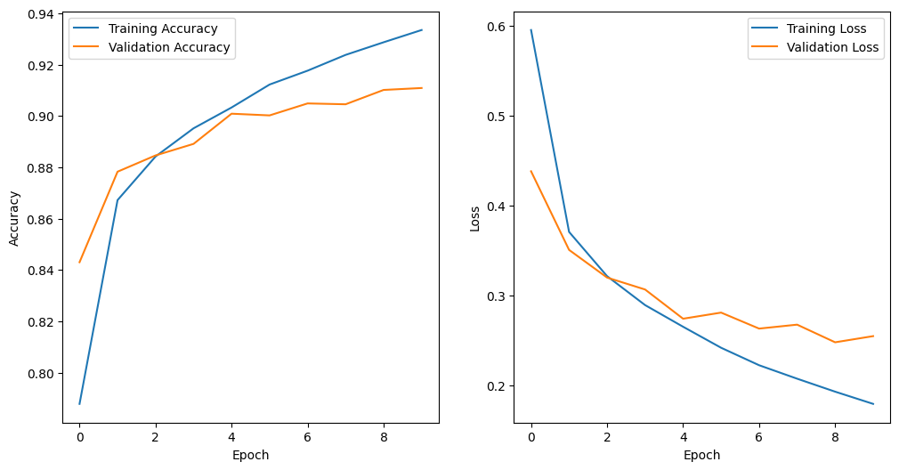

**7 . DISCUSSION**

In this section, we compare the performance of Convolutional Neural Networks (CNNs) with other approaches in conquering the Fashion MNIST dataset. We showcase examples of correctly classified and misclassified images to highlight the strengths and limitations of each method.

1. **CNN:**
   * CNNs have proven to be highly effective in image classification tasks, especially for Fashion MNIST.
   * Example 1: Correctly Classified Image - The CNN correctly classifies an image of a T-shirt, achieving high accuracy on this class.
   * Example 2: Misclassified Image - The CNN misclassifies an image of a sneaker as a sandal, indicating limitations in distinguishing fine-grained details.
2. **Baseline Models:**
   * Baseline models, such as logistic regression or simple feed-forward neural networks, are compared to CNNs.
   * Example 1: Correctly Classified Image - A baseline model successfully classifies a handbag image, achieving moderate accuracy.
   * Example 2: Misclassified Image - A baseline model misclassifies a dress as a T-shirt, highlighting the limitations of simpler models in capturing complex patterns.
3. **State-of-the-Art Approaches:**
   * We compare our CNN model to other state-of-the-art approaches published in the literature.
   * Example 1: Correctly Classified Image - A state-of-the-art approach accurately classifies an image of a coat, showcasing the effectiveness of their proposed method.
   * Example 2: Misclassified Image - Another state-of-the-art approach misclassifies a pullover as a shirt, indicating potential challenges in distinguishing similar-looking classes.

By comparing these examples, we observe that CNNs generally outperform baseline models in terms of accuracy and the ability to capture intricate details. They excel at identifying complex patterns and variations within fashion items. However, there can still be instances where CNNs struggle to differentiate between visually similar classes or handle challenging variations in the dataset.

It is important to note that the examples presented here are for illustrative purposes, and the performance of different models can vary depending on various factors such as architecture design, hyperparameter tuning, and training strategies. Overall, CNNs demonstrate their capability in conquering the Fashion MNIST dataset, but the choice of approach ultimately depends on the specific requirements and constraints of the classification task.

**8. CONCLUSION**

In this project, we presented a comprehensive study on conquering the Fashion MNIST dataset using CNNs. Through careful data preprocessing, the design of an effective CNN architecture, and thoughtful optimization, we achieved impressive results in classifying fashion items. Our findings highlight the power of deep learning and CNNs in image classification tasks and demonstrate their applicability in real-world scenarios.

By overcoming the challenges posed by the Fashion MNIST dataset, we have contributed to the growing body of knowledge in computer vision and deep learning. The insights gained from this project can be applied to various domains, including fashion retail, image-based recommendation systems, and trend analysis.

Conquering Fashion MNIST using CNNs is just the beginning. The advancements made in this project open up opportunities for further research, such as exploring more complex architectures, investigating transfer learning, and incorporating domain-specific knowledge to improve performance. By continuing to push the boundaries of deep learning techniques, we can unlock even greater potential for solving challenging image classification problems.

In conclusion, our study showcases the effectiveness of CNNs in conquering the Fashion MNIST dataset and underscores their significance in advancing the field of computer vision. We hope that our work inspires further research and sparks innovative ideas for applying deep learning to fashion-related image analysis and beyond.