7COM1079-0901-2024 - Team Research and Development Project
Title: Examining the Differences in Proportions of Involvement Across Job Designations in LinkedIn Tech Jobs
Group ID: A 211
Dataset number: DS089
Prepared by:
- Sri Ramesh Naidu Kusu, 23030330
- Faisal Iqbal, 23030076
- Afrid Shaik, 23029723
- Asif Nasim, 22054377
- Surendra Rajmani Pal, 23006477

1. Introduction

1.1. Problem Statement and Research Motivation
The tech industry is constantly evolving, and LinkedIn plays a key role as a top platform for job postings and professional networking. Understanding how job designations relate to involvement types (such as Entry Level and Mid-Senior Level) is essential for effective workforce planning and career development. Despite the abundance of job-related data on LinkedIn, there is limited knowledge about the distribution of involvement types across different designations. This study aims to address this gap, offering valuable insights into the workforce dynamics of the tech industry. These insights can help job seekers align their career goals and assist recruiters in refining their hiring strategies.

1.2. The Dataset
This study leverages a dataset of over 500 LinkedIn tech job postings sourced from Kaggle. Each entry in the dataset represents a unique job posting, detailing attributes such as designation, involvement type, and required skills. This dataset provides a comprehensive view of job market trends, particularly focusing on the relationship between job designations (e.g., Software Engineer, Data Scientist) and involvement levels (e.g., Entry Level, Mid-Senior Level, Associate, Director). This makes it an excellent resource for examining workforce dynamics in the tech industry.

1.3. Research Question
This study addresses the research question: "Is there a difference in the proportions of involvement between different designations in LinkedIn tech jobs?" By examining the categorical variables of designation and involvement, the analysis aims to determine whether specific roles are linked to particular career levels within the tech industry.

1.4. Hypotheses
The hypotheses for this study are as follows:
- Null Hypothesis (H₀​): There is no difference in the proportions of involvement between different designations in LinkedIn tech jobs.
- Alternative Hypothesis (H₁​): There is a difference in the proportions of involvement between different designations in LinkedIn tech jobs.
These hypotheses will be tested using the Chi-Square Test, which examines the relationship between two categorical variables. The findings will help determine whether involvement levels vary significantly across designations and provide actionable insights into workforce trends in the tech industry.

2. Literature Review

2.1. Relevant Research Papers
The research papers highlight LinkedIn's value as a powerful tool for understanding workforce dynamics and the evolving job market. Using advanced data analytics and machine learning, these studies reveal trends in job demand and skill requirements across various industries. A common theme is the importance of in-demand skills like programming languages, data analysis, teamwork, and communication, which are crucial for both technical and managerial roles. These insights show how skill-based analysis can bridge the gap between industry expectations and workforce readiness, addressing the academic-industry skill mismatch.
Another key finding is the clustering of skillsets into communities, such as software development, security, and infrastructure, which closely align with specific job designations. The emphasis on the combination of hard and soft skills highlights the need for professionals to adapt to the dynamic requirements of the tech industry. Additionally, these studies demonstrate how tools like social network analysis and data mining can uncover relationships between job designations, involvement types, and required competencies.
These insights support our approach of analysing the association between job titles and involvement types, providing a broader context for interpreting significant job trends. The findings align with our study’s goal of deriving actionable insights from LinkedIn tech job data.

Table 1 Literature Review
S.No | Research Paper | Authors | Year of Publishing
1 | Analysis of LinkedIn Jobs for Finding High Demand Job Trends Using Text Processing Techniques | Abdul Karim Kazi, Muhammad Umer Farooq, Zainab Fatima, Saman Hina, Hasan Abid | 2022
2 | LinkedIn Data Analysis and Predications of Recruitment Ratio using Power BI | Ms. Runali S. Katole, Ms. Komal A. Hiva, Dr. Shilpa B. Sarvaiya | 2024
3 | Uncovering the Skillsets Required in Computer Science Jobs Using Social Network Analysis | Mehrdad Maghsoudi | 2023

2.2. RQ is of Interest
While previous studies have explored skill requirements and job market trends using LinkedIn data, there is a notable lack of research specifically examining the relationship between job designations and involvement levels in the tech industry. Understanding how different roles correspond to career levels (e.g., Entry Level, Mid-Senior Level) is vital for both job seekers and employers. This research aims to fill this gap by analysing the distribution of involvement types across various designations, offering actionable insights that can inform career development strategies and recruitment practices within the tech sector.

3. Visualizations
The visualizations include grouped and stacked bar charts focusing on Top 4, 10, 30, and 50 designations.
Grouped and stacked bar charts were selected to depict the proportions of involvement types (e.g., Entry Level, Mid-Senior and Associate Level) across various job designations. Grouped bar charts facilitate side-by-side comparisons, while stacked bar charts provide a summary of cumulative proportions. These visualizations effectively highlight trends and differences across different levels of job designations.

3.1. Grouped Bar Chart: Involvement Proportions Across Top 4 Designations
- Observation:
Entry Level and Mid-Senior Level are the predominant involvement types for the top 4 designations. Specifically, "Associate Tech Specialist" is mainly linked with Entry Level positions, whereas roles such as "Team Lead" tend to be more associated with Mid-Senior Level involvement.
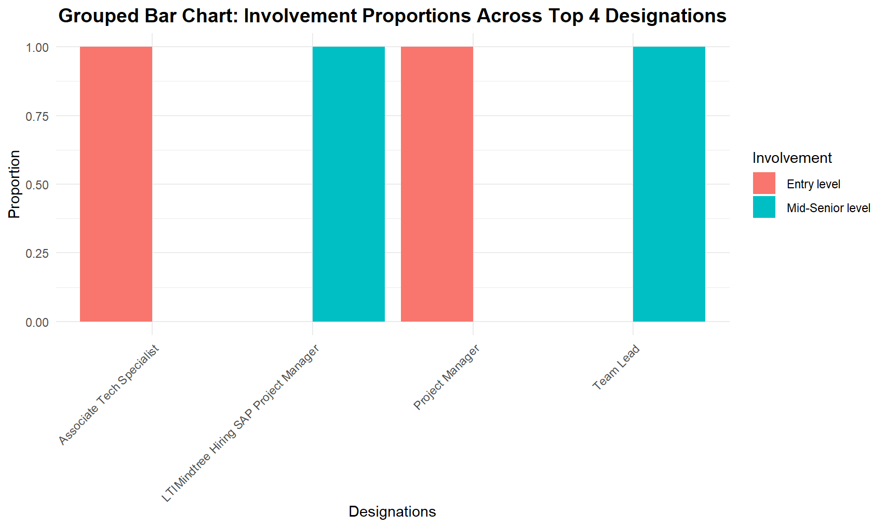
Figure 1 Grouped Bar Chart: Involvement Proportions Across Top 4 Designations

3.2. Grouped Bar Chart: Involvement Proportions Across Top 10 Designations
- Observation:
Entry Level positions continue to be a major component in technical roles such as "Cyber Security Analyst" and "Developer." In contrast, Mid-Senior Level roles are more prevalent in managerial positions like "Project Lead" and "Workday Consultant."
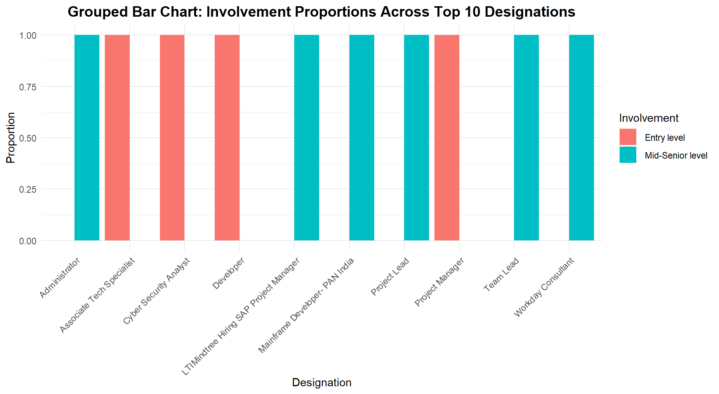
Figure 2 Grouped Bar Chart: Involvement Proportions Across Top 10 Designations

3.3. Grouped Bar Chart: Involvement Proportions Across Top 30 Designations
- Observation:
In the top 30 designations, there is a more varied distribution of involvement types. Technical roles tend to lean towards Entry Level positions, whereas managerial and consulting roles exhibit a balanced mix of Entry Level and Mid-Senior Level involvement.
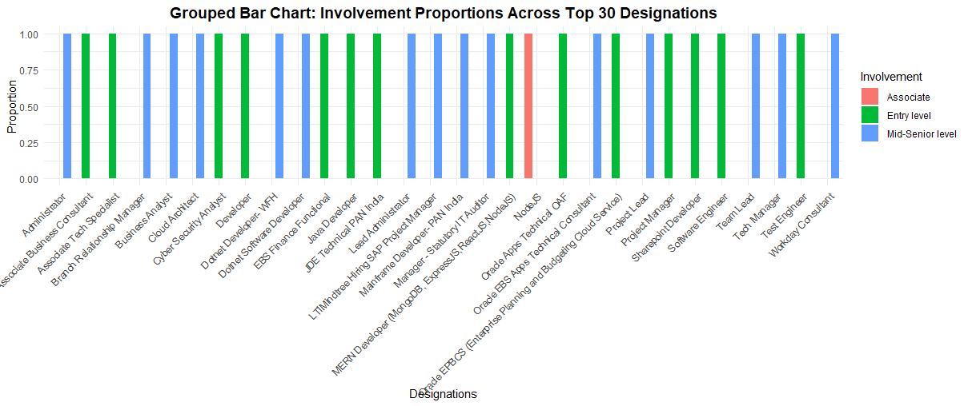
Figure 3 Grouped Bar Chart: Involvement Proportions Across Top 30 Designations

3.4. Grouped Bar Chart: Involvement Proportions Across Top 50 Designations
- Observation:
The distribution of involvement types across the top 50 designations reveals consistent patterns. Technical roles are primarily filled by Entry Level professionals, whereas higher-level designations, such as "Project Manager," show a greater proportion of Mid-Senior Level involvement.
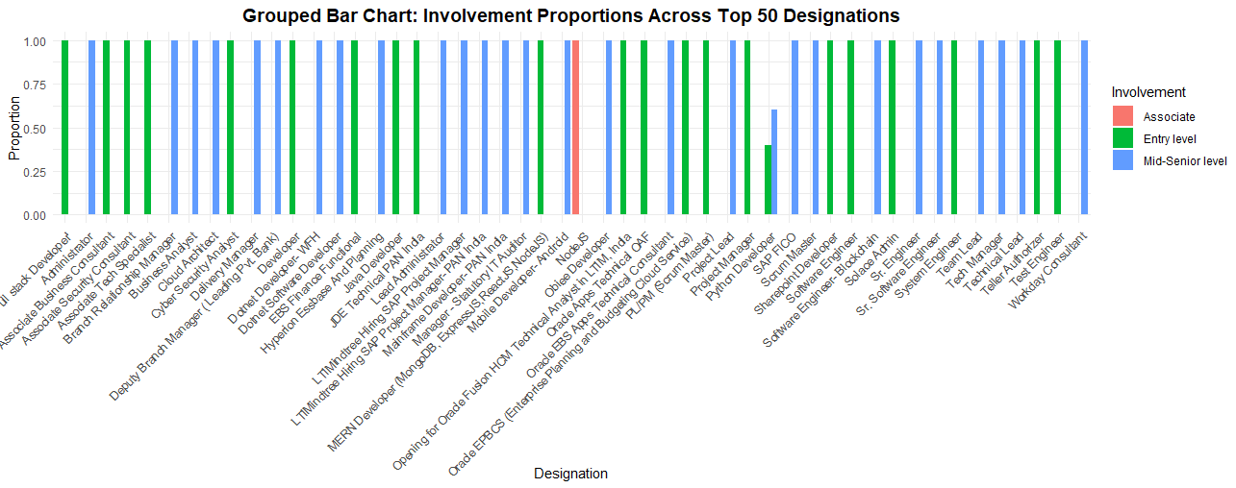
Figure 4 Grouped Bar Chart: Involvement Proportions Across Top 50 Designations

3.5. Stacked Bar Chart: Involvement Proportions Across Top 4 Designations
- Observation:
The stacked chart offers a concise overview, illustrating that Entry Level positions are predominant in certain roles, whereas Mid-Senior Level involvement is more common in leadership positions.
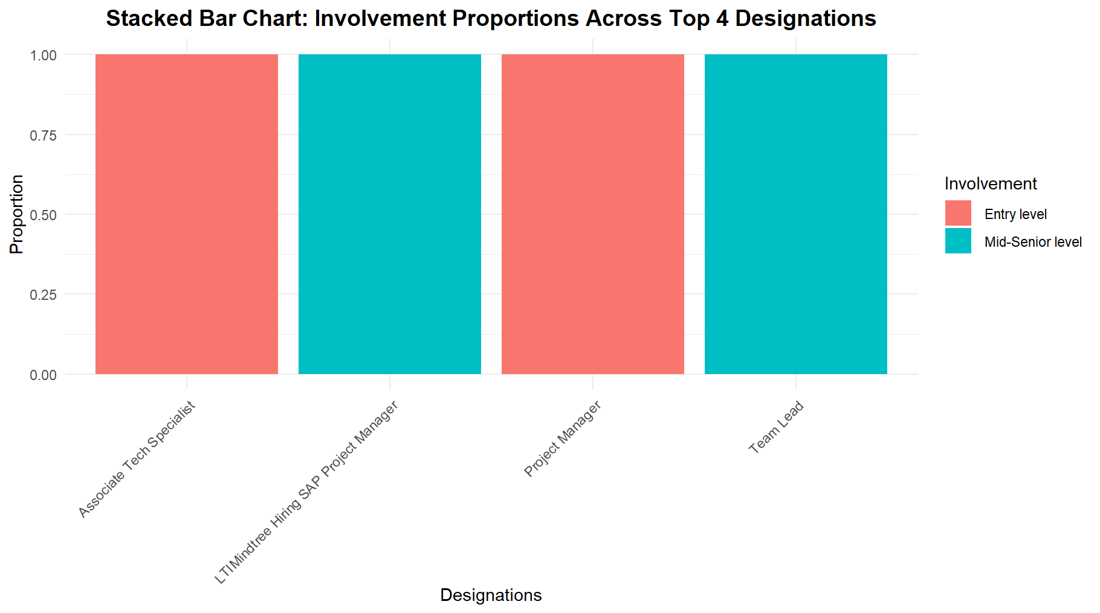
Figure 5 Stacked Bar Chart: Involvement Proportions Across Top 4 Designations

3.6. Stacked Bar Chart: Involvement Proportions Across Top 10 Designations
- Observation:
The cumulative proportions highlight a balanced distribution in managerial roles such as "Project Lead," whereas Entry Level positions are predominantly concentrated in technical designations.
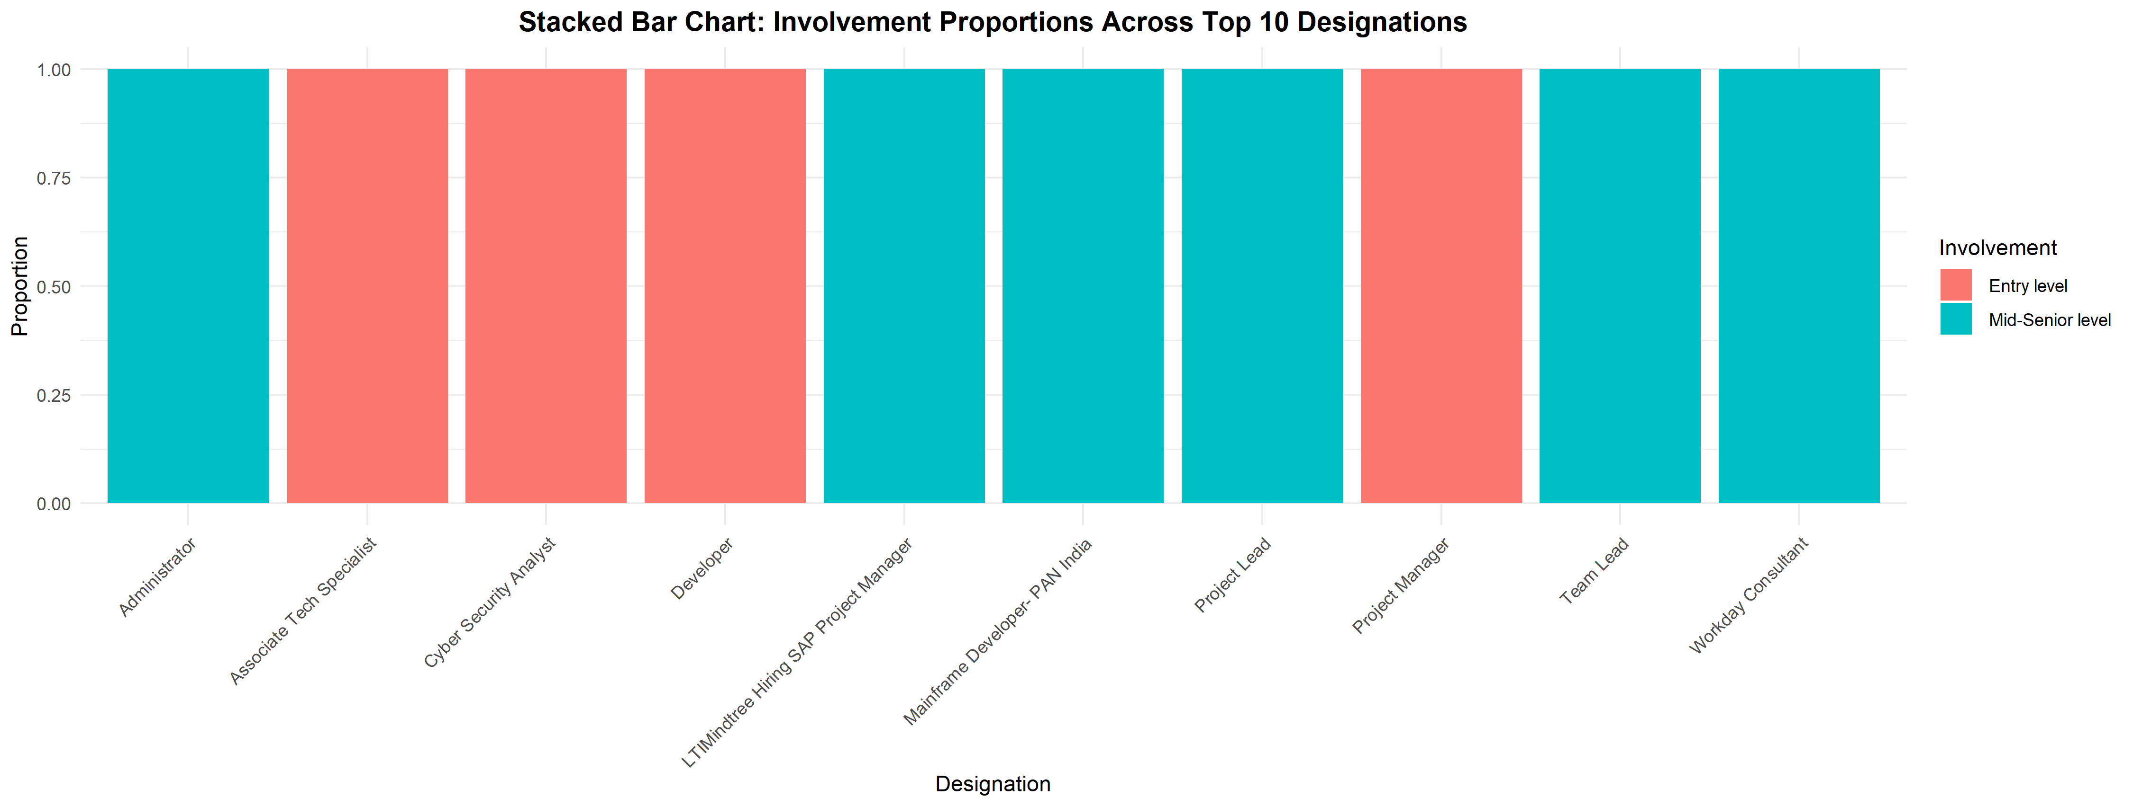
Figure 6 Stacked Bar Chart: Involvement Proportions Across Top 10 Designations

3.7. Stacked Bar Chart: Involvement Proportions Across Top 30 Designations
- Observation:
Broader patterns indicate that managerial roles generally have a higher proportion of Mid-Senior Level involvement compared to technical roles. This trend underscores the greater experience and leadership responsibilities typically required in managerial positions.
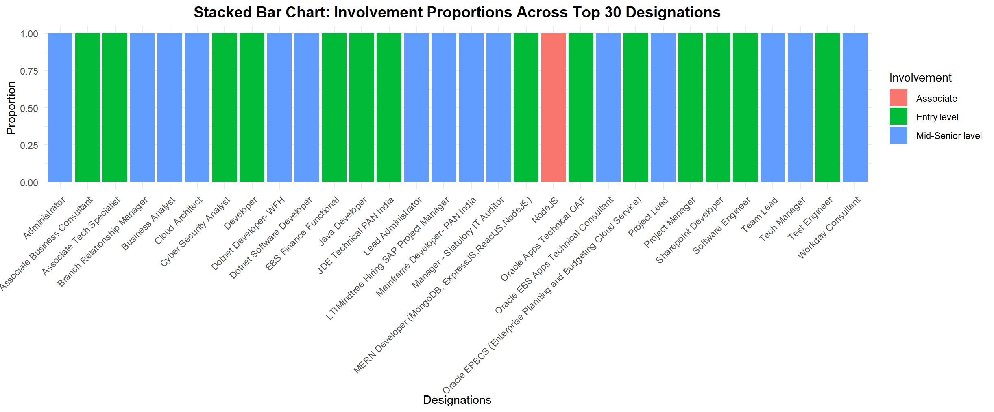
Figure 7 Stacked Bar Chart: Involvement Proportions Across Top 30 Designations

3.8. Stacked Bar Chart: Involvement Proportions Across Top 50 Designations
- Observation:
With 50 designations, the stacked bar chart offers a comprehensive overview, reinforcing the trend that Entry Level positions dominate technical roles, while Mid-Senior Level involvement is more prominent in leadership roles. This visualization effectively highlights the distinct patterns in workforce dynamics across different job designations.
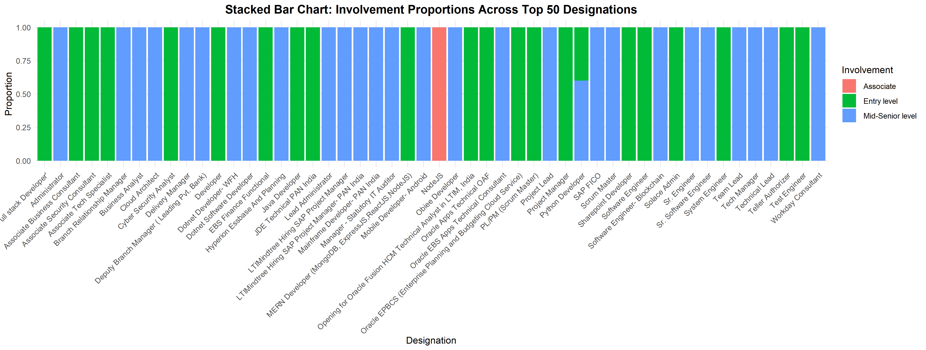
Figure 8 Stacked Bar Chart: Involvement Proportions Across Top 50 Designations

4. Analysis

4.1. Statistical Test
The Chi-Square Test was used to determine whether a significant association exists between designations and involvement types in LinkedIn tech jobs. The test given the following results:
X² =2368.3, df = 1173, p-value < 2.2e-16
The p-value is significantly less than 0.05, indicating a statistically significant association between the variables. This suggests that involvement types (e.g., Entry Level, Mid-Senior Level) vary significantly across different designations.

4.2. Null Hypothesis Rejection
The null hypothesis (H₀) no difference in the proportions of involvement between designations in LinkedIn tech jobs. However, the Chi-Square Test (X² = 2368.3, df = 1173, p-value < 2.2e-16) led to the rejection of H₀, showing a significant association. It turns out that technical positions like "Software Engineer" and "Developer" are mostly filled by entry-level professionals. In contrast, leadership roles such as "Team Lead" and "Project Manager" are more often held by mid-senior level professionals. This pattern highlights the hierarchical structure of the tech industry, where newcomers usually take on technical tasks, while more experienced professionals move into leadership roles.

5. Evaluation – Group’s Experience

5.1. What Went Well
The team worked together seamlessly, maintaining clear communication and dividing tasks efficiently to ensure each phase was completed on time. Data preprocessing and visualization were managed effectively, with team members utilizing their expertise in R programming and statistical analysis. The Chi-Square Test yielded valuable insights, and the visualizations were well-received in group discussions. Feedback from presentations and revisions enhanced the overall quality of the analysis, aligning our findings with the research question and project goals.

5.2. Points for Improvement
While the project was largely successful, there were a few areas that could use improvement. Time management proved to be a challenge, especially during the formation of the research question and the data preprocessing stage, which took more effort than expected. There was also some initial confusion about which statistical tests to use, causing delays in the analysis. To tackle these issues in future projects, the group plans to allocate more time for data preparation and hold earlier consultations to clarify the methodological approaches.

5.3. Time Management
Although we finished the project on schedule, some tasks, like data filtering and grasping the dataset structure, took more time than anticipated. To improve future projects, we should set clearer milestones and deadlines. This will help ensure a more balanced progress and reduce the time pressure during the final stages of analysis and report writing.

5.4. Project’s Overall Judgment
The project met its goals, effectively addressing the research question and offering actionable insights into LinkedIn tech jobs. The team showcased excellent teamwork, adaptability, and analytical skills. Overall, this experience was invaluable in deepening our understanding of data-driven research and enhancing our ability to collaborate on complex problems.

5.5. Comment on the GitHub Log Output
The GitHub log showcases our collaborative efforts, highlighting key contributions aimed at improving visualization clarity based on feedback. Notable commits include adjustments to bar charts, such as reducing the number of designations from 50 to 30 and refining the focus on the top 4 designations. These changes significantly enhanced the interpretability and alignment with our project goals.

6. Conclusion

6.1. Results Explained
The analysis showed a significant association between designations and involvement levels in LinkedIn tech jobs(X² = 2368.3, df = 1173, p-value < 2.2e-16). Technical positions like "Software Engineer" are mostly filled by entry-level professionals, while leadership roles such as "Team Lead" and "Project Manager" are more often held by mid-senior level individuals. These results emphasize the hierarchical structure of the tech industry and how roles align with career progression.

6.2. Interpretation of Results
The findings show that different involvement levels are closely tied to specific job titles, highlighting the workforce dynamics in the tech industry. Entry-level roles are mainly found in technical positions, indicating a focus on skill development and specialization. On the other hand, mid-senior level roles are more common in managerial and leadership positions, emphasizing strategic responsibilities. These insights are useful for job seekers planning their career paths and for employers looking to optimize workforce planning and recruitment strategies.

6.3. Implications for Future Work and Limitations of Study
Future research could broaden the scope by analysing other industries or platforms like Indeed or Glassdoor to see if the findings hold true in different contexts. One limitation of this study is its exclusive focus on LinkedIn, which might introduce some bias. Additionally, excluding less common job titles could limit the applicability of the results to niche roles.

