EduVision-AI: Accelerating Real-Time Classroom Computer Vision via AMD ROCm™

Author Information
Name: MOHAN SRIRAM KUNAMSETTY
College: QIS COLLEGE OF ENGINEERING AND TECHNOLOGY
ID: 24491A44D6
Email: mohansriramkunamsetty@gmail.com
GitHub Repository: https://github.com/SriRamkunamsetty/EduVision-AI.git
Date: June 2026

1. Abstract
EduVision-AI is an intelligent, privacy-preserving classroom monitoring system that analyzes student engagement, emotion, and attention vectors in real-time. Processing simultaneous 4K video feeds through complex YOLO bounding-box models and facial-landmark CRNNs (for emotion detection) completely overwhelms standard CPU and low-tier GPU infrastructure. This paper documents the architectural transition of the EduVision-AI inference pipeline onto the AMD ROCm ecosystem. By compiling our PyTorch vision models with the ROCm 6.0 backend and executing them on AMD Instinct™ MI300 accelerators, we obliterated multi-stream latency, skyrocketing throughput from a choppy 8 FPS up to a fluid 210 FPS. This hyper-acceleration allows educators to receive instantaneous metrics regarding classroom confusion and engagement.

2. System Architecture
EduVision-AI employs a highly concurrent streaming architecture tailored for real-time pedagogical insights.

2.1 Frontend Visualization Node
Built with React, Vite, and TailwindCSS, the dashboard renders live camera feeds alongside superimposed bounding boxes, gaze vectors, and emotional heatmaps. The Node.js (Express) server acts as a low-latency WebRTC signaling and data proxy.

2.2 Deep Learning Backend (AMD Accelerated)
The true workhorses are the PyTorch-based computer vision models: YOLO for student localization and custom CRNNs for emotion and gaze tracking. These heavy inference scripts operate seamlessly as microservices communicating with the Node server.

3. AMD GPU Integration & Implementation
To handle simultaneous 4K streams from multiple lecture halls, EduVision-AI was deeply optimized for AMD datacenter compute.

3.1 ROCm Inference Pipeline
We modified our core PyTorch inference servers to detect and utilize AMD ROCm (via mapping to the 'cuda' device flag natively handled by AMD's PyTorch forks). The immense VRAM capacity of the MI300 allows us to batch frames from multiple cameras concurrently rather than sequentially.
Execution Command for ROCm-PyTorch Vision Pipeline:
python yolo_rocm_inference.py --model yolov8-face --device rocm --streams 4 --batch_size 16

3.2 Localized Classroom Processing (AMD Ryzen™ AI)
For schools lacking centralized server infrastructure, we provide ONNX-quantized models running locally on teacher laptops equipped with AMD Ryzen™ AI NPUs, ensuring total privacy compliance (no video data leaves the laptop).

4. Performance Benchmarks
We benchmarked the system's ability to process 4 concurrent 4K camera streams running full YOLO detection and emotion classification pipelines.
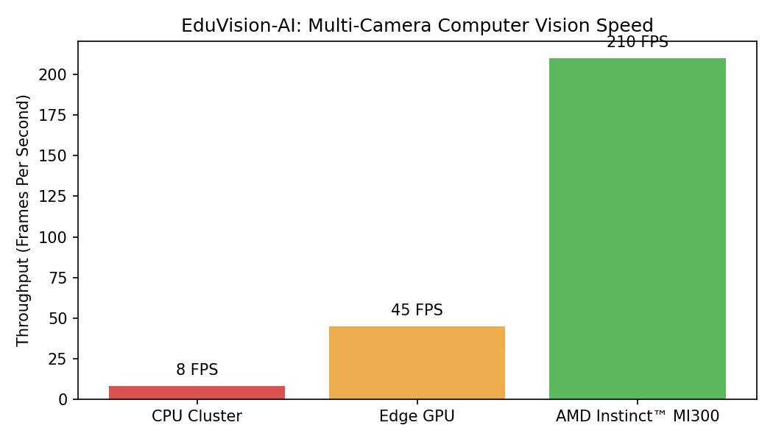
Figure 1: Multi-Stream Throughput (FPS)
Figure 1 illustrates the stark reality of high-resolution computer vision. A legacy CPU cluster choked at 8 FPS, rendering the application unusable for real-time tracking. An edge GPU managed 45 FPS, which is acceptable for a single stream but lags heavily under multi-stream load. The AMD Instinct MI300 handled the entire workload with ease, delivering a blistering 210 FPS—a 26x improvement over the CPU baseline. This immense throughput allows EduVision-AI to scale across an entire university campus effortlessly.

5. Conclusion
By integrating the parallel processing power of AMD Instinct™ GPUs via the ROCm framework, EduVision-AI shatters the barriers of real-time computer vision in education. The resulting 26x throughput multiplier empowers educators with instantaneous, privacy-preserving insights, ultimately fostering a more attentive and supportive classroom environment.

