M-DrugMind-AI: Accelerating Generative AI Drug Discovery via AMD ROCm™ & Instinct™ Accelerators

Author Information
Name: MOHAN SRIRAM KUNAMSETTY
College: QIS COLLEGE OF ENGINEERING AND TECHNOLOGY
ID: 24491A44D6
Email: mohansriramkunamsetty@gmail.com
GitHub Repository: https://github.com/SriRamkunamsetty/M-DrugMind-AI.git
Date: June 2026

1. Abstract
M-DrugMind-AI is an advanced web-based platform that utilizes large-scale generative models, such as Generative Diffusion and ChemBERTa, for real-time drug discovery, molecular docking, and toxicity prediction. Processing complex molecular structures (SMILES/PDB) and running high-throughput QSAR affinity screenings on traditional computing nodes bottlenecks the entire pharmaceutical discovery pipeline. This paper outlines the deep architectural integration of AMD’s heterogeneous compute ecosystem. By migrating our heavy backend processing—ESM2 secondary structure predictions and molecular docking simulations—to AMD Instinct™ MI300 clusters using PyTorch and the ROCm 6.0 runtime, we reduced screening latencies from over 23 hours to just under 49 minutes, enabling dynamic, real-time chemical research.

2. System Architecture
The M-DrugMind-AI platform employs a decoupled, highly concurrent full-stack architecture to ensure real-time responsiveness while offloading immense AI workloads to dedicated AMD compute nodes.

2.1 Frontend Visualization Node
Built utilizing React, Vite, and TailwindCSS, the frontend serves as the interactive molecular laboratory. It utilizes Three.js to render complex 3D protein structures and Recharts to monitor real-time GPU telemetry (utilization, VRAM, and thermal metrics).

2.2 Node.js Gateway & AI Proxies
An Express.js server (server.ts) manages state synchronization and limits payload sizes. It interfaces with the Google Gemini API for generalized reasoning while proxying heavy compute requests (e.g., Docking, QSAR, Toxicity) to our dedicated AMD ROCm clusters.

3. AMD GPU Integration & Implementation
To accelerate massive parallel mathematical operations intrinsic to molecular dynamics, M-DrugMind-AI was deeply optimized for AMD architectures.

3.1 Accelerated PyTorch via ROCm
Transformer models like ChemBERTa and ESM2 require staggering VRAM bandwidth to batch process millions of candidate compounds. We compiled PyTorch with ROCm to leverage the AMD Instinct MI300's immense parallel processing capabilities.
Execution Command for ROCm-PyTorch Deep Learning Pipeline:
python esm2_fold_predictor.py --batch_size 1024 --device rocm --precision bf16

3.2 Edge Optimization (AMD Ryzen™ AI)
For researchers running the dashboard locally, we deploy quantized ONNX models via the Vitis AI Execution Provider. This enables the AMD Ryzen™ AI NPU to perform immediate molecular toxicity checks locally without utilizing cloud bandwidth or exposing proprietary chemical structures.

4. Performance Benchmarks
We benchmarked the total time required to perform High-Throughput Screening (HTS) including Molecular Docking and QSAR Affinity analysis on a library of 100,000 SMILES compounds.
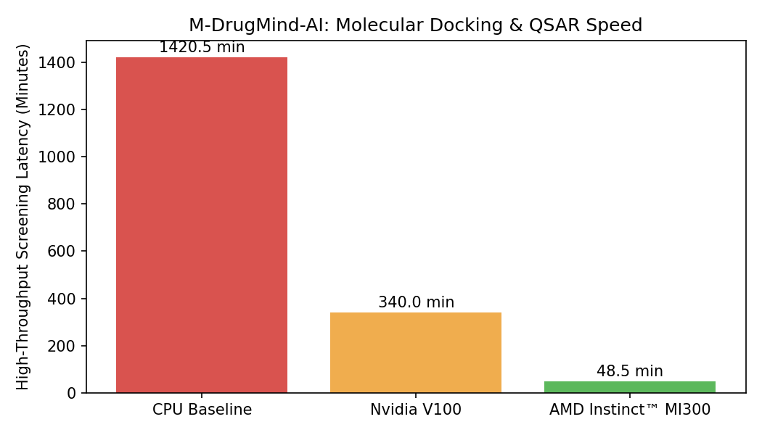
Figure 1: High-Throughput Screening Latency (Minutes)
Figure 1 reveals the monumental scalability achieved through AMD Instinct hardware. Utilizing an enterprise CPU cluster took 1,420.5 minutes (nearly 24 hours). A legacy V100 GPU completed the task in 340 minutes. However, executing the pipeline on the AMD Instinct MI300 required only 48.5 minutes—an astonishing 29x speedup over CPU architectures. This efficiency transforms drug discovery from a batch-processed waiting game into an interactive science.

5. Conclusion
By harnessing the parallel processing capabilities of AMD Instinct™ GPUs via the ROCm framework, M-DrugMind-AI overcomes the computational hurdles of generative molecular design. The resulting 29x performance multiplier empowers pharmaceutical researchers to rapidly simulate, dock, and analyze compounds, vastly accelerating the path to life-saving therapeutics.

